outcome TC LI #30 with the agreed modifications and additions indicated (clean)
Draft ETSI DTR 101 567 V0.1.0 (2012-05)

Lawful Interception (LI);
Cloud/Virtual Services (CLI)
Work Item: DTR/LI-00084

Draft Technical Report
Reference
DTR/LI-00084
Keywords
cloud/virtual services lawful interception
ETSI
650 Route des Lucioles
F-06921 Sophia Antipolis Cedex - FRANCE

Tel.: +33 4 92 94 42 00 Fax: +33 4 93 65 47 16

Siret N° 348 623 562 00017 - NAF 742 C
Association à but non lucratif enregistrée à la
Sous-Préfecture de Grasse (06) N° 7803/88

Important notice
Individual copies of the present document can be downloaded from:
http://www.etsi.org
The present document may be made available in more than one electronic version or in print. In any case of existing or perceived difference in contents between such versions, the reference version is the Portable Document Format (PDF). In case of dispute, the reference shall be the printing on ETSI printers of the PDF version kept on a specific network drive within ETSI Secretariat.
Users of the present document should be aware that the document may be subject to revision or change of status. Information on the current status of this and other ETSI documents is available at http://portal.etsi.org/tb/status/status.asp
If you find errors in the present document, please send your comment to one of the following services:
http://portal.etsi.org/chaircor/ETSI_support.asp
Copyright Notification
No part may be reproduced except as authorized by written permission.
The copyright and the foregoing restriction extend to reproduction in all media.

© European Telecommunications Standards Institute 2012.
All rights reserved.
DECTTM, PLUGTESTSTM, UMTSTM and the ETSI logo are Trade Marks of ETSI registered for the benefit of its Members.
3GPPTM and LTETM are Trade Marks of ETSI registered for the benefit of its Members and
of the 3GPP Organizational Partners.
GSM® and the GSM logo are Trade Marks registered and owned by the GSM Association.
Contents
Intellectual Property Rights 5
Foreword 5
1 Scope 6
2 References 6
2.1 Normative references 6
2.2 Informative references 6
3 Definitions and abbreviations 7
3.1 Definitions 7
3.2 Abbreviations 9
4 Cloud/Virtual Services Overview 11
4.1 Perspectives on cloud/virtual services 11
4.2 Resource management 15
4.3 Cloud/virtual services security 16
5 Lawful Interception Requirements 17
5.1 LEA Requirements 17
5.1.1 LEA Requirements to identify and communicate with the responsible service providers 17
5.1.2 LEA Requirements to facilitate access and delivery across different jurisdictions 17
5.1.3 LEA Requirements for legacy services implemented using cloud/virtual capabilities 17
5.2 CSP / C(L)SP Provider Obligations 17
5.2.1 Use of trusted third parties (TTP) 18
5.3 Lawful Interception security requirements 19
5.4 LI implementation scenarios 19
5.5 Implementation Challenges 19
6 Legacy LI models and methods applied to the Cloud environment 21
6.1 Legacy LI models 21
6.2 Adaptation to the Cloud environment 21
6.3 Interfaces for non-legacy cloud/virtual services 22
6.4 Hybrid Services 23
6.4.1 VoLTE 23
6.4.2 Peer to Peer Services 23
7 Lawful Interception as a Cloud Service (LIaaS) 24
7.1 Applicability of existing reference models 24
7.2 LI Law Enforcement Monitoring Facility (LEMF) as a cloud service 24
7.3 Other LI tools as cloud services 24
8 Security in the Cloud LI environment 25
8.1 Potential LI vulnerabilities in the Cloud services ecosystem 25
8.2 Continuous Security Monitoring for Cloud LI 25
9 LI – Cloud gaps and challenges 26
9.1 Generic “simple” cloud LI interface specification gap 26
9.2 Specific cloud/virtual LI specification gaps 26
9.2.1 eWarrant expressions extension for cloud/virtual environment 26
9.2.2 Virtual Target Identity (VTI) expressions for cloud/virtual LI/RD 26
9.2.3 Virtual Application Identity (VAI) expressions for cloud/virtual LI/RD 26
9.2.4 Virtual Observable (VO) expressions for cloud/virtual LI/RD 27
9.2.5 Dynamic Triggering 27
9.2.6 Virtual data acquisition 27
Annex A: Several Use cases 28
A.1 Telepresence use case 1: TSP offers Telepresence and all participants are subscribers of the TSP 28
A.2 Telepresence use case 2: Telepresence is offered by a Third Party provider. Participants are subscribers of the same or different TSP(s) 29
Annex B: Cloud Virtualization Fora 31
Annex C: Change Request History 42
History 42

Intellectual Property Rights
IPRs essential or potentially essential to the present document may have been declared to ETSI. The information pertaining to these essential IPRs, if any, is publicly available for ETSI members and non-members, and can be found in ETSI SR 000 314: "Intellectual Property Rights (IPRs); Essential, or potentially Essential, IPRs notified to ETSI in respect of ETSI standards", which is available from the ETSI Secretariat. Latest updates are available on the ETSI Web server (http://ipr.etsi.org).
Pursuant to the ETSI IPR Policy, no investigation, including IPR searches, has been carried out by ETSI. No guarantee can be given as to the existence of other IPRs not referenced in ETSI SR 000 314 (or the updates on the ETSI Web server) which are, or may be, or may become, essential to the present document.

Foreword
This Technical Report (TR) has been produced by ETSI Technical Committee Lawful Interception (LI).
This Technical Report does not in any matter establish or imply legal obligations to meet specified LI/RD capability requirements for cloud/virtual service providers.

1 Scope
The present document provides an overview on requests for handover and delivery of real-time information associated with cloud/virtual services. The report identifies Lawful Interception needs and requirements in the converged cloud/virtual service environment, the challenges and obstacles of complying with those requirements, what implementations can be achieved under existing ETSI LI standards, and what new work may be required to achieve needed Lawful Interception capabilities. Cloud Services in whichever forms they take (Infrastructure, Software, Platform or combinations of these) are often trans border in nature and the information required to maintain Lawful Interception (LI) capability or sufficient coverage for LI support may vary in different countries, or within platforms of different security assurance levels. This work aims to ensure capabilities can be maintained while allowing business to utilise the advantages and innovations of Cloud Services and was undertaken cooperatively with relevant cloud security technical bodies.

2 References
References are either specific (identified by date of publication and/or edition number or version number) or non-specific. For specific references, only the cited version applies. For non-specific references, the latest version of the reference document (including any amendments) applies.
Referenced documents which are not found to be publicly available in the expected location might be found at http://docbox.etsi.org/Reference.
NOTE: While any hyperlinks included in this clause were valid at the time of publication, ETSI cannot guarantee their long term validity.

2.1 Normative references
The following referenced documents are necessary for the application of the present document.
Not applicable.

2.2 Informative references
The following referenced documents are not necessary for the application of the present document but they assist the user with regard to a particular subject area.
[i.1] ETSI TS 101 331: "Lawful Interception (LI); Requirements of Law Enforcement Agencies".
[i.2] ETSI TS 101 671: "Lawful Interception (LI); Handover interface for the lawful interception of telecommunications traffic.
NOTE: Periodically TS 101 671 is published as ES 201 671. A reference to the latest version of the TS as above reflects the latest stable content from ETSI/TC LI.
[i.3] ETSI TS 102 232-1: " Lawful Interception (LI); Handover Interface and Service-Specific Details (SSD) for IP delivery; Part 1: Handover specification for IP delivery".
[i.4] ETSI TS 102 232-2: " Handover Interface and Service-Specific Details (SSD) for IP delivery; Part 2: Service-specific details for messaging services".
[i.5] ETSI TS 102 232-3: "Lawful Interception (LI); Handover Interface and Service-Specific Details (SSD) for IP delivery; Part 3: Service-specific details for internet access services".
[i.6] ETSI TS 101 232-4: "Lawful Interception (LI); Handover Interface and Service-Specific Details (SSD) for IP delivery; Part 4: Service-specific details for Layer 2 services".
[i.7] ETSI TS 101 232-5: "Lawful Interception (LI); Handover Interface and Service-Specific Details (SSD) for IP delivery; Part 5: Service-specific details for IP Multimedia services".
[i.8] ETSI TR 103 690: "Lawful Interception (LI); eWarrant Interface".
[i.9] Special Publication 800-145, The NIST Definition of Cloud Computing, Sept 2011

3 Definitions and abbreviations

3.1 Definitions
[Editorial note: some definitions are not used in the text, but are kept for the moment for possible future use.]
For the purposes of the present document, the following terms and definitions apply:
appliance: A self-contained IT system that can be plugged into an existing IT infrastructure to carry out a single purpose.
application virtualization: A virtual implementation of the application programming interface (API) that a running application expects to use.
Authentication: Verifying the identity of a user, process, or device, often as a prerequisite to allowing access to resources in an information system.
broad network access: Capabilities are available over the network and accessed through standard mechanisms that promote use by heterogeneous thin or thick client platforms (e.g. mobile phones, tablets, laptops, and workstations).
cloud communication centre: A cloud communication centre is a service that enables advanced features for the customer-enterprise interaction using the communication and management capabilities provided by a cloud based telecommunication infrastructure (managed by the cloud service provider).
cloud computing: A model for enabling service user’s ubiquitous, convenient, on-demand network access to a shared pool of configurable computing resources (e.g. networks, servers, storage, applications, and services), that can be rapidly provisioned and released with minimal management effort or service provider interaction. Cloud computing enables cloud services.
cloud federation: Cloud federation is a manner to implement inter-cloud computing in which mutually trusted clouds logically join together by integrating their resources. Cloud federation allows a cloud service provider to dynamically outsource resources to other cloud service provider in response to demand variations.
cloud infrastructure: The basis of a cloud, which provides capabilities for computing, storage and network resources, including resource orchestration, virtualization and sharing. It also provides relevant cross layer supporting functions to support the upper layer cloud services as well.
Cloud Infrastructure as a Service (IaaS): A category of cloud services where the capability provided by the cloud service provider to the cloud service user is to provision processing, storage, intra-cloud network connectivity services (e.g. VLAN, firewall, load balancer, application acceleration), and other fundamental computing resources of the cloud infrastructure where the cloud service user is able to deploy and run arbitrary applications.
Cloud Platform as a Service (PaaS): A category of cloud services where the capability provided to the cloud service user is to deploy user-created or acquired applications onto the cloud infrastructure using platform tools supported by the cloud service provider.
cloud platform: A set of capabilities to develop and enable Cloud Services utilizing IT and CT Resources. Some combinations of platform functionalities can be provided as cloud services. Editor’s note: it should be checked if current text is aligned with the components diagram in clause 6.
cloud service: A service that is delivered and consumed on demand at any time, through any access network and using any connected devices using cloud computing technologies.
Cloud Software as a Service (SaaS): A category of cloud services where the capability provided to the cloud service user is to use the cloud service provider’s applications running on a cloud infrastructure.
EXAMPLE: All applications have all the common characteristic to be non real time and may be of different kinds, including IT and business applications, and may be accessible from different user devices. The cloud service user does not manage or control the underlying cloud infrastructure with the possible exception of limited user-specific application configuration settings.
Cloud service partner (CSN): A person or organization who provides support to cloud service provider’s service offer building (e.g. service integration). [to be checked for use]
CLoud Service Provider (C(L)SP): A provider that provides and/or maintains cloud services.
Cloud Service User (CSU): A person or organization that consumes cloud services. End-users can be persons, machines, applications.
Communications as a Service (CaaS): A category of cloud services where the capability provided to the cloud service user is to use real time communication and collaboration services (this includes voice over IP, instant messaging, video conferencing, for different user devices).
community cloud: The cloud infrastructure is provisioned for exclusive use by a specific community of consumers from organizations that have shared concerns (e.g. mission, security requirements, policy, and compliance considerations). It may be owned, managed, and operated by one or more of the organizations in the community, a third party, or some combination of them, and it may exist on or off premises.
compliance: The act of adhering to, and demonstrating adherence to, a standard or regulation.
control: the ability to decide, with high confidence, who and what is allowed to access subscriber data and programs, and the ability to perform actions.
Desktop as a Service (DaaS): The capability provided to the cloud service user to use virtualized desktops from a cloud service provider in the form of outsourcing.
hybrid cloud: The cloud infrastructure is a composition of two or more clouds (private, community, or public) that remain unique entities but are bound together by standardized or proprietary technology that enables data and application portability (e.g. cloud bursting for load-balancing between clouds).
NOTE: It should be noted that the cloud deployment models do not reflect where services, platforms, applications, resources are actually hosted. For example, a private cloud can be hosted internally (on-site) or externally (outsourced).
hypervisor: The virtualization component that manages the guest OSs on a host and controls the flow of instructions between the guest OSs and the physical hardware.
Infrastructure as a Service (IaaS). The capability provided to the consumer is to provision processing, storage, networks, and other fundamental computing resources where the consumer is able to deploy and run arbitrary software, which can include operating systems and applications. The consumer does not manage or control the underlying cloud infrastructure but has control over operating systems, storage, and deployed applications; and possibly limited control of select networking components (e.g. host firewalls).
inter-cloud computing: Inter-cloud computing allows on-demand reassignment of cloud resources including compute, storage and network, and transfer of workload through interworking of cloud systems.
Inter-cloud federation: A manner to implement inter-cloud computing in which mutually trusted clouds logically join together by integrating their resources. Inter-cloud federation allows a C(L)SP to dynamically outsource resources to other C(L)SPs in response to demand variations.
Inter-cloud peering: direct inter-connection between two C(L)SPs.
Inter-cloud service broker (ISB): An indirect interconnection between two (or more) C(L)SPs achieved through an interconnecting C(L)SP which, in addition to providing interworking service functions between the interconnected C(L)SPs, also provides brokering service functions for one (or more) of the interconnected C(L)SPs. ISB also covers the case in which one (or more) of the interconnected entities receiving brokering service is a cloud service user (CSU). [FFS]
NOTE: Brokering service functions generally include, but are not limited to, the following three categories: service intermediation, service aggregation and service arbitrage.
measured service: Cloud systems automatically control and optimize resource use by leveraging a metering capability at some level of abstraction appropriate to the type of service (e.g. storage, processing, bandwidth, and active user accounts). Resource usage can be monitored, controlled, and reported, providing transparency for both the cloud service provider and cloud service user of the utilized service.
multi-tenancy: A characteristic of cloud in which resources are shared amongst multiple cloud tenants.
Network as a Service (NaaS): A category of cloud services where the capability provided to the cloud service user is to use transport connectivity services and/or inter-cloud network connectivity services.
NOTE: NaaS services include flexible and extended VPN, Bandwidth on demand etc.
on-demand self-service: A cloud service user can unilaterally provision computing capabilities, such as server time, network storage and communication and collaboration services, as needed automatically without requiring human interaction with each service’s cloud service provider.
partitioning: Managing guest operating system access to hardware so that each guest OS can access its own resources but cannot encroach on the other guest OSs’ resources or any resources not allocated for virtualization use.
Platform as a Service (PaaS): The capability provided to the consumer is to deploy onto the cloud infrastructure consumer-created or acquired applications created using programming languages, libraries, services, and tools supported by the provider. The consumer does not manage or control the underlying cloud infrastructure including network, servers, operating systems, or storage, but has control over the deployed applications and possibly configuration settings for the application-hosting environment.
private cloud: The cloud infrastructure is operated solely for exclusive use by a single organization comprising multiple consumers (e.g. business units). It may be owned, managed, or operated by the organization, a third party, or some combination of them.
public cloud: The cloud infrastructure provisioned for open use by the general public. It may be owned, managed, or operated by a business, academic, or government organization, or some combination of them.
resource: any kinds of resources to be shared to compose cloud services including computing power, storage, network, database, and applications.
service aggregation: This capability combines and integrates multiple services into one or more new services. It ensures that data are modelled across all component services and integrated, as well as ensures the movement and security of data between the cloud service user and multiple cloud service providers.
service arbitrage: This capability is similar to the service aggregation capability. The difference between them is that the services being aggregated aren’t fixed. Indeed, the goal of arbitrage is to provide flexibility and opportunistic choices for the service aggregator, e.g. providing multiple e-mail services through one cloud service provider or providing a credit-scoring service that checks multiple scoring agencies and selects the best score.
Service Delivery Platform: A system architecture or environment that enables the efficient creation, deployment, execution, orchestration and management of one or more classes of services.
service intermediation: This capability provides a service that directly enhances a given service delivered to one or more cloud service users, essentially adding value on top of a given service to enhance some specific capability.
Software as a Service (SaaS): The capability provided to the consumer is to use the provider’s applications running on a cloud infrastructure. The applications are accessible from various client devices through either a thin client interface, such as a web browser (e.g. web-based email), or a program interface. The consumer does not manage or control the underlying cloud infrastructure including network, servers, operating systems, storage, or even individual application capabilities, with the possible exception of limited user-specific application configuration settings.
Virtual Data Centre (VDC): The “virtual data centre” is an evolutionary computing model that presents the data centre as a service view to a single computer, which virtualizes all hardware and software resources behind it.
virtual hardware: The hardware (including the CPU, controllers, Ethernet devices, and disks) that is seen by the guest software.
virtual machine: The complete environment that supports the execution of guest software. A virtual machine is a full encapsulation of the virtual hardware, virtual disks, and the metadata associated with it. Virtual machines allow multiplexing of the underlying physical machine through a software layer called a hypervisor.
virtualization: The simulation of the software and/or hardware upon which other software runs.

3.2 Abbreviations
[Editorial note: some abbreviations are not used in the text, but are kept for the moment for possible future use.]
For the purposes of the present document, the following abbreviations apply:
AAA Authentication, Authorization, and Audit
API Applications Programming Interface
ASP Application Service Provider
BCP Business Continuity Plan
BI Business Intelligence
BSS Business Support System
CaaS Communications as a Service
CDMI Cloud Data Management Interface
CIM Common Information Model
CLIF Cloud Lawful Interception Function
C(L)SP Cloud Service Provider
CPU Central Processing Unit
CSA Cloud Security Alliance
CSB Cloud Service Broker
CSN Cloud Service Partner
CSP Communication Service Provider
CSR Cloud Service Requester
CSU Cloud Service User
DaaS Desktop as a Service
DRAM Dynamic random-access memory
DSaaS Data Storage as a Service
DT Dynamic Triggering
DSL
HSS
IaaS Infrastructure as a Service
ICT Information and Communication Technologies
IDC Internet Data Centre
IdM Identity management
IMS IP Multimedia Subsystem
IoT Internet of Things
IPTV Internet Protocol Television
ISB Inter-cloud Service Broker
ISP Internet Service Provider
LEA Law Enforcement Agency
LEMF Law Enforcement Monitoring Facility
LIaaS Lawful Interception as a Cloud Service
M2M Machine to Machine
NaaS Network as a Service
NIST
OCCI Open Cloud Computing Interface
OSS Operations Support System
OVF Open Virtualization Format
PaaS Platform as a Service
PC Personal Computer
QoS Quality of Service
RDaaS Retained Data as a Cloud Service
RDBMS Relational Database Management System
SaaS Software as a Service
SAS Statements on Auditing Standards
SDP Service Delivery Platform
SDPaaS SDP as a Service
SLA Service Level Agreement
TAS
TSP (in annex A)
TTP Trusted Third Party
VDC Virtual Data Centre
VLAN Virtual Local Area Network
VM Virtual Machine
VNO Virtual Network Operator
VoLTE
VPN Virtual Private Network

4 Cloud/Virtual Services Overview
Cloud/virtual services are very diverse and constantly evolving. Work on service conceptualization, reference architectures, infrastructure models, resource management, and other important topics are the subject of on-going work in many different industry standards forums listed in annex B. Many of the service definitions that have achieved a level of stability are included in section 3. This section provides an overview on cloud/virtual services.

4.1 Perspectives on cloud/virtual services
Cloud computing, including distributed virtual services, is an evolving paradigm that is fundamentally and rapid changing communication services and infrastructure.
The diversity of these services and the underlying infrastructure has itself produced different perspectives.
In general, most of the many forums dealing with cloud computing have found common ground in the following description (Special Publication 800-145, The NIST Definition of Cloud Computing, Sept 2011 [i.9]).
“Cloud Computing is a model for enabling ubiquitous, convenient, on-demand network access to a shared pool of configurable computing resources (e.g. networks, servers, storage, applications, and services) that can be rapidly provisioned and released with minimal management effort or service provider interaction. This cloud model promotes availability and is composed of five essential characteristics, three service models, and four deployment models.”
General characteristics of cloud services
On-demand self-service. A consumer can unilaterally provision computing capabilities, such as server time and network storage, as needed automatically without requiring human interaction with each service provider.
Broad network access. Capabilities are available over the network and accessed through standard mechanisms that promote use by heterogeneous thin or thick client platforms (e.g. mobile phones, tablets, laptops, and workstations).
Resource pooling. The provider’s computing resources are pooled to serve multiple consumers using a multi-tenant model, with different physical and virtual resources dynamically assigned and reassigned according to consumer demand. There is a sense of location independence in that the customer generally has no control or knowledge over the exact location of the provided resources but may be able to specify location at a higher level of abstraction (e.g. country, state, or data centre). Examples of resources include storage, processing, memory, and network bandwidth.
Rapid elasticity. Capabilities can be elastically provisioned and released, in some cases automatically, to scale rapidly outward and inward commensurate with demand. To the consumer, the capabilities available for provisioning often appear to be unlimited and can be appropriated in any quantity at any time.
Measured service. Cloud systems automatically control and optimize resource use by leveraging a metering capability at some level of abstraction appropriate to the type of service (e.g. storage, processing, bandwidth, and active user accounts). Resource usage can be monitored, controlled, and reported, providing transparency for both the provider and consumer of the utilized service.
Service models
Software as a Service (SaaS). The capability provided to the consumer is to use the provider’s applications running on a cloud infrastructure. The applications are accessible from various client devices through either a thin client interface, such as a web browser (e.g. web-based email), or a program interface. The consumer does not manage or control the underlying cloud infrastructure including network, servers, operating systems, storage, or even individual application capabilities, with the possible exception of limited user-specific application configuration settings.
Platform as a Service (PaaS). The capability provided to the consumer is to deploy onto the cloud infrastructure consumer-created or acquired applications created using programming languages, libraries, services, and tools supported by the provider. The consumer does not manage or control the underlying cloud infrastructure including network, servers, operating systems, or storage, but has control over the deployed applications and possibly configuration settings for the application-hosting environment.
Infrastructure as a Service (IaaS). The capability provided to the consumer is to provision processing, storage, networks, and other fundamental computing resources where the consumer is able to deploy and run arbitrary software, which can include operating systems and applications. The consumer does not manage or control the underlying cloud infrastructure but has control over operating systems, storage, and deployed applications; and possibly limited control of select networking components (e.g. host firewalls).
Deployment models
Private cloud. The cloud infrastructure is provisioned for exclusive use by a single organization comprising multiple consumers (e.g. business units). It may be owned, managed, and operated by the organization, a third party, or some combination of them, and it may exist on or off premises.
Community cloud. The cloud infrastructure is provisioned for exclusive use by a specific community of consumers from organizations that have shared concerns (e.g. mission, security requirements, policy, and compliance considerations). It may be owned, managed, and operated by one or more of the organizations in the community, a third party, or some combination of them, and it may exist on or off premises.
Public cloud. The cloud infrastructure is provisioned for open use by the general public. It may be owned, managed, and operated by a business, academic, or government organization, or some combination of them. It exists on the premises of the cloud provider.
Hybrid cloud. The cloud infrastructure is a composition of two or more distinct cloud infrastructures (private, community, or public) that remain unique entities, but are bound together by standardized or proprietary technology that enables data and application portability (e.g. cloud bursting for load balancing between clouds).

4.2 Cloud reference architectures and infrastructures
The cloud architecture must meet several requirements to enable sustained innovation and development of cloud services. With multiple stakeholders involved, the cloud architecture must be flexible to fit the needs of infrastructure C(L)SPs, CSPs and service resellers. The following high-level requirements are broadly envisioned for the cloud architecture.
- Support for many standards within the same cloud infrastructure and allow for evolution of these standards, without requiring disruptive infrastructure changes.
- Broadband access.
- The cloud architecture must enable multiple current and future deployment models, cloud service categories and use cases, in whole or in part.
- For private and hybrid cloud operations, cloud services must appear like intranet services.
- Early detection, diagnosis and fixing of infrastructure or service-related problems.
- Auditing and compliance, including service-level monitoring of resources allocated to users.
- Invisibility of cloud resource allocations to cloud service users. A C(L)SP may choose to expose service-operation details without having to share cloud internal infrastructure allocation and provisioning details for security and business reasons, including meeting LI requirements.
- Users consuming cloud services must be able to control cloud resource access to the CSP transparently, and enable IT procedures to work without compromise in legal or organizational mandates.
- Intranet-level security capabilities that may include access records, activity reports, session monitoring, packet inspections, firewalling, access control and malicious attack detection and prevention.
- Resource mobility which includes virtual machine mobility.
- Resource scalability.
- Naming identity management.
- Automated resource deployments.
Cloud computing reference architectures typically make use of a framework that defines the layers of a cloud functional architecture derived by grouping cloud related functions, see figure 1.
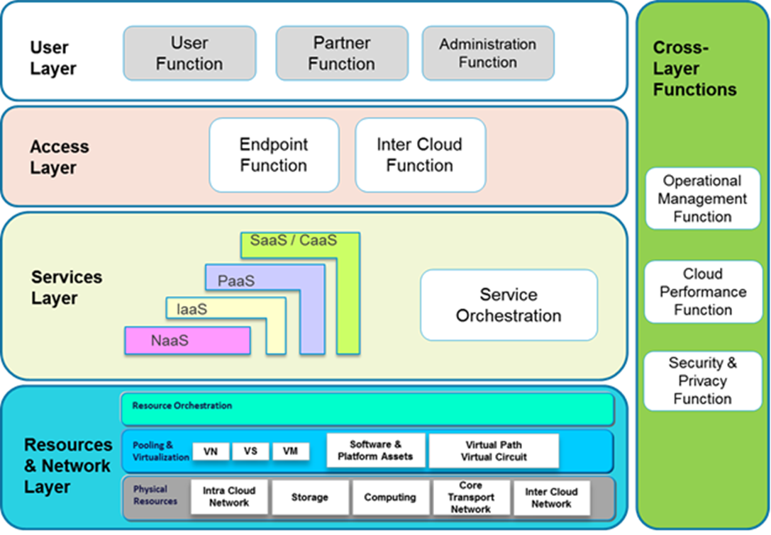
Source: ITU-T Focus Group on Cloud Computing Technical Report, Part 2: Functional requirements and reference architecture (02/2012)
Figure 1: Cloud related functions
The user layer performs interaction between the cloud service user and the cloud infrastructure. The user layer is used to set up a secure mechanism with the cloud, to send cloud service requests to the cloud, and receive cloud services from the cloud, perform cloud service access, and administrate and monitor cloud resources. Five categories are typical: Communication as a Service, Software as a Service, Platform as a Service, Infrastructure as a Service, and Network as a Service.
The access layer provides a common interface for both manual and automated cloud service capabilities and service consumption. The access layer accepts cloud service consumption requests using cloud APIs to access services and resources. The services layer is where services are orchestrated and exposed in the five cloud service categories. The resources and network layer is where the physical resources reside.
Cross-layer functions perform overall system management (i.e., operations, administration, maintenance and provisioning, and monitoring, including secure mechanisms.
One architecture dimension that is unique to the cloud/virtual environment is the concept of the Inter-cloud function. Cloud services are expected to be offered by C(L)SPs globally and must rely on inter-cloud connections with other C(L)SPs. The inter-cloud function can be implemented through inter-cloud peering, inter-cloud service broker and inter-cloud federation arrangements.
The cloud/virtual services reference architecture abstractions are ultimately manifested across multiple network infrastructures as depicted in figure 2.
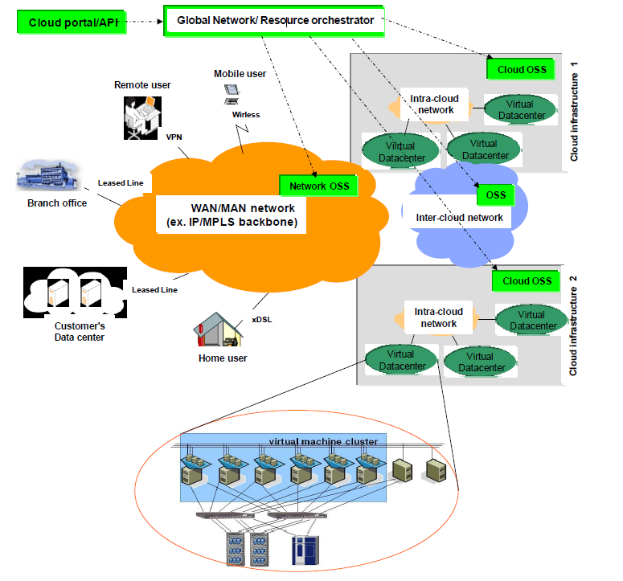
Figure 2: Cloud/virtual network infrastructure model (ITU-T Cloud TR3)
These resulting infrastructures in turn enable the far reaching changes being witnessed today. Millions of “app” clients are able to be autonomously provided to many different mobile and fixed end user smart devices that facilitate direct access to tailored services, see figure 3.
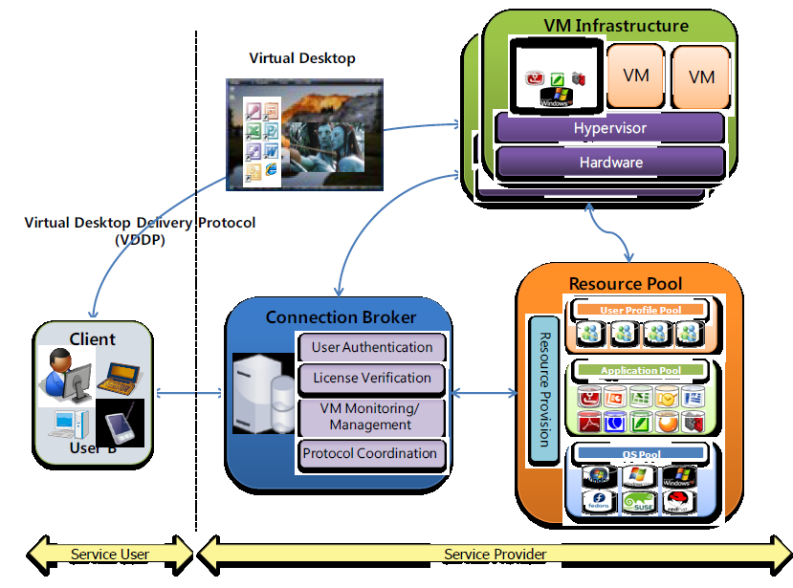
Figure 3: Cloud/virtual infrastructure (ITU-T Technical Report Part 2, fig. I.1)
[it will be tried to "combine" the figures into one specifically relevant to LI]

4.2 Resource management
Resource management is necessary for maintaining processing, storage, and I/O capabilities – physical and virtual – within or across cloud environments. Cloud infrastructure should provide a unified resource management function for the upper-layers (including virtualized and physical computing resource, storage resource, and network resource). The resource management function should provide resource packaging, resource deployment, and resource scheduling, whilst managing templates and assets.
Resource packaging provides a unified interface of heterogeneous resource, whether virtualized or physical, to upper-layers for management and utilization. Resource deployment and scheduling provide elastic, dynamic, on-demand and automation management for the down-layers, based on user-defined policies. They also provide resource access control interfaces to the upper-layers, and can dynamically allocate the resource by the real-time monitoring of applications and SLAs. Template management provides the capability to describe groups of computing, storage and network resources within their life cycles. Asset management provides unified management of the physical devices, including configuration information and topology of assets.
Resource management is a critical enabler, and consists of the ability in a trusted manner to uniquely identify, locate, acquire, format, protect, and deliver specific forensics described by a target signature. These requirements may necessitate an overlay, compartmentalized resource management implementation.
A cloud resource management model in common use is depicted in figure 4.
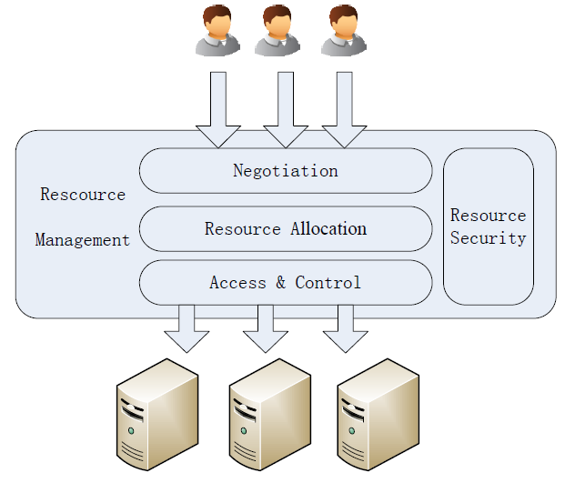
Figure 4: Cloud resource management model (ITU-T Technical Report Part 3, Fig 11)
An abstract view of the resource management model is shown in figure 5.
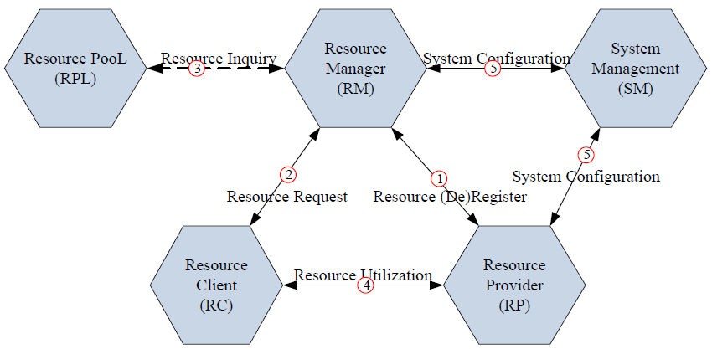
Figure 5: Resource management model (ITU-T Technical Report Part 3, Fig 13)
One of the most important of these virtual entities is the Resource Provider. It is the entity which provides and maintains virtualized resources to the resource management platform and is consists of hypervisors.

4.3 Cloud/virtual services security
For purposes of the present document, cloud/virtual services security consists of capabilities that enable the assessment and mitigation of risks associated with those services and the supporting infrastructures. Security capabilities of interest for Lawful Interception purposes generally encompass either Identity Management or security related implementations that enable or facilitate acquisition of traffic or patterns of interest. Cloud/virtual Deep Packet Inspection (DPI) platforms, for example, are inherently multi-use in nature. However, the compartmentalization requirements for LI may necessitate independent overlay systems within cloud infrastructures.
The cloud/virtual security work is spread across many of the forums identified in annex B and constantly evolving.
[ed note: could be moved to security section]

5 Lawful Interception Requirements
The on-going work in the industry and standards forums dealing with cloud/virtual services recognize that a broad array of existing “obligatory predicates” apply to the services being provided, including lawful interception. This section describes lawful interception predicates.

5.1 LEA Requirements

5.1.1 LEA Requirements to identify and communicate with the responsible service providers
The most fundamental predicate for LEAs is to be able to identify and communicate with the service provider(s) responsible for the communications involving specific targets. Cloud/virtual environments are especially challenging because the relevant C(L)SP providers are often not subject to registration, regulatory, or CSP partnership requirements that facilitate discovery of their identity(ies). Furthermore, the responsible providers may be layered, e.g. an “app” provider or service provider with the direct customer relationship that uses a Software-as-a-Service provider that aggregates Infrastructure-as-a-Service resources at a data centre.

5.1.2 LEA Requirements to facilitate access and delivery across different jurisdictions
Because the imposition of LI requirements is oriented around jurisdiction and geography, significant complications can occur when access to cloud facilities and services occurs by a target subject in another country. [The handover aspects need to be addressed in this section]

5.1.3 LEA Requirements for legacy services implemented using cloud/virtual capabilities
A substantial diversity exists among cloud facilities and services that affect the nature and implementation of Law Enforcement Agency (LEA) requirements. However, if a Communication Service Provider (CSP) elects to implement a cloud service and becomes a Cloud Service Provider (C(L)SP), their legal obligation to support LI is unchanged. To the extent relevant, the requirements of Law Enforcement Agencies articulated in ETSI TS 101 331 [i.1] still apply. What may be impacted are the technical solutions outlined in ETSI LI standards as the underlying architecture may be changed by the implementation of cloud services.
The specific telecommunications traffic that is to be intercepted is subject to national laws. National laws may require different levels of capabilities and procedures for LI in public and private networks. Additionally, there may also be different definitions or criteria to determine what defines a private network in the different jurisdictions.
The list below defines the telecommunications services for which there are LI solutions.
- Voice, conferencing
- E-mail/Messaging
- Internet Access
NOTE: This list is subject to further extension.
Other services – most of which are cloud-based – have no standardized LI solution. This includes services such as file sharing, telepresence, so-called “social networks,” or “virtual games”.

5.2 CSP / C(L)SP Provider Obligations
Communication Service Providers (CSPs) typically have a number of responsibilities which can be roughly summarised into two areas:
- Provision and Maintenance of lawful interception capability.
- Protection of information and activities pursuant to this responsibility.
In accordance to national law, CSPs are still responsible to provide the “access” interception capability and “service” interception capability for those services which they offer.
Cloud Service Providers (C(L)SPs) and cloud facility operators are subject to many legal and regulatory requirements that vary among the jurisdictions in which they have physical presence or offer service. Service agreements among Cloud Service providers and with Communication Service Providers may also impose additional requirements.
National regulations may determine if and which type of cloud providers (e.g. Communications as a Service (CaaS), Infrastructure as a Service (IaaS), Platform as a Service (PaaS), Software as a Service (SaaS)) will be subject to lawful interception requirements. National regulations may determine other means to identify which cloud providers have lawful interception obligations (e.g. by specific service provided). Some cloud providers may have an obligation because they offer a particular user service identified in that nation as required to be intercepted but other cloud providers would not have a similar obligation if they do not offer services specifically identified.
Trusted Third Parties (TTPs) may also by service agreement and local/national law provide support for some of those requirements see section 5.2.1.
In most jurisdictions, CSPs or their designated Trusted Third Party (TTP) (see section 5.2.1) must support in a timely fashion law enforcement requests for lawful interception in a manner that complies with the law and other requirements of that jurisdiction. Some lawful interception implementations may require some kind of Dynamic Triggering (DT) capabilities. A generic overview of how CSP's view interception responsibilities is described below.
[Ed NOTE: a split of the diagram needs to be investigated]
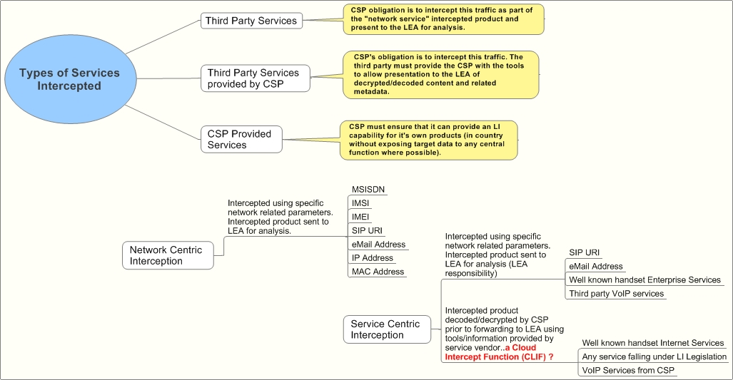
Figure 6:

5.2.1 Use of trusted third parties (TTP)
There is a basic model for the use of trusted third parties (TTP).
Basic model: A CSP or LEA may choose to ask a TTP to help meet their obligations and requirements. As agreed between the CSP or LEA and TTP, the TTP may perform some functions in support of the responsibilities of the CSP and LEA. Ultimately, the responsibility to ensure the capabilities outlined in the present document are available, lies with the CSP or LEA.

5.3 Lawful Interception security requirements
Existing LI specifications for legacy services include extensive security capabilities. See, e.g. Handover specification for IP delivery, TS 102 232-1 [i.3]. Some comparable secure delivery capability is necessary in the cloud/virtual service environment – not only for delivery, but for requests such as eWarrants described in TR 103 690 [i.8].
Additional LI security capabilities may also need to be specified relating to avoidance of detection and compartmentalization of LI implementations in cloud/virtual services environments.

5.4 LI implementation scenarios
The collaboration among industry providers in the many standards activities identified in Annex A and discussed in section 4 has resulted in recognizing three distinct cloud service groupings as depicted in figure 7. The LI implementation can follow these three groups. The ability to implement LI capabilities varies significantly among these groups as described in figure 3. Thus, the expectations of LEAs are inherently constrained based on the access location and nature of the service provider, and request-responses tailored to the type of provider.
[ed note: the types of providers needs consideration. Will have impact on the figures and text.]
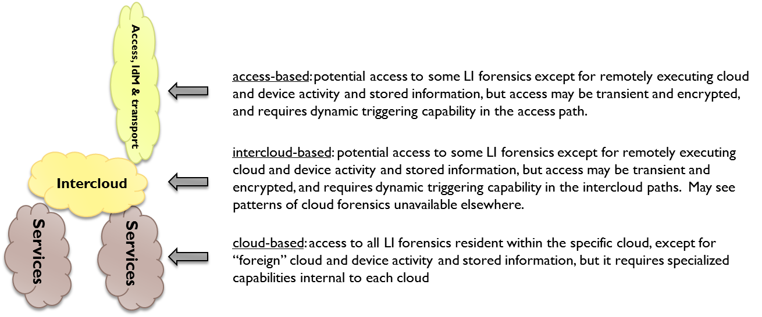Figure 7: Cloud service groupings

5.5 Implementation Challenges
Due to the nomadic access to cloud services, no one provider (as described in the diagram in figure 7 is likely to be capable of dealing with all warrants/intercept requests. Because the imposition of LI requirements is largely oriented around national jurisdiction and geography, it is unlikely that LEAs can serve a warrant on a cloud provider directly unless that cloud provider has an “in country” presence.
The specific cloud resources are generally not important nor should their geographical location – as long as they are within the jurisdiction of the LEA. For the CSP to intercept the traffic on the (local) LEA’s behalf the following tests must be passed:
- The warrant must be legal in that country.
- The traffic must be present i.e. it must be routed or handled in the same country. Duplication is permitted as is rerouting as long as the user or any other interested party remains unaware of LEA interest.
- It must be possible to clearly distinguish this traffic from others i.e. no collateral interception.
- If the traffic is encrypted, the entity responsible for key management must ensure it can be decrypted by the CSP or LEA.
In order to maintain LI coverage the cloud service provider can implement a Cloud Lawful Interception Function (CLIF). This can be by way of Applications Programming Interface (API) or more likely ensuring presentation of information in a format recognisable to interception mechanisms. Deep packet inspection is likely to be a constituent part of this system.
[ed. The table below was oddly placed in the old text as sections 5.4.1 thru 5.4.3, but clearly belonged with the above text.]
Table 1 describes a Cloud Lawful Interception Function to accommodate implementation jurisdiction challenges.
Table 1: Cloud Lawful Interception Functions
Locations | Cloud Lawful Interception Function
Cloud based provider outside LEA jurisdiction, but service is made available within jurisdiction | CLIF is required to enable the CSP intercept the traffic on the LEA’s behalf
Cloud based provider within the LEA jurisdiction with service carried internally | Although the LEA may be able to force the cloud service provider to intercept within its own infrastructure, it may be better to also use the CLIF - thus maintaining common interfaces, capabilities and coverage
Cloud based provider inside LEA jurisdiction but user outside

The CLIF describe here harmonises a necessary capability that it can be implemented in a cloud based environment.

5.5.2 The encryption problem
Media and/or metadata may be encrypted.

5.5.3 Multiple copies of intercepted traffic
The traffic may be intercepted in more than one location or on more than one CSP network.

5.5.4 Nomadism
Services can already move between WiFi, DSL and mobile access networks relatively seamlessly.

5.5.5 Location
It may be difficult to discern in an assured manner the location at which users are using cloud based services.

6 Legacy LI models and methods applied to the Cloud environment
As described in section 5, cloud/virtual emulations of existing legacy services for which there are LI handover specifications can generally use those specifications and associated models to meet handover obligations. This section describes those specifications and how they can be adapted to the cloud environment, together with extensions to the models that can be used for non-legacy services.

6.1 Legacy LI models
The diagrams of Annex E (informative) of TS 101 331 [i.1] may provide a conceptual foundation for cloud services LI.
LI models for telecommunications services are currently found in:
- ETSI TS 101 671, "Lawful Interception (LI); Handover interface for the lawful interception of telecommunications traffic [i.2];
- ETSI TS 101 232-2, Lawful Interception (LI); Handover Interface and Service-Specific Details (SSD) for IP delivery; Part 2: Service-specific details for Messaging services [i.4];
- ETSI TS 101 232-3, Lawful Interception (LI); Handover Interface and Service-Specific Details (SSD) for IP delivery; Part 3: Service-specific details for internet access services [i.5];
- ETSI TS 101 232-4, Lawful Interception (LI); Handover Interface and Service-Specific Details (SSD) for IP delivery; Part 4: Service-specific details for Layer 2 services [i.6];
- ETSI TS 101 232-5, Lawful Interception (LI); Handover Interface and Service-Specific Details (SSD) for IP delivery; Part 5: Service-specific details for IP Multimedia services [i.7].

6.2 Adaptation to the Cloud environment
Irrespective of how the services are provided, LEA requirements apply – to intercept designated traffic in a secure and trusted manner sufficient to meet any applicable judicial evidence requirements, as expeditiously as possible.
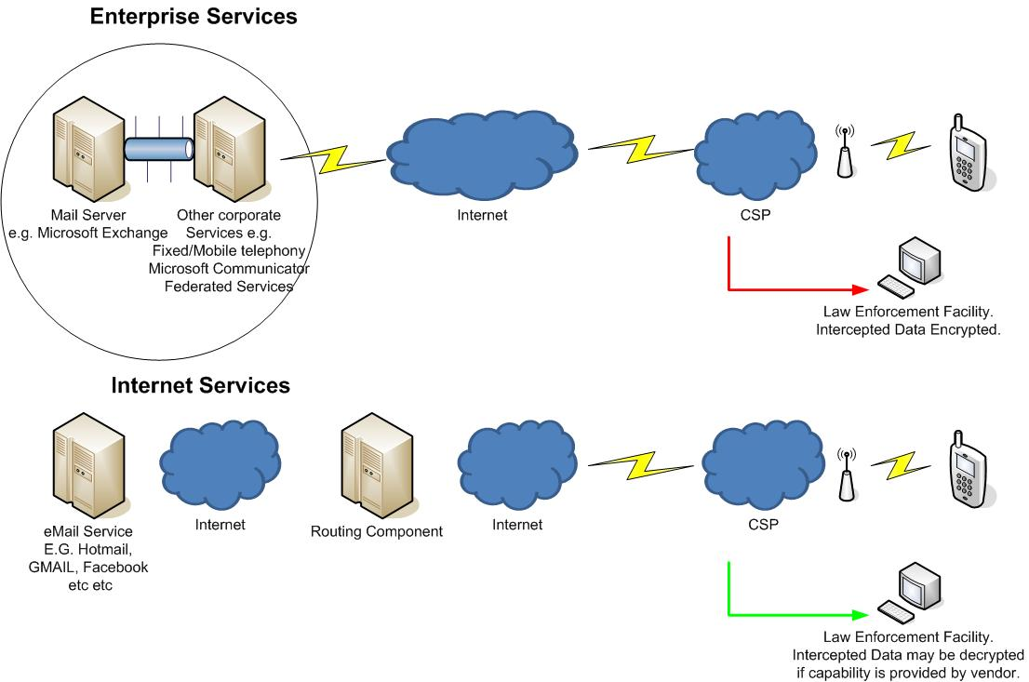Figure 8:
[ed: these diagrams should replace vendor names with generic equivalents. If enterprise services are to be included in this TR, it will also be necessary to reflect this broader scope throughout the TR. These diagrams distinguish between two entities identified as Internet and CSP. What does CSP mean in this context? Facebook does not really fall into the category of a legacy service. Indeed in the previous section they are placed in the category of new services for which LI handover specifications do not exist.]

6.3 Interfaces for non-legacy cloud/virtual services
The standard interface developed by TC LI for LEA/CSP use legacy services LI implementations worldwide is depicted in figure 9.
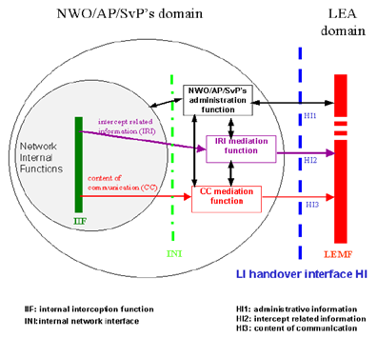
Figure 9: Standard CSP-LEA interface for legacy services
The basic request-response interface demarcation between with the LEA will continue to exist. However, what gets transferred across that interface is likely to be fundamentally different. The new non-legacy cloud/virtual services described in section 5 treatment of targets, applications/services, and the available information expected to be returned by the C(L)SP is generally very different.
There are no existing specifications for describing and structuring cloud/virtual targets, applications, and available LI response information.

6.4 Hybrid Services

6.4.1 VoLTE
Given the options in how certain network elements can be deployed and how they may be geographically shared it is possible that a combination of legacy and cloud LI techniques may be required e.g. centralised HSS or TAS.

6.4.2 Peer to Peer Services
Some peer to peer services only contact a centralised point to ensure they know what IP address to contact another user – the media is not routed via any easily predictable infrastructure. However this setup information may, if structured correctly and unencrypted (?) allow the various CSPs intercept the traffic.
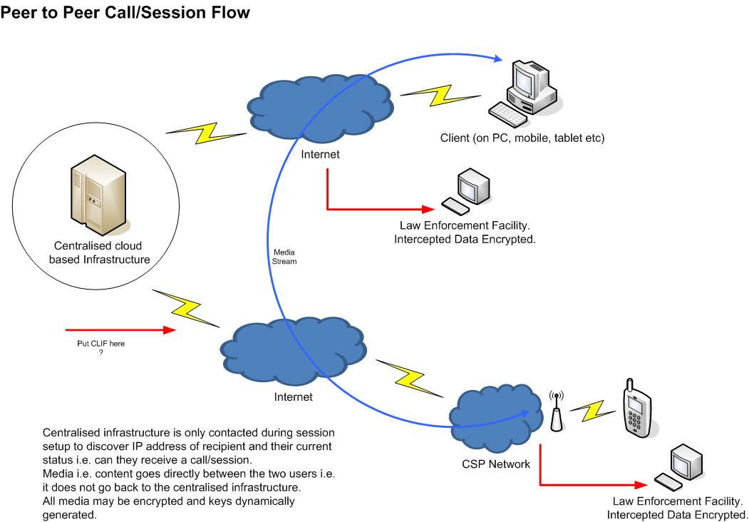

7 Lawful Interception as a Cloud Service (LIaaS)

7.1 Applicability of existing reference models
Applicability of the following services is likely to be highly restrictive due to security or legislative requirements.
The services below are for discussion as part of an alignment with Tony’s strategy for non LEA related data retention.

7.2 LI Law Enforcement Monitoring Facility (LEMF) as a cloud service

7.3 Other LI tools as cloud services

8 Security in the Cloud LI environment

8.1 Potential LI vulnerabilities in the Cloud services ecosystem
[ed. The topics below are not LI vulnerabilities, but rather challenges that should be moved to Sec. 5,5 and the treatment of Implementation Challenges]

8.2 Continuous Security Monitoring for Cloud LI

9 LI – Cloud gaps and challenges

9.1 Generic “simple” cloud LI interface specification gap
At present, all the many standards bodies referenced in Appendix 1 have deferred to TC LI for technical standards actions relating to lawful interception. The present document is intended to provide an initial overview of cloud LI. However, there remains an important obvious need for a specification that establishes a generic “simple” interface for cloud/virtual environments. Large data centres are expanding worldwide and transforming the world of ICT globally. Components of that environment such as “app” based services now number several million and increasing at the rate of ten percent per month; and user devices such smart phones, tablets, and next generation laptops are approaching a billion units and account for the preponderance of mobile user devices sold today. All new computer operating system versions are designed to facilitate these dynamics.
Considering this significant exponential scaling of cloud/virtual environments, some kind of generic “simple” specification between C(L)SPs, CSPs and LEAs is essential for all parties. It should include a structured trusted means to request LI capabilities and receive a response as well as best practices for implementations.

9.2 Specific cloud/virtual LI specification gaps
The subsections below are intended to amplify on component capabilities associated with the generic “simple” specification gap described above, as other work aimed at other gaps.

9.2.1 eWarrant expressions extension for cloud/virtual environment

9.2.2 Virtual Target Identity (VTI) expressions for cloud/virtual LI/RD
Unlike legacy telecom and Internet environments, in a cloud/virtual environment, target identities are unlikely to be well structured and are frequently elusive. With more than two million app and other cloud/virtual services and expansion rates of 10% per month, the identities of targets vary significantly. Indeed, virtual target identities usually consist only of some set of attributes that collectively can be associated with a specific individual.
There is a compelling need to develop an extensible structured expression for a “virtual target identity” that enables law enforcement to effectively describe a target in cloud/virtual environments. Without such a structured expression, it is not possible to describe the desired target, and every request becomes a “free form” text description that is difficult and costly to produce and implement.

9.2.3 Virtual Application Identity (VAI) expressions for cloud/virtual LI/RD
Similar to the virtual target identity challenge/gap described above, in a cloud/virtual environment, the applications number in the hundreds of thousands and are constantly changing. Some applications may also be malware.
A number of organizations and vendors are attempting to develop means for instantiating virtual service application identities in conjunction with traffic management, cybersecurity, and LI/RD. Even more advanced in the area of application identities is the structure expression work progressed by US government agencies for describing malware known as the Malware Attribute Enumeration and Characterization (MAEC). This language specification is also scheduled to be adopted by the ITU-T as X.1546 as part of its cybersecurity information exchange suite of Recommendations.
There is a compelling need to develop an extensible structured expression for a “virtual application identity” that enables law enforcement to effectively describe an application in cloud/virtual environments. Without such a structured expression, it is not possible to describe the service application associated with the target, and every request becomes a “free form” text description that is difficult and costly to produce and implement. A new work item to produce this specification seems appropriate.

9.2.4 Virtual Observable (VO) expressions for cloud/virtual LI/RD
In a cloud/virtual environment, available information - whether LI content or “IRI” associated with the virtual target identity - is usually very diverse, associated with applications that are not well understood, or acquired from many kinds of distributed network resources. The information of interest may also include complex resource use signatures within the virtualization environment.
One of the significant emerging means for capturing and exchanging this information is the creation of a common modular structured specification for “observables” known as CybOX. The rapidly evolving CybOX specification from US government security community organizations has been recently introduced into the IETF for exchanging cybersecurity and forensics information. It can form the basis for TC LI work for a Virtual Observable expression for cloud/virtual LI/RD.
There is a compelling need to develop an extensible structured expression for “virtual observables” that enables the acquisition and handover of information in cloud/virtual environments. Without such a structured expression, it is not possible for a C(L)SP or CSP to respond to a LEA request with information associated with the target. Every response becomes a “free form” text description that is difficult and costly to process by LEAs.

9.2.5 Dynamic Triggering

9.2.6 Virtual data acquisition
Identification of Virtual data acquisition point for LI.

Annex A:
Several Use cases

A.1 Telepresence use case 1:
TSP offers Telepresence and all participants are subscribers of the TSP
- Overview
- This use case describes basic telepresence service. A TSP offers Telepresence and all the participants are subscribers to that TSP.
- Actors
- The users are Jean (the subject of the lawful interception), and her two associates: Greg and Peter.
- McCloud is the mobile TSP/cloud service provider providing a Telepresence Service.
- Preconditions
- Jean, Greg and Peter all are subscribers of the McCloud Telepresence services.
- McCloud has been provided a lawful authorization to assist Law Enforcement in intercepting Jean’s communications, which includes Telepresence.
- McCloud, being a good corporate citizen and a responsible TSP, has an LI solution for Telepresence implemented in their network.
- Actions
- Jean initiates Telepresence (conference) session with Greg and Peter.
- Jean, not having extensive video administration experience, relies heavily on the McCloud Help Desk Service for assistance in using the service (e.g. to initiate and troubleshoot problems) while Peter and Greg join her in the Telepresence meeting.
- The three cohorts meet in a virtual face-to-face meeting via McCloud’s Telepresence Service. They are discussing criminal activities, showing maps and pictures of the criminal venue (e.g. bank and surrounding streets for their “get-away”). Greg shows a short silent movie clip of the bank guards to show their routine and guard positions.
- Peter’s video and audio are not up to the quality specified in the Service Level Agreement (SLA) with McCloud. He troubleshoots with McCloud during the Telepresence session.
- The Telepresence session ends.
- Results
- McCloud is hosting/managing a Telepresence (i.e. conference) session operating on behalf of Jean which is supporting the purposes of the illegal activity.
- McCloud is a TSP providing that service to Jean (and her associates).
- McCloud provides LE with Jean’s intercepted communications for the duration of the lawful authorization per their LI solution(s). This includes separate delivery for her voice communications (to include VoIP and conferencing/Telepresence), SMS, and packet data/broadband services.
- LI Discussion/Challenges
- McCloud has a legal obligation to provide LI for the Telepresence session. Whether the video is provided to Law Enforcement is a national option. At a minimum, the audio of this conference, as well as the IRI is required to be reported, as Telepresence is a conference per 3GPP definition. The exact set of events and information is outside the scope of this use case (as SA3-LI has not yet discussed/agreed/defined LI for Telepresence).
- The identities of the participants are known to McCloud, as they are all subscribers to McCloud’s Telepresence service. The McCloud Telepresence Service has the service logic for Jean’s Telepresence session, the identities of the participants, and access to the media.
- As with any other service lawfully intercepted, if McCloud provides encryption for the Telepresence Service, McCloud is responsible for either decrypting or providing the keys to law enforcement to decrypt.

A.2 Telepresence use case 2:
Telepresence is offered by a Third Party provider. Participants are subscribers of the same or different TSP(s)
- Overview
- This use case describes basic telepresence service. The mobile TSP acts as a “cloud carrier” for the cloud provider’s Telepresence service.
- Actors
- The users are Jean (the subject of the lawful interception), and her two associates: Gabor and Terry.
- McCloud is the mobile TSP/cloud carrier. Jean and Terry are subscribers of McCloud.
- ExcellAlex Mobile is a mobile TSP. Gabor is a subscriber of ExcellAlex Mobile.
- TellyServ is a (third party) cloud service provider providing the Telepresence Service. TellyServ is NOT offering Telepresence Service on McCloud’s behalf nor does TellyServ have any business relationship with McCloud.
- Preconditions
- Jean, Terry and Gabor all subscribe to TellyServ’s Telepresence Service.
- McCloud has been provided a lawful authorization to assist Law Enforcement in intercepting Jean’s communications, to include Telepresence. McCloud, being a good corporate citizen and a responsible TSP, has an LI solution for Telepresence implemented in their network.
- TellyServ has also been provided a lawful authorization for Jean’s communications, but the only service of Jean’s that they provide is the Telepresence Service. They are waiting for a specific LI solution for Telepresence to be developed, but in the meantime, they have “adapted” the 3GPP IMS Conferencing LI solution for their interim Telepresence LI solution.
- ExcellAlex Mobile has not been served a lawful authorization on Jean as it is not providing a service to her (the Subject).
- Actions
- Jean initiates a Telepresence (conference) session with Gabor and Terry.
- Jean, not having extensive video administration experience, relies heavily on the TellyServ’s Help Desk Service for assistance in using the service (e.g. to set-up the meeting and troubleshoot problems) while Gabor and Terry join her in the Telepresence meeting.
- The three cohorts meet in a virtual face-to-face meeting via TellyServ’s Telepresence Service. They are discussing criminal activities, showing maps and pictures of the criminal venue (e.g. bank and surrounding streets for their “get-away”). Gabor shows a short silent movie clip of the bank guards to show their routine and guard positions.
- Terry’s video and audio are not up to the quality specified in the Service Level Agreement (SLA) with TellyServ. He troubleshoots with TellyServ during the Telepresence session.
- The telepresence session ends.
- Results
- TellyServ is hosting/managing a Telepresence (i.e. conference) session operating on behalf of Jean which is supporting the purposes of the illegal activity.
- McCloud is a TSP providing Jean’s connectivity to TellyServ’s Telepresence service. McCloud is also providing Jean’s voice and Internet access.
- McCloud provides LE with Jean’s intercepted communications for the duration of the lawful authorization per their LI solution(s). This includes separate delivery for her voice communications (to include VoIP and conferencing), SMS, and packet data/broadband services. McCloud provides LE with Jean’s Telepresence communications as part of their packet data/broadband services delivery. McCloud does not have access to the Telepresence service logic nor is it required to deliver the intercepted Telepresence communications separately.
- TellyServ delivers IRI on Jean’s Telepresence session per TS 33.108. Luckily, their implementation also gives them access to the media, so they also report the intercepted content. Whether the video is provided to Law Enforcement is a national option. At a minimum, the audio of this conference, as well as the CII, is required to be reported.
- LI Discussion/Challenges
- McCloud has a legal obligation to provide LI for the services that they offer the target. In this use case, they do not offer the Telepresence Service, so they are not obligated to provide separate delivery of this service. Since it is “available” in Jean’s packet data stream, it is delivered as part of McCloud’s packet data interception. McCloud isolates and reports Jean’s intercepted voice, SMS, and packet data/broadband services per their LI solutions.
- TellyServ has the legal obligation to provide LI for the services that they offer the target. In this use case, this is only the Telepresence Service. They provide the CII and CC for the Telepresence service per their LI solution. TellyServ knows the identities of the participants; they have the service logic and access the media.
- As with any other service lawfully intercepted, if TellyServ provides encryption for the Telepresence Service, TellyServ is responsible for either decrypting or providing the keys to law enforcement to decrypt.

Annex B:
Cloud Virtualization Fora
Abbreviation |  |  | Forum Name | SubGroup | SubGroup Name |  | SubGroup URL
Cloud industry platform technical standards developer forums
Android |  | Android Developers Forum |  |  |  |  | http://developer.android.com/index.html
AWS |  | Amazon Web Services Forum |  |  |  |  | https://forums.aws.amazon.com/forum.jspa?forumID=30
BMC |  | BMC Software |  |  |  |  | http://www.bmc.com/solutions/cloud-computing/cloud-computing-management/Cloud-Computing-Management-CCM.html
CA |  | CA Technologies |  |  |  |  | http://www.ca.com/us/cloud-solutions.aspx
Cisco |  | Cisco Developer Network |  |  |  |  | http://developer.cisco.com/web/partner/search?technologyIds=a0G400000070wGiEAI
 |  | CloudMade |  |  |  |  | http://cloudmade.com/
 |  | GitHub |  |  |  |  | https://github.com/
Google |  | Google Developers |  |  |  |  | https://developers.google.com/
HP |  | HP Cloud Services |  |  |  |  | https://hpcloud.com/content/about-us
IBM |  | developerWorks |  |  |  |  | http://www.ibm.com/developerworks/aboutdw/contacts.html
iCloud |  | iCloud for Developers |  |  |  |  | https://developer.apple.com/icloud/index.php
Intel |  | Intel Cloud Builders |  |  |  |  | http://www.intel.com/content/www/us/en/cloud-computing/cloud-builders-provide-proven-advice.html?cid=sem116p9128
Jive |  | Jive apps developers |  |  |  |  | https://developers.jivesoftware.com/community/index.jspa
Microsoft |  | Windows Azure Community |  |  |  |  | http://www.windowsazure.com/en-us/community/blog/
Oracle |  | Oracle Cloud Computing |  |  |  |  | http://www.oracle.com/us/technologies/cloud/index.html
 |  | ProgrammableWeb |  |  |  |  | http://www.programmableweb.com/
Radckspace |  | OpenStack Developer Community |  |  |  |  | http://www.rackspace.com/blog/
RedHat |  | OpenShift Developer Community |  |  |  |  | https://openshift.redhat.com/app/platform
 |  | SourceForge |  |  |  |  | http://sourceforge.net/
 |  | TopCoder |  |  |  |  | http://www.topcoder.com/
VMware |  | VMware Community |  |  | [multiple] |  | http://communities.vmware.com/groups/
xda |  | XDA Developers Forum |  |  |  |  | http://forum.xda-developers.com/
Cloud industry generic technical standards forums
3GPP | 3rd Generation Partnership Project |  |  | CT1 | MM/CC/SM [lu] |  |  | http://portal.etsi.org/portal/server.pt/community/3GPP/296?tbId=651
3GPP | 3rd Generation Partnership Project |  |  | SA2 | Architecture |  |  | http://portal.etsi.org/portal/server.pt/community/3GPP/296?tbId=385
3GPP | 3rd Generation Partnership Project |  |  | SA3 | Security |  |  | http://portal.etsi.org/portal/server.pt/community/3GPP/296?tbId=386
3GPP | 3rd Generation Partnership Project |  |  | SA3LI | Mobile LI |  |  | http://portal.etsi.org/portal/server.pt/community/3GPP/296?tbId=386
ARTS | Association for Retail Technology Standards |  |  |  | UnifiedPOS |  |  | http://www.nrf-arts.org/
ARTS | Association for Retail Technology Standards |  |  |  | Data Model |  |  | http://www.nrf-arts.org/
ARTS | Association for Retail Technology Standards |  |  |  | ARTS XML |  |  | http://www.nrf-arts.org/
ARTS | Association for Retail Technology Standards |  |  |  | Standard RFPs |  |  | http://www.nrf-arts.org/
ATIS | Alliance for Telecommunications Industry Solutions |  |  | SON | Service Oriented Network Forum |  |  | http://www.atis.org/SON/index.asp
CA/B Forum | Certification Authority Browser Forum |  |  |  |  |  |  | http://www.cabforum.org/
CableLabs | CableLabs |  |  |  |  |  |  | http://www.cablelabs.com/
CCDB | Common Criteria Control Board |  |  |  |  |  |  | http://www.commoncriteriaportal.org/cc/
CCDB | Common Criteria Control Board |  |  | CC Forum | Common Criteria Forum |  |  | http://www.commoncriteriaforum.org/
CCIF | Cloud Computing Interoperability Forum |  |  |  | Standard and Interoperability Working Group |  |  | http://www.cloudforum.org/
CCIF | Cloud Computing Interoperability Forum |  |  |  | Unified Cloud Interface Working Group |  |  | http://code.google.com/p/unifiedcloud/
CIE | Chinese Institute of Electronics |  |  | CCEA | Cloud Computing Experts Association |  |  | http://www.ciecloud.org/
CSA | Cloud Security Alliance |  |  | CloudAudit | Cloud Audit Working group |  |  | https://cloudsecurityalliance.org/research/cloudaudit/
CSA | Cloud Security Alliance |  |  | TWG | Telecom Working Group |  |  | https://cloudsecurityalliance.org/research/telecom/
CSA | Cloud Security Alliance |  |  | SecaaS | Security as a Service Working Group |  |  | https://cloudsecurityalliance.org/research/secaas/
CSA | Cloud Security Alliance |  |  | CSA Mobile | Mobile Working Group |  |  | https://cloudsecurityalliance.org/research/mobile/
CSA | Cloud Security Alliance |  |  | Security Guidance | Security Guidance Initiative Working Group |  |  | https://cloudsecurityalliance.org/research/security-guidance/
CSA | Cloud Security Alliance |  |  | CSA Innovate | Innovation Initiative Working Group |  |  | https://cloudsecurityalliance.org/research/innovation/
CSA | Cloud Security Alliance |  |  | GRC | GRC Stack Working Group |  |  | https://cloudsecurityalliance.org/research/grc-stack/
CSA | Cloud Security Alliance |  |  | CAI | Consensus Assessments Initiative Working Group |  |  | https://cloudsecurityalliance.org/research/cai/
CSA | Cloud Security Alliance |  |  | CCM | Cloud Controls Matrix Working Group |  |  | https://cloudsecurityalliance.org/research/ccm/
CSA | Cloud Security Alliance |  |  | CTP | CloudTrust Protocol Working Group |  |  | https://cloudsecurityalliance.org/research/ctp/
CSA | Cloud Security Alliance |  |  | CDG | Cloud Data Governance Working Group |  |  | https://cloudsecurityalliance.org/research/cdg/
CSA | Cloud Security Alliance |  |  | TCI | Trusted Cloud Initiative Working Group |  |  | https://cloudsecurityalliance.org/research/tci/
CSA | Cloud Security Alliance |  |  | HIM | Health Information Management Working Group |  |  | https://cloudsecurityalliance.org/research/him/
CSA | Cloud Security Alliance |  |  | Top Threats | Top Threats to Cloud Computing Working Group |  |  | https://cloudsecurityalliance.org/research/top-threats/
CSA | Cloud Security Alliance |  |  | Cloud SIRT | CloudSIRT Working Group |  |  | https://cloudsecurityalliance.org/research/cloudsirt/
CSA | Cloud Security Alliance |  |  | MWG | Cloud Metrics Working Group |  |  | http://www.cloudforum.org/
 | Cloud Standards Coordination |  |  |  |  |  |  | http://cloud-standards.org/wiki/
CCSA | China Communications Standards Association |  |  | WG1 | Network protocol system and Device workgroup |  |  | http://www.ccsa.org.cn/
CCSA | China Communications Standards Association |  |  | WG4 | New Technology and International Standards Workgroup |  |  | http://www.ccsa.org.cn/
CCSA | China Communications Standards Association |  |  |  | Mobile Internet Application and Terminal Technical Committee |  |  | http://www.ccsa.org.cn/english/tc.php?tcid=tc11
CSCC | Cloud Standards Customer Council |  |  |  | Financial Services |  |  | http://www.cloud-council.org
CSCC | Cloud Standards Customer Council |  |  |  | Government |  |  | http://www.cloud-council.org
CSCC | Cloud Standards Customer Council |  |  |  | Healthcare |  |  | http://www.cloud-council.org
CSCC | Cloud Standards Customer Council |  |  |  | Practical Guide |  |  | http://www.cloud-council.org
CSCC | Cloud Standards Customer Council |  |  |  | Security |  |  | http://www.cloud-council.org
CSCC | Cloud Standards Customer Council |  |  |  | XaaS |  |  | http://www.cloud-council.org
DMTF | Distributed Management Task Force |  |  |  | Technical Committee |  |  | http://www.dmtf.org/about/working-groups
DMTF | Distributed Management Task Force |  |  |  | Interoperability Committee |  |  | http://www.dmtf.org/about/working-groups
DMTF | Distributed Management Task Force |  |  |  | Process and Incubation Committee |  |  | http://www.dmtf.org/about/working-groups
ENISA | European Network and Information Security Agency |  |  | SAS | Secure Applications and Services |  |  | http://www.enisa.europa.eu/activities/application-security
ETSI | European Telecommunications Standards Institute |  |  | TC CLOUD | Cloud |  |  | http://portal.etsi.org/portal/server.pt/community/3GPP/296?tbId=651
ETSI | European Telecommunications Standards Institute |  |  | TC LI | Lawful Interception and Retained Data |  |  | http://portal.etsi.org/portal/server.pt/community/3GPP/296?tbId=654
ETSI | European Telecommunications Standards Institute |  |  | TC ATTM | Access, Terminals, Transmission and Multiplexing |  |  | http://portal.etsi.org/portal/server.pt/community/ATTM/297
GICTF | Global Inter-Cloud Technology Forum |  |  |  | Technology Task Force |  |  | http://www.gictf.jp/index_e.html
GICTF | Global Inter-Cloud Technology Forum |  |  |  | Service Useage Task Force |  |  | http://www.gictf.jp/index_e.html
GSC | Global Standards Collaboration |  |  |  | Plenary |  |  | http://www.gsc16.ca/english/index.html
GSMA | GSM Association |  |  | GSM-IREG | Inter-Working, Roaming Expert Group |  |  | http://www.gsma.com/working-groups/
GSMA | GSM Association |  |  |  | The Security Group |  |  | http://www.gsma.com/working-groups/
GSMA | GSM Association |  |  | GSM-TSG | Terminal Steering Group |  |  | http://www.gsma.com/working-groups/
IEEE | Institute of Electrical and Electronics Engineers |  |  | P2301 | Cloud Profiles WG (CPWG) Working Group |  |  | http://standards.ieee.org/develop/wg/CPWG-2301_WG.html
IEEE | Institute of Electrical and Electronics Engineers |  |  | P2302 | Intercloud WG (ICWG) Working Group |  |  | http://standards.ieee.org/develop/wg/ICWG-2302_WG.html
IETF | Internet Engineering Task Force |  |  | appsawg | Applications Area Working Group |  |  | http://datatracker.ietf.org/wg/appsawg/
IETF | Internet Engineering Task Force |  |  | lisp | Locator/ID Separation Protocol (lisp) |  |  | http://datatracker.ietf.org/wg/lisp/
IETF | Internet Engineering Task Force |  |  | armd | Address Resolution for Massive numbers of hosts in the Data center |  |  | http://datatracker.ietf.org/wg/armd/
IETF | Internet Engineering Task Force |  |  | eman | Energy Management |  |  | http://datatracker.ietf.org/wg/eman/
IETF | Internet Engineering Task Force |  |  | opsawg | Operations and Management Area Working Group |  |  | http://datatracker.ietf.org/wg/opsawg/
IETF | Internet Engineering Task Force |  |  | mile | Managed Incident Lightweight Exchange |  |  | http://datatracker.ietf.org/wg/mile/
IETF | Internet Engineering Task Force |  |  | sacm | Security Content Automation Protocol (SCAP) |  |  | https://www.ietf.org/mailman/listinfo/sacm
IETF | Internet Engineering Task Force |  |  | scim | Simple Cloud Identity Management BOF |  |  | https://www.ietf.org/mailman/listinfo/scim
IETF | Internet Engineering Task Force |  |  | cmdi | Cloud Data Management Interface |  |  | http://datatracker.ietf.org/wg/decade/
IETF | Internet Engineering Task Force |  |  | syslog | Syslog Extension for Cloud Using Syslog Structured Data |  |  | http://www.ietf.org/mail-archive/web/syslog/current/maillist.html
IETF | Internet Engineering Task Force |  |  | SOP | Service Orchestration and Desciption for Cloud Services |  |  | https://www.ietf.org/mailman/listinfo/sop
IETF | Internet Engineering Task Force |  |  | cloud mob | cloud services mobility |  |  | https://www.ietf.org/mailman/listinfo/clouds
ISO/IEC JTC1 | International Organization for Standardization |  |  | SC06 | Telecommunications and information exchange between systems |  |  | http://www.iso.org/iso/iso_technical_committee.html?commid=45072
ISO/IEC JTC1 | International Organization for Standardization |  |  | SC07 | Software and systems engineering |  |  | http://www.iso.org/iso/standards_development/technical_committees/list_of_iso_technical  _committees/iso_technical_committee.htm?commid=45086
ISO/IEC JTC1 | International Organization for Standardization |  |  | SC27 | IT Security techniques |  |  | http://www.iso.org/iso/standards_development/technical_committees/list_of_iso_technical_  committees/iso_technical_committee.htm?commid=45306
ISO/IEC JTC1 | International Organization for Standardization |  |  | SC38 | Distributed application platforms and services (DAPS) |  |  | http://www.iso.org/iso/standards_development/technical_committees/list_of_iso_technical_  committees/iso_technical_committee.htm?commid=601355
ITU-T | International Telecommunication Union - Telecommunications Standardization Sector |  |  | liaison-JTC1 | Information technology |  |  | http://www.iso.org/iso/iso_technical_committee?commid=45020
ITU-T | International Telecommunication Union - Telecommunications Standardization Sector |  |  | SG02 | Operational aspects of service provision and telecommunications management |  |  | http://www.itu.int/ITU-T/studygroups/com02/index.asp
ITU-T | International Telecommunication Union - Telecommunications Standardization Sector |  |  | SG05 | Environment and climate change |  |  | http://www.itu.int/ITU-T/studygroups/com05/index.asp
ITU-T | International Telecommunication Union - Telecommunications Standardization Sector |  |  | SG09 | Television and sound transmission and integrated broadband cable networks |  |  | http://www.itu.int/ITU-T/studygroups/com09/index.asp
ITU-T | International Telecommunication Union - Telecommunications Standardization Sector |  |  | SG11 | Signalling requirements, protocols and test specifications |  |  | http://www.itu.int/ITU-T/studygroups/com11/index.asp
ITU-T | International Telecommunication Union - Telecommunications Standardization Sector |  |  | SG12 | Performance, QoS and QoE |  |  | http://www.itu.int/ITU-T/studygroups/com12/index.asp
ITU-T | International Telecommunication Union - Telecommunications Standardization Sector |  |  | SG13 | Future networks including mobile and NGN |  |  | http://www.itu.int/ITU-T/studygroups/com13/index.asp
ITU-T | International Telecommunication Union - Telecommunications Standardization Sector |  |  | SG15 | Optical transport networks and access network infrastructures |  |  | http://www.itu.int/ITU-T/studygroups/com15/index.asp
ITU-T | International Telecommunication Union - Telecommunications Standardization Sector |  |  | SG16 | Multimedia coding, systems and applications |  |  | http://www.itu.int/ITU-T/studygroups/com16/index.asp
ITU-T | International Telecommunication Union - Telecommunications Standardization Sector |  |  | SG17 | Security |  |  | http://www.itu.int/ITU-T/studygroups/com17/index.asp
ITU-T | International Telecommunication Union - Telecommunications Standardization Sector |  |  | TSAG | Telecommunication Standardization Advisory Group |  |  | http://www.itu.int/ITU-T/tsag/index.asp
Metro Ethernet Forum | Metro Ethernet Forum |  |  |  | Technical Committee |  |  | http://metroethernetforum.org/page_loader.php?p_id=79
NIST | National Institute of Standards and Technology |  |  |  | Cloud Computing Program |  |  | http://www.nist.gov/itl/cloud/
NIST | National Institute of Standards and Technology |  |  |  | Reference Architecture and Taxonomy Working Group |  |  | http://collaborate.nist.gov/twiki-cloud-computing/bin/view/CloudComputing/ReferenceArchitectureTaxonomy
NIST | National Institute of Standards and Technology |  |  |  | Standards Acceleration to Jumpstart the Adoption of Cloud Computing Working Group |  |  | http://collaborate.nist.gov/twiki-cloud-computing/bin/view/CloudComputing/SAJACC
NIST | National Institute of Standards and Technology |  |  |  | Cloud Security Working Group |  |  | http://collaborate.nist.gov/twiki-cloud-computing/bin/view/CloudComputing/CloudSecurity
NIST | National Institute of Standards and Technology |  |  |  | Standards Roadmap Working Group |  |  | http://collaborate.nist.gov/twiki-cloud-computing/bin/view/CloudComputing/StandardsRoadmap
NIST | National Institute of Standards and Technology |  |  |  | CC Business Use Cases Working Group |  |  | http://collaborate.nist.gov/twiki-cloud-computing/bin/view/CloudComputing/BusinessUseCases
NIST | National Institute of Standards and Technology |  |  |  | Useful Documents for Cloud Adopters |  |  | http://collaborate.nist.gov/twiki-cloud-computing/bin/view/CloudComputing/Documents
NIST | National Institute of Standards and Technology |  |  |  | Koala Project |  |  | http://collaborate.nist.gov/twiki-cloud-computing/bin/view/CloudComputing/KoalaProject
OASIS | Organization for the Advancement of Structured Information Standards |  |  | ID-CLOUD | Identity in the Cloud TC |  |  | http://www.oasis-open.org/committees/id-cloud/charter.php
OASIS | Organization for the Advancement of Structured Information Standards |  |  | TOSCA | Topology and Orchestration Specification for Cloud Applications (TOSCA) TC |  |  | http://www.oasis-open.org/committees/tc_home.php?wg_abbrev=tosca
OASIS | Organization for the Advancement of Structured Information Standards |  |  |  | SOA Reference Model TC |  |  | http://www.oasis-open.org/committees/tc_home.php?wg_abbrev=soa-rm
OASIS | Organization for the Advancement of Structured Information Standards |  |  |  | PMRM | Privacy Management Reference Model TC |  | http://www.oasis-open.org/committees/tc_home.php?wg_abbrev=pmrm
OASIS | Organization for the Advancement of Structured Information Standards |  |  |  | AMQP | Advanced Message Queuing Protocol TC |  | http://www.oasis-open.org/committees/tc_home.php?wg_abbrev=amqp
OASIS | Organization for the Advancement of Structured Information Standards |  |  |  | Transformational Government Framework TC |  | http://www.oasis-open.org/committees/tc_home.php?wg_abbrev=tgf
OCC | Open Cloud Consortium |  |  |  | OCSD | The Open Science Data Cloud Working Group |  | http://opencloudconsortium.org/working-groups/
OCC | Open Cloud Consortium |  |  |  |  | Project Matsu |  | http://opencloudconsortium.org/working-groups/
OCC | Open Cloud Consortium |  |  |  |  | OCC Virtual Network Testbed |  | http://opencloudconsortium.org/working-groups/
OCC | Open Cloud Consortium |  |  |  |  | Open Cloud Testbed Working Group |  | http://opencloudconsortium.org/working-groups/
ODCA | Open Data Center Alliance |  |  |  |  | Infrastructure |  | http://www.opendatacenteralliance.org/ourwork/technicalworkgroups
ODCA | Open Data Center Alliance |  |  |  |  | Management |  | http://www.opendatacenteralliance.org/ourwork/technicalworkgroups
ODCA | Open Data Center Alliance |  |  |  |  | Regulation and Ecosystem |  | http://www.opendatacenteralliance.org/ourwork/technicalworkgroups
ODCA | Open Data Center Alliance |  |  |  |  | Security |  | http://www.opendatacenteralliance.org/ourwork/technicalworkgroups
ODCA | Open Data Center Alliance |  |  |  |  | Services |  | http://www.opendatacenteralliance.org/ourwork/technicalworkgroups
OGF | Open Grid Forum |  |  |  |  | Applications Working Groups |  | http://www.ogf.org/gf/group_info/areasgroups.php?area_id=5
OGF | Open Grid Forum |  |  |  |  | Architecture Working Groups |  | http://www.ogf.org/gf/group_info/areasgroups.php?area_id=4
OGF | Open Grid Forum |  |  |  |  | Compute Working Groups |  | http://www.ogf.org/gf/group_info/areasgroups.php?area_id=3
OGF | Open Grid Forum |  |  |  |  | Data Working Groups |  | http://www.ogf.org/gf/group_info/areasgroups.php?area_id=2
OGF | Open Grid Forum |  |  |  |  | Infrastructure Working Groups |  | http://www.ogf.org/gf/group_info/areasgroups.php?area_id=1
OGF | Open Grid Forum |  |  |  |  | Liaison Working Group |  | http://www.ogf.org/gf/group_info/areasgroups.php?area_id=8
OGF | Open Grid Forum |  |  |  |  | Management Working Groups |  | http://www.ogf.org/gf/group_info/areasgroups.php?area_id=6
OGF | Open Grid Forum |  |  |  |  | Security Working Groups |  | http://www.ogf.org/gf/group_info/areasgroups.php?area_id=7
OGF | Open Grid Forum |  |  |  | OCCI | Open Cloud Computing Interface Working Group |  | http://occi-wg.org/
OMA | Open Mobile Alliance |  |  |  | ARC | Architecture Working Group |  | http://www.openmobilealliance.org/Technical/arc.aspx
OMA | Open Mobile Alliance |  |  |  | BCASR | Broadcasting Working Group |  | http://www.openmobilealliance.org/Technical/bcast.aspx
OMA | Open Mobile Alliance |  |  |  | COM | Communications Working Group |  | http://www.openmobilealliance.org/Technical/com.aspx
OMA | Open Mobile Alliance |  |  |  | CD | Content Delivery Working Group |  | http://www.openmobilealliance.org/Technical/cd.aspx
OMA | Open Mobile Alliance |  |  |  | DM | Device Management Working Group |  | http://www.openmobilealliance.org/Technical/DM.aspx
OMA | Open Mobile Alliance |  |  |  | DRM | Digital Rights Management Working Group |  | http://www.openmobilealliance.org/Technical/DRM.aspx
OMA | Open Mobile Alliance |  |  |  | IOP | Interoperability Working Group |  | http://www.openmobilealliance.org/Technical/IOP.aspx
OMA | Open Mobile Alliance |  |  |  | LOC | Location Working Group |  | http://www.openmobilealliance.org/Technical/LOC.aspx
OMA | Open Mobile Alliance |  |  |  | REL | Release Planning and Management Committee |  | http://www.openmobilealliance.org/Technical/rel.aspx
OMA | Open Mobile Alliance |  |  |  | REQ | Requirements Working Group |  | http://www.openmobilealliance.org/Technical/req.aspx
OMG | Object Management Group |  |  |  |  | Telecommunications PSIG |  | http://telecom.omg.org/
Open Group | The Open Group |  |  |  |  | Cloud Computing Work Group |  | http://www3.opengroup.org/getinvolved/workgroups/cloudcomputing
Open Group | The Open Group |  |  |  |  | Service-Oriented Architecture Work Group |  | http://www3.opengroup.org/standards/soa
Open Group | The Open Group |  |  |  |  | Security Forum |  | http://www3.opengroup.org/getinvolved/forums/security
Open Group | The Open Group |  |  |  | OTTF | Trusted Technology Forum |  | http://www3.opengroup.org/getinvolved/forums/trusted
SNIA | Storage Networking Industry Association |  |  |  | ABDC | Analytics and Big Data Committee |  | http://www.snia.org/forums/abdc
SNIA | Storage Networking Industry Association |  |  |  | CSI | The Cloud Storage Initiative |  | http://www.snia.org/forums/csi
SNIA | Storage Networking Industry Association |  |  |  | DPCO | Data Protection and Capacity Optimization Committee |  | http://www.snia.org/forums/dpco
SNIA | Storage Networking Industry Association |  |  |  | ESF | Ethernet Storage Forum |  | http://www.snia.org/forums/esf
SNIA | Storage Networking Industry Association |  |  |  | GSI | Green Storage Initiative |  | http://www.snia.org/forums/green
SNIA | Storage Networking Industry Association |  |  |  | SMI | Storage Management Initiative |  | http://www.snia.org/forums/smi
SNIA | Storage Networking Industry Association |  |  |  | SSIF | Storage Security Industry Forum |  | http://www.snia.org/forums/ssif
SNIA | Storage Networking Industry Association |  |  |  | XAM | XAM Initiative |  | http://www.snia.org/forums/xam
TCG | Trusted Computing Group |  |  |  |  | Authentication Work Group |  | http://www.trustedcomputinggroup.org/solutions/authentication
TCG | Trusted Computing Group |  |  |  |  | Infrastructure Work Group |  | http://www.trustedcomputinggroup.org/developers/infrastructure
TCG | Trusted Computing Group |  |  |  | MTM | Mobile Phone Work Group |  | http://www.trustedcomputinggroup.org/developers/mobile
TCG | Trusted Computing Group |  |  |  |  | PC Client Work Group |  | http://www.trustedcomputinggroup.org/developers/pc_client
TCG | Trusted Computing Group |  |  |  |  | Server Work Group |  | http://www.trustedcomputinggroup.org/developers/server
TCG | Trusted Computing Group |  |  |  |  | Storage Work Group |  | http://www.trustedcomputinggroup.org/developers/storage
TCG | Trusted Computing Group |  |  |  | TMI | Trusted Multi-tenant Infrastructure Work Group |  | http://www.trustedcomputinggroup.org/developers/trusted_multitenant_infrastructure
TCG | Trusted Computing Group |  |  |  | TNC | Trusted Network Connect Work Group |  | http://www.trustedcomputinggroup.org/developers/trusted_network_connect
TCG | Trusted Computing Group |  |  |  | TPM | Trusted Platform Module Work Group |  | http://www.trustedcomputinggroup.org/developers/trusted_platform_module
TCG | Trusted Computing Group |  |  |  | TSS | TCG Software Stack Work Group |  | http://www.trustedcomputinggroup.org/developers/software_stack
TCG | Trusted Computing Group |  |  |  | VPWG | Virtualized Platform Work Group |  | http://www.trustedcomputinggroup.org/developers/virtualized_platform
TMForum | TeleManagement Forum |  |  |  | TMForum | Enterprise Cloud Leadership Council |  | http://www.tmforum.org/EnterpriseCloudLeadership/8009/home.html
TMForum | TeleManagement Forum |  |  |  |  | Cloud & New Services Initiatve |  | http://www.tmforum.org/EnablingCloudServices/8006/home.html
TMForum | TeleManagement Forum |  |  |  | TAM | Application Framework Domain |  | http://www.tmforum.org/ApplicationFramework/10819/home.html
TMForum | TeleManagement Forum |  |  |  | eTOM | Business Process Framework Domain |  | http://www.tmforum.org/BusinessProcessFramework/8175/Home.html
TMForum | TeleManagement Forum |  |  |  | SID | Information Framework Domain |  | http://www.tmforum.org/InformationFramework/10817/home.html
TMForum | TeleManagement Forum |  |  |  |  | Integration Framework Domain |  | http://www.tmforum.org/IntegrationFramework/10818/home.html
TMForum | TeleManagement Forum |  |  |  |  | Revenue Assurance Solution Domain |  | http://www.tmforum.org/Guidebooks/GB941RevenueAssurance/45341/article.html
TMForum | TeleManagement Forum |  |  |  |  | Enabling New Services Initiative |  | http://www.tmforum.org/EnablingCloudServices/8006/home.html

Annex C:
Change Request History
Status of the present document
TR 101 567 LI Could/Virtual services
TC LI approval date | Version | Remarks
 | 1.1.1 | First publication of the TR after approval by ETSI/TC LI#?? ( , )  Version 1.1.1 prepared by Gerry McQuaid (Vodafone Group) (Rapporteur)

History
Document history
 |  | Initial Draft
V0.0.2 | January 2012 | input to TC LI#29
V0.0.3 | April 2012 | lay-out corrections, input to TC LI Rap#26, 4-5 April Mainz
V0.0.4 | April 2012 | output of TC LI Rap#26 with agreed modifications in revMarks
V0.0.5 | April 2012 | clean output of TC LI Rap#26 (with some editorials)
V0.0.6 | May 2012 | agreed modifications by TC LI#30. included:Tdocs 017, 027r1, 042r1 028r1,030, 031r1, 039r1
V0.1.0 | May 2012 | clean output TC LI#30 Amsterdam

