

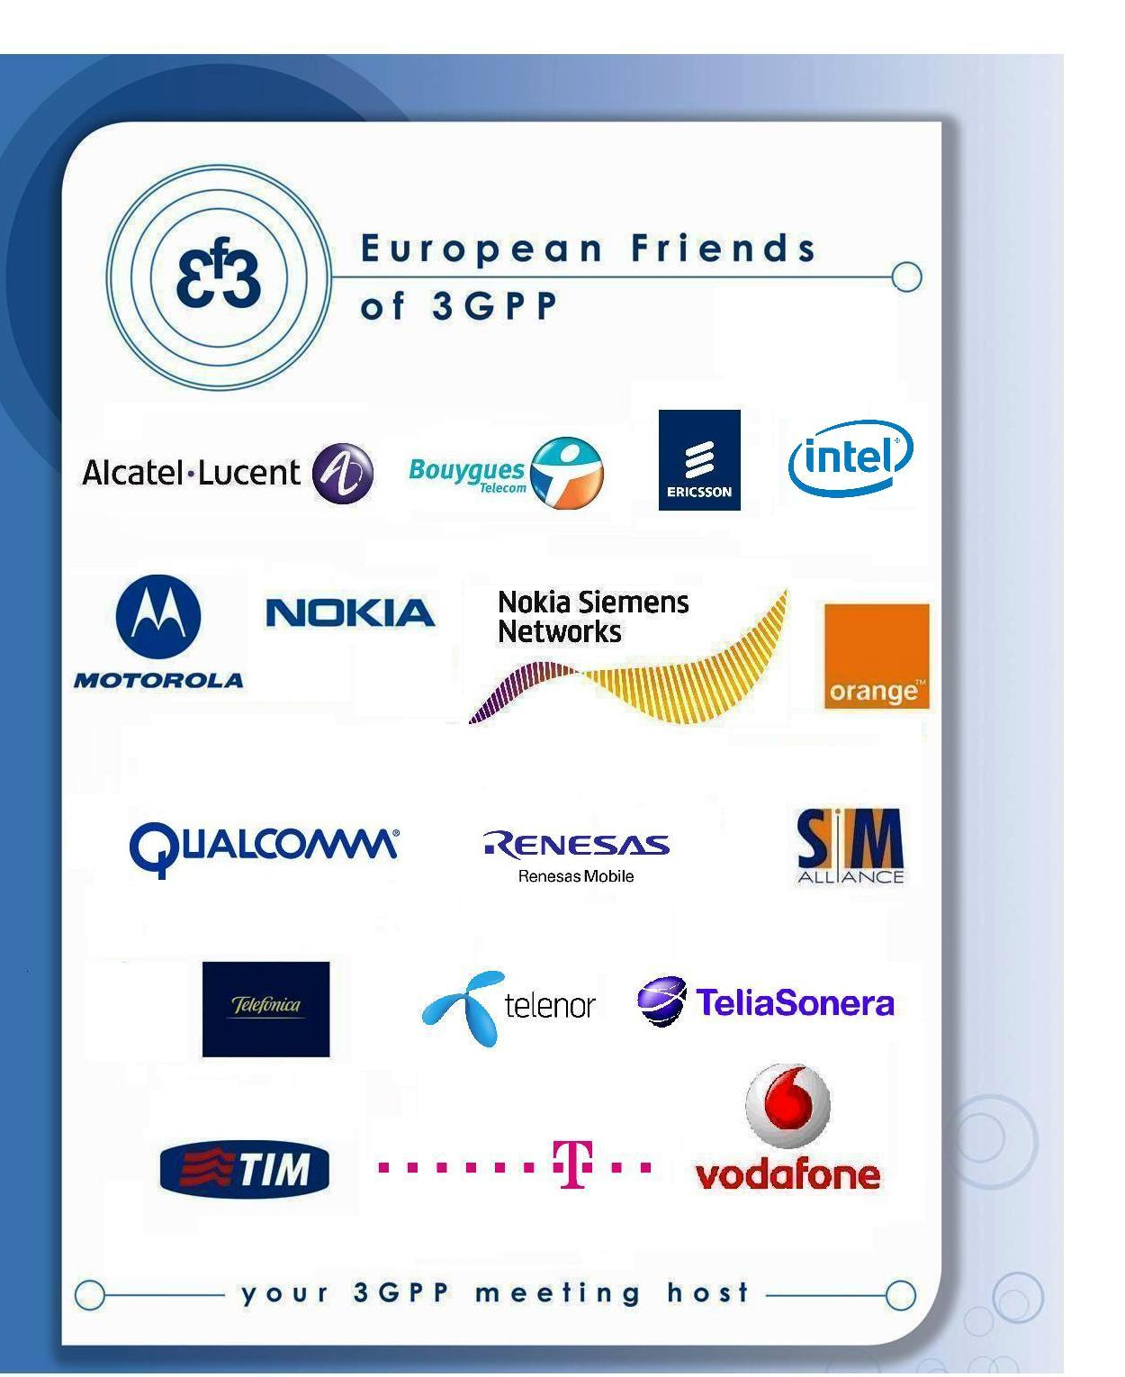

Have the pleasure of inviting you to
3GPP SA3#68 in Bratislava, Slovakia

Jul 2012
TITLE | TYPE | DATES | LOCATION | CTRY
3GPPSA3#68 | OR | 9 - 13 Jul 2012 | Bratislava | SK

Sophia Antipolis, 29 February 2012

3GPP SA3#68
from Monday 9 to Friday 13 July 2012 in Bratislava

Dear Delegate,

The European Friends of 3GPP, Alcatel-Lucent, Bouygues, Deutsche Telekom, Ericsson, Intel, Motorola, Nokia, Nokia Siemens Networks, Orange, Qualcomm, Renesas Mobile, SIMAlliance, TeliaSonera, Telefonica, Telecom Italia, Telenor, Vodafone have the pleasure of inviting you to the above-mentioned meeting.
Meeting Venue

Crowne Plaza Bratislava

Hodžovo námestie 2

816 25 Bratislava, Slovakia

tel +421 2 5934 8111

fax +421 2 5443 3265
WEB SITE
Standard room @ 105€ B&B, internet, VAT included
Hotel cut-off date, 27th May 2012
Meeting Registration
Please register for the meeting online at: on-line registration
You might find the hotel cancellation policy unreasonable. If you need to cancel your room, on a reasonable basis, please contact Emmanuelle.wurffel@etsi.org.

The Hotel is situated in the heart of Bratislava, within 10 km distance from the Airport in Bratislava or 50 km distance from the Airport in Vienna, Austria. The connection from Vienna Airport takes 40 minutes. Please find here below some information:
- Please book your taxi from Vienna Airport or Bratislava Airport (see attached information in the hotel booking form)
- Please book your shuttle bus: 1 hour trip, departure every 30 minutes, around 7,7€ one way:. http://www.slovaklines.sk/main-page.html
A quality meeting form will be launched after the meeting.

We look forward to seeing you all in Bratislava.

Yours sincerely,
the European Friends of 3GPP.

Accommodation
EF3 is not responsible for reservation confirmations, cancelled or changed reservations or no-shows. Please contact the hotel directly to make any changes. Please make your own booking filling in the hotel registration form. You might find the hotel cancellation policy unreasonable. If you need to cancel your room, on a reasonable basis, please contact contact@eurofriends3.org.

WLAN: There will be a wireless LAN.

Host Contacts
For any questions about anything relating to the meeting please contact:
Emmanuelle Wurffel Phone:+33 4 92 94 42 66 E-mail: contact@eurofriends3.org

Visa letter

****VISA LETTER****
 Delegates needing a visa in order to attend a meeting hosted by EF3 should make their hotel booking where the meeting will take place. As soon as they book their room please ask the hotel to provide you with a personal letter.
New Procedure We would like to invite you to fill-in your own invitation letter which contains all your personal information. Please follow these steps:
- Please download the visa application letter template at
http://www.3gpp.org/delegates-corner#outil_sommaire
(under meeting document templates, “visa application letter template”)
- Please update the letter accordingly
- Please send it to contact@eurofriends3.org for signature.
Deadline to apply is May, 27th 2012.



CROWNE PLAZA BRATISLAVA
Awarded Best Crowne Plaza Hotel in EMEA in 2010
8 – 14 JULY, 2012
Group: 3GPP SA3#68

HOTEL RESERVATION FORM
Date :
Mr/ Mrs/ Ms: |  |  | First Name: |  |  |  |  | Last Name:
Name of the 2nd person in the room:
Tel: |  |  |  | Fax: |  |  |  |  | E-mail:

1. HOTEL RESERVATION
Crowne Plaza Bratislava  Hodžovo nám. 2  816 25 Bratislava, Slovak Republic |  |  | Tel: +421 2 5934 8116 |  |  | Fax: +421 2 5443 3265
Hotel contact person for reservations:
Mrs. Katarina Varga - Katarina.Varga@ihg.com
Room rates per night:

Single Standard Room Rate: | 105 | EUR |  |  | Double Standard Room Rate: |  | 130 | EUR
Club room Single (Superior): | 154 | EUR |  |  | Club room Double (Superior): |  | 179 | EUR
Junior Suite (Single use): | 204 | EUR |  |  | Junior Suite (Double use): |  | 229 | EUR
Corner Suite (Single use): | 254 | EUR |  |  | Corner Suite (Double use): |  | 279 | EUR
The above room rates include all applicable taxes, breakfast buffet, free internet in the hotel rooms, free access to hotel swimming pool, fitness centre and sauna.

ARRIVAL:  Date: Time: | DEPARTURE:  Date: Time:
2. PAYMENT
We kindly ask you to guarantee the reservation with a valid credit card number and expiration date:

Visa | Amex | Master card | Dinners
Card holder: | Credit card No.: | Expiration date:

3. CANCELLATION
Reservations may be cancelled free of charge until May 27, 2012.
- Cancellations between May 28, 2012 and June 9, 2012 are subject to one night cancellation fee.
- Cancellations between June 10, 2012 and June 30, 2012 are subject to two nights cancellation fee.
- Cancellations after July 1, 2012 including or no shows are subject to 100 % cancellation fee (full length of stay).

Early departures and late arrivals must be informed at least 3 days prior to the requested date of earlier departure/original arrival date. Early departures/late arrivals after this deadline will result in 100% charge of the contracted room rate for the length of the contracted time.
Reservation confirmation number:

ROOMS MAY BE RESERVED UNTIL MAY 27, 2012 AT ABOVE MENTIONED RATES.
RESERVATIONS AFTER THAT DATE ARE SUBJECT TO AVAILABILITY.

Stamp & Signature |  | Hotel´s stamp and signature

Additional important information:

Should the guest not provide credit card details, a full prepayment of the room needs to be done due by May 28, 2012 (date of first cancellation fee). A deposit invoice will be provided upon request.
Payment for accommodation and all extra room charges will be settled upon the check out of each guests

FIRE SAFETY
Please note that according to Slovak and international Fire Life Safety law, it is prohibited to use any electronic devices (cooking devices, sources of open fire, flammable liquids/ solids) in the hotel rooms.

If you need to arrange transport from/to the hotel, please, contact our Limousine Service providing full comfort in door to door transportation:

Transportation arrangement:

From / to Bratislava airport
Mercedes E Class (max 3-4 persons) 26 EUR / car (regardless the amount of passengers)
Mercedes Viano (max 6 passengers) 37 EUR / car (regardless the amount of passengers)

From / to Vienna airport
Mercedes E Class (max 3-4 persons) 70 EUR / car (regardless the amount of passengers)
Mercedes Viano (max 6 passengers) 105 EUR / car (regardless the amount of passengers)

You can settle the transportation payment at the reception upon the check out.
For pick up arrangement, please contact the Limousine service directly at:
+421 2 5934 8644 or e-mail: vipcars@vipcars.sk

