3GPP TSG-SA3 Meeting #115e ad-hoc draft_S3-241267-r1

Electronic meeting, online, 15 - 19 April 2024

Source: China Telecom

Title: New solution to KI#2- CIWF as an delegate for SBA interface

Document for: Approval
Agenda Item: 5.3

1 Decision/action requested
This contribution proposes to add new solution to KI#2- CIWF as an delegate for SBA interface.

2 References

3 Rationale
The contribution proposes to add new solution to KI#2- CIWF as an delegate for SBA interface.

4 Detailed proposal
It is suggested to approve the following change.

*************** Start of the change ****************

7.Y Solution #Y: CIWF as an delegate for SBA interface

7.Y.1 Introduction
This solution addresses key issue 2 to provide security to the PLMN from the attacks that may be initiated by the dedicted NFs in the PNI-NPN operational domain. The solution presents a Customer InterWoking Function henceforth referred to as CIWF. The CIWF is deployed in the PLMN operational domain.

7.Y.2 Solution details

7.Y.2.1 General
Figure 7.Y.2.1-1 illustrates CIWF deployed in PLMN operational domain when dedicated NFs is deployed in PNI-NPN operational domain. Dedicated NFs connect to the PLMN through CIWF. The CIWF may connect dedicated NFs from different PNI-NPN operational domains simultaneously. CIWF acts as an delegate to protect the PLMN from the attacks that may be initiated by the dedicated NFs.
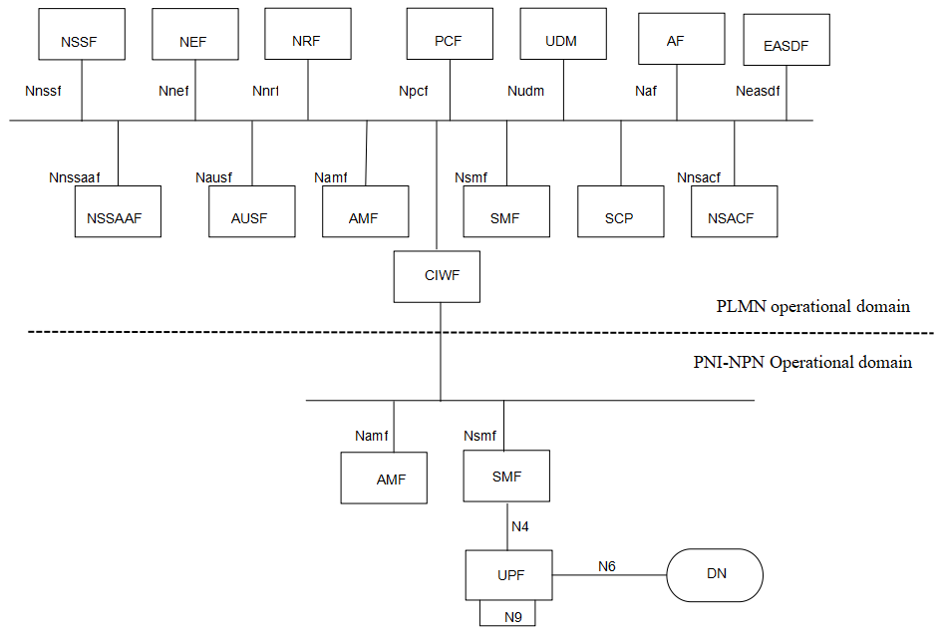
Figure 7.Y.2.1-1 CIWF deployed in PLMN operational domain to protect PLMN through SBA interface

7.Y.2.2 Procedure
The CIWF does topology hiding between PLMN operational domain and PNI-NPN operational domain.
Mutual authentication between NFs in the PNI-NPN operational domain and CIWF can be provided by TLS. Mutual authentication between NFs in the PLMN operational domain and CIWF can also be provided by TLS. Client credentials assertion(CCA) based authentication is optionally used between NFs in the PNI-NPN operational domain and NFs in the PLMN operational domain.
SBA authorization framework can be used to authorize the service requests between NFs in the PNI-NPN operational domain and NFs in the PLMN operational domain. CIWF requests access tokens on behalf of NF service consumers in the PNI-NPN operational domain.
The CIWF does malformed and wrong type message blocking between PLMN operational domain and PNI-NPN operational domain. CIWF maintains a restriction list of services/operations that NFs in the PNI-NPN operational domain are not allowed to request from NFs in the PLMN operational domain. CIWF also maintains a restriction list of information that NFs in the PNI-NPN operational domain are not allowed to access from NFs in the PLMN operational domain.When CIWF forwards messages between PNI-NPN operational domain and PLMN operational domain:
1. CIWF checks if the message is malformed or wrong type message. If yes, CIWF drops the message.
2. CIWF checks if the service request from PNI-NPN operational domain to PLMN operational domain is in the restriction list of services/operations. If yes, CIWF drops the service request.
3. CIWF checks if the message from PLMN operational domain to PNI-NPN operational domain contains information in the restriction list of information. If yes, CIWF drops the message.
Figure 7.Y.2.2-1 illustrates an example of the procedure.
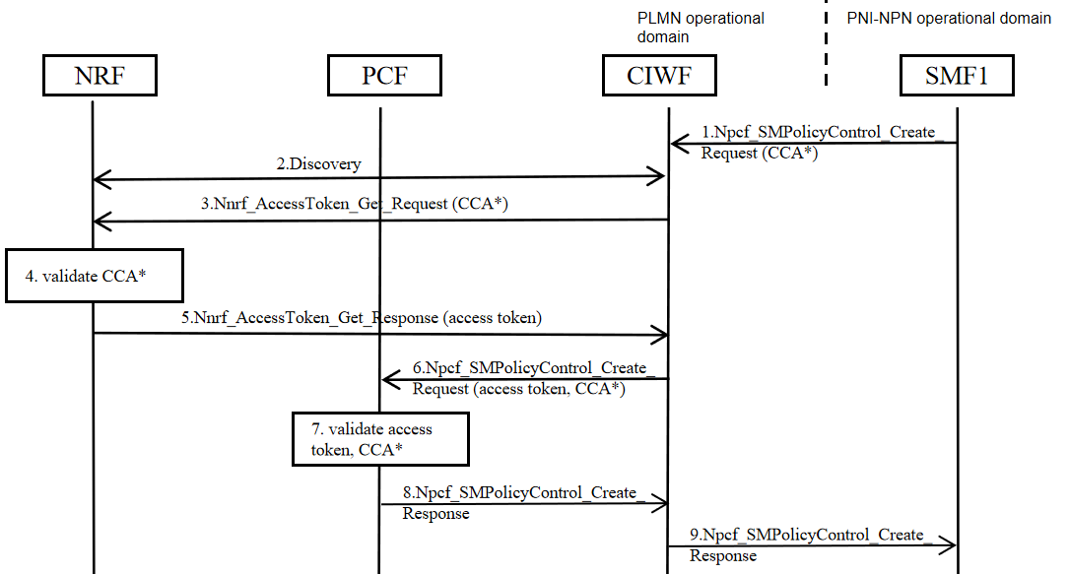
Figure 7.Y.2.2-1 Example of procedure
1. SMF1 in the PNI-NPN operational domain sends Npcf_SMPolicyControl_Create_Request to CIWF. The service request may include SMF1's CCA.
2. CIWF checks if the message is malformed, or wrong type message, or in the restriction list of services/operations. If yes, CIWF drops the message. If no, CIWF may performs a service discovery with the NRF in the PLMN operational domain. If SMF1 has included an access token in step 1, or if the CIWF has a cached granted access token, then CIWF may reuse the access token, do topology hiding and proceeds to step 6.
3. CIWF sends Nnrf_AccessToken_Get_Request to the NRF. The access token request may include SMF1's CCA if received in Step 1.
4. If CCA is included, NRF validates SMF1’s CCA. NRF issues an access token.
5. The NRF sends the access token to CIWF in Nnrf_AccessToken_Get_Response.
6. CIWF sends Npcf_SMPolicyControl_Create_Request to the PCF in the PLMN operational domain. The service request includes an access token received in Step 5, and may include the SMF1's CCA if received in Step 1.
7. If CCA is included, PCF validates SMF1’s CCA. PCF validates access token.
8. PCF sends Npcf_SMPolicyControl_Create_Response to CIWF.
9. CIWF checks if the message is malformed, or wrong type message, or contains information in the restriction list of informaion. If yes, CIWF drops the message. If no, CIWF does topology hiding and forwards Npcf_SMPolicyControl_Create_Response to SMF1.

7.Y.3 Evaluation
TBD.

*************** End of the change ****************

