3GPP TSG-SA3 Meeting #115e ad-hoc draft_S3-241255-r1

Electronic meeting, online, 15 - 19 April 2024

Source: China Telecom

Title: New solution to KI#1- CIWF for N4 interface

Document for: Approval
Agenda Item: 5.3

1 Decision/action requested
This contribution proposes to add new solution to KI#1- CIWF for N4 interface.

2 References

3 Rationale
The contribution proposes to add new solution to KI#1- CIWF for N4 interface.

4 Detailed proposal
It is suggested to approve the following change.

*************** Start of the change ****************

7.Y Solution #Y: CIWF for N4 interface

7.Y.1 Introduction
This solution addresses key issue 1 to provide security to the PLMN from the attacks that may be initiated by the dedicted UPF. The solution presents a Customer InterWoking Function henceforth referred to as CIWF. The CIWF is deployed in the PLMN operational domain.
This solution assumes that the PNI-NPN customer trusts the PLMN operator to have its topology information and to update/maintain the PNI-NPN topology information.
This solution assumes that the PNI-NPN customer trusts the PLMN operator to have access to and content of messages exchanged with the NF’s residing in the PNI-NPN customer’s operational domain.

7.Y.2 Solution details

7.Y.2.1 General
Figure 7.Y.2.1-1 illustrates CIWF deployed in PLMN operational domain when dedicated UPF is deployed in PNI-NPN operational domain. Dedicated UPF connects to the PLMN through CIWF. The CIWF may connect dedicated UPFs from different PNI-NPN operational domains simultaneously. CIWF protects the PLMN from the attacks that may be initiated by the dedicated UPF.
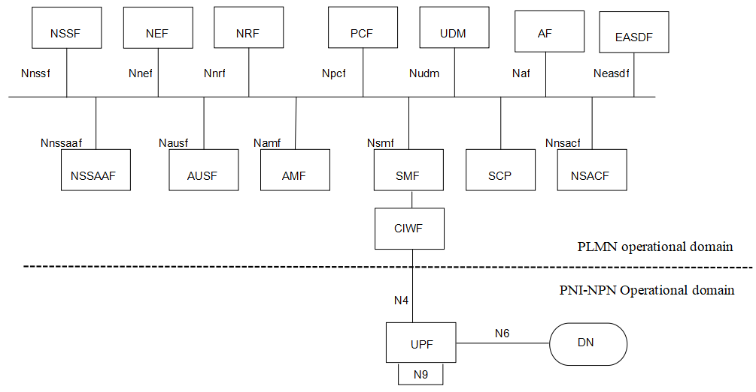
Figure 7.Y.2.1-1 CIWF deployed in PLMN operational domain to protect PLMN through N4 interface

7.Y.2.2 Procedure
IPsec ESP and IKEv2 certificate-based authentication are used to provide confidentiality, integrity and replay protection between UPF in PNI-NPN operational domain and CIWF.
IPsec ESP and IKEv2 certificate-based authentication are used to provide confidentiality, integrity and replay protection between SMF in PLMN operational domain and CIWF.
The CIWF does topology hiding, malformed and wrong type message blocking between PLMN operational domain and PNI-NPN operational domain.
Note: The CIWF can support topology hiding and message filtering for messages sent from PLMN to NPN and from NPN to PLMN. However, since the CIWF resides in the PLMN operator’s domain, the PLMN operator will configure the CIWF and therefore the PLMN operator will know the topology and content of messages exchanged with the NF’s residing in the PNI-NPN customer’s operational domain.
Figure 7.Y.2.2-1 illustrates an example of the procedure.
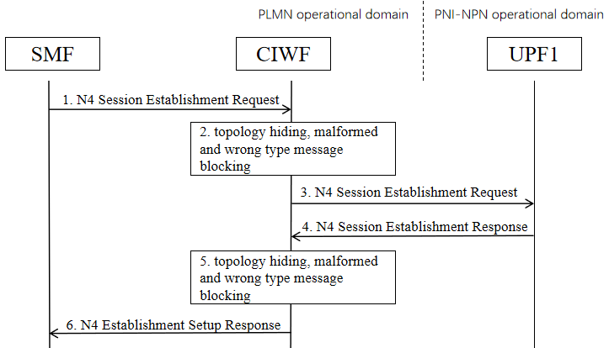
Figure 7.Y.2.2-1 Example of procedure
1. SMF sends an N4 Session Establishment Request to CIWF.
2. CIWF checks if it is malformed message or wrong type message. If yes, CIWF drops the message. If no, CIWF does topology hiding and forwards the message.
3. CIWF forwards the N4 Session Establishment Request to UPF1.
4. UPF1 sends an N4 Session Establishment Response to CIWF.
5. CIWF checks if it is malformed message or wrong type message. If yes, CIWF drops the message. If no, CIWF does topology hiding and forwards the message.
6. CIWF forwards the N4 Session Establishment Response to UPF1.

7.Y.3 Evaluation
TBD.

*************** End of the change ****************

