3GPP TSG-SA3 Meeting #108adhoc-e S3-222660r1

e-meeting, 10 – 14 Oct 2022

Source: Apple

Title: Addressing EN#2 on solution#7

Document for: Approval
Agenda Item: 5.9

1 Decision/action requested
This contribution proposes to update solution#7 in TR 33.739

2 References
[1] TS 33.739 v020

3 Rationale
This contribution proposes to address the 2nd EN in solution#7,
“Editor’s Note: it is FFS how to solve the authentication selection failure case if there do not exist the same authentication mechanisms.”
There may be authentication selection failure in roaming cases, as the implementation of VPLMN varies a lot, and there is no gurantee on the MNO’s implementations in supporting MEC authentication. When the authentication selection failure happens, i.e, there is no shared authentication mechanisms between UE and network, then the network needs to decide the next steps: 1) the network could cease the authentication, 2) the network could also use the one-way TLS authentication, and indicate to UE, assuming UE is supporting server side TLS authentication

4 Detailed proposal
It is suggested to approve the following changes.

***************************Start of Change ****************************

6.7 Solution #7: Negotiation procedure for the Authentication and Authorization

6.7.1 Solution overview
This contribution addresses key issue #2.2 “Authentication mechanism selection between EEC and ECS/EES”.

6.7.2 Solution details
The negotiation procedure is as following:
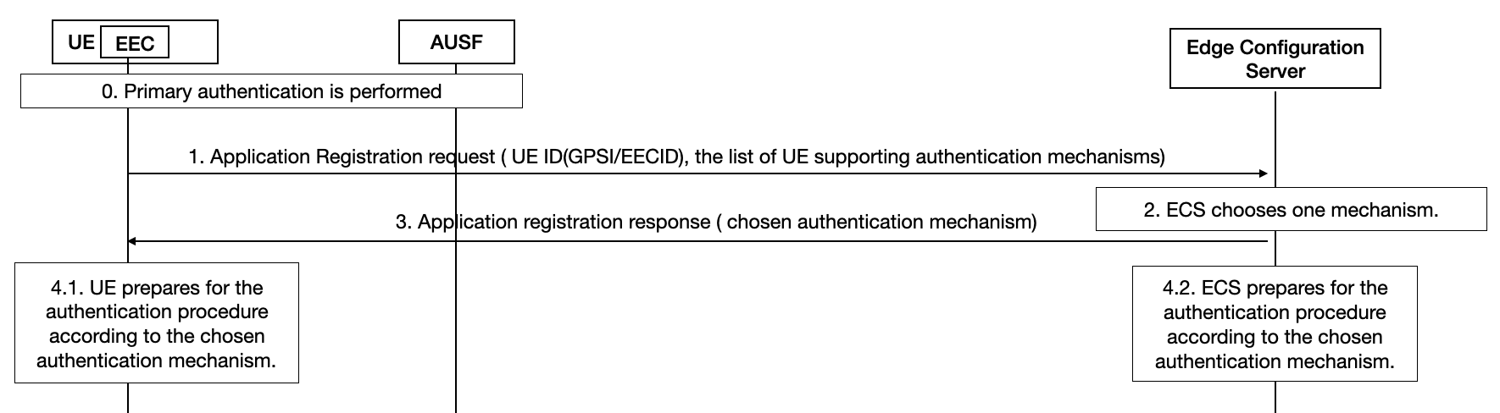
Figure 6.7．2-1: Negotiation Procedure for the Authentication and Authorization between EEC and ECS
Step 0. Primary authentication is performed as defined in TS 33.501 [7]. After this step, UE is successfully registered into the 5GS network.
Step 1. UE sends the EEC Registration Request message as defined in TS 23.558, which includes the list of UE supporting authentication mechanisms. The potential authentication mechanisms list includes TLS with AKMA, TLS with GBA, TLS with certificate, or other mechanisms if any. The order in the list indicates the priority of the UE preference.
Step 2. ECS selects one authentication method from the list of UE supporting authentication mechanisms based on local policy. If there is no shared authentication mechanisms between EEC and network, then the network need to decide the next steps: 1) the network could cease the authentication, and the following steps from step 3 will not take place, 2) the network could also use the one-way TLS authentication, and indicate to UE, assuming UE is supporting server side TLS authentication.
Step 3. If there is shared authentication mechanis, and ECS successfully chose one in Step 2, then ECS sends the EEC registration response including the chosen authentication mechanism to UE.
Step 4.1. After receiving the response from ECS in step 3, UE prepares for the authentication procedure according to the chosen authentication mechanism. e.g. generating AKMA/GBA keys or key for other mechanisms. The procedures to derive the credentials follow the TS 33.535 [8] for AKMA, TS 33.220 [6] for GBA, RFC 8446 [xx] for TLS 1.3.
Step 4.2. After sending the response to UE in step 3, network prepares for the authentication procedure according to the chosen authentication mechanism. e.g. generating AKMA/GBA keys or generating certificates. The procedures follow the TS 33.535 [8] for AKMA, TS 33.220 [6] for GBA, RFC 8446 [xx] for TLS 1.3.
Editor’s Note: It is FFS how to consider the HPLMN’s capability during the negotiation procedure.

Editor’s Note: Whether and what should be a default mechanism between UE ad network is FFS.

6.7.3 Solution evaluation
TBA

***************************End of change****************************

