3GPP TSG-SA3 Meeting #108Adhoc-e S3-222511

e-meeting, 10th – 14th October, 2022

Source: Huawei, HiSilicon

Title: Update solution#2

Document for: Approval
Agenda Item: 5.7

1 Decision/action requested
Approve the changes in clause 4 for inclusion in 33.741.

2 References
NA

3 Rationale
This contribution addresses the ENs and adds an evaluation.
The first EN is deleted because this solution relies on a new AMF service. Whether the new AMF service is acceptable or not should be discussed in the conclusion phase.
The second EN is deleted and more details on the triggering conditions at the UDM are provided to resolve the concerns.
Furthermore, other details are added, in particular for the new services in order to complete the solution.

4 Detailed proposal
********* Begin 1st change*********

5.2 Solution #2: UDM triggered primary authentication

5.2.1 Introduction
This solution is to address the KI#1 by providing a basic procedure on Home network triggering authentication.
The solution introduces a new service exhibited by the AMF and to be used only by the UDM to request primary authentication. This is because in 5GC the UDM knows which AMF is serving the UE. Upon a request from the UDM, the AMF triggers primary authentication using the existing services and NAS procedures.

5.2.2 Solution details

5.2.2.1 Procedure
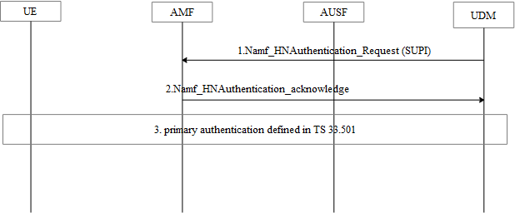
Figure 5.2.2.4-1: Home network trigger primary authentication procedure
1. The UDM decides to run primary a authentication based on the request from the UDM or AUSF or the AAnF . For example, when the UDM needs to send the UPU data or SoR data but cannot find a valid AUSF instance which means there is no valid K_{AUSF}. Another example is when the AAnF needs to refresh K_{AKMA} based on the cause value sent by the AF due to any reason.
The AUSF and the AAnF sends Nudm_HNAuthenticate-Request message to the AMFfor this purpose.
After receiving the request, the UDM needs to further consider the local policy before determine to run the primary authentication, such as whether the primary authentication has successfully run in a very short period. Then, the UDM selects the AMF that is serving the UE from the UE context. The UDM sends Namf_HNAuthentication_Request message to the AMF the message contains the SUPI of the UE.

2. The AMF may reply the Namf_HNAuthentication_acknowledge message to the UDM.
3. The AMF starts the primary authentication procedure defined in TS 33.501[3].
Editor’s Note: How the solution addresses the different use cases is FFS

5.2.2.2 Service provided by AMF

5.2.2.2.1 General
The AMF provides Home Network Authentication service to the requester NF, i.e. UDM, by Namf_HN Authentication.

5.2.2.2.2 Namf_HN Authentication service

5.2.2.2.2.1 Namf_HNAuthentication service operation
Service operation name: Namf_ HNAuthentication _Request.
Description: Request the AMF starts the primary authentication procedure.
Input, Required: SUPI
Output, Required: None
Output, Optional: None

5.2.2.2 Service provided by UDM

5.2.2.2.1 General
The UDM provides Home Network Authentication service to the requester, i.e. AUSF and AAnF, NF by Nudm_HN Authentication. The service consumer uses this service to request the UDM to trigger the primary authentication for requesting the K_{AUSF}.

5.2.2.2.2 Nudm_HN Authentication service

5.2.2.2.2.1 Nudm_HNAuthentication service operation
Service operation name: Nudm_ HNAuthentication _Request.
Description: Request the UDM to trigger the primary authentication.
Input, Required: SUPI
Output, Required:None
Output, Optional: None

5.2.3 Evaluation

This solution addresses KI#1.
This solution can address the 4G-5G interworking case, K_{AKMA} refresh use case, SoR/UPU counter wrap around use case, and other potential use case that needs to refresh the K_{AUSF}.
A new AMF service and a new UDM service are defined, because there is no existing SBA message can be reused.
This solution impacts on AMF and UDM.
Editors Note： further evaluation is FFS.

******** End of change*********

