3GPP TSG-SA3 Meeting #108Adhoc-e S3-222490

e-meeting, 10th – 14th October, 2022

Source: Huawei, HiSilicon

Title: add evaluation to solution#2

Document for: Approval
Agenda Item: 5.6

1 Decision/action requested
This contribution is accepted by the group.

2 References
NA

3 Rationale
This contribution proposes to add evaluations to solution 6.2. The editor’s Notes in solution 6.2 are addressed in another contribution. The whole copy of solution 6.2 is just for convenience.

4 Detailed proposal
********* Begin 1st change*********

6.2 Solution #2: New solution for AKMA roaming when both UE and AF are in VPLMN

6.2.1 Introduction
This solution addresses the requirement in KI#1 about the AKMA roaming.
This solution provides a method that when both UE and the AF in the same visited network. When the AF is inside 5GC, it can communicate with the UE’s AAnF in HPLMN directly. Otherwise, when AF is outside 5GC, it first connects to the NEF in HPLMN, and then the NEF will receive and send the message for the UE and the AAnF.

6.2.2 Solution details
Editor’s Note: The details of the AF being a regulatory control point for LI are FFS.

6.2.2.1 Architecture
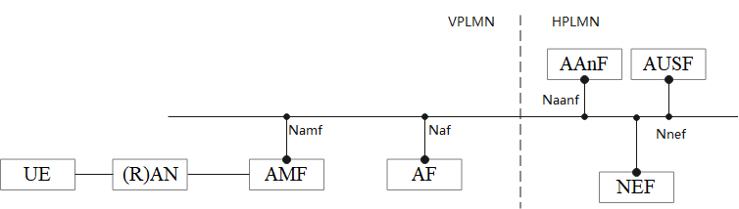
Figure 6.2.2.1-1: Reference Model when UE and the AF are in the VPLMN
The Figure 6.2.2.1-1 shows an architecture model when UE and the AF are in the VPLMN.

6.2.2.2 Solution detail

6.2.2.2.1 Deriving AKMA Application Key for a specific AF
Clause 6.2 in TS 33.535[2] applies with additionall descriptions:
- replace the AF with the AF in visited network.
- replace the UE with the UE in visited network.
Editor’s Note: The details of interconnect SBA security are FFS.

6.2.2.2.2 AKMA Application Key request via NEF
As described in clause 6.3 in TS 33.535[2] applies with additionall descriptions:
- replace the NEF with the NEF in home network.
- replace the AF with the AF in visited network.
- replace the UE with the UE in visited network.

6.2.3 Evaluation

This solution addresses the requirement of KI#1 when the AF is in the visited network, in particularly, it addressed case 2 and case3.
This solution reuses the existing mechanisms and hence has no standard impact.
******** End of change*********

