3GPP TSG-SA3 Meeting #108Adhoc-e S3-222489

e-meeting, 10th – 14th October, 2022

Source: Huawei, HiSilicon

Title: address Editor's Note in solution#2

Document for: Approval
Agenda Item: 5.6

1 Decision/action requested
Approve the changes in solution#2.

2 References
NA

3 Rationale
This contribution addresses the Editor’s Note "Editor’s Note: The details of interconnect SBA security are FFS" In solution#2. From our perception, the AKMA operation of NEF service can be reused by the visited AF,because the visited AF is an external AF to UE’s HPLMN. Therefore, the 6.2 of TS 33.535 cannot be used anymore, and we propose to remove this clause.
For the editor’s Note Editor’s Note "The details of the AF being a regulatory control point for LI are FFS" , from visited network point of view, it’s nothing different from AKMA phase1, so this editor’s Note can be deleted without any change.

4 Detailed proposal
********* Begin 1st change*********

6.2 Solution #2: New solution for AKMA roaming when both UE and AF are in VPLMN

6.2.1 Introduction
This solution addresses the requirement in KI#1 about the AKMA roaming.This solution is designed to case2 and case3.
This solution provides a method that when both UE and the AF in the same visited network. When the AF is inside 5GC, it can communicate with the UE’s AAnF in HPLMN directly. Otherwise, when AF is outside 5GC, it first connects to the NEF in HPLMN, and then the NEF will receive and send the message for the UE and the AAnF.

6.2.2 Solution details

6.2.2.1 Architecture
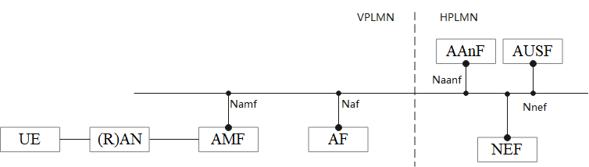
Figure 6.2.2.1-1: Reference Model when UE and the AF are in the VPLMN
The Figure 6.2.2.1-1 shows an architecture model when UE and the AF are in the VPLMN.
The AF can be an internal AF in VPLMN or an AF in the data network.

6.2.2.2 Solution detail

6.2.2.2.1 AKMA Application Key request via NEF
As described in clause 6.3 in TS 33.535[2] applies with additional descriptions:
- replace the NEF with the NEF in home network.
- replace the AF with the AF in visited network.
- replace the UE with the UE in visited network.
NOTE: the visited AF is an external AF to UE’s HPLMN
NOTE for an AF in the data network the AF may not be allowed to use SBA to access internal VPLMN NFs.

6.2.3 Evaluation
TBD
******** End of change*********

