3GPP TSG-SA3 Meeting #108Adhoc-e S3-222487

e-meeting, 10th – 14th October, 2022

Source: Huawei, HiSilicon

Title: E2E solution in L2 Relay

Document for: Approval
Agenda Item: 5.3

1 Decision/action requested
This contribution is accepted by the group.

2 References
NA

3 Rationale
This solution proposes to establish a PC5 link between the Source UE and the Target UE.

4 Detailed proposal
********* Begin 1st change*********

6.Y Solution #Y: End-to-end security in L2 Relay

6.Y.1 Introduction
This solution addressed the requirement “The 3GPP system shall support a means to establish a secure connection between the source UE and the target UE in the UE-to-UE relay scenario” in KI#2 by in L2 relay case. The solutions proposes to usePer-hop links setup first, and then the source UE and the target UE setup another PC5 link, i.e. the PC5-S and PC5-U can be used directly between the source UE and the target UE.

6.Y.2 Solution details
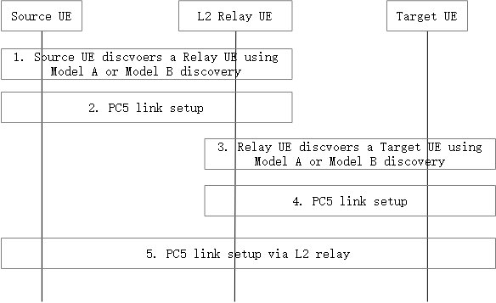
Figure 6.Y.2-1: Layer2 relay End-to-End security setup procedure
1. The source UE discovers a Relay UE using Model A or Model B discovery as concluded in TR 23.700-33[2].
2. The Source UE and the Relay UE performs PC5 link setup procedure.
NOTE 1: The detail of this procedure is not in the scope of this solution.
3. The Relay UE discovers a target UE using Model A or Model B discovery specified in TS 33.503[6].
4. The Relay UE and the target UE performs PC5 link setup procedure.
NOTE 2: The detail of this procedure is not in the scope of this solution.
5. The Source UE and the Target UE setup a PC5 link via L2 relay as described in TS 33.503[6]. By this way, End-to-end security is established between the Source UE and the Target UE.
Editor’s Note: whether perform both hop-by-hop link security and E2E security in U2U relay is FFS

6.Y.3 Evaluation
TBD

******** End of change*********

