3GPP TSG-SA3 Meeting #108Adhoc-e S3-222484-r1

e-meeting, 10th – 14th October, 2022

Source: Huawei, HiSilicon

Title: New solution to KI#3

Document for: Approval
Agenda Item: 5.13

1 Decision/action requested
Approve the changes in clause 4 for inclusion in 33.887.

2 References
NA

3 Rationale
This contribution is built on the solution#15 in TR 23.700-18 v030, but only includes the N3IWF Relocated case. In this solution, we propose to finish the IPsec tunnel setup procedure before initiating UE policy Association Establishment procedure and before the AMF sends Registration Reject message. Because according to TS 33.501, the NAS message is sent over the IPsec. Otherwise, new procedures need to be defined, for example, the Registration Reject is over EAP-5G. With this, we believe that using the IPsec tunnel is the best approach

4 Detailed proposal
********* Begin 1st change*********

2 References
The following documents contain provisions which, through reference in this text, constitute provisions of the present document.
- References are either specific (identified by date of publication, edition number, version number, etc.) or non-specific.
- For a specific reference, subsequent revisions do not apply.
- For a non-specific reference, the latest version applies. In the case of a reference to a 3GPP document (including a GSM document), a non-specific reference implicitly refers to the latest version of that document in the same Release as the present document.
[1] 3GPP TR 21.905: "Vocabulary for 3GPP Specifications".
[2] 3GPP TR 23700-17 "Study on the support for 5WWC, Phase 2"
[3] 3GPP TR 33.316 "Wireless and wireline convergence access support for the 5G System (5GS)"
[x] 3GPP TS 33.501: "Security Architecture and Procedures for 5G System".

******** End of 1st change*********

********* Begin 2nd change*********

6.Y Solution #Y: Security of TNGF/N3IWF reallocation

6.Y.1 Introduction
This solution addresses KI#3 by, and it is built on the solution#15 in TR 23.700-17[2] v030, but only includes the N3IWF Relocated case. In this solution, IPsec tunnel is setup before initiating UE policy Association Establishment procedure and before the AMF sends Registration Reject message. Because according to TS 33.501[x], the NAS message is sent over the IPsec.

6.Y.2 Solution details
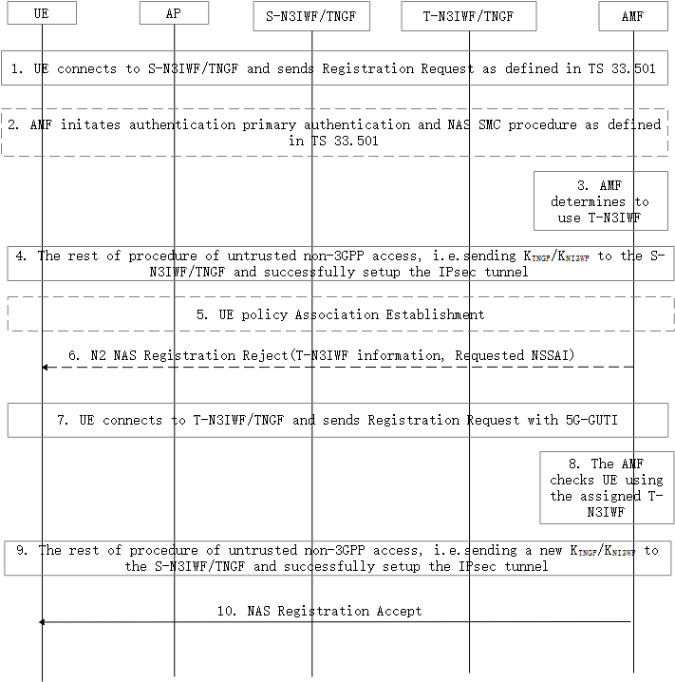
Figure 6.Y.2 N3IWF/TNGF Relocation procedure
1. UE connects to S-N3IWF or S-TNGF and sends the Registration Request message to the AMF as defined from step 1a to step 6b in clause 7.2.1 of TS 33.501[x] and as defined from step 1 to step 6b in clause 7A.2.1 of TS 33.501[x].
2. If the Registration Request contains a SUCI, AMF initiates authentication primary authentication and NAS SMC procedure as defined in TS 33.501[x]. If the UE contains a 5G-GUTI, and the AMF successfully verified the integrity protection of the Registration Request message, whether the AMF initiates authentication primary authentication and NAS SMC procedure complies with what is defined in TS 33.501[x].
3. The AMF determines to use T-N3IWF as described in TR 23.700-17[2].
4. The AMF generate a K_{TNGF}/K_{NI3WF}, and sends it to the S-N3IWF or S-TNGF for setting up the IPsec as defined from step 12 to step 15 in clause 7.2.1 of TS 33.501[x] and as defined from step 10a to step 14 in n clause 7A.2.1 of TS 33.501[x].
5. The same as step 9 described in solution#15 of TR 23.700-12[2].
6. The same as step 10a described in solution#15 of TR 23.700-12[2]. The UE and the AMF keep the security context. The AMF includes a new 5G-GUTI in the Registration Reject message.
7. After successfully verifying the integrity protection of the message in step 5 or step6, the UE re-registrated to the AMF using T-N3IWF. The Registration Request message contains the new 5G-GUTI and is protected by the security context generated in step2, or previously generated before step1.
8. After successfully verifying the integrity protection of Registration Request message, the AMF checks whether the UE use the assigned T-N3IWF or not, if yes, the AMF stops checking whether the N3IWF connected with UE currently (named S-N3IWF) should be the serving N3WIF, otherwise, the AMF checks again whether the N3IWF connected with UE currently (named S-N3IWF) should be the serving N3WIF.
9. If no Relocation is needed again, the AMF proceeds the rest of procedures defined in clause 7.2.1 of TS 33.501[x] and clause 7A.2.1 of TS 33.501[x]. Particularly, the AMF generates a new K_{TNGF}/K_{NI3WF} for setting up the IPsec.
10. The AMF sends NAS Registration Accept message to the UE.

6.Y.3 Evaluation
TBD
******** End of change*********

