3GPP TSG SA WG3 Meeting #107-e draft-S3-220866-r1

e-meeting, 16-20 May 2022 revision S3-22abcd

Source: Huawei, HiSilicon

Title: Update on solution 5

Document for: Approval
Agenda Item: 5.2

Decision/action requested
This contribution proposes to add an Editor’s Note in TR 33.848

References

Rational
In solution 5, the PACF and NRF are policy enhancement points in the proposed remote attestation architecture. However, the NRF and PACF are also virtualized network functions which may have the same security protection level with the NF service consumers. If those network entities are compromised, the whole proposed remote attestation architecture is useless. Thus, it is proposed to add an editor’s note: “How to attester the NRF and PACF is FFS”.

Detailed proposal
*************** Start of 1st Change ****************

6.6.3.5 NF Service Registration Procedure with Remote Attestation
This solution proposes to provide proof to the 3GPP functional domain that a new VNF has been successfully attested before registration occurs in the 5G Core.
Editor’s Note: The process for verifying attestation results for the NRF and PACF is FFS.
Once successfully instantiated, a new VNF will register with the NRF. The original NF Service Registration procedure is detailed in [13], clause 4.17.1. The modified NF Service Registration procedure shown in Figure 6.6.3.5-1 includes attestation by adding steps 2, 3, and 4. Steps 1, 5, and 6 are steps from the original procedure.
The modified NF Service Registration procedure retrieves attestation results based on the NF Instance ID in the NF profile. This solution proposes the use of digital signatures to enable integrity protection and verification of the NF profile sent in the registration request by the VNF. The NF profile should be signed by the entity that configures the profile (e.g., NFV MANO or OAM). Signing the NF profile prevents the registering VNF from altering the NF profile by forging the NF Instance ID of a successfully attested VNF.
NOTE: A signed NF profile is within alignment of TS 23.502 [13] clause 4.17.1. TS 23.502 clause 4.17.1, NOTE 2 states: the NF profile is configured by OAM system and NOTE 3 states: that whether the NF profile sent by NF service consumer to NRF needs to be integrity protected by the NF service consumer and verified by the NRF is to be decided by SA3.

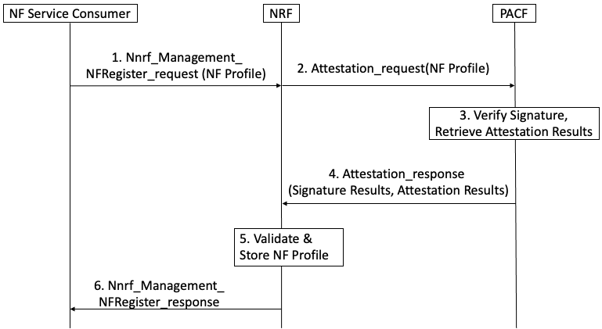
Figure 6.6.3.5-1: NF Service Registration Procedure with PACF

When an NF requires attestation results to register, the following steps are proposed for the registration procedure:
Step 1: NF service consumer, i.e. an NF instance, sends Nnrf_NFManagement_NFRegister Request message to NRF to inform the NRF of its NF profile when the NF service consumer becomes operative for the first time.
NOTE: The NF service consumer’s NF profile should be signed by the entity that configured the profile (e.g., NFV MANO, or OAM).
Step 2: The NRF initiates a request for attestation results and sends the signed NF profile to the PACF.
Step 3: The PACF verifies the signature on the NF profile and retrieves attestation results from the Verifier using the NF Instance ID from the NF profile.
If signature verification fails, the NF service consumer cannot be trusted and an exception handling procedure should be activated to handle an untrusted NF.

Step 4: The PACF responds to the NRF with attestation results it received from the Verifier.
Step 5: If the attestation results affirm successful attestation, the NF service consumer can be trusted. The NRF stores the NF profile of NF service consumer and marks the NF service consumer available.
Otherwise, if the attestation results affirm an unsuccessful attestation, the NF consumer cannot be trusted and a recovery procedure should be activated to handle an untrusted NF.
Step 6: The NRF acknowledge NF Registration is accepted via Nnrf_NFManagement_NFRegister response.
There can also be interactions between NFs with MnF (as defined in TS 28.533) for NF management service.
Besides the above procedures defined in 3GPP, the NFs can also interact with domains defined in other SDOs, e.g., MANO defined in ETSI.
The main idea is requiring the Verifier to expose the attestation results of different layers to the network entities (NRF, NFp, PS, MnF, MANO, OAM, etc.) which will interact with the attested NF, then, on receiving the interaction from the NF, these network entities can invoke the attestation /results and take further actions.
NOTE: The Verifier itself can also be distributed in different layers. The network entities can communicate with the Verifier directly or via a unified proxy

*************** End of 1st Change ****************

