3GPP TSG-SA3 Meeting #107e AdHoc S3-221415

e-meeting, 27 June - 1 July 2022

Source: Huawei, HiSilicon

Title: UDM triggered primary authentication

Document for: Approval
Agenda Item: 5.9

1 Decision/action requested
This contribution is accepted by the group.

2 References
NA

3 Rationale
The solution defines a new service between the UDM and the AMF. UDM is the only funcation that uses this sevice to request the authentication. Because it is the UDM that knows which AMF is serving the UE. The AMF will acknowledge the reception of the message, and then use the existing services to start the primary authentication.

4 Detailed proposal
********* Begin 1st change*********

6.Y Solution #Y: UDM triggered primary authentication

6.Y.1 Introduction
This solution is to address the KI#1 by providing a basic procedure on Home network triggering authentication.
The solution introduces a new service exhibited by the AMF and to be used only by the UDM to request primary authentication. This is because in 5GC the UDM knows which AMF is serving the UE. Upon a request from the UDM, the AMF triggers primary authentication using the existing services and NAS procedures.

6.Y.2 Solution details
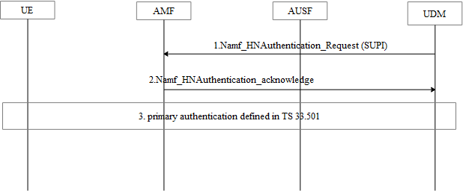
Figure 6.Y.2.4-1: Home network trigger primary authentication procedure
1. The UDM decide to run primary authentication based on decision at the UDM or is requested by the AUSF or the AanF. . The UDM selects the AMF that is serving the UE from the UE context.
Editort’s Note: Whether a new service operation is provided by AMF is FFS.
Editort’s Note: How UDM will trigger this primary authentication is FFS

2. The AMF replied the Namf_HNAuthentication_acknowledge message to the UDM.
3. The AMF starts the primary authentication procedure defined in TS 33.501[3].

6.Y.3 Evaluation
TBD
******** End of change*********

