3GPP TSG-SA3 Meeting #107-bis-e S3-221385

e-meeting, 16 - 20 May 2022

Source: Huawei, HiSilicon

Title: New solution for AKMA roaming when UE is in visited network but the AF in Home network

Document for: Approval
Agenda Item: 5.9

1 Decision/action requested
This contribution is accepted by the group.

2 References
NA

3 Rationale
The current solutions in TS 33.535 can be directly reused in roaming scerion with minor optimization, i.e. by clearly stating out where is the UE, AF and the NEF.
This solution addresses the case when UE in VPLMN, and the AF is in the HPLMN.

4 Detailed proposal
********* Begin 1st change*********

2 References
The following documents contain provisions which, through reference in this text, constitute provisions of the present document.
- References are either specific (identified by date of publication, edition number, version number, etc.) or non-specific.
- For a specific reference, subsequent revisions do not apply.
- For a non-specific reference, the latest version applies. In the case of a reference to a 3GPP document (including a GSM document), a non-specific reference implicitly refers to the latest version of that document in the same Release as the present document.
[1] 3GPP TR 21.905: "Vocabulary for 3GPP Specifications".
[2] 3GPP TR 33.535: " Authentication and key management for applications based on 3GPP credential in 5G （AKMA）".[3] 3GPP TS 33.220: "Generic Authentication Architecture (GAA); Generic Bootstrapping Architecture (GBA) ".
[3] 3GPP TS 23.502: "Procedures for the 5G System (5GS); Stage 2".
******** End of 1st change*********
********* Begin 2nd change*********

6.Y Solution #Y: AKMA roaming when UE is in visited network but the AF in Home network

6.Y.1 Introduction
This solution addresses the requirement in KI#1 about the AKMA roaming.

6.Y.2 Solution details
This solution addresses the requirement in KI#1 about the AKMA roaming.
This solution provides a method that when UE in VPLMN, and the AF is in the HPLMN. When the AF is inside 5GC, it can communicate with the UE’s AAnF in HPLMN directly. Otherwise, when AF is outside 5GC, it first connects to the NEF in HPLMN, and then the NEF will receive and send the message for the UE and the AAnF

6.Y.2.1 Architecture
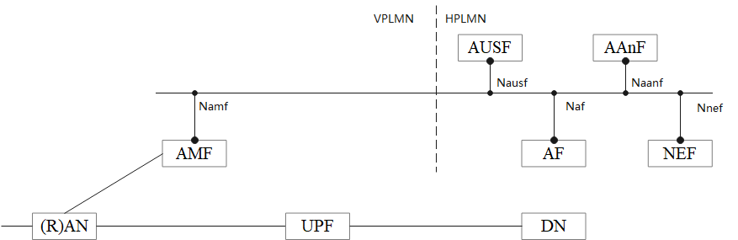
Figure 6.Y.2.1-1: Reference Model when UE is in VPLMN and the AF is in HPLMN
The Figure 6.Y.2.1-1 shows an architecture model when UE is in the VPLMN and the AF is in the HPLMN. The UE connects to AF via the UPF that is in the VPLMN. The AF can either connects to the AAnF by using SBA when the AF is inside 5GC or by using the NEF in HPLMN when AF is not in 5GC.

6.Y.2.2 Solution detail

6.Y.2.2.1 Deriving AKMA Application Key for a specific AF
Clause 6.2 in TS 33.535[2] applies with additionall descriptions:
- replace the AF with the AF in home network.
- replace the UE with the UE in visited network.
- the AF cannot enable the encryption protection.

6.Y.2.2.2 AKMA Application Key request via NEF
As described in clause 6.3 in TS 33.535[2] applies with additionall descriptions:
- replace the NEF with the NEF in home network.
- relace the AF with the AF in home network.
- replace the UE with the UE in visited network.
- the AF cannot enable the encryption protection.

6.Y.3 Evaluation
TBD
******** End of change*********

