3GPP TSG-SA3 Meeting #104-e-adhoc S3-213357r1

e-meeting, 27 – 30 September 2021

Source: Apple

Title: Adding evaluaiton to solution#11

Document for: Approval
Agenda Item: 5.1

1 Decision/action requested
This contribution proposes the evaluation for solution#11

2 References
[1] TR 33.839 v070

3 Rationale
The contribution proposed to add the evaluation of solution#11.
When using AKMA based solution, there will be only one K_{AKMA} in one UE. With the same K_{AKMA} and the same Application server, they will derive the same K_{AF} (K_{ECS} in solution #11)When there are multiple EECs in one UE, and all those EECs will share the same K_{ECS} , which is not acceptable from security point of view.
Therefore, the pCR proposes to add the evaluation that “This solution doesn’t apply to the case when there are multiple EECs in one UE.”

4 Detailed proposals
***************************Start of change****************************

6.11 Solution #11: Authentication between EEC and ECS

6.11.1 Solution overview
This solution addresses the security requirement for the Authentication between EEC and ECS in key issue #2.
In this solution, UE knows to use AKMA with ECS via interactions with 3GPP network before communication with ECS. If the ECS deployed by MNO is considered to be trusted by the operator, the ECS interacts directly with AAnF. Otherwise, the ECSs not allowed by the operator to access directly the Network Functions should use the NEF to interact with AAnF.

6.11.2 Solution details
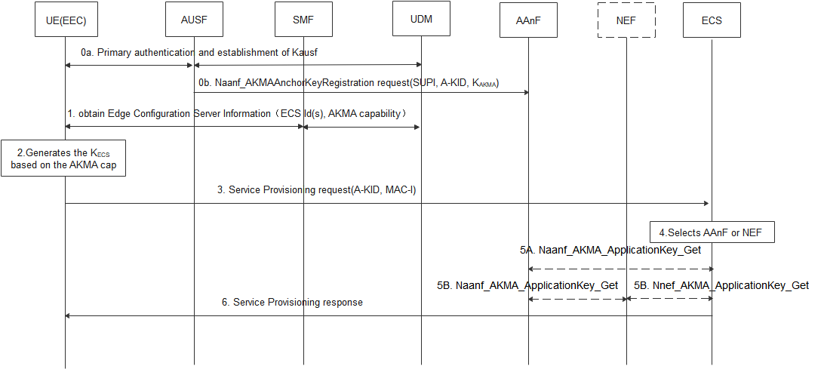
Figure 6.11.2-1 Authentication between the EEC and ECS based AKMA
0a. UE performs primary authentication with the network. Then K_{AUSF} is shared between UE and AUSF in Home network. If the AUSF receives the AKMA indication from the UDM, the AUSF should generate the AKMA Anchor Key (K_{AKMA}) and the A-KID from K_{AUSF} after the primary authentication procedure is successfully completed.
0b. After AKMA key material is generated, the AUSF should send the generated A-KID, and K_{AKMA} to the AAnF.
- During PDU Session Establishment, the SMF provides Edge Configuration Server Information (ECS ID (i.e. FQDN or IP address(es) of ECS), AKMA capability) to the UE. The AKMA capability indicates the ECS support to use AKMA.
- When the UE determines to communicate with ECS, if the UE supports AKMA, the UE derives the AKMA key and K_{ECS}(i.e K_{AF}) as specified in TS 33.535 [6] based on the received AKMA capability.
- UE computes the MAC-I over the request message using the K_{ECS} and sends service provision request with A-KID, MAC-I.

NOTE: TLS based on AKMA PSK solution is defined in other solutions.
- Upon receiving the request, the Edge Configuration Server discovers the AAnF or NEF.
NOTE : In the case of architecture without CAPIF support, the ECS is locally configured with the API termination points for the service. In the case of architecture with CAPIF support, the ECS obtains the service API information from the CAPIF core function via the Availability of service APIs event notification or Service Discover Response as specified in TS 23.222 [9].
5A-5B. The ECS contacts AAnF directly or via NEF to obtain the corresponding key K_{ECS} (K_{AF}) of the UE(as defined in TS33.535).
6. The ECS verifies the MAC-I based on the K_{ECS}, when the verification is succeed, and if the UE is authorized to perform the operation. Then the ECS computes MAC-I over the response message using K_{ECS,} and sends a service provisioning response with the MAC-I to the UE.

6.11.3 Solution evaluation
This solution addresses the security requirement for authentication between EEC and ECS in the key issue #2 based on the AKMA.
This solution requires the 5GC to provide the AKMA capability of ECS(s) to the UE, then the UE can determine to use AKMA when establish connection with ECS.
This solution also requires that the EEC and ECS supports the AKMA.
Authentication of apps in the UE before accessing to the key is out of scope of this solution.
The key isolation between multiple EECs connected to the same ECS is not addressed in this solution.

***************************End of change****************************

