3GPP TSG SA WG3 Meeting #103-e S3-211654

e-meeting, 17 – 28 May 2021 revision S3-21abcd

Source: Huawei, HiSilicon

Title: Solution Update for Solution #2

Document for: Approval
Agenda Item: 5.14

Decision/action requested
This contribution proposes to update current solution#2 in TR 33.867

References

Rational
There are two Editor’s Notes in solution #2 in TR 33.867, and the contribution is proposed to address them.
Editor’s Note: It is FFS if step 2 is done in another place like in NWDAF or UDM.
Editor’s Note: It is FFS when UDM itself is data provider.
In order to address the two Editor’s Notes, the procedure for NF authorization based on user consent is updated. The solution also adds evaluation part.

Detailed proposal
*************** Start of 1st Change ****************

7.X Solution #X: User Consent for UE Related Analytics of NWDAF

7.X.1 Solution overview
The solution addresses key issue #2.
The solution gives an overview for user consent on services provided by NWDAF.

7.X.2 Solution details

7.X.2.1 NF Authorization based on User Consent
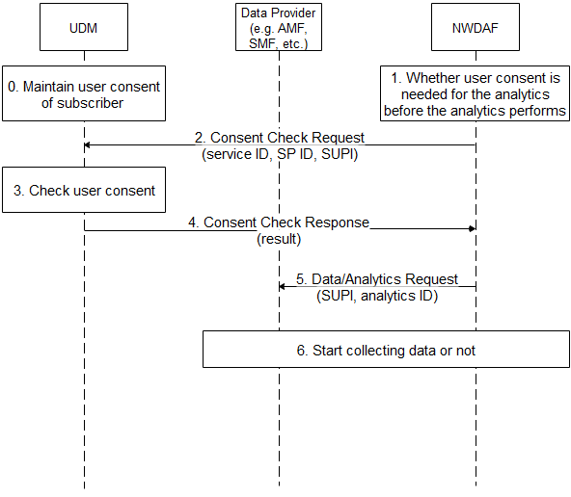
Figure 7.2.2.1-1 NF Authorization based on User Consent for NWDAF
- The UDM maintains user consent for the subscriber.
- If the NWDAF receives request for specific analytics from Data Consumer, e.g. it may collect UE’s information for UE related analytics, the NWDAF checks whether user consent is needed for the analytics according to local policy, e.g. regulation.
- The NWDAF sends Consent Check Request message to the UDM. The message includes the service ID, the Service Provider ID and the SUPI. The service ID is associated with the analytics ID.
- The UDM checks user consent according to the maintained user consent.
- The UDM sends Consent Check Response message to the Data Provider. The message includes the result, i.e. permission granted or denied.
- The NWDAF sends Data/Analytics Request to Data Provider, the request includes the SUPI and the analytics ID.
- The Data Provider starts to collect the requested data based on the result.

7.X.2.2 User Consent Format
The UDM maintains the following parameters for user consent for services provided by NWDAF:
- UE ID: refers to a subscriber, can be SUPI.
- Service Provider ID: refers to a service provider who provides data analytics service for the UE, can be PLMN ID.
- Service ID: refers to a data analytics service, can be analytics ID.
Those parameters are combined to indicate that a specific subscriber has user consent to consume specific network analytics service provided by the specific service provider.

7.X.2.3 Obtain of User Consent
The subscriber may give its consent to operator when the subscriber signs service contract with the operator.
The subscriber may change or add consent to operator when the subscriber changes its subscription with the operator.

7.X.3 Solution evaluation

TBA
*************** End of 1st Change ****************

