**3GPP TSG-SA3 Meeting #102-e *S3-210303r1***

**e-meeting, 18 -29 January 2021** Revision of S3-210303

**Source: China Mobile**

**Title: Clarifying the scope**

**Document for: Approval**

**Agenda Item: 5.2**

# 1 Decision/action requested

***This contribution clarifies the scope.***

# 2 Rationale

Currently, the virtualization technologies include the virtual machines and the containers, and the containers have become one of the key technologies of cloud native due to their lighter weight and faster deployment. Standards related to the containers are also being developed. However, because the virtual machines are a more mature technology than the containers, and are more secure than the container which shared host operating systems. At present, operators still use the virtual machines to deploy v5GC. Even if the containers are used, the containers are deployed in the virtual machine and are not displayed outside the virtual machine. Therefore, this document proposes to add note to explain that SECAM/SCAS of GVNP consider only the scenario that 3GPP VNF of 5GC deployed in the virtual machines. The scenario that 3GPP VNF deployed in the container will be studied further.

In addition, the ENs related the containers are proposed to delete.

# 3 Detailed proposal

****************** Start of the first change ******************

# 1 Scope

The present document studies the SECAM (Security Assurance Methodology) and SCAS (Security Assurance Specification) for 3GPP virtualised network products based on SECAM and SCAS defined in TR33.916 [2]. It makes thorough gap analysis between current SECAM/SCAS work in TR 33.916 [2] and SECAM/SCAS work for 3GPP virtualised network products. It also identifies, defines ToE and roles of SECAM/SCAS for 3GPP virtualised network products according to deployment scenarios and decoupling ways. Based on the identified ToE and roles, the present document details the needed change or additional work to current security assurance methodology for the creation, evaluation procedure of related SCAS documents, etc. It studies new threats of the identified ToE and identifies the additional security requirements of the ToE, or/and identifies existing relevant/supporting requirements specified in ETSI NFV specifications or the equivalent. The present document also provides potential new SECAM/SCAS proposals and points out the impact to existing SECAM/SCAS documents (including TR 33.916 [2], TR 33.926 [3], TS 33.117 [4], etc.).

NOTE: SECAM/SCAS of 3GPP virtualised network products in this document considers only the scenario that 3GPP VNF deployed in the virtual machines.

****************** End of the first change ******************

****************** Start of the second change ******************

#### 5.2.3.2 Generic virtualised network product model of type 1

For the virtualised network product class type 1 (i.e. implementing 3GPP defined functionalities only), the following figure 5.2.3.2-1 depicts the components of a generic network product model at a high level.

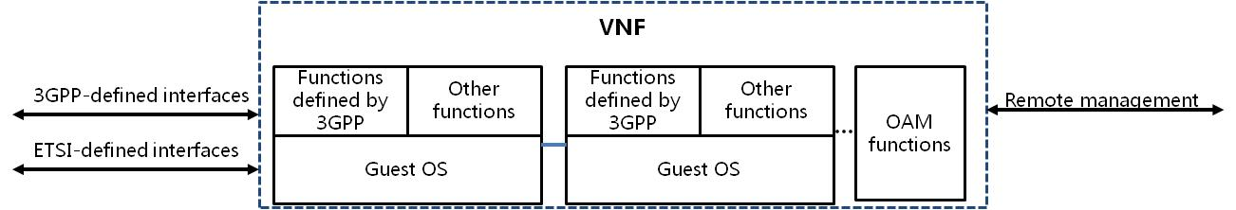

Figure 5.2.3.2-1: GVNP model

Editor's Note: The figure needs to be updated.

The components in the figure 5.2.3.2-1are further described in the following clauses.

****************** End of the second change ******************

****************** Start of the third change ******************

#### 5.2.3.3 Generic virtualised network product model of type 2

For the virtualised network product class type 2 (i.e. implementing 3GPP defined functionalities and virtualisation layer), the following figure 5.2.3.3-1 depicts the components of a generic network product model at a high level.

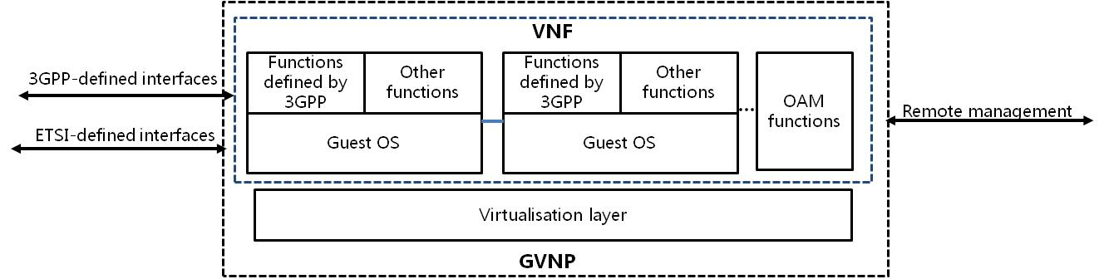

Figure 5.2.3.3-1: GVNP model

Editor's Note: The figure needs to be updated.

Compared to the GVNP model of the type 1 in figure 5.2.3.2-1, the GVNP model of the type 2 in the above figure has the Virtualisation layer in addition to 3GPP VNF. The VMs which deploy VNFCIs can be deployed in the multiple hosts, so there may be more than one instance of virtualisation layer that provide virtualisation resource for VNF. For simplicity, only one instance of virtualisation layer is shown in the figure 5.2.3.3-1. The components in the figure 5.2.3.3-1 are further described in the following clauses.

****************** End of the third change ******************

****************** Start of the fourth change ******************

#### 5.2.3.4 Generic virtualised network product model of type 3

For the virtualised network product class model of type 3 (i.e. implementing 3GPP defined functionalities, virtualisation layer, and hardware layer), the following figure 5.2.3.4-1 depicts the components of a generic network product model of type 3 at a high level.

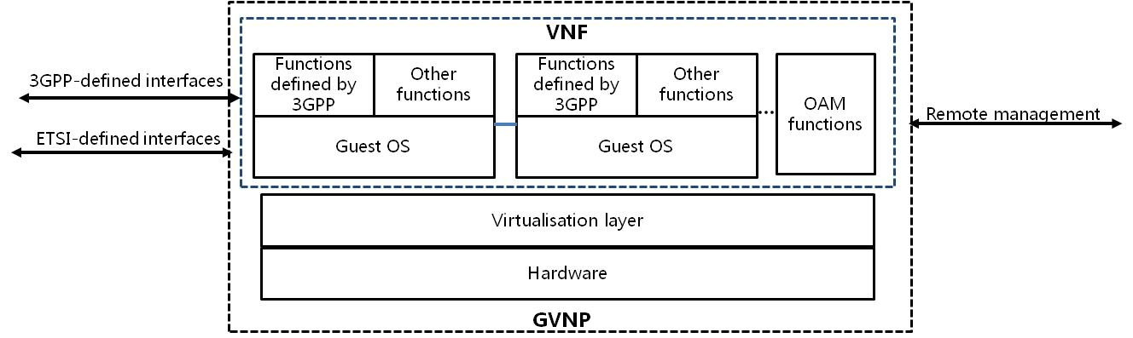

Figure 5.2.3.4-1: GVNP model

Editor's Note: The figure needs to be updated.

Compared to the GVNP model of type 2 in the figure 5.2.3.3-1, the GVNP model of type 3 in the above figure has hardware layer in addition to 3GPP VNF and virtualised layer. The VMs which deploy VNFCs can be deployed in the multiple hosts, so hardware layer that is shown in the figure 5.2.3.4-1 may consist of more than one host. The components in the figure 5.2.3.4-1 are further described in the following clauses.

****************** End of the fourth change ******************