3GPP TSG SA WG3 Meeting #102e S3-210226

e-meeting, 18 – 29 January 2021 revision S3-20abcd

Source: Huawei, HiSilicon, Samsung

Title: New Use Case for MEC

Document for: Approval
Agenda Item: 5.14

Decision/action requested
This contribution proposes to add a new use case for MEC for TR 33.867

References

Rational
The contribution proposes to add a new use case for MEC.

Detailed proposal
*************** Start of 1st Change ****************

2 References
The following documents contain provisions which, through reference in this text, constitute provisions of the present document.
- References are either specific (identified by date of publication, edition number, version number, etc.) or non-specific.
- For a specific reference, subsequent revisions do not apply.
- For a non-specific reference, the latest version applies. In the case of a reference to a 3GPP document (including a GSM document), a non-specific reference implicitly refers to the latest version of that document in the same Release as the present document.
[1] 3GPP TR 21.905: "Vocabulary for 3GPP Specifications".
[2] 3GPP TS 23.558: "Architecture for enabling Edge Applications (EA) ".
[yy] 3GPP TS 23.501: “System architecture for the 5G System (5GS)”
*************** End of 1st Change ****************

*************** Start of 2nd Change ****************

5.X Use Cases #X: UE Information Exposure for Mobile Edge Computing

5.X.1 Use Case details
An edge enabler server (EES) of the edge data network caters to the edge applications running at an edge data network. The EES is configured to expose APIs (e.g. location service, UE identifier (GPSI)) to the edge application server (EAS), and the PLMN NFs are also configured to expose the relevant APIs to the EES.
The EAS collects the UE information via the EES’s APIs to provide specific services for the user, e.g. collect GPSI and related GPS to provide accurate location service, and the EES may collect the UE information via the PLMN NFs’ APIs.
The EAS can process UE information as the following:
- Collect UE information to provide specific services for the user, e.g. collect UE location to provide accurate location service.
The EES can process UE information as following:
- Collect and store UE information.
- Share UE information to EAS.
The NFs in PLMN can process UE information as following:
- Collect and store UE information.
- Share UE information to EES.
Since the UE information is derived from user, and may be relevant to user privacy, thus, processing of those data should consider user consent aspects.

5.X.2 Individual Architecture
For this use case, the architecture and framework as specified in TS 23.558 [2], TS 23.501 [yy] are regarded as the baseline. The solutions shall build on the 5G System architectural principles as in TS 23.501 [yy], including flexibility and modularity for newly introduced functionalities.
Moreover, the individual architecture is shown in figure 5.X.2-1.
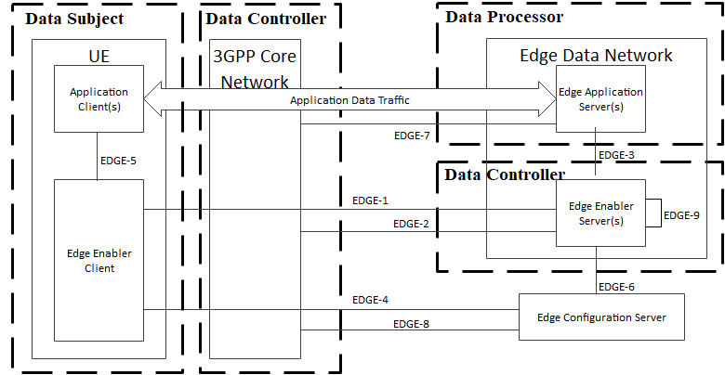
5.X.2-1 Individual architecture for data analytics
The UE information is derived from the UE. Thus, the user of UE is data subject, who is the owner of the UE information collected by EAS to provide specific services for the user.
The PLMN NFs in 3GPP core network collect and store UE information derived from the UE. Thus, the legal entity of those network entities is data controller. In addition, the EES also collects and stores UE information from the 3GPP core network. Thus the legal entity of the EES is also data controller.
The EAS collects UE information from the the EES, and processes the UE information to provide specific services for the user. Thus, the legal entity of the EAS is data processor. The legal entity of the EAS is also data controller.
Editor’s Note: Whether “user” should be replaced by “subscriber” is FFS.
*************** End of 2nd Change ****************

