3GPP TSG-SA WG3 Meeting #100e S3-201911
E-meeting, 17-28 August 2020

Source: Apple

Title: pCR: New solution to address key issue#5

Document for: Approval
Agenda Item: 5.4 UPIP

1 Decision/action requested
This pCR proposes to add one solution for UP IP.

2 Rationale
This pCR proposes a solution for UP IP to address the key issue#5.

3 Detailed proposal
SA3 is kindly requested to agree to the below pCR to TR33.853.

********************** First Change ****************************

X.Y Solution #Y: Non-cryptography solution for PDCP layer data protection

X.Y.1 Introduction
Key issue#5 is proposing the security requirement as: The 5G system should support solution(s) to mitigate the threat mentioned in clause 5.5.3, when the integrity protection of a PDU session is not activated due to UE capability limitations or serving network policy.
This contribution proposes a solution to protect the PDCP layer data, when there is only ciphering but no integrity protection enabled.
The basic idea is exchanging the sequence of a set of bytes in the PDCP SDU packet before applying the PDCP layer ciphering. The changing of the PDCP SDU bytes sequence is known only by the UE and the network, therefore, in aLTEr attack, the location of the IP header destination address holding the real DNS server IP address can’t be assumed anymore by the attacker as it could be scattered anywhere within the ciphered PDCP SDU (e.g. IP header destination address first byte could be anywhere within the ciphered PDCP SDU).

X.Y.2 Solution details

X.Y.2.1 Procedure
Before the PDCP PDU is encrypted, all the bytes will be scramed following specifc pattern. Information about the PDCP PDU bytes exchange pattern applied by the transmitter would be indicated to the receiver as the the last extra byte. Using this information, the receiver should be able to identify the bytes exchange sequence applied by the transmitter. This information would be part of the PDCP PDU that is ciphered, as shown in Figure X.Y.2.1-1.
Then the PDU packet including this extra byte will be ciphered using the K_{NASenc} and the NEA 1/2/3.
After receiving the ciphered PDU, the receiver performs the decryption and the last extra byte will be clear to the receiver. The receiver uses the information in the last extra byte to recover the scrammed bytes to the original sequence.

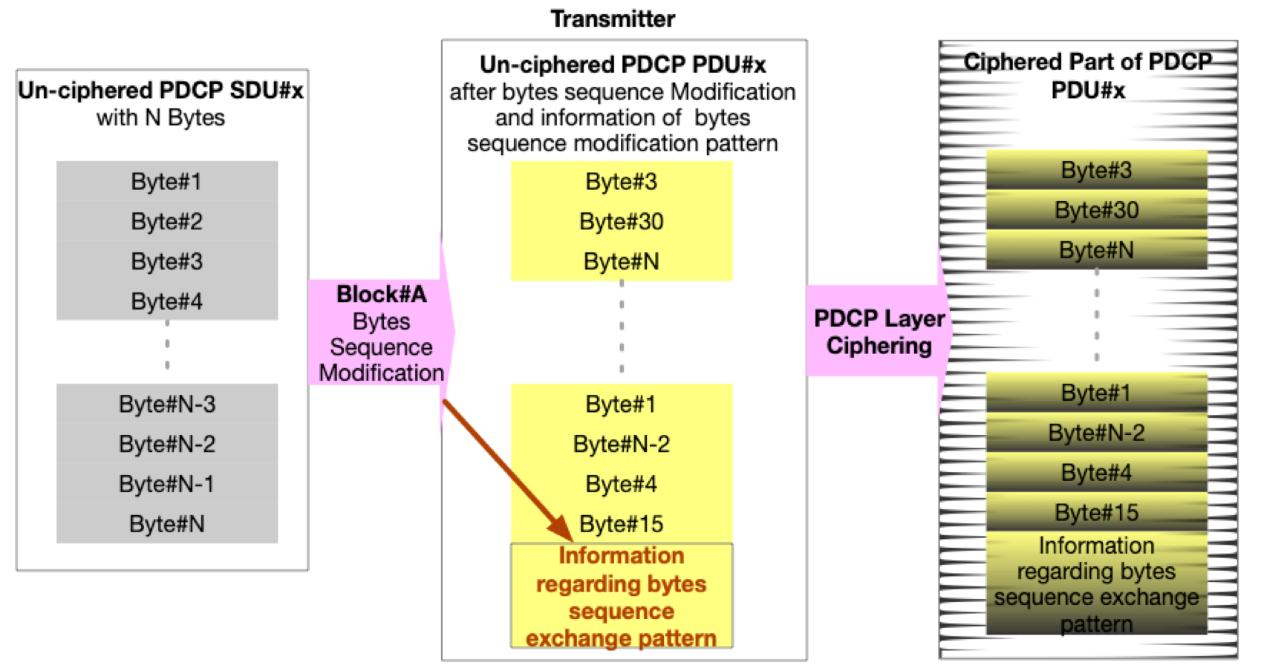
Figure X.Y.2.1-1. PDCP SDU Bytes Exchange Pattern Indicated to the receiver as part of the ciphered PDCP PDU-transmitter side

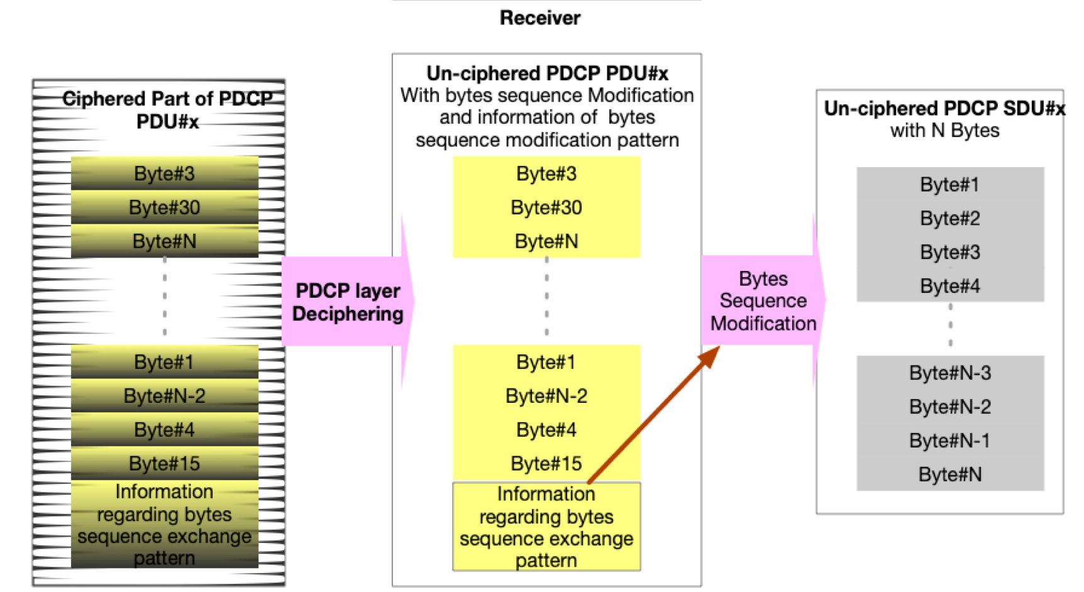

Figure X.Y.2.1-2. PDCP SDU Bytes Exchange Pattern Indicated to the receiver as part of the ciphered PDCP PDU- receiver side

X.Y.3 Solution Evaluation
Since the PDU data are encrypted, the attackers won’t be able to locate the right place of DNS destination address, thus the attackers won’t be able to add an offset to redirect the DNS request.
Editor’s Note: Impact of byte re-ordering at the PDCP layer processing and signaling of original order to the receiver are FFS

********************** End of pCR********************

