3GPP TSG-SA WG3 Meeting #100e S3-201907r2
E-meeting, 17-28 August 2020

Source: Apple

Title: pCR: New solution on authentication based on 3GPP credentials

Document for: Approval
Agenda Item: 5.9 FS_enh_EC_SEC

1 Decision/action requested
This pCR proposes to add one solution for FS_enh_EC_SEC.

2 Rationale
A new key issue is proposed that Edge Computing system needs to support the 3GPP credential based authentication. This contribution proposes the authentication procedure between Edge Enabler Client and Edge Configuration Server based on primary authentication.

3 Detailed proposal
SA3 is kindly requested to agree to the below pCR to TR33.839.

********************** First Change ****************************

X.Y Solution #Y: Authentication between EEC and ECS based on primary authentication

X.Y.1 Introduction
A new key issue is proposed that Edge Computing system needs to support the 3GPP credential based authentication. This solution proposes the authentication between EEC (Edge Enabler Client) and ECS (Edge Configuration Server). To be more specific, it is proposed to use the Kausf derived from the primary authentication as the trust root to perform the authentication between EEC and ECS.
It is assumed in this solution that ECS is located outside of the MNO’s network.

X.Y.2 Solution details

X.Y.2.1 Procedure

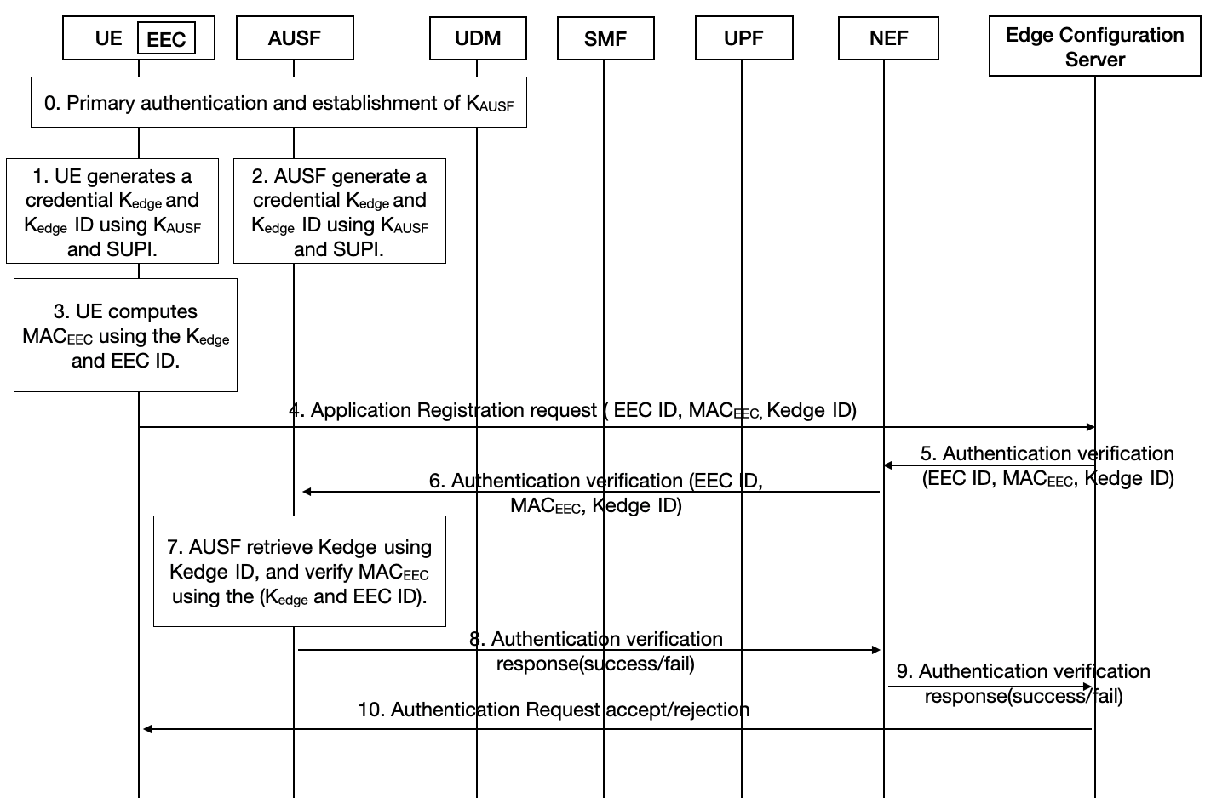
Figure-X.Y.2.1-1. Authentication between the EEC and ECS based on primary authentication

The authentication procedure details are as following:
Step 0: UE performs primary authentication with the network. Then K_{AUSF} is shared between UE and AUSF in Home network. UE performs PDU session establishment procedure as defined in TS 23.502.
Step 1: UE generates a credential K_{edge} and K_{edge} ID using K_{AUSF} and SUPI, and stored securely. The method to derive generate K_{edge} and K_{edge} ID is in X.Y.2.2.
Step 2: AUSF generates a credential K_{edge} and K_{edge} ID using K_{AUSF} and SUPI, and stored securely.
Step 3: UE computes MAC_{EEC} using the K_{edge} and EEC ID (defined in TS 23.558). The method to generate MAC_{EEC} is in X.Y.2.3.
Step 4: UE sends Application Registration request (EEC ID, MAC_{EEC,} K_{edge} ID) to ECS. Whether this message is send using NAS or user plane is based on SA2’s decision.
Step 5: ECS sends Authentication verification (EEC ID, MAC_{EEC}, K_{edge} ID) to NEF for verification.
Step 6: NEF sends Authentication verification (EEC ID, MAC_{EEC}, K_{edge} ID) to AUSF for MAC_{EEC} verification.
Step 7: AUSF retrieves K_{edge} using Kedge ID, and verify MAC_{EEC} using the (K_{edge} and EEC ID).
Step 8: If verification in AUSF succeed, then AUSF sends Authentication verification response(success) back to NEF, otherwise, AUSF sends Authentication verification response(fail) to NEF.
Step 9: NEF sends Authentication verification response(success/fail) from AUSF to ECS.
Step 10: Based on the verification results, ECS decides whether to accept or reject the authentication request, and sends Authentication Request accept/rejection to EEC in the UE.
Editor’s Note: it is FFS what is the impact on the existing key hierarchy.
Editor’s Note: How the AUSF can be aware of each specific Kedge per UE is FFS

X.Y.2.2 Derivation of K_{edge} and K_{edge} ID
K_{edge} is generated using KDF defined in Annex B.2.0 of TS 33.220. When deriving a K_{edge} from KAUSF, the following parameters shall be used to form the input S to the KDF:

- FC = xxxx(to be allocated by 3GPP)

- P0 = <SUPI>,

- L0 = length of <SUPI>.

The input key KEY shall be K_{AUSF}.

K_{edge} ID is generated by AUSF, and uniquely identify only one K_{edge}.

X.Y.2.3 Generation of MAC_{EEC}
When deriving MAC_{EEC} in the UE and AUSF, the following parameters shall be used to form the input S to the SHA-256 hashing algorithm:

- P0 = K_{edge},

- P1 = EEC ID,

The input S shall be equal to the concatenation P0||P1 of the P0 and P1.
The MAC_{EEC} is identified with the 32 least significant bits of the output of the SHA-256 function.
Editor’s Note: This derivation is dependent on SA6’s decision on making EEC ID mandatory or not

X.Y.3 Solution Evaluation
TBD.

********************** End of pCR********************

