SA WG2 Meeting #169 S2-2505621
19 - 23 May, 2025, Fukuoka, Japan

Title: KI#2, New Sol: Authorization of Sensing Service Requests
Source: Toyota Motor Corporation, BUPT
Document for: Approval
Agenda Item: 20.2.1
Abstract: Sensing service request authorization for FS_Sensing_ARC is proposed.

1. Introduction
This pCR proposes a solution for Key issue#2 authorization and revocation to support sensing service:
- When a sensing service request is initiated by an AF, authorization of the AF, NF or UE shall be performed. The authorization information for a sensing area is stored in a sensing authorization profile, which is used to indicate whether the request from an AF is allowed. This solution specifies the content of the sensing authorization profile and a kind of authorization flow rule.
- The sensing authorization profile is managed by the UDM. The UDM may also store the target sensing authorization profile in the UDR.
- In terms of which entity(/entities) performs the sensing service request, a new function Sensing Gateway is introduced to perform authorization which may be co-located with the Sensing Function. After receiving a sensing service request, the Sensing Gateway shall first check whether the sensing authorization profile is overridden. If not, the Sensing Gateway subsequently performs the authorization of the sensing service based on the sensing authorization profile retrieved from the UDM.

2. Text Proposal
It is proposed to capture the following changes in TR 23.700-14.

* * * * First change * * * *

6 Solutions

6.0 Mapping of Solutions to Key Issues
Table 6.0-1: Mapping of Solutions to Key Issues
 | Key Issues
Solutions | 1 | 2 | 3 | 4 | 5 | 6
x |  | x

* * * * Second change (All Text New) * * * *

6.X Solution #X: Authorization of Sensing Service Requests

6.X.0 High-level solution Principles
The solution follows the following principles:
- A new network function called Sensing Gateway is introduced to perform the authorization of sensing services requests from the AF, based on the override information and sensing authorization profile for the sensing area managed by the other function.
- The sensing authorization profile includes parameters such as the Sensing Authorization Indication and the Sensing Notification Indication.

6.X.1 Description
This solution introduces a mechanism that enables sensing service authorization through a new function Sensing Gateway which may be co-located with the Sensing Function. A AF may or may not be authorized to request a particular sensing service. Authorization of the sensing service request can be supported via subscription and via Sensing authorization profile handling. The Sensing Gateway shall perform authorization of the sensing service request based on the authorization information received from the UDM.
The Sensing Gateway is introduced to perform authorization, including:
- authorize the sensing service requests from AF
- request authorization information of the sensing target from the UDM

The UDM is enhanced to support the sensing authorization profile management for sensing areas. Additionally, the UDM may store the authorization profile for sensing areas in the UDR. The AF can provide and update part of the sensing authorization profile and provide it to the network as an update to the UDR.
Editor’s Note: Whether the authorization information will be managed in UDM/UDR is FFS.
In addition, the UDM shall send a notification to the subscribed consumer i.e. Sensing Gateway about the change of sensing authorization profile:
- Sensing area identification information (e.g., sensing area ID);
- Updated sensing authorization profile
For the target within a sensing area where authorization is permitted based on the sensing authorization profile, the target shall be considered authorized for sensing.

6.X.2 Authorization Override Indicator (AOI)
Upon receiving a sensing request, the Sensing Gateway performs authorization. The Sensing Gateway shall first evaluate the Authorization Override Indicator (AOI) to determine whether the sensing authorization profile of the sensing area shall be overridden by the sensing service request. The AOI value in the Sensing Gateway profile indicates either "Override" or "Not Override", and is assigned during the provisioning. The AOI can be applicable to regulatory services.
Editor’s Note: Further details of the AOI is FFS.

6.X.3 Content of Sensing Authorization Profile

The Sensing Authorization Indication (SAI) defines whether sensing service requests from any AF are allowed or not. The generation or modification of the SAI may be performed by the UE, the operator, or a trusted AF, depending on the deployment and policy configuration.
The SAI shall include at least one of the following global settings:
- Sensing is disallowed (Sensing service not allowed to anyAFexcept AOI applies).
- Sensing is allowed (default setting).
The SAI also allows the following optional settings:
- Valid time period for SAI, including start time and end time.
- Valid area for sensing
- Sensing accuracy, in some cases, only a limited accuracy of sensing is allowed, e.g., some sensitive areas.

Editor’s Note: More detailed parameters may need collaboration with SA3.

6.X.4 Sensing Service Authorization Flow Rule
The authorization selection flow is shown in 6.X.4-1. The AOI shall be evaluated first. If the AOI indicates "Override" (e.g. in the case of an emergency service), the authorization profile is considered overridden and the sensing request shall be allowed without further checks. If the AOI indicates "Not Override", the SAI shall be evaluated. If the SAI is valid, the sensing request is further assessed based on the parameters defined within the SAI, including the permitted sensing start time, geographic area, and sensing accuracy. If the request does not comply with these SAI constraints, the sensing request is not allowed..
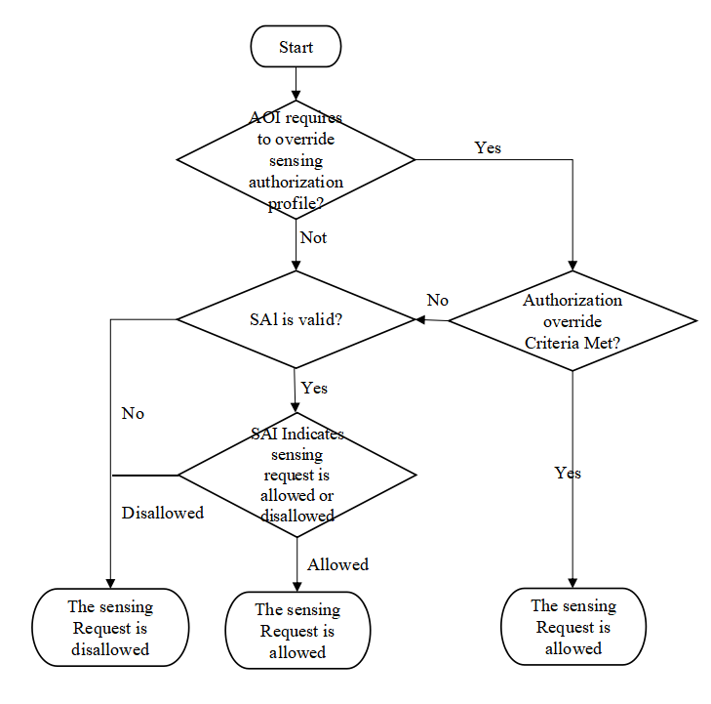

Figure 6.X.4-1: Authorization flow diagram

6.X.5 Sensing Service Procedure With Authorization
Figure 6.X.5-1 shows a sensing service operation with authorization
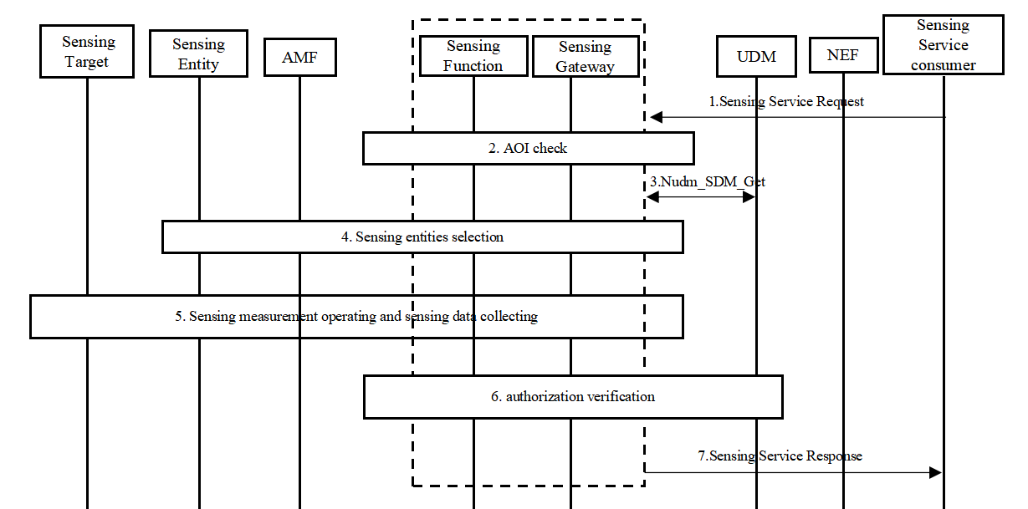
Figure 6.X.5-1: Sensing Service Procedures With Authorization
- The AF sends a sensing service request to the Sensing Gateway. This request may be delivered via the NEF. The Sensing Gateway/NEF first check whether the AF has subscribed the sensing service, if not, skip to step 7 with authorization reject response. The sensing service request may include: sensing area information, sensing service ID and QoS requirements.
- The Sensing Gateway shall first evaluate the AOI to determine whether the sensing authorization profile of the sensing target shall be overridden by the sensing service request. If the AOI indicates "Not Override", skip Step 3.
- If the AOI indicates "Not Override", the Sensing Gateway retrieve the sensing service authorization profile of the sensing area from the UDM via Nudm_SDM_Get service operation, and shall perform authorization. If the sensing request is not allowed, the Sensing Gateway shall reject the service request and return an error response to the AF in step 7.
- The Sensing Function or the Sensing Gateway performs the selection of the sensing entities. The selection of the AMF may optionally be performed.
- The sensing entity performs the sensing operation and obtains the sensing measurement data. The Sensing Function subsequently collects the sensing data from one or more sensing entities and performs the calculation to generate the final sensing result.
- If the authorization indication in Step 2 requires further authorization verification (e.g. the sensing process require continuous sensing and different authorization settings are defined for different areas), the Sensing Gateway shall perform an additional authorization check to determine whether the sensing result can be delivered to the AF. If no further check is required, this step shall be skipped.
- The Sensing Function reports the sensing result to AF. If the AF is authorized to perform sensing, the Sensing Gateway shall deliver the sensing result to the AF. Otherwise, the Sensing Gateway shall return an error response indicating the appropriate cause.

6.X.6 Impacts on services, entities and interfaces
Sensing Gateway:
- Supports the sensing service requests authorization
- Support requesting the sensing authorization profile of the sensing target from the UDM.
UDM:
- Support the sensing authorization profile management for sensing areas.
- Supports subscription, creation, update, and deletion of the sensing target's sensing authorization profile by other NF(e.g. Sensing Gateway, NEF).

* * * * End of changes * * * *

