**SA WG2 Meeting #161 S2-2401939r01**

**Athens , GR, Feb 26 – Mar 1, 2024**

**Source: IPLOOK**

**Title: KI #2, New Sol: Support of S&F during N2 handover and registration procedure**

**Document for: Approval**

**Agenda Item: 19.1**

**Work Item / Release: FS_5GSAT_ARCH_Ph3 / Rel-19**

*Abstract of the contribution: This contribution proposes a new solution for KI#2*

# Introduction

*A new solution is proposed in this contribution for inclusion in TR 23.700-29. This solution outlines the specifics of the minimum necessary set of core network elements/network functions that should be placed on board and the procedure of S&F Satellite operation during N2 handover procedure.*

# 2 Proposal

It is proposed to capture the following solution in TR 23.700-29.

Start of Changes

# 6 Solutions

## 6.0 Mapping of Solutions to Key Issues

Table 6.0-1: Mapping of Solutions to Key Issues

|  |  |  |  |  |
| --- | --- | --- | --- | --- |
|  | Key Issues | | | |
| Solutions | 1 | 2 | 3 |  |
| x |  | x |  |  |
|  |  |  |  |  |
|  |  |  |  |  |
|  |  |  |  |  |
|  |  |  |  |  |

## 6.1 Solution #x: Support of Store and Forward Satellite operation

### 6.x.1 Description

This solution attempts to resolve Key Issue #2 about to support of store and forward satellite operation.

Considering the high-speedy of satellites , frequent switching between UE and onboard gNB leads to a significant amount of signaling exchange.To achieve a kind of trade-off between low latency and low load of onboard. This solution defines a lightweight core network on board that integrates AMF and UPF. AMF onboard is beneficial for users to access gNB onboard and mobility management, UPF responsible for user data traffic forwarding.

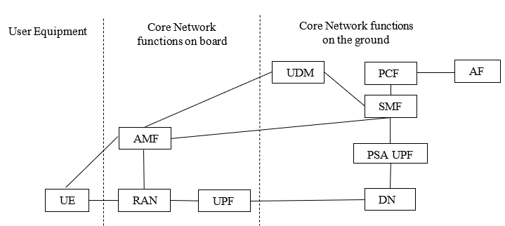

**Figure 6.X.1-1: The architecture of the minimum necessary set of core network elements/network functions on board**

### X.2 Procedures

6.X.2.1 N2 handover preparation phase

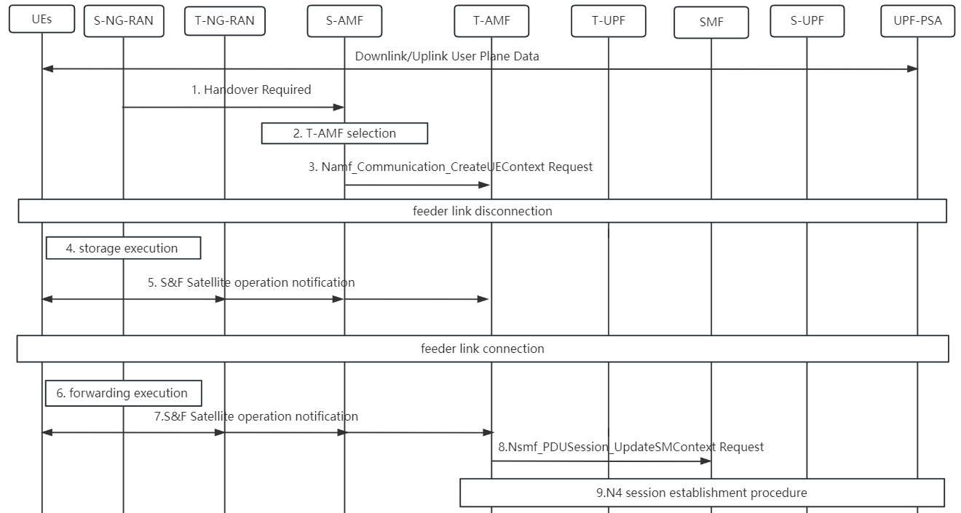

**Figure 6.X.2.1-1 Supporting S&F Satellite operation during N2 handover preparation phase**

1. The source NG-RAN sends handover required to source AMF to inform that UE needs handover. Handover Required is NGAP message, the detailed can be find in TS 38.413 clause 9.2.3.1.
2. If the source AMF can not continue to service UE, then the source AMF selects a target AMF that can provide services, the detailed can be find in TS 23.501 clause 6.3.5.
3. The Source AMF sends Namf_Communication_CreateUEContext Request to initiate the procedure of switching resource allocation.
4. When the feeder link is disconnected, the storage is automatically executed. Source NG_RAN stores UL data and measurement report from UE, measurement report includes RSRP, RSRQ, SINR of service cell and neighbor cell.
5. Source NG-RAN sends S&F storage operation notification to UE and target NG-RAN to indicate storage operations, then target NG-RAN sends the notification to target AMF.
6. When the feeder link is connected, source NG-RAN forwarding the UL information from UE.
7. Source NG-RAN sends S&F storage operation notification to UE and target NG-RAN to indicate forwarding operations, then target NG-RAN sends the notification to target AMF.
8. Target-AMF sends Nsmf_PDUSession_UpdateSMContext to SMF.
9. SMF initiates session establishment procedure, the remaining detailed can be find in TS 23.502 clause 4.9.1.3.2.

6.X.2.2 N2 handover execution phase

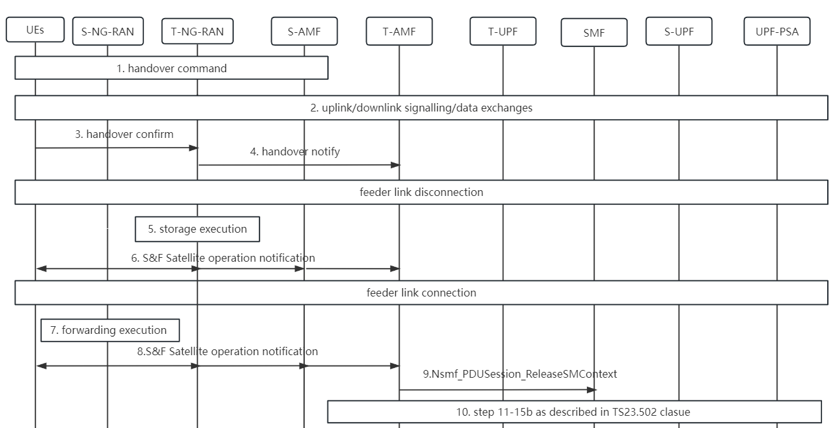

**Figure 6.X.2.2-1 Supporting S&F Satellite operation during N2 handover execution phase**

1. Handover command indicates that handover preparation completed and UE should release resource.
2. There are some uplink/downlink signalling/data exchanges, the details of these interaction between UE and NFscan be find in TS 23.502 clause 4.9.1.3.3.
3. UE sends handover confirm to target NG-RAN to indicate handover is successful.
4. Target NG-RAN sends handover notify to target AMF to indicate handover is successful.
5. When the feeder link is disconnected, the storage is automatically executed. Source NG_RAN stores UL information from UE, includes handover confirm.
6. Source NG-RAN sends S&F storage operation notification to UE and target NG-RAN to indicate storage operations, then target NG-RAN sends the notification to target AMF.
7. When the feeder link is connected, source NG-RAN forwarding the UL information from UE.
8. Source NG-RAN sends S&F storage operation notification to UE and target NG-RAN to indicate forwarding operations, then target NG-RAN sends the notification to target AMF.
9. Target-AMF sends Nsmf_PDUSession_ReleaseSMContext to SMF.
10. The remaining detailed can be find in TS 23.502 clause 4.9.1.3.3.

6.X.2.3 Initial registration procedure

when feeder link disconnect, The registration procedure is as follows:

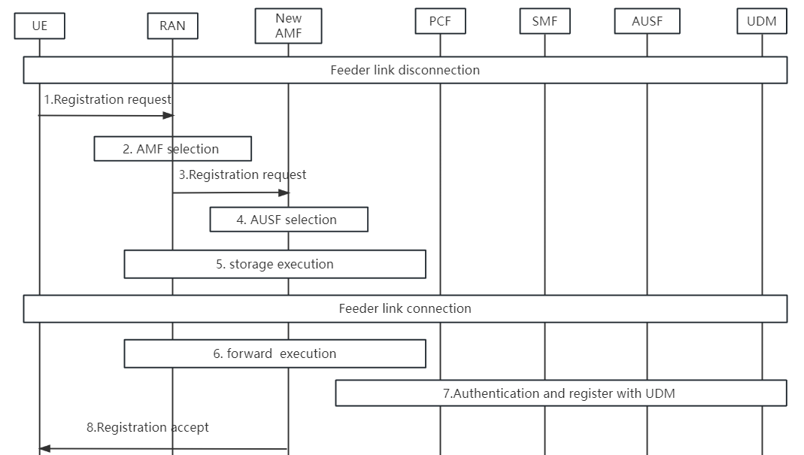

**6.x.2.3-1 Supporting S&F Satellite operation during initial registration**

1.UE sends Registration Request to RAN with parameters e.g. registration type, UE identity, Requested NSSAI (see TS 23.502, clause 4.2.2.2.2).

2.(R)AN selects a new AMF based on the UE's temporary identity or slice, and if (R)AN cannot find a suitable AMF, the Registration Request is sent to the default AMF, which conducts the AMF re-selection process.

3.(R)AN forward Registration Request to the new AMF

4.The new AMF selects an AUSF for authentication, then storage is executed due to the feeder link still disconnect.

5.when feeder link is connected, (R)AN forwards the stored information to the ground network to continue the authentication process and register with the UDM.

6.The new AMF sends Registration Accept to UE to accept the registration request initiated by UE.

6.X.2.4 periodic registration procedure

when feeder link disconnect, The period registration procedure is as follows:

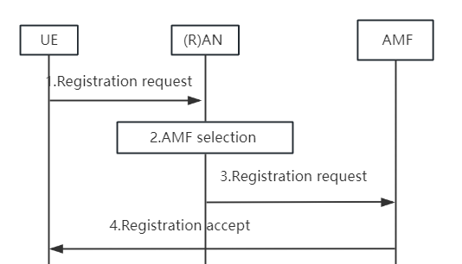

**6x.2.4-1 Supporting S&F Satellite operation during initial registration.**

1.UE sends Registration Request to RAN with parameters e.g. registration type, UE identity, Requested NSSAI (see TS 23.502, clause 4.2.2.2.2).

2.(R)AN selects an AMF based on the UE's temporary identity or slice, and if (R)AN cannot find a suitable AMF, the Registration Request is sent to the default AMF, which conducts the AMF re-selection process.

3.(R)AN forward Registration Request to AMF

4. AMF sends Registration Accept to UE to accept the registration request initiated by UE.

### 6.X.3 Impacts to Services, Entities and Interfaces

SMF:SMF always chooses UPF on the same satellite as itself.

End of Changes