Invitation and General information
on 3GPP SA1#89 and SA3#98 meetings

from Monday 10 to Friday 14 of February 2020 in Guangzhou, China

Beijing, 8 November 2019

Dear Delegate,

The Chinese Friends of 3GPP (CF3) has the pleasure of inviting you to the 3GPP SA1#89 and SA3#98 meetings in Guangzhou, China.

- SA1#89 and SA3 #98 meetings will be held in CONRAD Guangzhou.

We look forward to seeing you all in Guangzhou.

Yours sincerely,
the Chinese Friends of 3GPP

Accommodation
CF3 is not responsible for reservation confirmations, cancelled or changed reservations or no-shows. Please contact the hotel directly to make the reservation (Yuding.Can@ConradHotels.com).

Meeting Venue for 3GPP SA1#89 and SA3#98
CONRAD Guangzhou
No.222 Xingmin Road Zhujiang New Town, Tianhe District, Guangzhou, China
Tel: +86-20-37392222
Group Rates:
- TWIN DELUXE ROOM/KING DELUXE ROOM: CNY 1200 net per room per night with one breakfast or CNY 1300 net per room per night with two breakfasts.

* The above rate includes Service Charge and government taxes. Broadband Internet access is complimentary in guest rooms.
* Cancellation Policy:
- For the detailed Cancellation Policy, Please refer to hotel booking link.
Hotel cut-off date, 18 January 2020
Hotel booking
Meeting Registration
Please register for the meetings online at:
on-line registration for SA1
on-line registration for SA3

Visa letter
If you need an invitation letter for applying a VISA, complete the provided request form and send it to the person below no later than 18 January, 2020 (Beijing time, GMT+8). Late submission will not be accepted. It is recommended for each company to designate one delegate from your company to collect all the information of your delegates who need the invitation letter and to send one request e-mail by the designated person. Please contact the Chinese Embassy at your country for further information.

Contact person for invitation letter:
Mr. Xu Qi (CCSA)
E-mail: ccsavisa@163.com
Tel: +86-10-6230-4200

Time Zone
GMT +8 hours

Voltage
Commercial power in China is 220V. Please be sure you have the correct adapter. Voltage converters will not be provided at the meeting.


City Profile/ Area Attractions
https://www.lifeofguangzhou.com/index.do

Host Contact
For any questions about anything relating to the meeting please contact:
Mr. Xu QI
Tel.: +86-10-6230 4200
E-mail: qixu@ccsa.org.cn

Ms. Hongyan JIA
Tel.: +86-10-6230 2735
E-mail: jiahy@ccsa.org.cn

Mr. Shizhuo ZHAO
Tel.: +86-10-6230 2645
E-mail: zhaosz@ccsa.org.cn

Attachment 1: Invitation letter request form for VISA
Attachment 2: Transport Information about the meeting venue
Attachment 1: Invitation letter request form for VISA

INVITATION LETTER REQUEST FORM

To enter China for the meetings indicated above, you may need a letter of invitation from the Chinese host, which you will need to present to the Chinese Embassy/Consulate in your area in order to obtain your visa. In order to obtain the invitation letter, please:

- fill out the form below
- Send it to (please reference “Invitation letter request for 3GPP SAX meeting” as the subject):

Mr. Xu Qi

China Communications Standards Association (CCSA)

ccsavisa@163.com
(It’s recommended to scan your passport page and email to us so that it’s discernible and can be used.)
Fax number: +86-10-6230 1849-4200 (if your passport page is photocopied and enlarged)
Company
Applicant Information | [ Click and Type in your full name ] |  |  | Mr Ms Mrs
Applicant Information | [ Nationality ] |  |  | [ Passport No.]
Applicant Information | Date of birth : |  |  | [ Job Title ]
Applicant Information | Is this your first visit to China? |  |  | __ Yes ___ No
Applicant Information | If the country in which you'll obtain your visa is different from your nationality, please indicate it here:  [ Country to obtain your visa]
Applicant Information | The name and the address of the Chinese Embassy/Consulate, which you are going to apply your visa.  Name:  Address:
Your Address
Place to visit after entry | In this case, it is Guangzhou by default.
Date of arrival at China |  |  | Date of departure from China
End of form
(Please do not forget to attach a copy of your passport photograph page before sending.)
Your information should be sent out before 18 January, 2020.

Attachment 2: Transport Information about Meeting Venue

Transportation from Guangzhou Baiyun International Airport (ICAO: ZGGG; IATA: CAN)
CONRAD Guangzhou is about 45 km and 60 mins by car from Guangzhou Baiyun International Airport.
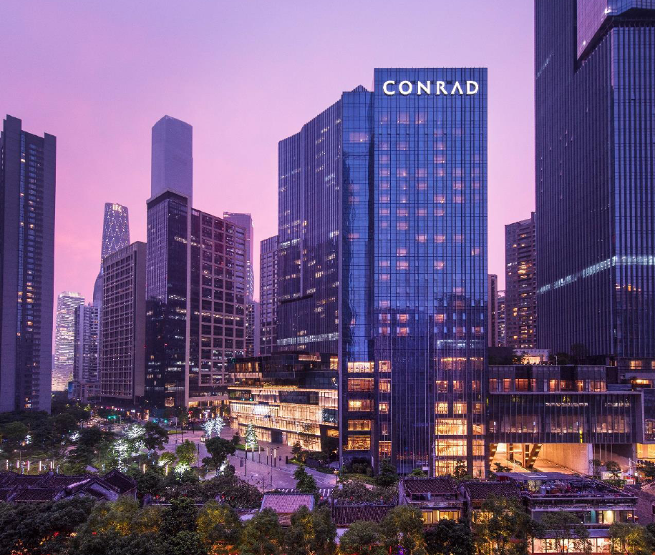

Taxi (60 mins)
The fare for taxi from the Airport to the hotel is around CNY 130 per way. (Please take the taxi which can provide the invoice for your trip)

In case of taking a taxi, please print the following note which shows taxi driver the address of CONRAD Guangzhou in both English and Chinese.

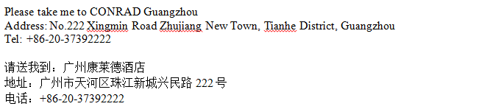

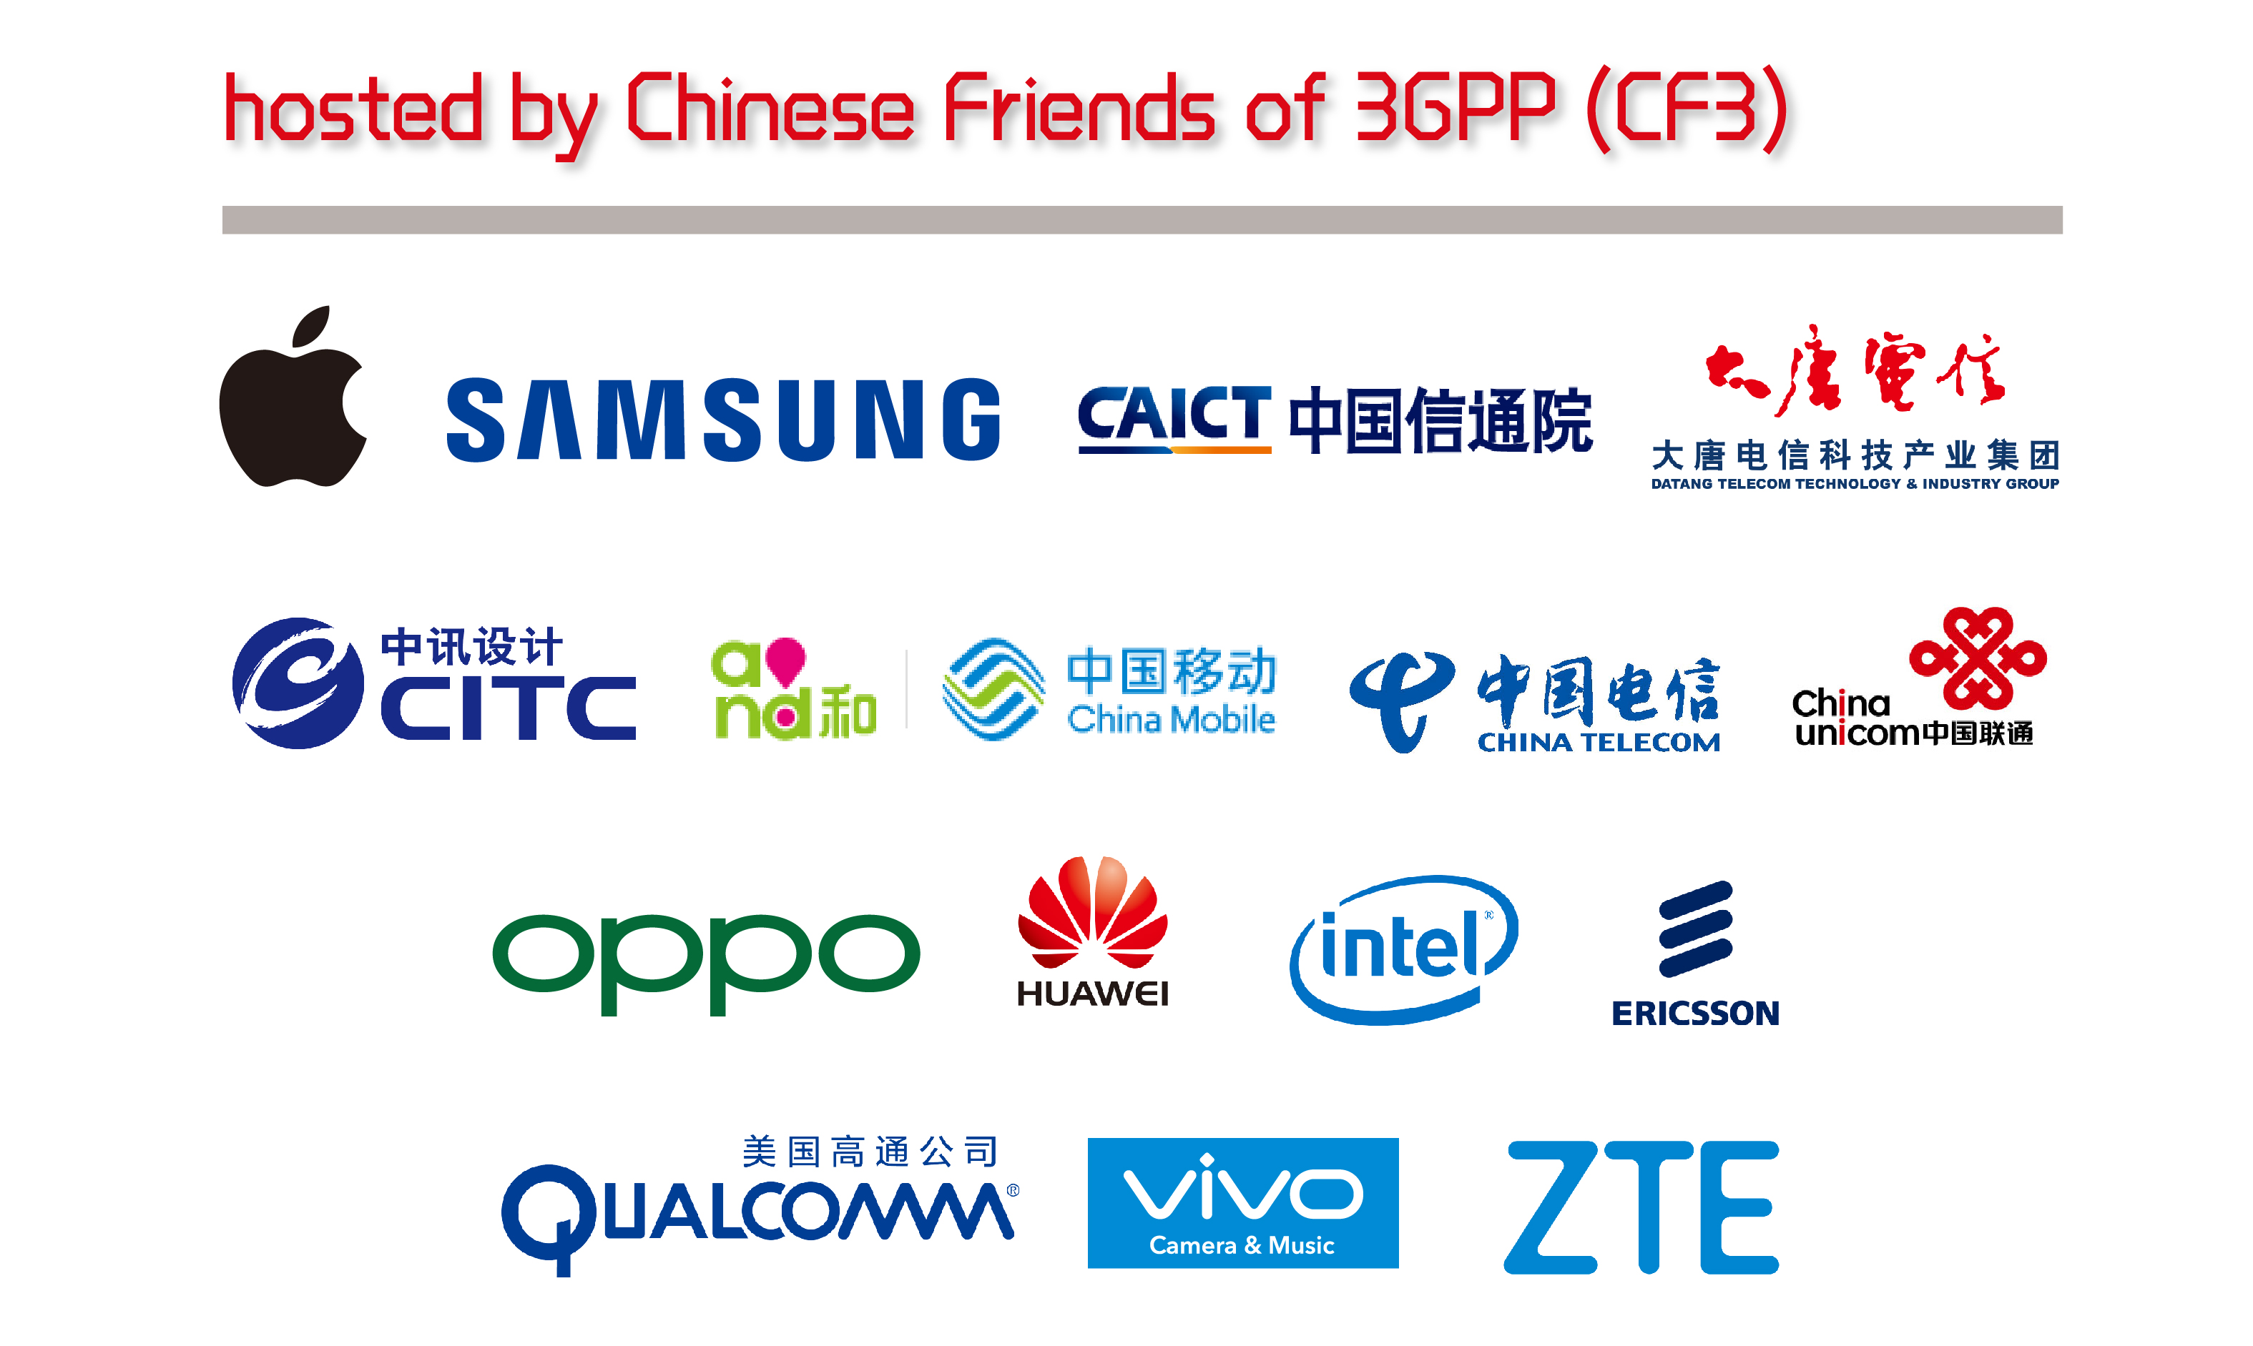

- Apple Computer Trading Co., Ltd.
- BEIJING SAMSUNG TELECOM R&D CENTER
- China Academy of Information and Communications Technology
- China Academy of Telecommunication Technology
- China Information Technology Design & Consulting Institute Co., Ltd.
- China Mobile Communications Corporation
- China Telecommunications Corporation
- China Unicom
- Guangdong OPPO Mobile Telecommunications Corp., Ltd.
- Huawei Technologies Co.,Ltd.
- Intel China Ltd.
- Nanjing Ericsson Panda Com Ltd.
- Qualcomm Wireless Communication Technologies (China) Limited.
- vivo Mobile Communication Co., Ltd.
- ZTE Corporation

Have a successful meeting and enjoy your stay in Guangzhou!

