3GPP TSG-SA5 Meeting #163 S5-254881
Wuhan, China, 14 - 17 October 2025

Source: Huawei, CMCC, ZTE, Rakuten

Title: Discussion on the management support for NG-RAN/5GC feature

Document for: Endorsement
Agenda Item: 6.19.13

1 Decision/action requested
In this box give a very clear / short /concise statement of what is wanted.

2 References
- SP-251191, SA5 Status Report to SA#109
- TS 28.541, Management and orchestration; 5G Network Resource Model (NRM);
- TS 28.540, Management and orchestration; 5G Network Resource Model (NRM); Stage 2 and stage 3;
- TS 28.313, Management and orchestration; Self-Organizing Networks (SON) for 5G networks;

3 Rationale

3.1 Problem statement
According to the SP-251191, the Summary of SA5 Rel-19 management support to SA2 features are described as following:
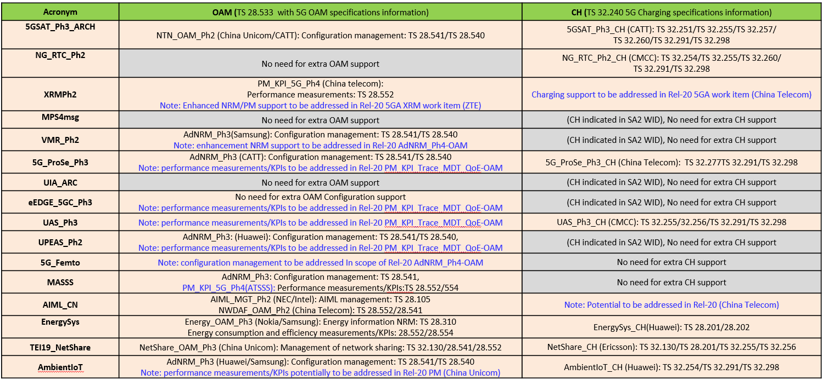
The Summary of SA5 Rel-19 management support to SA2 features and RAN1/2/3 features are described as following:
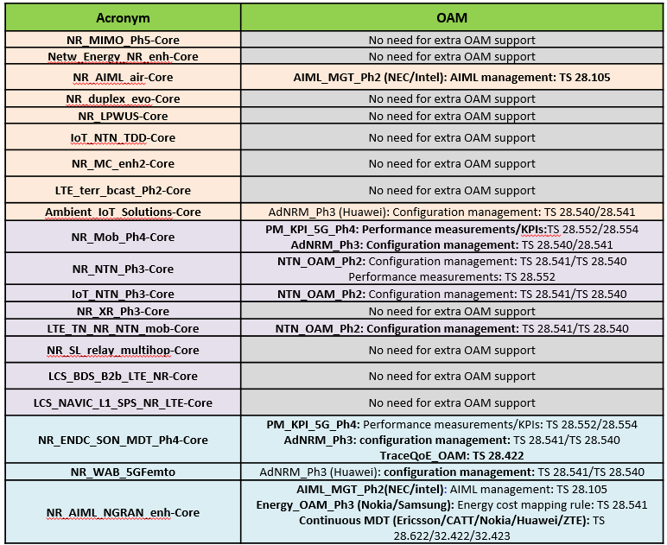
In current TS 28.541 [2], to support the SA2 and RAN1/2/3 features, several IOCs and attributes have been introduced. However, the lack of direct explanations for numerous IOCs and attributes for each feature makes it difficult for operators and readers to directly identify which IOCs and attributes are used for certain features, which could lead to confusion and potentially result in incorrect configurations. Such as, for RAN2 NR mobility feature (Acronym: NR_Mob_Ph4-Core), according to clause 7.1.8 in TS 28.313 [4], the LTM function control defined in GNBCUCPFunction IOC (the attribute dLTMControl) and parameters defined in DMROFunction IOC should be used, these parameters are distributed across different IOCs, making it difficult for readers to correlate them.
For current TS 28.540 [3], the concepts and requirements for Stage 1 of some features have already been presented as following, and each feature has a corresponding chapter to describe its concept.
===========================Start TS 28.540==============================================
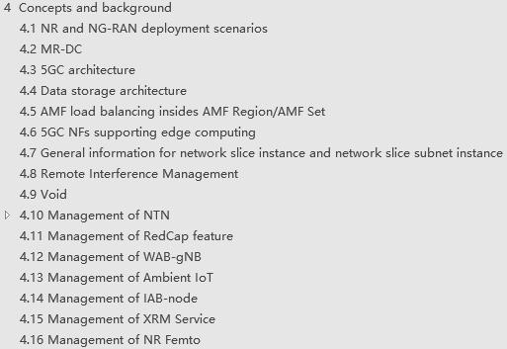
===========================End TS 28.540==============================================
However, there are still some features whose stage 2/3 solution have already been supported but its concepts and requirements remain missing. Such as SA2 feature ATSSS (Acronym: MASSS), 5G Prose (Acronym: 5G_ProSe_Ph3), and RAN2 feautre NR mobility (Acronym: NR_Mob_Ph4-Core), the Stage 2 and Stage 3 solutions of these feature already been supported in TS 28.541, however, the current chapters in TS 28.540 lack descriptions of these features in the concepts and background.
Therefore, we propose to enhance the current TS 28.541 and TS 28.540 to clearly show the management support to SA2 features and RAN1/2/3 features.

3.2 Proposed solution
We propose to have the following enhancements for TS 28.541 and TS 28.540
- Enhance the TS 28.541 with adding annex to describe the NR and 5GC related NRM usage introduction to show the management support to SA2 features and RAN1/2/3 features.
- Enhance the TS 28.540 with adding the concept and requirements for the features that already have solutions to show the management support to SA2 features and RAN1/2/3 features.

4 Detailed proposal
It is proposed to endorse the following proposal.
- Enhance the TS 28.541 with adding annex to describe the NR and 5GC related NRM usage introduction to show the management support to SA2 features and RAN1/2/3 features.
- Enhance the TS 28.540 with adding the concept and requirements for the features that already have solutions to show the management support to SA2 features and RAN1/2/3 features.
The corresponding R19 CR’s (S5-254257 and S5-254256) are also submitted to this meeting to implement the proposals.
The corresponding R20 CR’s (S5-254266) are also submitted to this meeting to implement the proposals

