3GPP TSG-SA5 Meeting #163 S5-254749
Wuhan, China, 14 - 17 October 2025

Source: Huawei
Title: Pseudo-CR on TR 28.882 add ML model registration management use case
Document for: Approval
Agenda item: 6.20.2
Spec: 3GPP TR 28.882
Version: 0.0.0
Work Item: FS_AIML_MGT_Ph3

Comments
The new SID SP-2501197 on study on MDA was approved at the SA #108 meeting. The objectives including:
WT-4: Registration and Discovery management for AI/ML
WT-4.1: Study enhancements to support registration and discovery management for AI/ML
For management ML model in management system, there are certain scenarios, such as coverage optimization analysis, where different ML models may be applicable to different regions/scenarios. Operator should have capability to be aware of the management ML model information.
This contribution proposes to add use case to support management ML model registration management.
Proposed Changes
* * * First Change * * * *

3 Definitions of terms, symbols and abbreviations

3.1 Terms
For the purposes of the present document, the terms given in TR 21.905 [1] and the following apply. A term defined in the present document takes precedence over the definition of the same term, if any, in TR 21.905 [1].
example: text used to clarify abstract rules by applying them literally.
ML model registration/deregistration: a process of register and deregister of ML model(s) that ML training function trains.

3.2 Symbols
For the purposes of the present document, the following symbols apply:
<symbol> <Explanation>

3.3 Abbreviations
For the purposes of the present document, the abbreviations given in TR 21.905 [1] and the following apply. An abbreviation defined in the present document takes precedence over the definition of the same abbreviation, if any, in TR 21.905 [1].
<ABBREVIATION> <Expansion>

* * * Next Change * * * *

X Use cases

X.Y Registration and Discovery management for AI/ML

X.Y.Z Management Registration for AI/ML

X.Y.Z.1 Description
The network environment may involve numerous management ML models developed by different producers for various tasks (e.g., coverage optimization, traffic prediction, failure detection, resource optimization). Registration provides a centralized directory where management ML model(s) are uniquely identified by assigned registration identifiers and store their attributes (model version, applicable inference scenarios, model capabilities, etc.). This is crucial for network operators to understand existing models and their intended purposes to enable network performance improvement.
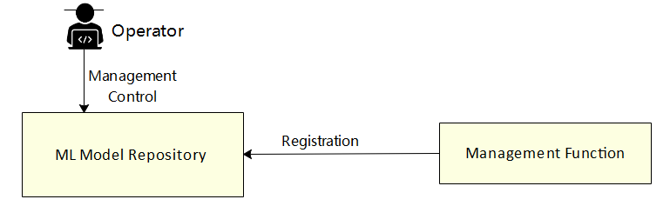
The 3GPP management system needs to support management ML model registration or deregistration.

X.Y.Z.2 Potential requirements
REQ-ML_REGIS-x1: The 3GPP management system shall have a capability allowing the ML model training producer to provide the management ML model information for management function.
REQ-ML_REGIS-x2: The 3GPP management system shall have a capability allowing the authorized consumer to assigned a uniquely registration identifiers for the ML model(s).

X.Y.Z.3 Potential solutions
TBD

X.Y.Z.4 Evaluation of solutions
TBD

* * * End of Changes * * * *

