3GPP TSG-SA5 Meeting #163 S5-254696d1
Wuhan, CHINA 13 - 17 October 2025

Source: Huawei
Title: pCR TR 28.888 Add use case on transformation of MnS information for external MnS consumers
Document for: Approval
Agenda item: 6.20.9
Spec: 3GPP TR 28.888
Version: 0.0.0
Work Item: FS_EnExpo

Comments
Based on the following justification for WT-4: Investigate new management services to support exposure to external MnS consumers of the FS_EnExpo:
According to Reply-LS on Internal 5G Core information expose to trusted AF (tdoc number S5-250295) from SA3 to SA6 with SA2, CT3 and SA5 in cc, the following is stated:
"As far as information exposure to an AF is of concerns, it is allowed to expose "Internal 5G Core information" to an AF within the operator’s domain. Besides, it is also possible to expose internal 5G Core information to an AF outside the operator’s domain after proper security protection or privacy protection. For example, an "S-NSSAI" can be mapped to an AF-Service-Identifier before exposing to an AF outside the 3GPP operator domain (i.e., the "S-NSSAI" shall not be exposed directly in this case to be in line with the security requirements specified in the TS 33.501)."
Further when exposing management services to external MnS consumers, it might be necessary to hide the NRM name-containment hierarchy which is captured by default as part of the "distinguished name (DN)" of the managed object resources or attributes. Accordingly, when publishing management services to external MnS consumers, the management services must be abstracted to avoid exposing directly internal network information to external MnS consumers, e.g., the "DNs" of the MOIs or attributes could be replaced with other identifiers.
Hence, there is a need to identify what kind of management services require abstraction before exposing it to external MnS consumers directly from the management system or through CAPIF (TS 28.579).
Secondly, when exposing management services directly from the management system, there is a need to define an interface to request and report the abstracted management services to external MnS consumers.
This pCR proposes to add use case and potential requirements on transformation of MnS information for external MnS consumers.

Proposed Changes
* * * First Change * * * *

2 References
The following documents contain provisions which, through reference in this text, constitute provisions of the present document.
- References are either specific (identified by date of publication, edition number, version number, etc.) or non-specific.
- For a specific reference, subsequent revisions do not apply.
- For a non-specific reference, the latest version applies. In the case of a reference to a 3GPP document (including a GSM document), a non-specific reference implicitly refers to the latest version of that document in the same Release as the present document.
[1] 3GPP TR 21.905: "Vocabulary for 3GPP Specifications".
[AA] 3GPP TS 28.533: "Management and orchestration; Architecture framework".
[BB] 3GPP TS 33.501 " Security architecture and procedures for 5G system"
[CC] 3GPP TS 23.501: "System Architecture for the 5G system".

3 Definitions of terms, symbols and abbreviations

3.1 Terms
For the purposes of the present document, the terms given in TR 21.905 [1] and the following apply. A term defined in the present document takes precedence over the definition of the same term, if any, in TR 21.905 [1].
Management Service (MnS): defined in TS 28.533 [AA].
External MnS consumer: defined in TS 28.533 [AA].
Internal MnS consumer: defined in TS 28.533 [AA].

* * * Next Change * * * *

5 Use cases and potential solutions

5.X Use case #<X>: Transformation of MnS information for external MnS consumers

5.X.1 Description
As an example shown in Figure 5.X.1-1: two different external MnS consumers, denoted as Y1-a and Y1-b, are located outside the PLMN trust domain and request access to internal 5G Core information, e.g., network slice identifiers. When exposing management services to such external MnS consumers Y1(e.g. Y1-a and Y1-b), the management system needs to ensure that internal 5G Core information is not revealed. For instance, the relevant "S-NSSAI" need to be transformed/mapped to an AF-Service-Identifier before exposure, rather than being exposed directly, see clause 6.2.5 of TS 23.501 [CC]. In this example, 5GC information internal "S-NSSAI 1" is transformed to "AF-Service-Identifier 1" exposed to Y1-a, 5GC information internal "S-NSSAI 2" is transformed to "AF-Service-Identifier 2" exposed to Y1-b, aligned with the existing NEF solution in TS 23.501 [CC] to expose the same mapped information to the external MnS consumer. This kind of transformation and abstraction is required in order to comply with the security requirements specified in TS 33.501 [BB].
Therefore, the study should investigate whether and how an logical entity Management Services Exposure Domain Function (MSEDF), which is located inside the 3GPP management system, can support the transformation and abstraction of MnS information before exposure to external MnS consumers.
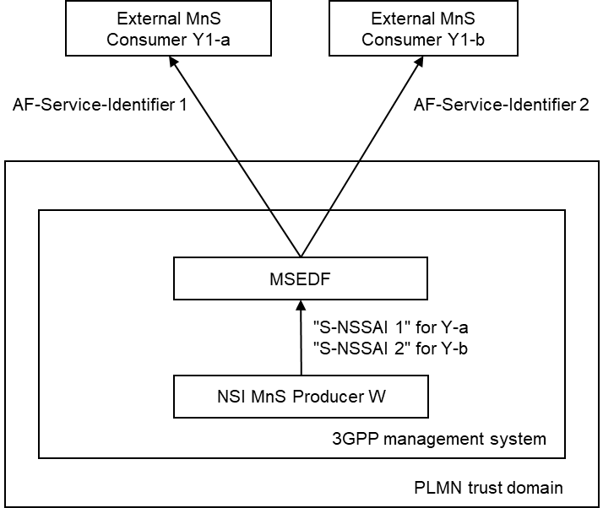
Figure 5.X.1-1: Transformation of MnS information for external MnS consumers

5.X.2 Potential requirements
REQ-EnExpo-Trans-01: The 3GPP management system should provide an abstraction mechanism to prevent direct exposure of internal 5G Core information (e.g., S‑NSSAI, DN of MOIs) to external MnS consumers.
REQ-EnExpo-Trans-02: The 3GPP management system should support a transformation mechanism (e.g., mapping S‑NSSAI to an AF‑Service‑Identifier) to replace internal identifiers with abstracted identifiers before exposure.
REQ-EnExpo-Trans-03: The 3GPP management system should allow operators to configure transformation and abstraction policies, defining which internal attributes require abstraction prior to exposure.

5.X.3 Potential solutions

5.X.4 Evaluation of potential solutions

* * * End of Changes * * * *

