3GPP TSG-SA5 Meeting #163 S5-254672d6
Wuhan, China, 13. - 17. October 2025

Source: China Mobile
Title: Rel-20 pCR TS 28.883 Add a use case of NDT data generation
Document for: Approval
Agenda item: 6.20.3
Spec: 3GPP TR 28.883
Version: V0.0.0
Work Item: FS_NDT_Ph2

Comments
This contribution is proposed to add a use case of NDT data generation.

Proposed Changes
* * * First Change * * * *

5 Use cases

5.X Use case #X: Collaborate with ML training Producer to generate data

5.X.1 Description
In 3GPP TS 28.561 [a], the existing use case and requirements for using NDT to generate ML training data is described in clause 5.4.2.2. However, using NDT alone to generate data may be insufficient to support the following scenarios:
- Due to the coverage limitations of the physical network simulated by NDT, some extreme scenario data (such as sudden traffic peaks or unforeseen equipment failures) may not be generated.
- NDT-based data generation depends on complex procedures such as simulating network topology and device interactions, making it time-consuming when generating large volumes of data.
Therefore, for scenarios requiring extreme data generation or large-scale data generation, it is considered to introduce AI-based data generation models, generated by the ML training Producer, into NDT to enable rapid, batch, and comprehensive data generation.
As shown in the Figure 5.X.1-1, the MnS Consumer can request the MnS producer to create an NDT instance for generating data with an indication of simulation object, data type, and data requirements, etc. Data requirements may specify large-scale data, extreme data requirements. The MnS producer creates an NDT instance based on the request and sends a response to the MnS consumer. The MnS producer can act as an ML training consumer to send a request to the ML training producer for generating a data generation model. Subsequently, the MnS producer executes simulation based on the NDT instance to obtain simulation data (e.g.,the generated UE throughput data), which is then sent to the ML training producer. This simulation data is used as training data to update and train the data generation model. The MnS producer can act as an ML inference function to receive the updated model from the ML training producer, execute it to obtain the final generated data, and send this data to the MnS consumer.
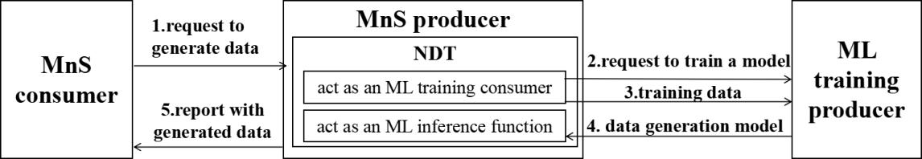
Figure 5.X.1-1 Collaborate with ML training Producer to generate data

Through this method, after the ML training producer completes ML model training and updates based on the initial NDT simulation data, it only needs to perform AI inference for subsequent data generation, which can reduce certain resource consumption.

* * * End of Changes * * * *

