3GPP TSG-SA5 Meeting #163 S5-254670
Wuhan, CHINA 13 - 17 October 2025

Source: Huawei
Title: Rel-20 pCR TR 28.883 Use case on NDT support intent pre-evaluation
Document for: Approval
Agenda item: 6.20.3
Spec: 3GPP TR 28.883
Version: V0.0.0
Work Item: FS_NDT_Ph2

Comments
One of the NDT management capabilities defined in TS 28.561 is the NDT support for network automation (e.g., MDA, SON, etc). Same relation can also be applied to NDT and Intent Handling Function as a network automation management function. Especially for intent pre-evaluation scenario, NDT can support the simulation which can be used for intent pre-evaluation. This contribution proposes to add use case on NDT support intent pre-evaluation for TR 28.883.

Proposed Changes
* * * First Change * * * *

2 References
The following documents contain provisions which, through reference in this text, constitute provisions of the present document.
- References are either specific (identified by date of publication, edition number, version number, etc.) or non-specific.
- For a specific reference, subsequent revisions do not apply.
- For a non-specific reference, the latest version applies. In the case of a reference to a 3GPP document (including a GSM document), a non-specific reference implicitly refers to the latest version of that document in the same Release as the present document.
[1] 3GPP TR 21.905: "Vocabulary for 3GPP Specifications".
[a] 3GPP TS 28.312: " Management and orchestration; Intent driven management services for mobile networks".

* * * Next Change * * * *

5 Use cases

5.X Use Case #X: NDT support intent pre-evaluation

5.X.1 Description
TS 28.312 [a] introduces the intent pre-evaluation which includes Intent Feasibility check and Intent Exploration. Intent feasibility check enables the MnS consumer to check if the proposed intent can be supported by the MnS producer. Intent exploration enables the MnS consumer and the MnS producer to find the intent for fulfilment that is best aligned with MnS producer's capabilities. NDTF can be used to support for intent pre-evaluation.
The relation between NDTF and Intent Handling Function follows the relation between NDTFs and network automation functions defined in TS 28.561 clause 4.3. An adaption figure based on Figure 4.3-1 in TS 28.561 is shown below.
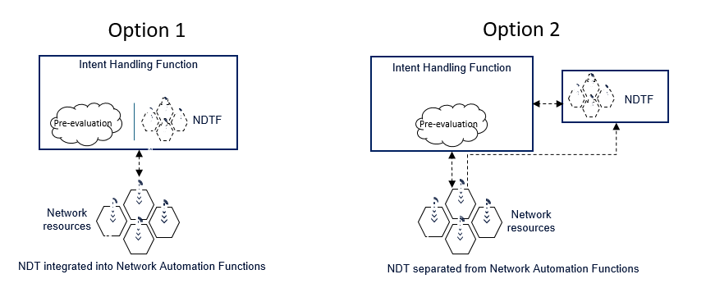
Figure 5.X.1-1: Relation between NDTF and Intent Handling Function
In the scenario of radio network/service intent pre-evaluation, the MnS consumer may request to obtain the best values for a given target or context, e.g., the number of terminal devices. NDTF can support intent handling function to evaluate the number of terminal devices (e.g., UE) given certain simulation conditions, such as intent objects scope (e.g., area scope, cell lists, civic address, etc), intent object type (e.g., radio service, radio network, etc). IHF requests NDTF to simulate the network performance under various conditions, NDTF simulates the network performance and reports to IHF with simulation results.
This use case proposes to enhance the description related to network automation in TS 28.561 to capture the relationship between NDT and IHF and specify that NDT can support network automation capability including intent pre-evaluation.

5.X.2 Potential requirements
No new requirements

5.X.3 Potential solutions

5.X.4 Evaluation of potential solutions

* * * End of Changes * * * *

