3GPP TSG-SA5 Meeting #163 S5-254667
Wuhan, CHINA 13 - 17 October 2025

Source: Huawei, Nokia
Title: Pseudo-CR on TR 28.882 Add Management support to NW-Side model training use case
Document for: Approval
Agenda item: 6.20.2
Spec: 3GPP TR 28.882
Version: 0.0.0
Work Item: FS_AIML_MGT_Ph3

Comments
The new SID study on MDA was approved at the SA #108 meeting. The objectives including:
WT-1: AI/ML Lifecycle Management Enhancements
WT-1.1: Investigate enhancements of AI/ML management capabilities throughout the AI/ML lifecycle in 5GS, including training, testing, emulation, deployment, inference, to support AI/ML-enabled features in the 5GS. This includes:
- ML model transfer/delivery as defined by RAN for Solution 4b: OAM can transfer/delivery AI/ML model(s) to UE.
- NG-RAN use cases including QoE optimization, network energy saving, and mobility use case(as defined in RP-250812).
- 5GC Analytics: Encompasses new 5GC analytics use cases currently under study under WT#2 (see SP-250413) and investigates OAM support for provisioning ML models to relevant 5GC functions to enable AI/ML-based analytics.
- LMF-based AI/ML Positioning including data collection and ML model training by the OAM for UE positioning.
- Study feasibility and potential requirements for data collection for (e.g., UE-side and Network-side) to enable model training.
The bullet 5 is to study feasibility and potential requirements for data collection to enable model training.
The approved reply LS S5-252842 confirm that the current Management based immediate MDT procedure defined in TS 32.422 can be reused to support RAN2 OAM-centric NW-side data collection.
According to the agreed CR RP- 252772 in TS 38.300, for AI/ML-based beam management, both NW-side model and UE-side model are supported.
This contribution proposes to add Management support to beam management use case for management support to NW-Side model training.

Proposed Changes
* * * First Change * * * *

2 References
The following documents contain provisions which, through reference in this text, constitute provisions of the present document.
- References are either specific (identified by date of publication, edition number, version number, etc.) or non-specific.
- For a specific reference, subsequent revisions do not apply.
- For a non-specific reference, the latest version applies. In the case of a reference to a 3GPP document (including a GSM document), a non-specific reference implicitly refers to the latest version of that document in the same Release as the present document.
[1] 3GPP TR 21.905: "Vocabulary for 3GPP Specifications".
…

[x1] 3GPP TS 38.300: "NR and NG-RAN Overall Description; Stage 2"
[x2] 3GPP TR 28.622: "Telecommunication management; Generic Network Resource Model (NRM) Integration Reference Point (IRP); Information Service (IS)".
[x3] 3GPP TS 28.532: "Management and orchestration; Generic management services".

* * * Next Change * * * *

3.3 Abbreviations
For the purposes of the present document, the abbreviations given in TR 21.905 [1] and the following apply. An abbreviation defined in the present document takes precedence over the definition of the same abbreviation, if any, in TR 21.905 [1].
<ABBREVIATION> <Expansion>

* * * Next Change * * * *

5 Management capabilities for AI/ML lifecycle

5.x ML model training

5.x.1 Use cases

5.x.1.1 Management support to OAM-centric training for NG-RAN NW-side model

5.x.1.1.1 Management support to AI/ML-based beam management

5.x.1.1.1.1 Description

To support AI/ML-based beam management defined in TS 38.300 [x1], UE can provide data of beam management to 3GPP management system via gNB (see NOTE 1). 3GPP management system needs to collect data from gNB for OAM-centric training for NG-RAN NW-side model.
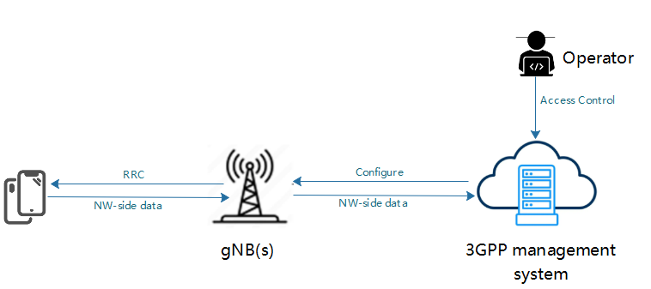
Figure 5.x.1.1.1.1-1: Management of NW-side data collection and reporting for NW-side model training
The 3GPP management system request gNB(s) to collect the NW-side training data of beam management and provides the configuration to gNB(s), then gNB(s) shall send configuration information to the UE(s) for NW-side training data collection. After the NW-side training data are produced, UE(s) shall report the NW-side training data to gNB(s), and 3GPP management system shall collect data from the gNB(s). 3GPP management system collect data should depend on access control information specified by operator(see NOTE 2).
NOTE 1: The OAM centric NW-side training data are subject to further discussion, pending ongoing correspondence and confirmation by RAN2.
NOTE 2: Access control information is for further discussion.

5.x.1.1.1.2 Potential requirements

REQ-ML_NWSIDE-x1: The 3GPP management system should have a capability to configure the NW-side training data collection for OAM-centric NW-side model training.
REQ-ML_NWSIDE-x2: The 3GPP management system should have a capability to obtain the NW-side training data for OAM-centric NW-side model training.

5.x.1.1.1.3 Potential solutions

TBD

5.x.1.1.1.4 Potential solutions

TBD

* * * End of Changes * * * *

