3GPP TSG-SA5 Meeting #163 S5-254260
Wuhan, CHINA 13 - 17 October 2025

Source: Huawei, Nokia, Samsung
Title: Pseudo-CR on TR 28.882 Add Management support to UE-Side model training use case
Document for: Approval
Agenda item: 6.20.2
Spec: 3GPP TR 28.882
Version: 0.0.0
Work Item: FS_AIML_MGT_Ph3

Comments
The new SID on study on AIML was approved at the SA #108 meeting. The objectives including:
WT-1: AI/ML Lifecycle Management Enhancements
WT-1.1: Investigate enhancements of AI/ML management capabilities throughout the AI/ML lifecycle in 5GS, including training, testing, emulation, deployment, inference, to support AI/ML-enabled features in the 5GS. This includes:
- ML model transfer/delivery as defined by RAN for Solution 4b: OAM can transfer/delivery AI/ML model(s) to UE.
- NG-RAN use cases including QoE optimization, network energy saving, and mobility use case(as defined in RP-250812).
- 5GC Analytics: Encompasses new 5GC analytics use cases currently under study under WT#2 (see SP-250413) and investigates OAM support for provisioning ML models to relevant 5GC functions to enable AI/ML-based analytics.
- LMF-based AI/ML Positioning including data collection and ML model training by the OAM for UE positioning.
- Study feasibility and potential requirements for data collection for (e.g., UE-side and Network-side) to enable model training.
The bullet 5 is to study feasibility and potential requirements for data collection to enable model training.
According to the agreed CR RP- 252772 in TS 38.300, for AI/ML-based beam management, both NW-side model and UE-side model are supported. And for AI/ML-based CSI prediction, only temporal-domain CSI prediction with UE-side model is supported.
This contribution proposes to add Management support to beam management and CSI prediction for management support to UE-Side model training use case.

Proposed Changes
* * * First Change * * * *

2 References
The following documents contain provisions which, through reference in this text, constitute provisions of the present document.
- References are either specific (identified by date of publication, edition number, version number, etc.) or non-specific.
- For a specific reference, subsequent revisions do not apply.
- For a non-specific reference, the latest version applies. In the case of a reference to a 3GPP document (including a GSM document), a non-specific reference implicitly refers to the latest version of that document in the same Release as the present document.
[1] 3GPP TR 21.905: "Vocabulary for 3GPP Specifications".
…

[x1] 3GPP TS 38.300: "NR and NG-RAN Overall Description; Stage 2".
[x2] 3GPP TR 28.622: "Telecommunication management; Generic Network Resource Model (NRM) Integration Reference Point (IRP); Information Service (IS)".
[x3] 3GPP TS 28.532: "Management and orchestration; Generic management services".

* * * Next Change * * * *

3.3 Abbreviations
For the purposes of the present document, the abbreviations given in TR 21.905 [1] and the following apply. An abbreviation defined in the present document takes precedence over the definition of the same abbreviation, if any, in TR 21.905 [1].

OTT Over-The-Top

* * * Next Change * * * *

5 Management capabilities for AI/ML lifecycle

5.x ML model training

5.x.1 Use cases

5.x.1.1 Management support to training for UE-side model

5.x.1.1.1 Management support to AI/ML-based beam management

5.x.1.1.1.1 Potential requirements
To support AI/ML-based beam management defined in TS 38.300 [x1], UE can send the data of beam management to UE-side training entity (e.g. a server inside MNO or an OTT server) via gNB and 3GPP management system for UE-side model training (see NOTE 1). 3GPP management system needs to collect data from gNB and report it to UE-side training entity to management support of training for UE-side model.
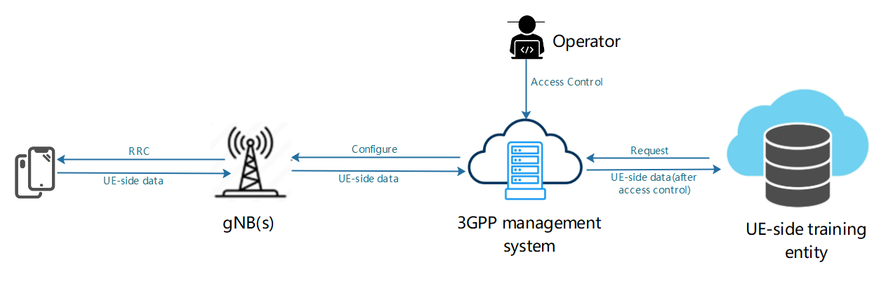
Figure 5.x.1.1.1.1-1: Management of UE-side data collection and reporting for UE-side model training
The UE-side training entity requests 3GPP management system to collect the UE-side data of beam management, then 3GPP management system configure the gNB(s) to collects data from specified UEs, and gNB shall send configuration information to the UE(s). The request from UE-side training entity shall include the type of data (e.g. based on UE/UE Group, location, time) to be produced and the gNB(s) where the data shall be collected.
After the UE-side training data such as beam management data are produced, UE(s) shall report the UE-side data to gNB(s), and 3GPP management system shall collect data from the gNB(s). 3GPP management system report the collected data to UE-side training entity depending on access information specified by operator (see NOTE 2).
NOTE 1: The UE-side data are subject to further discussion, pending ongoing correspondence and confirmation by RAN2 and RAN1.
NOTE 2: Access control information is for further discussion.

5.x.1.1.1.2 Potential requirements

REQ-ML_UESIDE-x1: The 3GPP management system should have a capability allowing the authorized UE-side training entity to request the UE-side training data for the UE-side model training.
REQ-ML_UESIDE-x2: The 3GPP management system should have a capability to request and get the UE-side training data from gNB(s) for the UE-side model training.
REQ-ML_UESIDE-x3: The 3GPP management system should have a capability to report the UE-side data to authorized UE-side training entity for UE-side model training.

5.x.1.1.1.3 Potential solutions

TBD

5.x.1.1.1.4 Potential solutions

TBD

* * * End of Changes * * * *

