3GPP TSG-SA5 Meeting #163 S5-254665d2
Wuhan, CHINA 13 - 17 October 2025

Source: NEC, Huawei, Nokia, Samsung
Title: Pseudo-CR on TR 28.882 add Management support use case and requirement to Two-Side model training
Document for: Approval
Agenda item: 6.20.2
Spec: 3GPP TR 28.882
Version: 0.0.0
Work Item: FS_AIML_MGT_Ph3

Comments
The new SID SP-250867 study on AIML management phase 3 has been approved at the SA #108 meeting. The objectives including:
WT-1: AI/ML Lifecycle Management Enhancements
WT-1.1: Investigate enhancements of AI/ML management capabilities throughout the AI/ML lifecycle in 5GS, including training, testing, emulation, deployment, inference, to support AI/ML-enabled features in the 5GS. This includes:
- ML model transfer/delivery as defined by RAN for Solution 4b: OAM can transfer/delivery AI/ML model(s) to UE.
- NG-RAN use cases including QoE optimization, network energy saving, and mobility use case(as defined in RP-250812).
- 5GC Analytics: Encompasses new 5GC analytics use cases currently under study under WT#2 (see SP-250413) and investigates OAM support for provisioning ML models to relevant 5GC functions to enable AI/ML-based analytics.
- LMF-based AI/ML Positioning including data collection and ML model training by the OAM for UE positioning.
- Study feasibility and potential requirements for data collection for (e.g., UE-side and Network-side) to enable model training.
Item 5 under sub work task WT-1.1 is to study feasibility and potential requirements for data collection to enable model training.
According to the incoming LS in RP-252966, the action for SA5 is to complete the study of dataset/model parameter exchange in Rel-20.
In line with this, this contribution proposes to add a use case on management support to Two-side model training to study management procedures for dataset/model parameter collection and reporting to enable two-side model training supporting the CSI compression features defined in TR 38.843.

Proposed Changes
* * * 1st change * * * *

2 References
The following documents contain provisions which, through reference in this text, constitute provisions of the present document.
- References are either specific (identified by date of publication, edition number, version number, etc.) or non-specific.
- For a specific reference, subsequent revisions do not apply.
- For a non-specific reference, the latest version applies. In the case of a reference to a 3GPP document (including a GSM document), a non-specific reference implicitly refers to the latest version of that document in the same Release as the present document.
[1] 3GPP TR 21.905: "Vocabulary for 3GPP Specifications".
…
[x1] 3GPP TR 38.843: " Study on Artificial Intelligence (AI)/Machine Learning (ML) for NR air interface ".

* * * Next change * * * *

3.3 Abbreviations
For the purposes of the present document, the abbreviations given in TR 21.905 [1] and the following apply. An abbreviation defined in the present document takes precedence over the definition of the same abbreviation, if any, in TR 21.905 [1].

OTT Over the top
* * * Next change * * * *

5 Management capabilities for AI/ML lifecycle

5.x ML model training

5.x.1 Use cases

5.x.1.1 Management support to Two-Side model training

5.x.1.1.1 Management support to CSI compression

5.x.1.1.1.1 Description
To support CSI compression defined in TR 38.843 [x1], gNB(s) can share NW-side training information (see Note 1) with a UE-side training entity (e.g. a server deployed by an MNO or by an OTT service provider) to enable UE-part model training for two-side CSI compression.
In this use case, the gNB acts as the source of the NW-side training information, while the 3GPP management system performs orchestration and coordination functions. The management system configures the gNB(s) to produce or collect the required NW-side training information, collects the results, and reports them to the authorised UE-side training entity in accordance with operator-defined access control policies (see Note 2).

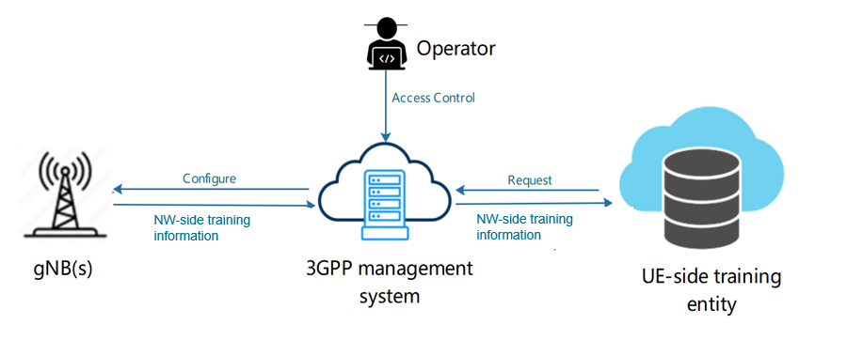

Figure 5.x.1.1.1-1 Illustration of NW-side training information collection and reporting for two-side CSI model training.
Being an SBMA interface consumer, the UE-side training entity requests the 3GPP management system to collect the NW-side training information, and the management system configures the gNB(s) accordingly. After the NW-side training information is produced, the management system collects the data from the gNB(s) and reports it to the UE-side training entity based on access control information specified by the operator (see Note 2). The request from the UE-side training entity includes the type of data to be produced and the gNB(s) from which the data shall be collected.
NOTE 1: The NW-side training information corresponds to NW-side dataset and/or model parameters. The exact types of data and parameters are subject to further discussion, pending ongoing correspondence and confirmation by RAN2.
NOTE 2: Access control information is for further discussion.

5.x.1.1.1.2 Potential requirements
REQ-ML_TWOSIDE-x1: The 3GPP management system should have a capability allowing an authorised UE-side training entity to request and obtain NW-side training information.
REQ-ML_TWOSIDE-x2: The 3GPP management system should have a capability of controlling the collection of NW-side training information by one or more gNBs, as requested by an authorised UE-side training entity.

REQ-ML_TWOSIDE-x3: The 3GPP management system should have a capability of reporting the collected NW-side training information to an authorised UE-side training entity.
NOTE 3: the interaction between the 3GPP system and the UE-side training server, including details on the requested information is for further discussion.
* * * End of Changes * * * *

