3GPP TSG SA WG5 Meeting #163 S5-254658
Wuhan, CHINA 13 - 17 October 2025

Source: Huawei, China Mobile
Title: Pseudo-CR on 28.881 Add use case for the investigation on the applicability and potential impacts to support natural language intents translation
Document for: Approval
Agenda item: 6.20.1
Spec: 3GPP TR 28.881
Version: V0.1.0
Work Item: FS_IDMS_MN_Ph4

Comments
This contribution proposes to add use case for the Investigation on the applicability and potential impacts to support natural language intents translation based on corresponding use case documented in TR 28.914.
This is related to WT-6.

Proposed Changes

* * * First Change * * * *

4.X Use case #X: Investigation on the applicability and potential impacts to support natural language intents translation

4.X.1 Description
In TR 28.914 [X], clause 5.6 described the use case for investigating potential impacts to support natural language intents translation. It also states that there are some use cases where the use of natural language for intent expression would be preferred. For example, on the human-machine interface presenting and expressing intent using natural language can lead to a more intuitive experience for human users. A concrete example of natural language RAN ES intent can be “Reduce 10% RAN energy consumption without impact on user experience for Region X”. The use case also described that if an intent interpreter is introduced to process intents described in natural language, it is necessary to clarify its position within the existing intent management framework, especially its relationship with the MnS consumer.
Deployment scnenario#1: Intent Interpreter as a separate management function outside the intent handling function. In this deployment scenario, Intent interpret receive the natural language intent from consumer (e.g. LUI) and translate it into a formal intent (the formal intent contains the attributes and corresponding values to enable the intent handling function to decide the actions to fulfil the intent expectation) according to intent model defined in TS 28.312 [1] and consume the 3GPP Intent driven MnS with formal intent model provided by intent handling function.

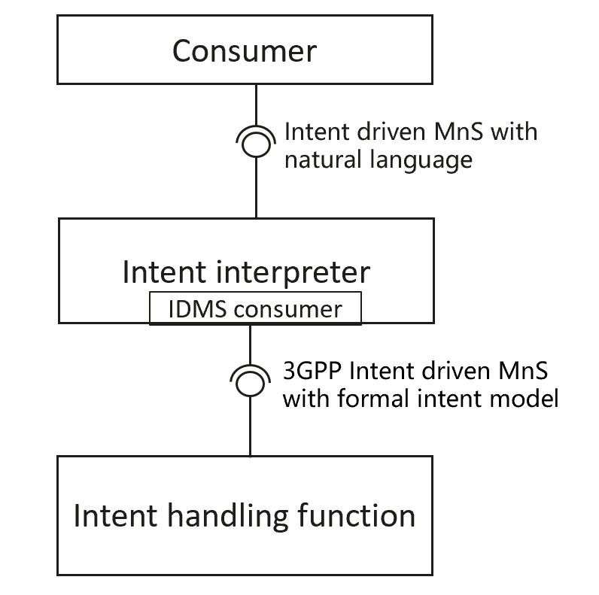
Figure 4.X-1 Deployment scnenario#1 Intent Interpreter as a separate management function outside the intent handling function
Deployment scnenario#2: Intent Interpreter is a management function integrated in intent handling function. In this deployment scenario, Intent interpret receive the natural language intent from consumer (e.g. LUI) and translate it into detailed actions to be executed to fulfil the intent.

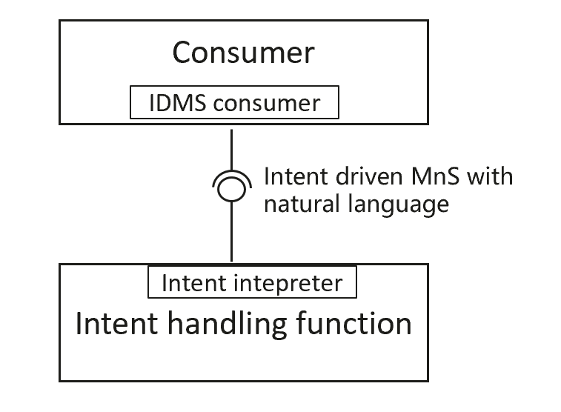
Figure 4.X-2 Deployment scnenario#2 Intent Interpreter is a management function integrated in intent handling function.
Above two deployment scenarios can be used to support different use cases.
Since MnS consumer may not be familiar with formal intent models, the natural language intent may lack certain necessary details, leading to incomplete or inaccurate translated intent model. For example, essential attributes like the "targetValueRange" in ExpectationTarget may be missing due to incomplete information.
Based on above two deployment scenarios, this study can investigate whether there is a need for a potential solution to enhance the intent-driven management service to support natural language

4.X.3 Potential solution
TBD

4.X.44 Evaluation of potential solutions
TBD

* * * End of Changes * * * *

