3GPP TSG-SA5 Meeting #163 S5-254634
Wuhan, China, 13 - 17 October 2025

Source: Rakuten Mobile, Inc., Nokia
Title: Pseudo-CR on TR 28.869 NRM updates for NF Deployment LCM
Document for: Approval
Agenda item: 6.19.6
Spec: 3GPP TR 28.869
Version: 1.6.0
Work Item: FS_Cloud_OAM

Comments
This contribution proposes some NRM attributes for LCM of NF Deployment.

Proposed Changes
* * * First Change * * * *

5.2.1.3 Potential solutions
Introduce a generic orchestration and management entity that interacts with 3GPP management system for LCM of NF Deployment instance via the new deployment management reference point.
The figure 5.2.1.3-1 below illustrates the interaction between 3GPP management system and orchestration and management entity in simplified view:
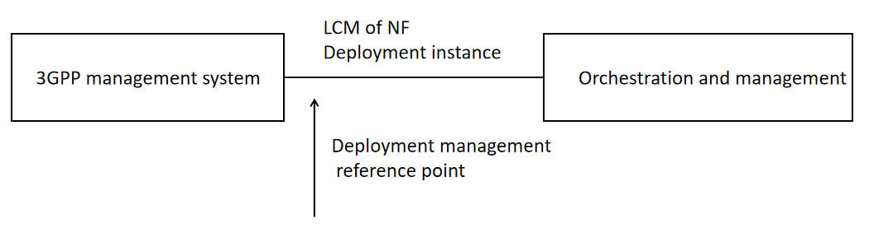
Figure 5.2.1.3-1: Lifecycle management of NF Deployment instance
The deployment management reference point includes the interfaces that 3GPP supports today with ETSI NFV MANO but not limited to it, e.g. Kubernetes based API. For the case of NFV-MANO the deployment management reference point includes the exchange of information over the interfaces that 3GPP supports with ETSI NFV-MANO (ETSI GS NFV-IFA 013 [8] and ETSI GS NFV-IFA 008 [9]).
The conceptual relationship between the Managed Function and the NF Deployment can be as shown in Figure 5.2.1.3-X. The Managed Function can be associated to zero, one or more NF Deployment(s). Conversely, a single NF Deployment can be associated to zero, one or more Managed Function(s).
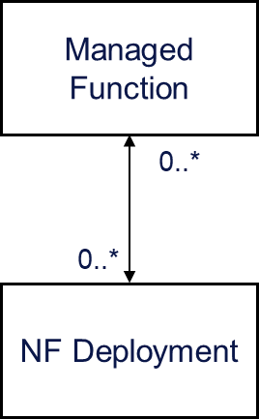
Figure 5.2.1.3-X: Conceptual Relationship between Managed Function and NF Deployment
Depending on the normative specification of the term “NF Deployment” and its relationship with “VNF” as currently defined in 3GPP specifications, a new attribute named NFDeploymentParametersList can be added to ManagedFunction IOC.

* * * End of Changes * * * *

