3GPP TSG-SA5 Meeting #163 S5-254634
Wuhan, China, 13 - 17 October 2025

Source: Rakuten Mobile, Inc., Nokia
Title: Pseudo-CR on TR 28.869 NRM updates for NF Deployment LCM
Document for: Approval
Agenda item: 6.19.6
Spec: 3GPP TR 28.869
Version: 1.6.0
Work Item: FS_Cloud_OAM

Comments
This contribution proposes some NRM attributes for LCM of NF Deployment.

Proposed Changes
* * * First Change * * * *

5.2.1.3 Potential solutions
Introduce a generic orchestration and management entity that interacts with 3GPP management system for LCM of NF Deployment instance via the new deployment management reference point.
The figure 5.2.1.3-1 below illustrates the interaction between 3GPP management system and orchestration and management entity in simplified view:
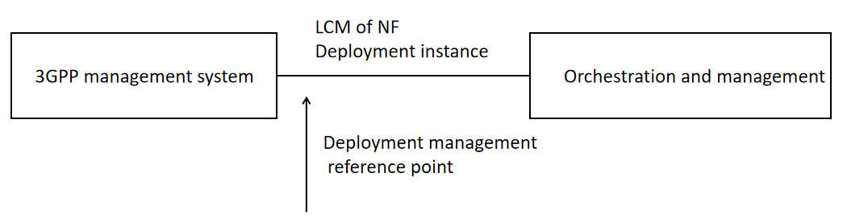
Figure 5.2.1.3-1: Lifecycle management of NF Deployment instance
The deployment management reference point includes the interfaces that 3GPP supports today with ETSI NFV MANO but not limited to it, e.g. Kubernetes based API. For the case of NFV-MANO the deployment management reference point includes the exchange of information over the interfaces that 3GPP supports with ETSI NFV-MANO (ETSI GS NFV-IFA 013 [8] and ETSI GS NFV-IFA 008 [9]).
The relationship between the ManagedFunction IOC and the NF Deployment is shown in Figure 5.2.1.3-X. The ManagedFunction IOC (defined in clause 4.3.4 of TS 28.622) can be associated to zero, one or more NF Deployment(s).
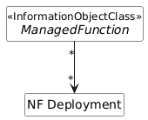
Figure 5.2.1.3-X: Relationship between ManagedFunction IOC and NF Deployment

To enable the LCM of NF Deployments, a new attribute named NFDeploymentParametersList can be added to ManagedFunction IOC. Accordindly, the updated attributes of the ManagedFunction IOC can be seen below:
Attribute Name | S | isReadable | isWritable | isInvariant | isNotifyable
vnfParametersList | CM | T | T | F | T
peeParametersList | CM | T | T | F | T
priorityLabel | O | T | T | F | T
supportedPerfMetricGroups | O | T | F | F | T
supportedTraceMetrics | O | T | F | F | T
nfDeploymentParametersList | CM | T | T | F | T

Attribute constraints
Name | Definition
nfDeploymentParametersList | Condition: The ManagedFunction instance is realized by one or more NF Deployment instance(s). Otherwise this attribute shall be absent.

NOTE: The relationship between VNF and NF Deployment will be further clarified in the normative phase. Hence, the relationship between vnfParametersList and nfDeploymentParametersList will be clarified as well.
The nfDeploymentParametersList attribute can be further described in clause 4.4.1 of TS 28.662 as below:
nfDeploymentParametersList | This attribute contains the parameter set of the NF Deployment instance(s) associated to a managed element. Each entry in the list contains:  - nfDeploymentInstanceId: corresponds to the identifier of the NF Deployment instance running in the cloud. This identifier can be assigned by the orchestration and management (O&M) system.  - nfDeploymentDescId (optional): Identifier of the NF Deployment descriptor, which is a deployment template that describes an NF Deployment in terms of its deployment and operational requirements.  - nfDeploymentFlavour (optional): This attribute represents key-value pairs corresponding to the desired resource footprint of this NF Deployment. | type: String  multiplicity: *  isOrdered: False  isUnique: True  defaultValue: None  isNullable: False

* * * End of Changes * * * *

