**3GPP TSG-SA5 Meeting #162 *S5-254041***

Goteborg, Sweden, 25 - 29 August 2025

**Source: Huawei**

**Title: Rel-20 pCR on TR 28.881 Add new issue for Intent utility function enhancement**

**Document for: Approval**

**Agenda item: 6.20.1**

**Spec: 3GPP TR 28.881**

**Version: V0.0.0**

**Work Item: FS_IDMS_MN_Ph4**

**Comments**

In TS 28.312, intent utility functions are mathematical expressions that indicate the MnS Consumer’s preference for expectation targets by quantifying the utility derived from the various levels of fulfilment. Currently, the basic components include variables, weights, function and result. However, the function is either not straightforward for the MnS consumer to understand and use, which is in the form of mathematical functions (example of it can see figure 1), or lacks the flexibility, which is predefined and vendor specific, the MnS consumer can only see the description and limited parameters (example of it can see figure 2).

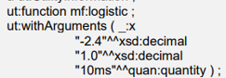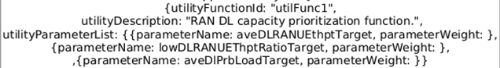

**Figure 1 mathematical function Figure 2 vendor specific description**

Thus, except using function in the form of mathematical functions or predefined and vendor specific, the MnS consumer can express the function in the form of a utility list, which contains the candidate target values and the corresponding utility, to indicate the preference for expectation targets. In the case of RANEnergyConsumptionTarget, the MnS consumer can specify that a candidate target value of '900' has a utility value of 1, while '1000' has a utility value of 0. Each expectation target has a utility list. The MnS producer can select the suitable utility function and then fulfill the intent based on the lists.

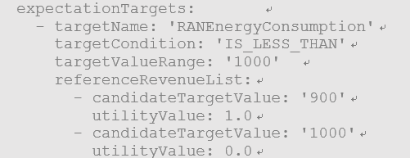

**Figure 3: Utility list usage example**

Therefore, this tdoc is to add a key issue to enhance the usage of Intent utility function.

This contribution related to WT-3.3

**Proposed Changes**

* * * First Change * * * *

# 2 References

The following documents contain provisions which, through reference in this text, constitute provisions of the present document.

- References are either specific (identified by date of publication, edition number, version number, etc.) or non‑specific.

- For a specific reference, subsequent revisions do not apply.

- For a non-specific reference, the latest version applies. In the case of a reference to a 3GPP document (including a GSM document), a non-specific reference implicitly refers to the latest version of that document *in the same Release as the present document*.

[1] 3GPP TR 21.905: "Vocabulary for 3GPP Specifications".

[y] 3GPP TS 28.312: "Management and orchestration; Intent driven management services for mobile networks"

…

[x] <doctype> <#>[ ([up to and including]{yyyy[-mm]|V<a[.b[.c]]>}[onwards])]: "<Title>".

* * * Next Change * * * *

## 4.X Issue#X: Intent Utility Function Enhancement

### 4.X.1 Description

In TS 28.312[y], the usage of intent utility function is explored, including how an MnS Producer can expose its supported Intent Utility Functions via intent capabilities, and how the MnS Consumer can use such information to provision the function. Intent utility functions are mathematical expressions that indicate the MnS Consumer’s preference for expectation targets by quantifying the utility derived from the various levels of fulfilment. Currently, the basic components include variables, weights, function and result. However, the function is either not straightforward for the MnS consumer to understand and use, as it is in the form of mathematical functions (e.g. linear, logarithmic, polynomials, scalars…), or lacks the flexibility, which is predefined and vendor specific, the MnS consumer can only see the description and limited parameters. Thus, except using function in the form of mathematical functions or predefined and vendor specific, the MnS consumer can express the function in the form of a utility list, which contains the candidate target values (or metric value) and the corresponding utility (or called revenue) for a target, to indicate the preference for expectation targets. The list of < candidate target values, utility value> pairs can be considered as some points in the following figure.  The producer will fit a corresponding curve (which is the specific utility function) based on these points. Subsequent steps are the same as TS 28.312, maximize the overall utility based on the fitted utility functions. In the case of RANEnergyConsumptionTarget, the MnS consumer can specify that a candidate target value of '900' has a utility value of 1, while '1000' has a utility value of 0. Each expectation target has a utility list. The MnS producer can select the suitable utility function and then fulfill the intent based on the lists.

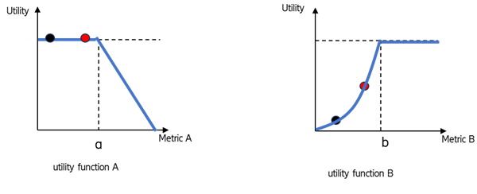

**Figure 4.X.1-1: Utility list usage example**

### 4.X.2 Potential requirements

### 4.X.3 Potential solutions

4.X.4 Evaluation of potential solutions

TBD

* * * End of Changes * * * *