3GPP TSG-SA5 Meeting #161 S5-254027
Goteborg, Sweden, 25 - 29 August 2025

Source: Nokia
Title: Pseudo-CR on Rel-19 pCR TS 28.579 Resolve Editor’s notes
Document for: Approval
Agenda item: 6.19.21.1
Spec: 3GPP TS 28.579
Version: 1.0.0
Work Item: MExpo

Comments
This pCR resolves editor’s notes in TS 28.579.

Proposed Changes
* * * First Change * * * *

5.1.2 Management Services Exposure Domain (MSED)
MSED provides the API provider domains by consuming the CAPIF-3, CAPIF-4 and CAPIF-5 interfaces as shown in Figure 5.1.2-1. The API invoker shown in Figure 5.1.2-1 outside the PLMN trust domain is the external MnS consumer. To enable the exposure of management services using CAPIF, the 3GPP management system is responsible for providing the mapping logic between the management service information and the CAPIF-defined information elements exchanged on the CAPIF-3, CAPIF-4 and CAPIF-5 interfaces (defined in TS 29.222 [4]).
The MSED publishes the service APIs (as a result of mapping the management service information to the CAPIF-defined service API information) to the CAPIF core function (CCF) using the CAPIF-4 interface. The API invokers can discover the published service APIs via the CAPIF-1e interface. The AEF of the MSED enables the API invokers to consume the published management services as service APIs via the CAPIF-2e interface as shown in Figure 5.1.2-1.

NOTE: The interactions or relation between the AEF of the MSED and the MnS producers is FFS.

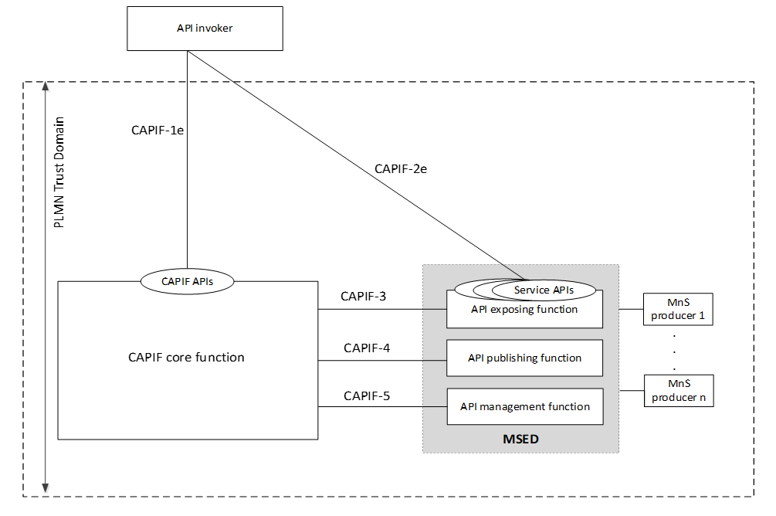
Figure 5.1.2-1: MSED interactions with the CCF and the API invokers (i.e., the external MnS consumers)
As shown in Figure 5.1.2-1, MSED does not implement the CAPIF core function(CCF) but is a consumer of the CAPIF-3, CAPIF-4 and CAPIF-5 interfaces, which are defined outside the 3GPP management system.

Traceability: REQ-MEXPO-FUN-01
* * * Next Change * * * *

6.1 Registration of the MSED into the CCF

6.1.1 Introduction
In CAPIF, the registration of MSED as a recognized API provider domain in CAPIF is initiated by the AMF of the MSED. To register, unregister or update MSED, the AMF of MSED invokes the CAPIF_API_Provider_Management API service (see clause 5.11 of TS 29.222 [4]) over the CAPIF-5 interface. As part of the registration process (i.e., registration and update registration), the AMF of the MSED sends HTTP requests to the CCF whose request body includes the APIProviderEnrolmentDetails data type (see clause 8.9.4.2.2 of TS 29.222 [4]).
Clause 6.1.2 describes how to map MSED registration information to the APIProviderEnrolmentDetails data type and clause 6.1.3 indicates the service operations that need to be supported by the AMF of the MSED to enable the registration procedures (i.e., registration, update registration and deregistration) of MSED.

6.1.2 Mapping of MSED information into APIProviderEnrolmentDetails
Table 6.1.2-1 presents the attributes of the APIProviderEnrolmentDetails data type (see clause 8.9.4.2.2 of TS 29.222 [4]) and provides information on how this data type can be populated with the MSED registration information. Refer to Table 8.9.4.2.2-1 of TS 29.222 [4] for detailed information on the attributes of APIProviderEnrolmentDetails data type (e.g., the attribute data type, presence indicator, cardinality, description and applicability information).
Table 6.1.2-1: Mapping of MSED registration information to APIProviderEnrolmentDetails data type attributes
Attribute name | Attribute additional information | Related MSED registration information/Comments
apiProvDomId | The data type of this attribute is defined as "string" and presence qualifier is defined as "O". | Assigned by the CCF to the AMF of the MSED during the registration procedure of the MSED at the CCF (see clause 6.1.3).
regSec | The data type of this attribute is defined as "string" and presence qualifier is defined as "M". | It can be used to store the security credentials of the MSED.  NOTE: The security credentials of MSED are provided to the AMF of MSED by means outside the scope of the present document.
apiProvFuncs | The data type of this attribute is defined as "array (APIProviderFunctionDetails)" and presence qualifier is defined as "O". | See Table 6.1.2-2.
apiProvDomInfo | The data type of this attribute is defined as "string" and presence qualifier is defined as "O".
suppFeat | The data type of this attribute is defined as "SupportedFeatures" and presence qualifier is defined as "C". | N/A
failReason | The data type of this attribute is defined as "string" and presence qualifier is defined as "C".
apiProvName | The data type of this attribute is defined as "string" and presence qualifier is defined as "O". | Applicable in RNAA scenarios.

Table 6.1.2-2 presents the attributes of the APIProviderFunctionDetails data type (see clause 8.9.4.2.3 of TS 29.222 [4]) and provides information on how this data type can be populated with the MSED related information. See table 8.9.4.2.3-1 of TS 29.222 [4] for detailed information on the attributes of APIProviderFunctionDetails data type (e.g., the attribute data type, presence indicator, cardinality, description and applicability information).
Table 6.1.2-2: Mapping MSED registration information to APIProviderFunctionDetails attributes
Attribute name | Attribute additional information | Related MSED registration information/Comments
apiProvFuncId | The data type of this attribute is defined as "string" and presence qualifier is defined as "C". | The API provider function id is assigned to each function composing the MSED (i.e., AEF, APF or the AMF) by the CCF as part of the MSED registration procedure.  The assigned ids of the API provider domain functions are used in the use case clauses 5.2.1 and 5.2.2.
regInfo | The data type of this attribute is defined as "RegistrationInformation" and presence qualifier is defined as "M". | See Table 6.1.2-3.
apiProvFuncRole | The data type of this attribute is defined as "ApiProviderFuncRole" and presence qualifier is defined as "M". | This data type serves to specify, for the MSED to be registered, which CAPIF API provider domain function(s) will be supported.  Allowed values are AEF, AMF, APF.
apiProvFuncInfo | See clause 8.9.4.3.3 of TS 29.222 [4] for the enumeration values and description of type ApiProviderFuncRole. | General information related to the specific MSED function (e.g., AEF, AMF or APF)

Table 6.1.2-3 presents the attributes of the RegistrationInformation data type (see clause 8.9.4.2.4 of TS 29.222 [4]) and provides information on how this data type can be populated with the MSED related information. See table 8.9.4.2.4-1 of TS 29.222 [4] for detailed information on the attributes of RegistrationInformation data type (e.g., the attribute data type, presence indicator, cardinality, description and applicability information).
Table 6.1.2-3: Representing MSED registration information with RegistrationInformation attributes
Attribute name | Attribute additional information | Related MSED registration information/Comments
apiProvPubKey | The data type of this attribute is defined as "string" and presence qualifier is defined as "M" (see table 8.9.4.2.4-1 of TS 29.222 [4]). | It can be used to store the public key of the MSED function(s).  NOTE: The public key(s) of the MSED function(s) are provided to the AMF of MSED by means outside the scope of the present document.
apiProvCert | The data type of this attribute is defined as "string" and presence qualifier is defined as "O" (see table 8.9.4.2.4-1 of TS 29.222 [4]). | It can be used to store the client certificate of the MSED function(s), if existing.  NOTE: The client certificate of the MSED function(s) are provided to the AMF of MSED by means outside the scope of the present document.

6.1.3 Service operations supported by the AMF of the MSED to enable the MSED registration functionality
To register MSED as the API provider domain for management services at the CCF, the AMF of the MSED invokes the Register_API_Provider service operation as described in clause 5.11.2.2 of TS 29.222 [4] via the CAPIF-5 interface. The body of the HTTP POST request shall include the API provider enrolment details as described in clause 6.1.2.
To update the registration details of MSED at the CCF, the AMF of the MSED invokes the Update_API_Provider service operation as described in clause 5.11.2.3 of TS 29.222 [4] via the CAPIF-5 interface. The body of the HTTP PUT request shall contain the updated API provider enrolment details as described in clause 6.1.2.
To unregister MSED as the API provider domain for management services from the CCF, the AMF of the MSED invokes the Deregister_API_Provider service operation as described in clause 5.11.2.4 of TS 29.222 [4] via the CAPIF-5 interface.

* * * End of Changes * * * *

