3GPP TSG-SA5 Meeting #161 S5-254015
Goteborg, Sweden, 25 - 29 August 2025

Source: Nokia, Ericsson
Title: Pseudo-CR on Rel-19 pCR TR 28.869 Editorial clean up- Clause 5.2.3.3.2, Annexes D, E and F
Document for: Approval
Agenda item: 6.19.6
Spec: 3GPP TR 28.869
Version: 1.5.1
Work Item: FS_Cloud_OAM

Comments
The pCR replaces occurrences of “NF deployment” in TR 28.869 with “NF Deployment” to ensure terminology consistency.

Proposed Changes
* * * First Change * * * *

5.2.3.3.2 Use of deployment management reference point based on declarative descriptor
In this solution the 3GPP management system interacts with an orchestration and management system using the deployment management reference point as described in clause 5.2.1.3 for creation of a NF Deployment instance. The deployment requirements for creating a workload of a NF are conveyed from the 3GPP management system to the orchestration and management system via a declarative descriptor.
Figure 5.2.3.3.2-1 depicts a high-level view of proposed procedure for creation of a NF Deployment instance based on declarative descriptor.
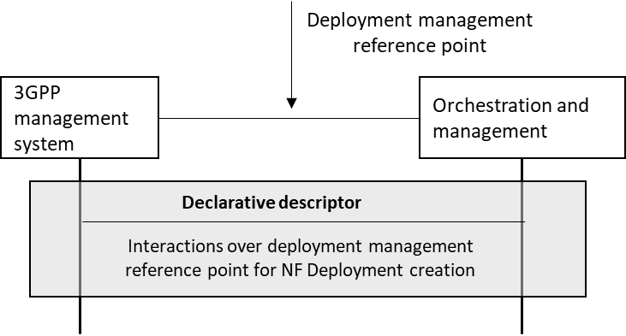
Figure 5.2.3.3.2-1: Interaction between 3GPP management system and orchestration and management system using deployment management reference point based on declarative descriptor
The declarative descriptor provides a declaration in high-level on what to be achieved by the orchestration and management system rather than how to achieve it.
If the orchestration and management system is ETSI NFV MANO, the interactions over deployment management reference point are as specified in clause 7.10 of 28.531 [7]. For the case of NFV-MANO, the declarative descriptor is VNFD,as per ETSI NFV specifications (see ETSI GS NFV-IFA 011 [22]). If another orchestration and management entity is considered, updates are needed in TS 28.531 [7] and possibly other specifications to describe the interactions over the deployment management reference point and to define the declarative descriptor.
NOTE: In case the orchestration and management system is ETSI NFV MANO, VNFD is defined to convey the deployment requirement information. For other industry solutions, currently there is no standardized descriptor.

* * * Next Change * * * *

Annex D : Example scenario using interactions with orchestration and management entity for the creation of NF Deployment instances
Figure D-1 depicts an example scenario for the interaction between the 3GPP management system and the orchestration and management entity for the creation of a NF Deployment instance.
An authorized NF provisioning MnS Consumer requests the creation of a 3GPP NF by creating the ManagedFunction IOC on the NF provisioning MnS producer specifying the network function related requirements. If the 3GPP NF contains containerized or virtualized parts, the NF provisioning MnS producer derives the associated requirements for the NF Deployment based on the network function related requirements.
Note: For the network function related requirements, see information model definition for NR NRM in clause 4 and information model definition for 5GC NRM in clause 5 in TS 28.541[17].

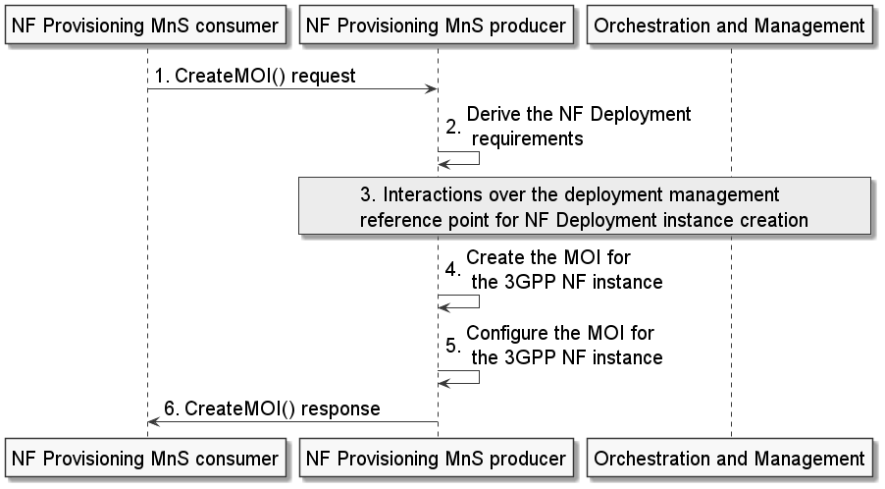
Figure D-1: Example scenario for interaction with orchestration and management entity for 3GPP NF creation procedure
The NF provisioning MnS producer invokes interactions with an orchestration and management entity for the creation of the NF Deployment instance. Following the completion of the required interactions with the orchestration and management entity, the NF provisioning MnS producer creates the MOI for the 3GPP NF instance and configures the new MOI with corresponding information. The NF provisioning MnS producer sends the createMOI response to the NF provisioning MnS Consumer with the DN of the MOI of the 3GPP NF instance.

Note 1: Figure D-1 shows step 3 after steps 1, alternatively step 3 could occur before step 1.

Note 2: If the orchestration and management entity is ETSI NFV MANO, the interactions over the deployment management reference point are as specified in clause 7.10 of 28.531[7].

* * * Next Change * * * *

Annex E : Example scenario using interactions with orchestration and management entity for modification of NF Deployment instances
Figure E-1 depicts an example scenario for interaction with orchestration and management entity for modification of an instance of a NF Deployment.

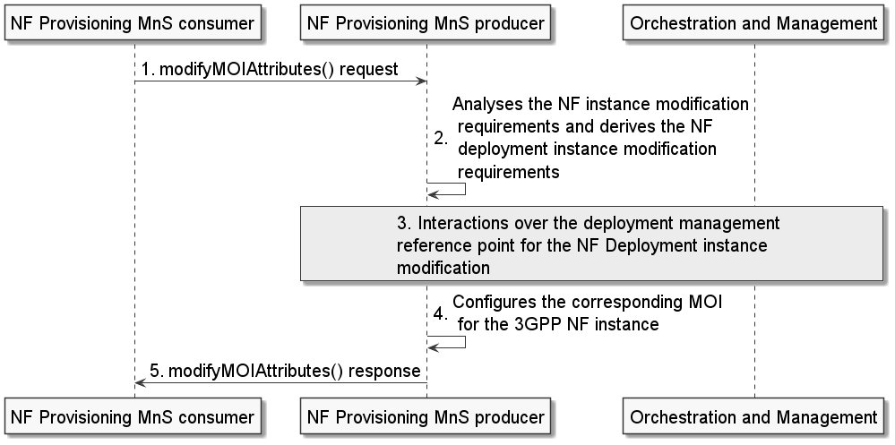
Figure E-1: Example scenario for interaction with orchestration and management entity for modification of an instance of a NF Deployment
An authorized NF provisioning MnS Consumer requests modification of a 3GPP NF instance from the NF provisioning MnS producer by sending a modifyMOIAttributes request with DN of the MOI for the ManagedFunction and the network function related modification requirements. The NF provisioning MnS producer analyses the 3GPP NF instance modification requirements and derives the NF Deployment modification requirements.
The NF provisioning MnS producer invokes interactions with an orchestration and management entity for the modification of the NF Deployment instance. Following the completion of the required interactions with the orchestration and management entity, the NF provisioning MnS producer reconfigures the corresponding MOI for the 3GPP NF instance and sends the modifyMOIAttributes response to the NF provisioning MnS Consumer.

NOTE 1: Figure E-1 shows step 3 after steps 1, alternatively step 3 could occur before step 1.

Note 2: If the orchestration and management entity is ETSI NFV MANO, the interactions over the deployment management reference point are as specified in clause 7.10 of 28.531[7].

* * * Next Change * * * *

Annex F (informative): Example scenario using interactions with orchestration and management entity for termination of NF Deployment instances
Figure F-1 depicts an example scenario for interaction with an orchestration and management entity for the termination of a 3GPP NF Deployment instance.

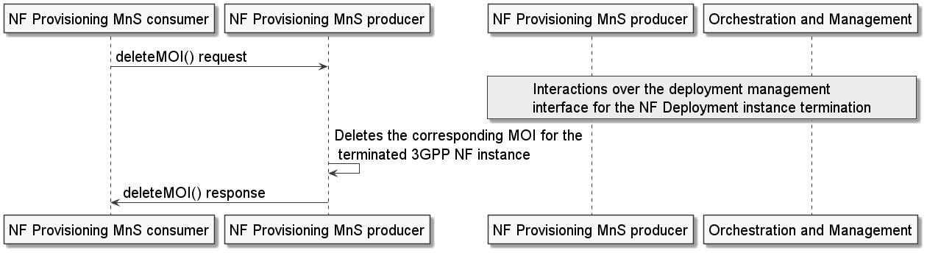
Figure F-1: Example scenario for interaction with the orchestration and management entity for the termination of a NF Deployment instance
An authorized NF provisioning MnS Consumer requests the termination of a3GPP NF instance from the NF provisioning MnS producer by sending a deleteMOI request with DN of the 3GPP NF MOI.
The NF provisioning MnS producer responsible for interacting with the orchestration and management (O & M) entity invokes interactions with an O & M entity for the termination of the corresponding NF Deployment instance(s) for the 3GPP NF instance. The NF provisioning MnS producer deletes the MOI of the 3GPP NF instance and sends the deleteMOI response to the NF provisioning MnS Consumer with the DN of the deleted MOI of the 3GPP NF instance. The NF provisioning MnS producer that receives the deleteMOI() request can or can not be the same NF provisioning MnS producer that interacts with the orchestration and management entity for the termination of the NF Deployment instance.

NOTE 1: Figure F-1 shows step 3 after step 1, alternatively step 3 could occur before step 1.
Note 2: If the orchestration and management entity is ETSI NFV MANO, the interactions over the NF Deployment management reference point are as specified in clause 7.12 of 28.531 [7].

* * * End of Changes * * * *

