**3GPP TSG-SA5 Meeting #162 *S5-253950***

Goteborg, Sweden, 25 - 29 August 2025

|  |  |  |  |  |  |  |  |  |
| --- | --- | --- | --- | --- | --- | --- | --- | --- |
| *CR-Form-v12.3* | | | | | | | | |
| **CHANGE REQUEST** | | | | | | | | |
|  | | | | | | | | |
|  | **28.541** | **CR** | **1595** | **rev** | **1** | **Current version:** | **19.4.0** |  |
|  | | | | | | | | |
| *For* [***HE******LP***](http://www.3gpp.org/3G_Specs/CRs.htm#_blank)*on using this form: comprehensive instructions can be found at* [*http://www.3gpp.org/Change-Requests*](http://www.3gpp.org/Change-Requests)*.* | | | | | | | | |
|  | | | | | | | | |

|  |  |  |  |  |  |  |  |  |
| --- | --- | --- | --- | --- | --- | --- | --- | --- |
| ***Proposed change affects:*** | UICC apps |  | ME |  | Radio Access Network |  | Core Network | **X** |

|  |  |  |  |  |  |  |  |  |  |  |
| --- | --- | --- | --- | --- | --- | --- | --- | --- | --- | --- |
|  | | | | | | | | | | |
| ***Title:*** | Rel-19 CR TS 28.541 Correction on diagram and description on EP_Rx | | | | | | | | | |
|  |  | | | | | | | | | |
| ***Source to WG:*** | CATT | | | | | | | | | |
| ***Source to TSG:*** | S5 | | | | | | | | | |
|  |  | | | | | | | | | |
| ***Work item code:*** | TEI19 | | | | |  | ***Date:*** | | | 2025-08-06 |
|  |  | | | |  | |  | | |  |
| ***Category:*** | **A** |  | | | | | ***Release:*** | | | Rel-19 |
|  | *Use one of the following categories:* ***F*** *(correction)* ***A*** *(mirror corresponding to a change in an earlier release)* ***B*** *(addition of feature),* ***C*** *(functional modification of feature)* ***D*** *(editorial modification)*  Detailed explanations of the above categories can be found in 3GPP [TR 21.900](http://www.3gpp.org/ftp/Specs/html-info/21900.htm). | | | | | | | | *Use one of the following releases: Rel-8 (Release 8) Rel-9 (Release 9) Rel-10 (Release 10) Rel-11 (Release 11) … Rel-17 (Release 17) Rel-18 (Release 18) Rel-19 (Release 19)  Rel-20 (Release 20)* | |
|  |  | | | | | | | | | |
| ***Reason for change:*** | | 1. Missing and wrong name for EP_Rx in class diagram of 5GC NFs: 2. In Figure 5.2.1.1-6, EP_NRx should be EP_Rx. 3. In Figure 5.2.1.2-2, EP_Rx is missing. 4. Rx interface between PCF and AF is defined in TS 23.503, not TS 23.501 5. Add PCF NRM relationship diagram | | | | | | | | |
|  | |  | | | | | | | | |
| ***Summary of change:*** | | Correction on wrong diagrams and references for Rx interface. | | | | | | | | |
|  | |  | | | | | | | | |
| ***Consequences if not approved:*** | | Incorrect stage 2 leads to incorrect implementation. | | | | | | | | |
|  | |  | | | | | | | | |
| ***Clauses affected:*** | | 5.2.1.1, 5.2.1.2, 5.4.43, Q.1.x (new), Q.2.2 | | | | | | | | |
|  | |  | | | | | | | | |
|  | | **Y** | **N** |  | | | |  | | |
| ***Other specs*** | |  | **X** | Other core specifications | | | | TS/TR ... CR ... | | |
| ***affected:*** | |  | **X** | Test specifications | | | | TS/TR ... CR ... | | |
| ***(show related CRs)*** | |  | **X** | O&M Specifications | | | | TS/TR ... CR ... | | |
|  | |  | | | | | | | | |
| ***Other comments:*** | | No impact on stage 3. | | | | | | | | |
|  | |  | | | | | | | | |
| ***This CR's revision history:*** | |  | | | | | | | | |

***Start of First change***

#### 5.2.1.1 Relationships

This clause depicts the set of classes (e.g. IOCs) that encapsulates the information relevant for NRM of 5GC NFs definitions. This clause provides the overview of the relationships of relevant classes in UML. Subsequent clauses provide more detailed specification of various aspects of these classes.

…

The Figure 5.2.1.1-6 shows the transport view of PCF NRM.

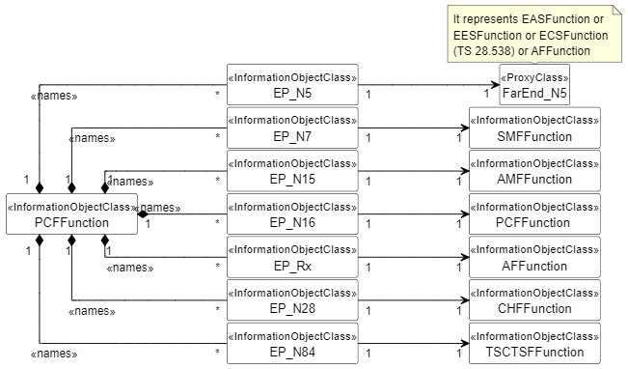

Figure 5.2.1.1-6: Transport view of PCF NRM

***Next change***

#### 5.2.1.2 Inheritance

This clause depicts the inheritance relationships that exist between IOCs.

Figure 5.2.1.2-1 shows the inheritance hierarchy from IOC ManagedFunction related to the 5GC NF NRM.

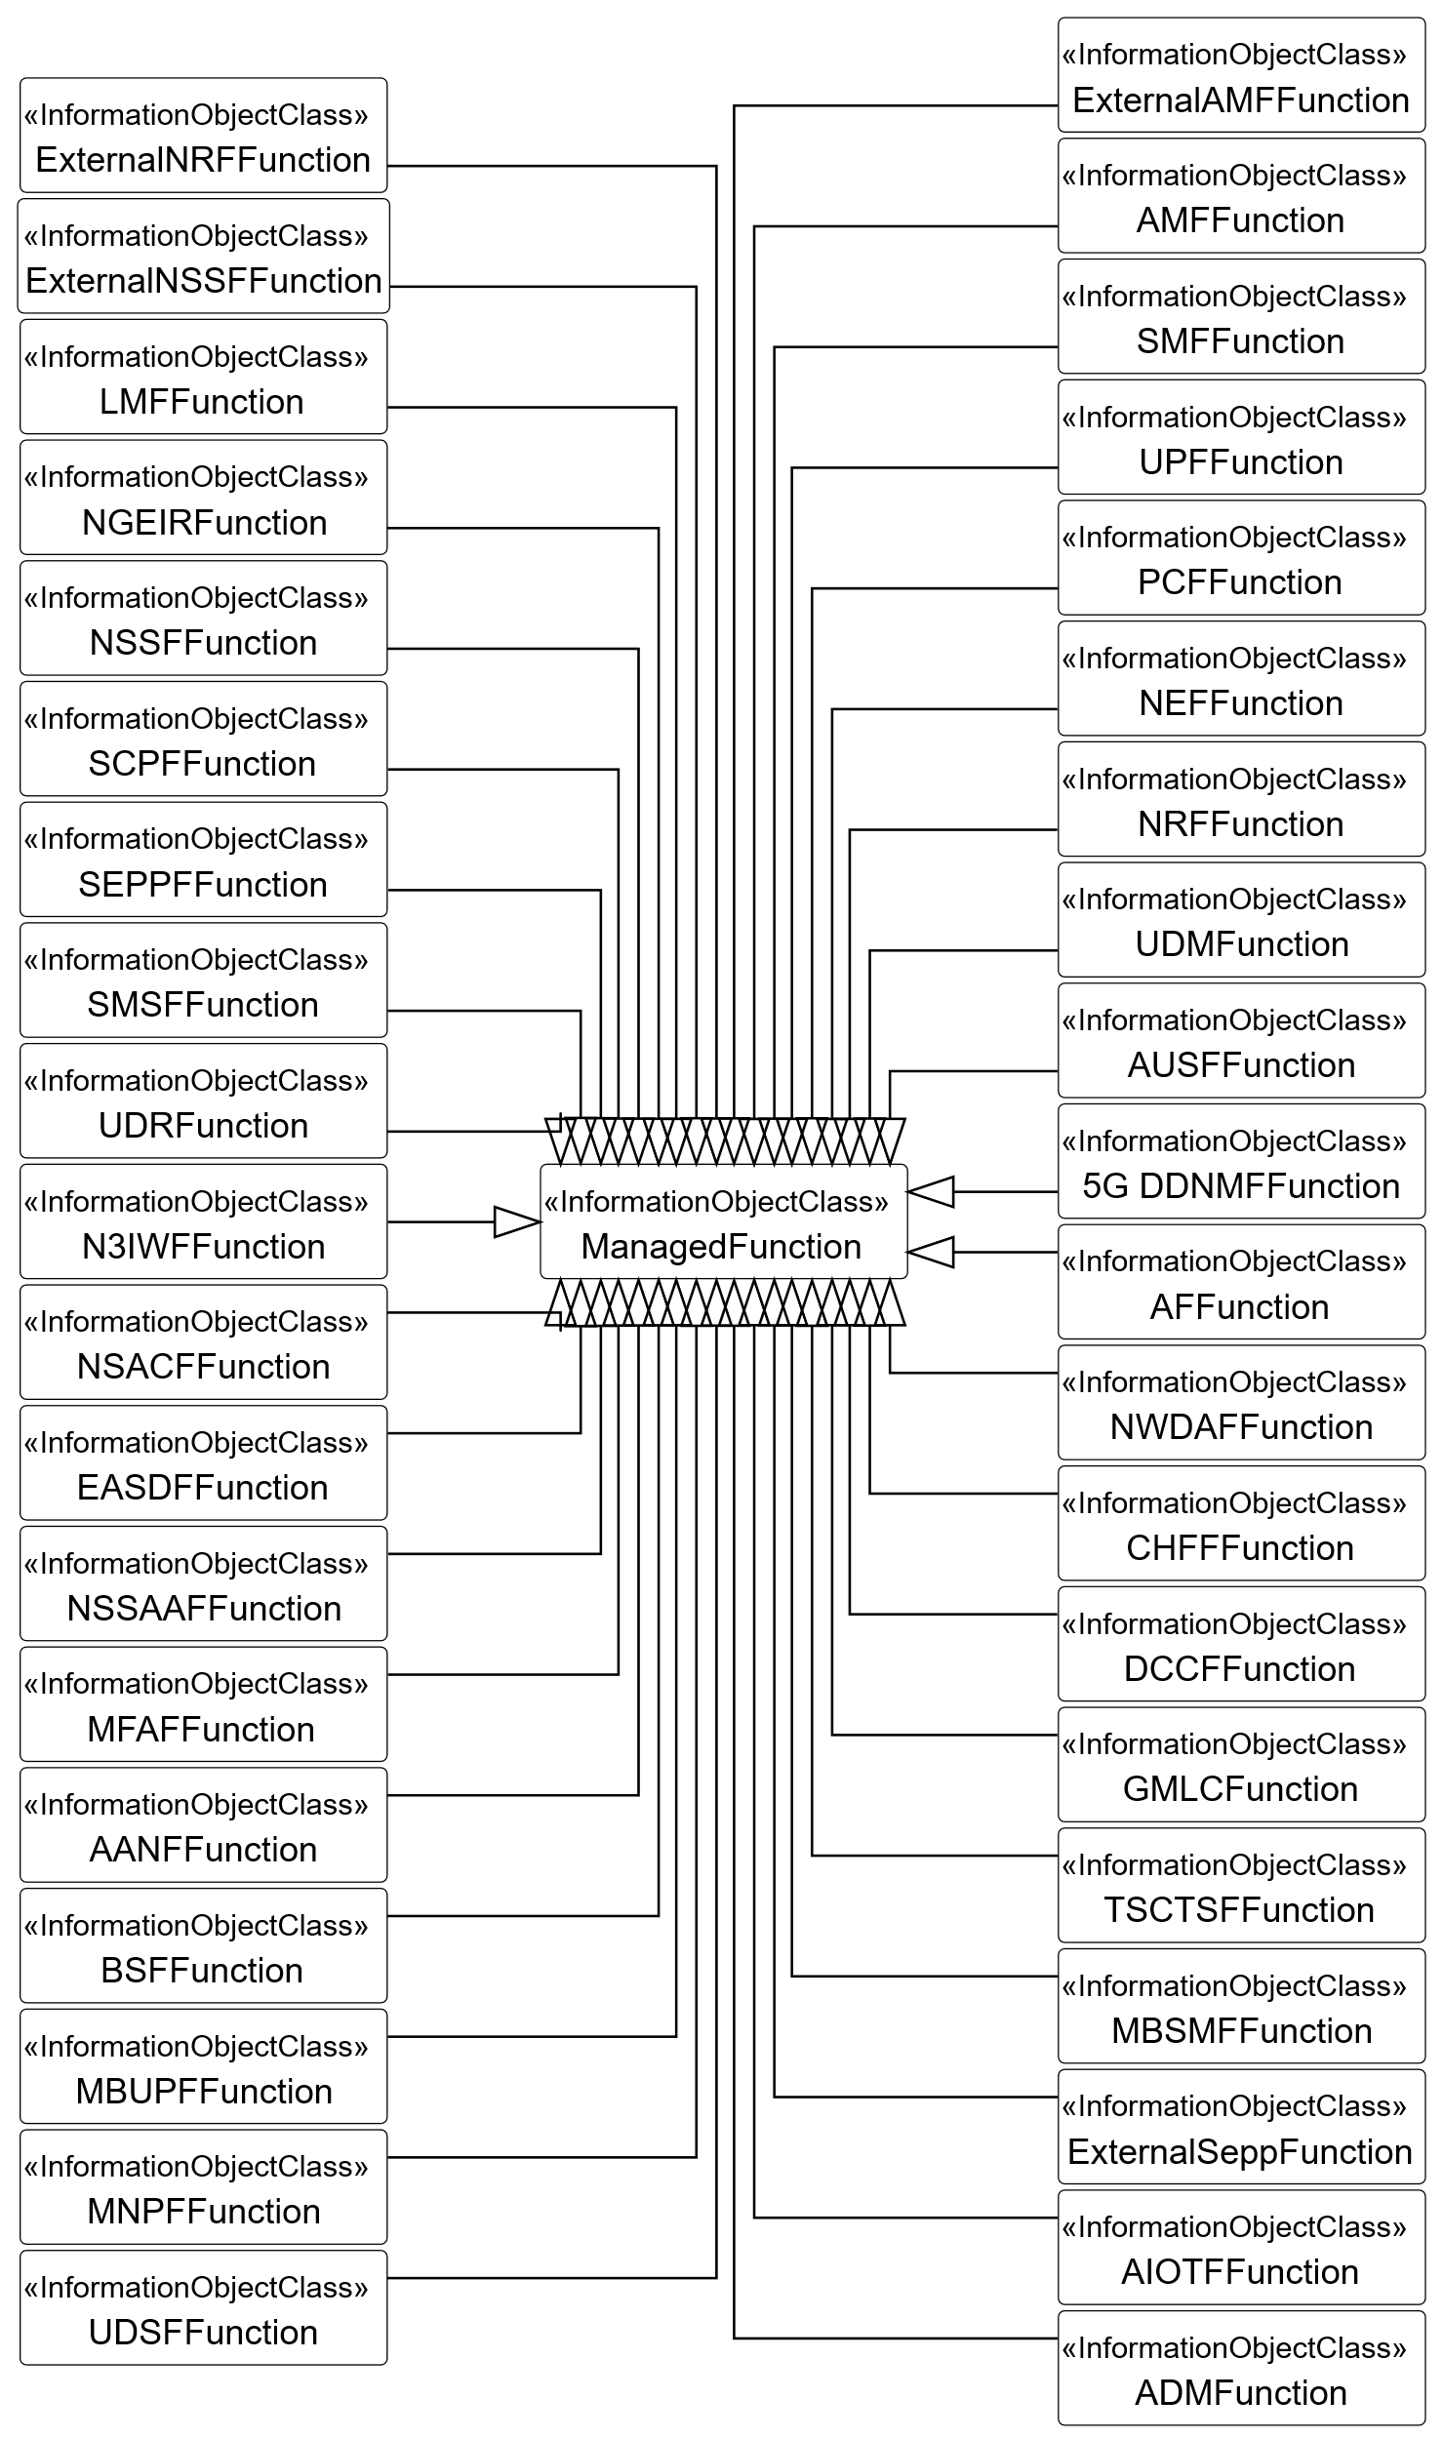

Figure 5.2.1.2-1: Inheritance hierarchy from IOC ManagedFunction related to the 5GC NF NRM

Figure 5.2.1.2-2 shows the inheritance hierarchy from IOC EP_RP related to 5GC NF NRM.

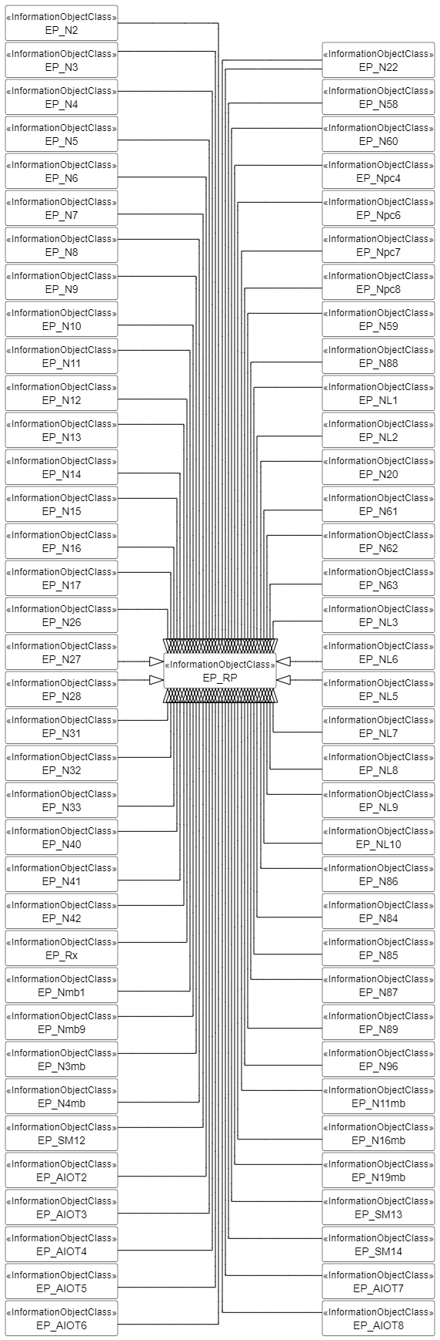

Figure 5.2.1.2-2: Inheritance hierarchy from IOC EP_RP related to the 5GC NF NRM



Figure 5.2.1.2-3: Inheritance hierarchy for IOC QFQoSMonitoringControl



Figure 5.2.1.2-4: Inheritance hierarchy for IOC GtpUPathQoSMonitoringControl



Figure 5.2.1.2-5: Inheritance hierarchy for IOC Configurable5QISet



Figure 5.2.1.2-6: Inheritance hierarchy for IOC FiveQiDscpMapping



Figure 5.2.1.2-7: Inheritance hierarchy for predefined PCC rule modeling



Figure 5.2.1.2-8: Inheritance hierarchy for IOC Dynamic5QISet



Figure 5.2.1.2-9: Inheritance hierarchy for EcmConnectionInfo



Figure 5.2.1.2-10: FiveQICharacteristics Inheritance



Figure 5.2.1.2-11: Inheritance hierarchy for AnLFFunction

Figure 5.2.1.2-12: Inheritance hierarchy for ManagedNFService

***Next change***

### 5.3.43 EP_Rx

#### 5.3.43.1 Definition

This IOC represents the Rx interface between PCF and AF, which is defined in 3GPP TS 23.503 [59].

#### 5.3.43.2 Attributes

The EP_Rx IOC includes attributes inherited from EP_RP IOC (defined in TS 28.622 [30]) and the following attributes:

|  |  |  |  |  |  |
| --- | --- | --- | --- | --- | --- |
| Attribute name | S | isReadable | isWritable | isInvariant | isNotifyable |
| localAddress | O | T | T | F | T |
| remoteAddress | O | T | T | F | T |

#### 5.3.43.3 Attribute constraints

None.

#### 5.3.43.4 Notifications

The common notifications defined in subclause 5.5 are valid for this IOC, without exceptions or additions.

***Next change***

## Q.1.x The Figure 5.2.1.1-6 for the transport view of PCF NRM

'Figure 5.2.1.1-6: Transport view of PCF NRM

@startuml Figure 5.2.1.1-6: Transport view of PCF NRM

hide empty members

hide circle

skinparam class {

BackgroundColor White

ArrowColor Black

BorderColor Black

}

skinparam ClassStereotypeFontStyle normal

skinparam linetype ortho

skinparam nodesep 2

skinparam ranksep 100

left to right direction

class PCFFunction <<InformationObjectClass>>

class EP_N5 <<InformationObjectClass>>

class EP_N7 <<InformationObjectClass>>

class EP_N15 <<InformationObjectClass>>

class EP_N16 <<InformationObjectClass>>

class EP_Rx <<InformationObjectClass>>

class EP_N28 <<InformationObjectClass>>

class EP_N84 <<InformationObjectClass>>

class FarEnd_N5 <<ProxyClass>>

class SMFFunction <<InformationObjectClass>>

class AMFFunction <<InformationObjectClass>>

class "PCFFunction " <<InformationObjectClass>>

class AFFunction <<InformationObjectClass>>

class CHFFunction <<InformationObjectClass>>

class TSCTSFFunction <<InformationObjectClass>>

PCFFunction "1" *-- "*" EP_N5: <<names>>

PCFFunction "1" *-- "*" EP_N7: <<names>>

PCFFunction "1" *-- "*" EP_N15: <<names>>

PCFFunction "1" *-- "*" EP_N16: <<names>>

PCFFunction "1" *-- "*" EP_Rx: <<names>>

PCFFunction "1" *-- "*" EP_N28: <<names>>

PCFFunction "1" *-- "*" EP_N84: <<names>>

EP_N5 "1" --> "1" FarEnd_N5

note top of FarEnd_N5

It represents EASFunction or

EESFunction or ECSFunction

(TS 28.538) or AFFunction

end note

EP_N7 "1" --> "1" SMFFunction

EP_N15 "1" --> "1" AMFFunction

EP_N16 "1" --> "1" "PCFFunction "

EP_Rx "1" --> "1" AFFunction

EP_N28 "1" --> "1" CHFFunction

EP_N84 "1" --> "1" TSCTSFFunction

@enduml

***Next change***

## Q.2.2 Figure 5.2.1.2-2 the inheritance hierarchy from IOC EP_RP related to 5GC NF NRM

@startuml igure 5.2.1.2-2: Inheritance hierarchy from IOC EP_RP related to the 5GC NF NRM

hide empty members

skinparam ClassStereotypeFontStyle normal

hide circle

skinparam class {

BackgroundColor White

ArrowColor Black

BorderColor Black

}

left to right direction

skinparam linetype ortho

'skinparam BoxPadding 40

skinparam nodesep 2

class EP_RP <<InformationObjectClass>>

class EP_N2 <<InformationObjectClass>>

class EP_N3 <<InformationObjectClass>>

class EP_N4 <<InformationObjectClass>>

class EP_N5 <<InformationObjectClass>>

class EP_N6 <<InformationObjectClass>>

class EP_N7 <<InformationObjectClass>>

class EP_N8 <<InformationObjectClass>>

class EP_N9 <<InformationObjectClass>>

class EP_N10 <<InformationObjectClass>>

class EP_N11 <<InformationObjectClass>>

class EP_N12 <<InformationObjectClass>>

class EP_N13 <<InformationObjectClass>>

class EP_N14 <<InformationObjectClass>>

class EP_N15 <<InformationObjectClass>>

class EP_N16 <<InformationObjectClass>>

class EP_N17 <<InformationObjectClass>>

'class EP_N18 <<InformationObjectClass>>

class EP_N22 <<InformationObjectClass>>

class EP_N26 <<InformationObjectClass>>

class EP_N27 <<InformationObjectClass>>

class EP_N28 <<InformationObjectClass>>

class EP_N31 <<InformationObjectClass>>

class EP_N32 <<InformationObjectClass>>

class EP_N33 <<InformationObjectClass>>

class EP_N40 <<InformationObjectClass>>

class EP_N41 <<InformationObjectClass>>

class EP_N42 <<InformationObjectClass>>

class EP_N58 <<InformationObjectClass>>

class EP_N60 <<InformationObjectClass>>

class EP_Rx <<InformationObjectClass>>

class EP_Npc4 <<InformationObjectClass>>

class EP_Npc6 <<InformationObjectClass>>

class EP_Npc7 <<InformationObjectClass>>

class EP_Npc8 <<InformationObjectClass>>

class EP_N59 <<InformationObjectClass>>

class EP_N88 <<InformationObjectClass>>

class EP_NL1 <<InformationObjectClass>>

class EP_NL2 <<InformationObjectClass>>

class EP_N20 <<InformationObjectClass>>

class EP_N22 <<InformationObjectClass>>

' AANFFunction

class EP_N61 <<InformationObjectClass>>

class EP_N62 <<InformationObjectClass>>

class EP_N63 <<InformationObjectClass>>' GMLC

class EP_NL3 <<InformationObjectClass>>

class EP_NL6 <<InformationObjectClass>>

class EP_NL5 <<InformationObjectClass>>

class EP_NL7 <<InformationObjectClass>>

class EP_NL8 <<InformationObjectClass>>

class EP_NL9 <<InformationObjectClass>>

class EP_NL10 <<InformationObjectClass>>

' TSCTSFFunction

class EP_N86 <<InformationObjectClass>>

class EP_N84 <<InformationObjectClass>>

class EP_N85 <<InformationObjectClass>>

class EP_N87 <<InformationObjectClass>>

class EP_N89 <<InformationObjectClass>>

class EP_N96 <<InformationObjectClass>>

' MB-SMF & MB-UPF

class EP_N11mb <<InformationObjectClass>>

class EP_N16mb <<InformationObjectClass>>

class EP_N19mb <<InformationObjectClass>>

class EP_Nmb1 <<InformationObjectClass>>

class EP_Nmb9 <<InformationObjectClass>>

class EP_N3mb <<InformationObjectClass>>

class EP_N4mb <<InformationObjectClass>>

' MNPF

class EP_SM12 <<InformationObjectClass>>

class EP_SM13 <<InformationObjectClass>>

class EP_SM14 <<InformationObjectClass>>

' AIOT

class EP_AIOT2 <<InformationObjectClass>>

class EP_AIOT3 <<InformationObjectClass>>

class EP_AIOT4 <<InformationObjectClass>>

class EP_AIOT5 <<InformationObjectClass>>

class EP_AIOT6 <<InformationObjectClass>>

class EP_AIOT7 <<InformationObjectClass>>

class EP_AIOT8 <<InformationObjectClass>>

EP_N2 --|> EP_RP

EP_N3 --|> EP_RP

EP_N4 --|> EP_RP

EP_N5 --|> EP_RP

EP_N6 --|> EP_RP

EP_N7 --|> EP_RP

EP_N8 --|> EP_RP

EP_N9 --|> EP_RP

EP_N10 --|> EP_RP

EP_N11 --|> EP_RP

EP_N12 --|> EP_RP

EP_N13 --|> EP_RP

EP_N14 --|> EP_RP

EP_N15 --|> EP_RP

EP_N16 --|> EP_RP

EP_N17 --|> EP_RP

EP_N22 --|> EP_RP

EP_N26 --|> EP_RP

EP_N27 --|> EP_RP

EP_N28 --|> EP_RP

EP_N31 --|> EP_RP

EP_N32 --|> EP_RP

EP_N33 --|> EP_RP

EP_N40 --|> EP_RP

EP_N41 --|> EP_RP

EP_N42 --|> EP_RP

EP_Rx --|> EP_RP

'since SA5#151

EP_Nmb1 --|> EP_RP

EP_Nmb9 --|> EP_RP

EP_N3mb --|> EP_RP

EP_N4mb --|> EP_RP

EP_SM12 --|> EP_RP

EP_AIOT2 --|> EP_RP

EP_AIOT3 --|> EP_RP

EP_AIOT4 --|> EP_RP

EP_AIOT5 --|> EP_RP

EP_AIOT6 --|> EP_RP

EP_RP <|-- EP_N58

EP_RP <|-- EP_N60

EP_RP <|-- EP_Npc4

EP_RP <|-- EP_Npc6

EP_RP <|-- EP_Npc7

EP_RP <|-- EP_Npc8

EP_RP <|-- EP_N59

EP_RP <|-- EP_N88

EP_RP <|-- EP_NL1

EP_RP <|-- EP_NL2

EP_RP <|-- EP_N20

EP_RP <|-- EP_N22

EP_RP <|-- EP_N61

EP_RP <|-- EP_N62

EP_RP <|-- EP_N63

EP_RP <|-- EP_NL3

EP_RP <|-- EP_NL6

EP_RP <|-- EP_NL5

EP_RP <|-- EP_NL7

EP_RP <|-- EP_NL8

EP_RP <|-- EP_NL9

EP_RP <|-- EP_NL10

EP_RP <|-- EP_N86

EP_RP <|-- EP_N84

EP_RP <|-- EP_N85

EP_RP <|-- EP_N87

EP_RP <|-- EP_N89

EP_RP <|-- EP_N96

'since SA5#151

EP_RP <|-- EP_N11mb

EP_RP <|-- EP_N16mb

EP_RP <|-- EP_N19mb

EP_RP <|-- EP_SM13

EP_RP <|-- EP_SM14

EP_RP <|-- EP_AIOT7

EP_RP <|-- EP_AIOT8

@enduml