3GPP TSG-SA5 Meeting #162 S5-253876d1
Goteborg, Sweden, 25 - 29 August 2025

Source: ZTE Corporation
Title: Rel-19 pCR TS 28.561 Update on the NDT Procedure
Document for: Approval
Agenda item: 6.19.5.1
Spec: 3GPP TS 28.561
Version: V1.0.0
Work Item: NDT

Comments
- Revise the structure of the NDT management-procedure section so that it can be extended in a flexible manner.
Update the description in the procedure to make it aligned with the NRM.

Proposed Changes

Start of First change

6.4 Procedure for NDT management

6.4.X Procedure for consuming NDT management service
4. Send the request for NDT job execution
5. Execute the NDT job and generate corresponding reports
2b. Synchronization
6. Notify the NDT reports
1. Request the creation of an NDT job instance
2a. Create and configure the NDT job instance
3. Response for the NDT job instance creation
MnS Consumer
NDT
Managed entities
Figure 6.4-1: Procedure of consuming NDT management service
1. NDT MnS Producer receives a request from NDT MnS consumer to create an NDT job instance (see createMOI operation defined in TS 28.532 [8]) which represents the consumer’s requirements for the NDT job. In the request to create the NDT job instance, the NDTCapability is specified to trigger scenario specific NDT job, e.g., signalling storm analysis, network configuration verification, data generation, etc. The request further includes nDTJobSynchScope indicating the scope of NDT job (e.g., simulated network objects such as network functions, S-NSSAI, time).
2a. NDT MnS Producer creates and configures the NDT job instance according to the request from MnS consumer.
2b. NDT MnS Consumer synchronizes the simulated network objects related information from managed entities for NDT job modelling and validation.
3. NDT MnS Producer sends a response (see createMOI operation defined in TS 28.532[8]) to the NDT MnS Consumer.
4. NDT MnS Consumer sends the request to NDT MnS Producer to start the execution of the NDT job instance.
5. NDT MnS Producer executes the NDT job, creates an NDTReport instance (i.e., the instance of NDTReport IOC) and configures NDTReport MOI according to the modelling results.
6. NDT MnS Producer notifies the NDT report to MnS consumer.

6.4.Y Procedure for delete an NDT job
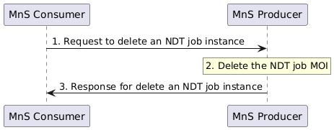
Figure 6.5-1: Procedure for delete an NDT job
1. MnS Consumer sends a request to delete an NDT job instance (see deleteMOI operation defined in TS 28.532 [8]) to MnS Producer with 'objectInstance' of the NDT job MOI.
2. Based on the request, MnS Producer deletes the NDT job MOI.
3. MnS Producer sends response (see deleteMOI operation defined in TS 28.532 [8]) to the MnS consumer with status (OperationSucceeded or OperationFailed) and 'objectInstance' of the deleted NDT job MOI.

6.4.Z Procedure for query an NDT job
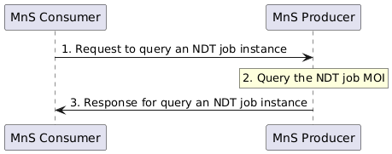
Figure 6.6-1: Procedure for query an NDT job
1. MnS Consumer sends a request to query an NDT job instance (see getMOIAttributes operation defined in TS 28.532 [8]) to MnS Producer with 'objectInstance' of the existing NDT job MOI and list of attribute names of NDT job IOC. The list of attribute names identifies the attributes to be returned by this operation.
2. Based on the request, the MnS Producer queries the concrete NDT job MOI.
3. MnS Producer sends a response (see getMOIAttributes operation defined in TS 28.532 [8]) to the MnS consumer with 'objectClass', 'objectInstance', and list of [Attribute,Value] which is defined in clause 6.2.
End of First change

