3GPP TSG-SA3 Meeting #123 draft_S3-253046-r2
Goteborg, Sweden, 25 – 29 August 2025

Title: LS on business model and architecture for SNPN cellular hotspots
Release: Rel-20

Source: Cisco Systems to be SA3
To: SA1, SA2
Cc: SA

Contact person: eckelcu@cisco.com
Send any reply LS to: 3GPP Liaisons Coordinator, mailto:3GPPLiaison@etsi.org

Attachments: S3-253048

1 Overall description
SA3 received an LS from the Wireless Broadband Alliance (S3-221740) on "Facilitating roaming adoption across 3GPP NPN deployments". Wireless Broadband Alliance specifies and operates OpenRoaming. OpenRoaming is a cloud federation–based framework that facilitates the operation of Wi-Fi hotspots by a broad community of Identity Providers (IdPs) and Access Network Providers (ANPs). Figure 1 shows the high-level architecture. The OpenRoaming federation was established by the Wireless Broadband Alliance in 2020 as an industry solution to enable scalable, seamless, and secure authentication between user devices provisioned with OpenRoaming profiles and their IdPs, who manage the user's credentials while those user's devices are using access networks of organizations that have joined the federation. OpenRoaming defined a legal framework within which the federation operates, a technical framework that covers the automatic establishment of secured signalling between ANPs and IdPs, federation-wide automatic network selection, and closed access group-based policy enforcement implemented by ANPs and IdPs.
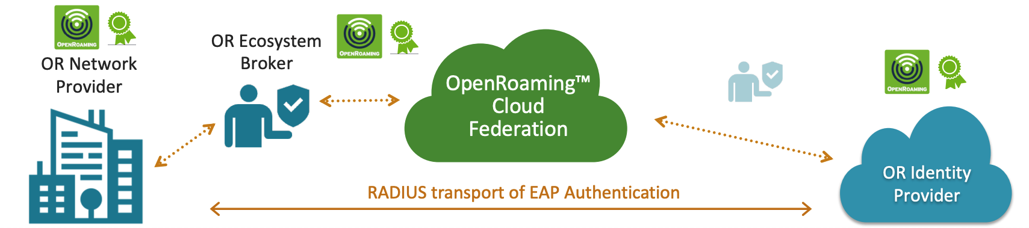
Figure 1: OpenRoaming architecture (source: WBA Website)
SA plenary advised that the most appropriate way for initiating related work in 3GPP is via SA1. This resulted in Study on Interconnect of SNPN (FS_ISN) in SA1, which led to the specification of requirements to support Stand-alone Non-Public Network (SNPN) cellular hotspots in TS 22.261.
A study item proposal to address the security aspects of SNPN cellular hotspots was discussed in SA3 during SA#123 (S3-253048). The proposal claims that the architectural aspects of SNPN cellular hotspots are already addressed in TS 23.501.
SA3 kindly requests SA1 to share the business model for SNPN cellular hotspots. SA3 kindly asks SA2 if additional work is needed in SA2 to address the architectural aspects of the requirements for SNPN cellular hotspots.

2 Actions
To SA1
ACTION: SA3 kindly asks SA1 to share the business model SA1 had in mind while defining the requirements for SNPN cellular hotspots.

To SA2
ACTION: SA3 kindly ask SA2 if additional work is needed in SA2 to address architectural aspects of SA1 requirements for SNPN cellular hotspots.

3 Dates of next TSG SA WG 3 meetings
SA3#124 13 – 17 October 2025 Wuhan, China
SA3#125 17 – 21 November 2025 Dallas, USA

