3GPP TSG-WG SA2 Meeting #171 S2-2509407
13-17 October, 2025, Wuhan , China was S2-2508880

Source: China Mobile
Title: [KI#2, New Solution] DO-A Capable AIoT Device Registration Procedure
Document for: Approval
Agenda Item: 20.5.1
Work Item / Release: FS_AmbientIoT_Ph2_ARC / Rel-20
Abstract: Solution for Registration Procedure for the DO-A Capable AIoT device.

1. Introduction/Discussion
In the WT in Study on Architecture support of FS_AmbientIoT_Ph2, the following is the description for the registration procedure for a DO-A capable AIoT device:
WT#2: Study the support of DO-A Capable AIoT Devices, including:
- Support of the AIoT Device informing the network of its presence autonomously (e.g., an AIoT Device initiated registration-like procedure).
- Support for an autonomous AIoT Device originated procedure to send data to the AIOTF, and support for routing the received data by AIOTF.
- Naiotf and Nnef interface enhancements to provide the data received from an AIoT Device to the AF.
NOTE 4: topology 2 aspect of WT#2 has dependency on WT#1.

2. Text Proposal
It is proposed to capture the following changes in TR 23.700-30.

* * * * First change (all new text) * * * *

6.X Solution #X: DO-A capable AIoT Device Registration Procedure

6.X.0 High-level solution Principles
DO-A capable AIoT devices possess the capability to transmit MO signalling and data. Furthermore, the AIoT device actively registers with the core network to notify it of its presence autonomously.

6.X.1 Description
This solution addresses KI#2, specifically concerning the method by which the DO-A capable AIoT device can autonomously notify the network of its presence for Topology 1.
In this solution, it is assumed:
The AIoT device actively initiates the registration process with the network. The registration types include:
- initial registration.
- mobility registration update.
- Periodic registration.
ADM stores the DO-A capable AIoT device profile information.
AIOTF handles NAS termination and device authentication for DO-A capable AIoT devices and manages registration and mobility for AIoT Devices.

6.X.2 Procedures
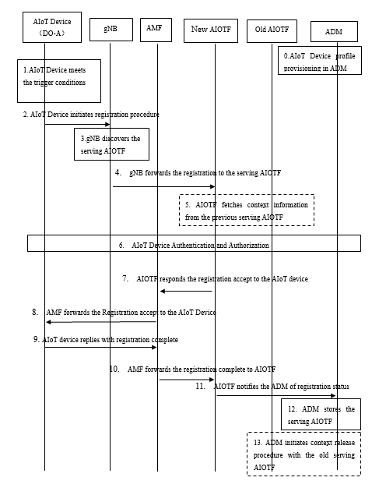
Figure 6.X.2.1: DO-A capable AIoT Device Registration Procedure

- The DO-A capable AIoT Device’s subscription data is provisioned in the ADM
Editor’s Note: The subscription data of a DO-A capable AIoT device is FFS.
- The DO-A capable AIoT Device meets the following trigger conditions, then it will send a NAS Registration Request to the core network.
The AIoT Device performs an Initial Registration if it is not registered with the network.
The AIoT Device performs Mobility Registration if it has moved outside of its AIoT Registration Area.
The AIoT Device performs periodic registration if it has registered on the network and remains in its AIoT Registration Area beyond the designated time period.
Editor’s Note: The details of the AIoT Registration Area need to align with the RAN WG
2. AIoT Device sends a message to NG-RAN, including a NAS Registration Request (Registration Type, Temporary ID, device information, security parameters). Registration can be initial registration, mobility registration, or periodic registration. Then, NG-RAN sends the Registration Request to the selected AMF.
3. The gNB discovers the serving AIOTF.
Editor’s Note: The details of how the gNB discover the serving AIOTF are FFS.

4. The gNB forwards the registration request to the serving AIOTF by either direct connection or indirect connection via the AMF.
5. [Conditional] The serving AIOTF determines the old AIOTF using the temporary ID and retrieves the AIoT Device context from the old AIOTF.
6. The AIOTF performs the Authentication/Security procedure and stores the security context.
Editor’s Note: Details of authentication/security procedures will be determined by the SA3 WG.

7. The AIOTF sends the Registration Accept to the AIoT device via AMF, including a new temporary ID assigned by the serving AIOTF, AIOT Registration Area, and periodical registration timer.
8. The AMF forwards the Registration Accept to the AIoT device via NG RAN.
9. The AIoT device responds to the AIOTF with Registration Complete via NG RAN and AMF.
10. The AMF forwards the Registration complete to the AIOTF.
11. The AIOTF notifies the ADM of the registration complete status about the AIoT device.
12. The ADM stores the serving AIOTF for the AIoT device.
13. [Conditional] If the ADM discovers that the serving AIOTF has changed, then it needs to initiate the context release procedure to the old AIOTF to delete the context in it.

6.X.3 Impacts on Services, Entities and Interfaces
AIOTF:
- Support Registration and Mobility Management.

NG-RAN:
- Supports the AIOTF selection and transferring NAS messages to and from the AIoT Device.
AIoT Device:
- Support performing the registration procedure.
ADM:
- Support new interface with AIOTF.

* * * * End of changes * * * *

