3GPP SA WG2#171 S2-2509387
Wuhan, China, 13-17 October, 2025 (Revision of S2-2508396)

Source: China Telecom
Title: 23.700-30: New Solution of DO-A procedure for DO-A Capable AIoT Devices
Document for: Approval
Agenda Item: 20.5.1
Work Item / Release: FS_AmbientIoT_Ph2_ARC / Rel-20
Abstract: This is a new solution proposal related to KI#2 in the R20 Ambient IoT TR 23.700-30 V0.1.0.

1. Introduction/Discussion
Based on TR 23.700-30 V0.1.0, the following KI#2 shall be studied:
Key Issue #2: Support of DO-A Capable AIoT Devices
This key issue will study the system architecture to support DO-A capable Ambient IoT Devices in Topology 1 and Topology 2.
The following aspects will be studied:
- How the AIoT Device informs the network of its presence autonomously (e.g., an AIoT Device initiated registration-like procedure) and what are the triggers for the DO-A capable device to inform the network of its presence.
- Whether and how to consider power consumption of DO-A Capable AIoT Devices.
- How an AIoT Device sends data to the AIOTF autonomously.
- Support for routing the data received by AIOTF from an AIoT Device to an AF.
- Whether and how to enhance the Inventory and Command procedures defined in TS 23.369 [3] to support DO-A capable AIoT Devices.
- Naiotf, Namf and Nnef interface enhancements to support DO-A capable AIoT Device .
NOTE 1: The conclusions from Key Issue #1 are the basis for supporting DO-A capable AIoT Devices in topology 2 in this key issue.
NOTE 2: Coordination with RAN WGs is required.

This pCR provides a new solution for corresponding to this KI#2 bullet 3, about an DO-A Capable AIoT Device originated DO-A procedure to send data to the AIoTF or AF(via AIoTF).

2. Text Proposal
It is proposed to capture the following changes vs. TR 23.700-30.

* * * * First change (all new texts)* * * *

6 Solutions

6.X DO-A procedure for DO-A Capable AIoT Devices

6.X.0 High-level solution Principles
This solution is for Key Issue #2, corresponding to bullet 3: How an AIoT Device sends data to the AIOTF autonomously.It includes DO-A procedure to send data to the AIOTF, get network resource/assistance information to initial DO-A procedure, and DO-A policy information which descibe when will peform the DO-A procedure.

6.X.1 Description
This solution is for Key Issue #2, corresponding to bullet 3: How an AIoT Device sends data to the AIOTF autonomously.
This solution is to support for an DO-A Capable AIoT Device autonomously originated DO-A procedure to send data to the AIOTF, and support for routing the received data by AIOTF to AF.
The main points are as following:
- The DO-A Capable AIoT Devices support autonomously originat DO-A procedure to send data to the AIOTF.
- The DO-A Capable AIoT Device has pre-configurated network resource/assistance information(e.g. frequency, Qos, Resource Expiration Date,etc) for autonomously originating DO-A procedure; or support to receive the network resource information/assistance information (e.g. frequency, Qos, Resource Expiration Date,etc) from the network for autonomously originating DO-A procedure, using by AIoT write commands or new AIoT service, or network system information etc.
NOTE 1: How to get and the details of the network resource/assistance information for autonomously originating DO-A procedure will be coordinated with RAN WG2.
- When the DO-A Capable AIoT Device will autonomously originats DO-A procedure to send data, is based on the DO-A policy information. The DO-A policy information may be received from network or AF via the network, which send by AF using AIoT write commands or some new AIoT service. Or the DO-A policy information can be pre-configurated in the AIoT device or UICC if have.
- The DO-A policy information may includes:
  - Target information: identify where and which AF the DOA data sends/routes to by AIoT device, for example AF identify, etc；
  - Service policy: describe when and how the AIot device autonomously originated to send DOA datas, such as: 9:00 am every day, when the timer expired, the upper layer initials, etc.
NOTE 2: The details of DO-A policy are coordinated between the operator and AF vender, which is out of 3GPP scope.
- The DO-A Capable AIoT Device supports to autonomously originat procedure to send data to the AIOTF, and support for routing the received data by AIOTF. The procedure may includes: security data, target information and the data information. The secruity data is used for the network authentication AIoT device; and the target information is used to identify where and which AF the DOA data sends/routes to, for example AF identify, etc; the data information is the real data which the AIoT device wants to send for AF.

6.X.2 Procedures
The following figure presents a DO-A procedure for DO-A Capable AIoT Devices for Topology 1 and Topology 2.
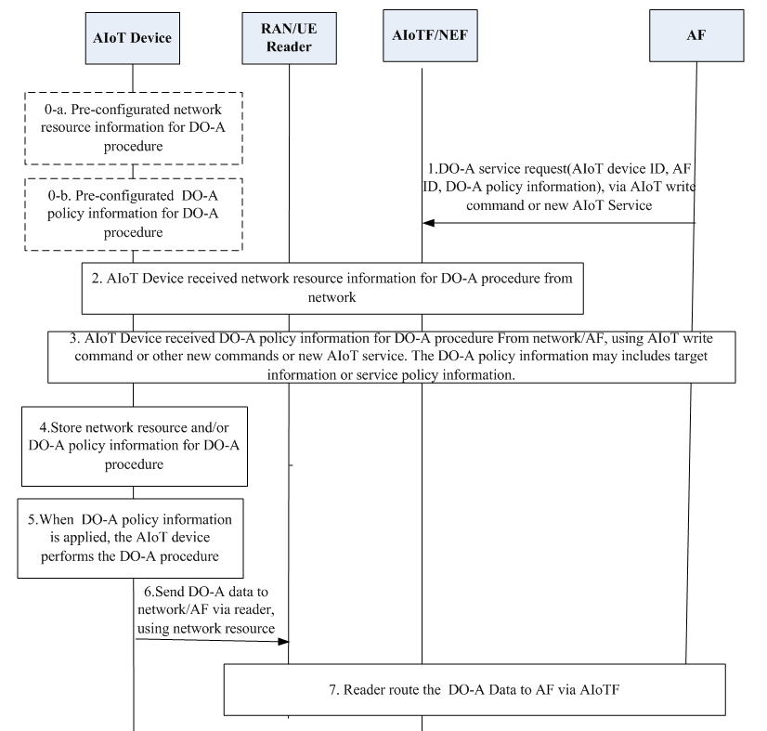
Figure 6.x.2-1: DO-A procedure for DO-A Capable AIoT Devices
0-a. DO-A Capable AIoT Devices may be pre-configured with network resource/assistance information(e.g. frequency, Qos, Resource Expiration Date,etc) for autonomously originating DO-A procedure.
0-b. DO-A Capable AIoT Devices may be pre-configured with DO-A policy information for autonomously originating DO-A procedure.
NOTE 3: How information is configured into AIoT device is out of scope of 3GPP.
NOTE 4: How to get and the details of the network resource/assistance information for autonomously originating DO-A procedure will be coordinated with RAN WG2.
- AF sends like DO-A service request to NEF via AIoT write command or new AIoT Service, it may includes following parameters: AIoT devices ID, AF ID, DO-A policy information, and so on.
- DO-A policy information may includes:
    - Target information: identify where and which AF the DOA data sends/routes to by AIoT device, for example AF identify, etc；
    - Service policy: describe when and how the AIot device autonomously originated to send DOA datas, such as: 9:00 am every day, when the timer expired, the upper layer initials, etc.
NOTE 5: The details of DO-A policy are coordinated between the operator and AF vender, which is out of 3GPP.
- AIoTF/NEF receives the DO-A service request from AF, and will check the authorization of AF and the authorization of DO-A Capable of AIoT devices based on the subscription in ADM. If it is allowed, the network function(e.g. AIoTF or RAN/UE reader) will send the network resource information/assistance information(e.g. frequency, Qos, Resource Expiration Date,etc) for DO-A Capable of AIoT devices autonomously originating DO-A procedure. DO-A Capable of AIoT devices receives these network resource information/assistance information.
- AIoTF/NEF sends the DO-A policy information from AF to DO-A Capable of AIoT devices. DO-A Capable of AIoT devices receives these DO-A policy information.
- DO-A Capable of AIoT devices store these receiving network resource and/or DO-A policy information for DO-A procedure from network.
- When DO-A policy information is applied, for example: the timers from the DO-A policy information expired, the DO-A Capable of AIoT device performs the DO-A procedure.
- The DO-A Capable of AIoT device sends DO-A data to network/AF via RAN/UE Reader, using the storing or pre-configured network resource. The procedure may includes: security data, target information and the data information. The secruity data is used for the network authentication AIoT device; and the target information is used to identify where and which AF the DOA data sends/routes to, for example AF identify, etc; the data information is the real data which the AIoT device wants to send for AF.
- RAN/UE Reader routes the DO-A Data from AIoT device to AF via AioTF based on the target information provide by AIoT device or other solutions.
Editor’s note: How the RAN/UE Reader routes the DO-A Data to AF will be coordinated with solutions for KI 2 bullet of “Support for routing the data received by AIOTF from an AIoT Device to an AF”, or be FFS.

6.X.3 Impacts on services, entities and interfaces
NEF:
- Supports AF to provide DO-A policy informaiton;
AIoTF:
- Supports to receive DO-A data from DO-A capcable AIoT Device and route for AF;
- Supports to provide network resource/assistance information(e.g. frequency, Resource Expiration Date, etc) for AIoT Device DO-A procedure;
RAN Reader or UE Reader:
- Supports to receive DO-A data from DO-A capcable AIoT Device and route for AIoTF;
- Supports to provide network resource/assistance information(e.g. frequency, Resource Expiration Date,etc) for AIoT Device DO-A procedure；
AIoT Device：
- Pre-configured or stores network resource/assistance information(e.g. frequency, Resource Expiration Date, etc) and/or DO-A policy information;
- Performing DO-A procedure once it is needed to send DO-A data.
- Support DO-A Policy(e.g. timer)
Note 6: How the AIoT device support DO-A Policy, e.g. timer, is up to UE implementation.

* * * * End of changes * * * *

