SA WG2 Meeting #172 S2-250xxxx
Dallas, US, 17 Nov – 21 Nov, 2025 (revision of S2-2509789)

Source: Huawei, HiSilicon
Title: [WT#1.2, Localized Service] WT & KI for Localized Service Access
Document for: Approval
Agenda Item: 20.6.1.2
Work Item / Release: FS_6G_ARC / Rel-20
Abstract: This document provides a gap analysis of 5G architecture and concludes that there is a need to improve architecture support for PLMN offered localized service access.

1. Introduction
6G provides the opportunity for operators to achieve CAPEX/OPEX reduction by introducing improvements to the overall 3GPP system performance, e.g., by means of simplifying the overall system, integrating of new technologies, etc. 5G core enabled a cloud-native deployment, and promoted business opportunities by unlocking the possibility of providing services to verticals alongside the traditional consumer services. To shape the 6G architecture to better support the localized service access, this document first provides a gap analysis and identifies the limitations of 5G and subsequently provides architectural motivations as the justifications for studying the architecture support for PLMN offered localized service in 6G.

2. PLMN offered localized service access

2.1 Localized service access
The service requirements for providing access to localized services are captured in clause 6.41 in TS 22.261. The hosting network providing the access to localized services can be a PLMN or NPN. 5G localized service focus on the scenario where localized services are provided by NPN (SNPN or PNI-NPN) as specified in Annex N of TS 23.501, the scenario where localized services are offered by PLMN are not fully investigated. This paper would like to focus on the scenario where the localized services are offered by PLMN.
Localized services can be offered via PLMN to support various services in public area, for example:
- Provisioning local data connectivity service and voice service in the disaster area in response to an urgent event (e.g., disaster, emergency and DDoS events) to improve network resilience, as described in clause 5.6.2 of TR 22.870.
- Verification of the new network services (e.g., XR services) rolling out on the local area network, running test on the selected users in response to new business contract to enable agile and zero-downtime rollout of new services, as described in clause 5.9.5 of TR 22.870.
- Offering customized local area network service (e.g., customized capabilities, and more localized management) for vertical scenarios like factories or campuses, adapting to differentiated and changing demands on network services of various local stakeholders, to simplify the network and improve the network flexibility, as described in clause 5.9.6, 11.10 and 11.23 of TR 22.870.
Offering localised services requires the operator to configure part of the PLMN as a local area network. The local areas network should be easy to deploy, offer the adequate performance and efficient costs, be sufficiently flexible to meet different demands etc. Taking these points into consideration, the PLMN offered localized service access can be characterized by the following attributes:
- it is possible to instantiate millions of PLMN offered localized networks
- the requirements for the PLMN offered localized services become increasingly diverse across difference scenarios and are dynamically changeable
- flexible enough to enable agile service delivery
- allow freedom to enable local control: local subscription, local signalling control, and local traffic forwarding for users, under the lightweight/no control of the PLMN
- changes of PLMN offered localized network are confined locally
- flexible inter-interactions or inter-connectivity among networks of the same PLMN operator
As specified in Annex N of TS 23.501, Localized Service is a service, which is provided at specific/limited area and/or can be bounded in time. The DNN/S-NSSAI can be used as service parameters to determine each Localized Service. And based on attributes characterized above, Figure 2.1-1 gives an architectural example of PLMN offering multiple localize services with each core serving a particular localized service.
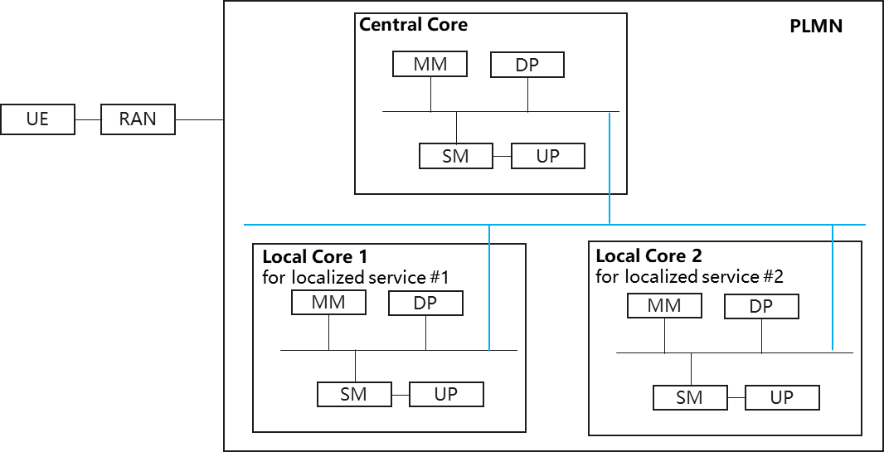
Figure 2.1-1: Architecture for PLMN offered localized service access

2.2 Gap Analysis
SA1 has proposed new use cases and requirements to support certain level of local control for PLMN offered localized service access in TR 22.870
[PR 5.6.1.2-2] Subject to regulatory requirements and operator’s policy, 6G network should support suitable means to ensure the stability of services provided by the edge network in case of abnormal transmission occurring between the public network and the edge network.
[PR 5.6.2.6-1] Subject to operator policies and service level agreements, the 6G system shall enable operators to provision network services as part of the operator’s PLMN network on-demand, e.g., in response to an urgent event (e.g., disaster, emergency and DDoS events), with certain level of local control and specific functionalities in a given area during a specific time period.
NOTE 1: The level of local control can be based on operator policies and agreements with 3rd party. For example, the authorization and policy control of users to access the provisioned services are not affected by the failure of the operator’s PLMN network.
NOTE 4: Local control refers to the capability of part of the operator’s PLMN network to operate autonomously and independently, e.g. management of local subscription, local traffic, without interaction with the operator’s PLMN.
[PR 11.10.6-3] The 6G network shall support a mechanism to allow the operator or authorized 3rd party to perform local control of the localized network when the localized network loses connection with the PLMN network.
[PR 11.10.6-4] The 6G system shall support a mechanism to allow the UE to discover and select the services provided by a localized network.
[PR 11.23.6-1] Subject to operator’s policy, the 6G network shall support means to enable communication between UEs and a service hosting environment in a local 6G network, managed by an authorized 3rd party, when the connection with the remote (non-local) network fails.
NOTE1: The local 6G network is composed of at least 6G RAN and core network of 6G which are deployed in the local area e.g. factory.
5G defined many features that could be used to provide localized service towards verticals such as e.g., NPN, EDGE, slicing etc., however, those features only provide the centralized control for CP signalling, user subscription, policy management. Figure 4.2-1 illustrates how these features can be used to create localized service access but they also suffer from a number of shortcomings. In particular:
- PNI-NPN requires PLMN to offer UDM, PCF, CAG and slicing services;
1) PNI-NPN uses the CAG feature for access control (i.e., prevent unallowed UEs to access the NPN).
1.1) The CAG feature introduces impacts to UE and RAN, thus 5G localized services have dependencies on UE and RAN. The localized services take a hard time to take off because of the complex implementation of CAG feature on UE/RAN and have not yet been widely commercialized till now.
1.2) The network providing localized services is bound to the localized services. Ideally, this network can only be selected during network selection if the UE is subscribed to and aiming to access the localized services. However, the CAG ID is used for network selection and this CAG is independent from any S-NSSAI as specified in clause 5.30.3.1 of TS 23.501. Instead, URSP mechanism is used for access to localized service. This introduces on extra UE dependency that delays the commercialization of localized service.
2) PNI-NPN supports interaction with PLMN network via roaming architecture as specified in Annex N.2.1 of TS 23.501. Even when PNI-NPN is deployed by the same operator as the PLMN network, the existing roaming architecture is used as specified in Annex N.2.1 of TS 23.501.
2.1) When networks providing localized services and the PLMN network are deployed by the same operator, the roaming architecture should not apply for the interactions among the Core network of those networks.
2.2) Policy management: for the home routed roaming case, V-PCF is not involved and thus policy control is managed by H-PCF in the HPLMN. The local policy control is not available in this case.
2.3) Subscription management: for both local breakout and home routed roaming case, UE subscription is managed by UDM in the H-PLMN. This means that local control of the access and mobility management, session management is not available in this case. What is more, the subscription to localized service (time/location validity) need frequent modification of UE subscription. Frequent modification of UE subscription in HPLMN is not efficient and large signalling would be caused.
- EDGE requires PLMN to offer AMF, PCF, UDM and SMF services;
- SLICING requires PLMN to offer network resources such that AMF, SMF, UDM, PCF, UPF are shared among tenants;
- SNPN can be deployed by PLMN operator, but SNPN introduces NID feature that have the same issues as CAG feature. In addition, the SNPN architecture uses underlay-overlay arrangements to support simultaneous connection to localized services and PLMN services. This arrangement is both inefficient and cumbersome for fulfilling the interworking requirement proposed in clause 5.6.2 of 3GPP TR 22.870: [PR 5.6.2.6-2] Subject to operator policies and service level agreements, the 6G system shall enable a network operator to authorize a UE, that is subscribed to local network services, to access services from the PLMN of the same operator.
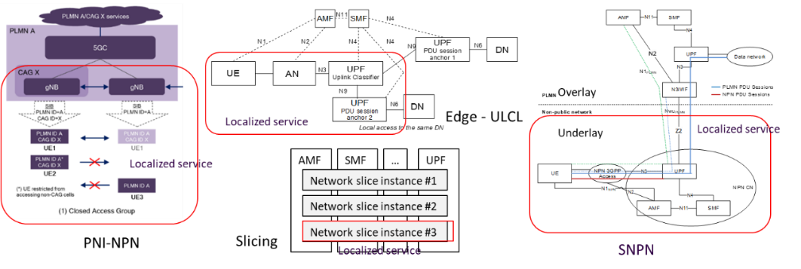
Figure 2.2-1: Architecture for PNI-NPN, Edge, Slicing, and SNPN
5G also attempts to define the certain level of local control on dedicated aspects: e.g., session management in ETSUN or information exposure in UPEAS. However, those features only allow very limited local control:
- In case of ETSUN, when the UE is outside of the SMF service area, an I-SMF and I-UPF are inserted to locally serve the UE location, and SMF and UPF anchor services are still remained for the PDU session.
- UPEAS only enables the local exposure for certain information (e.g., Private UE IP, Usage Data Usage etc.) via local NEF and UPF.
Observation 1: PLMN offered localized service access with the desired level of local control (e.g., Policy management, subscription management, access and mobility management, session management) cannot be fully supported in the context of 5G architecture. Additionally, the access control mechanism used for networks providing localized service doesn’t consider the UE’s localized service information and introduces heavy UE dependencies that hinder the commercialization.

As described in TS 22.870, the UE that is subscribed to the localized services can also use PLMN services or other localized services deployed by the same operator,
[PR 5.6.2.6-2] Subject to operator policies and service level agreements, the 6G system shall enable a network operator to authorize a UE, that is subscribed to local network services, to access services from the PLMN of the same operator.
[PR 5.9.6.6-2] Subject to operator policies, and agreement between the PLMN operator and authorized 3rd party, the 6G network shall support a mechanism to
- authorize PLMN’s users to access a subscribed service provided by an authorized 3rd party via a local area network (deployed by the PLMN operator)
- minimize service interruption when the serving network changes between the local area network and the PLMN network
[PR 11.10.6-1] Subject to an agreement between a PLMN operator and authorized 3rd party, operator policies and regulatory requirements, the 6G network shall support a mechanism to authorize UEs owned by a trusted authorized 3rd party (e.g. vertical industry) to access services provided by a localized network (deployed by the PLMN operator for the authorized 3rd party).
[PR 11.10.6-2] Subject to an agreement between a PLMN operator and authorized 3rd party, operator policies and regulatory requirements, the 6G network shall support a mechanism to authorize and authenticate UEs owned by a trusted authorized 3rd party to access services from the PLMN operator.
When the NRF is deployed at slice-specific level and the localized services are bound to a specific slice, there is no possibility to enable the interactions between the NFs tied to localized services (e.g., for verticals) and other NFs in the PLMN. When the NRF is deployed at PLMN-level or shared-slice level as the centralized NRF, in order to discover NFs tied to localized services by other NFs (e.g., AMF, SMF) in the network (or vice versa), following the current 5G mechanism, those NFs should register their NF profiles directly to the centralized NRF, or indirectly via an intermediate NRF serving the corresponding localized services, as specified in clause 5.2.2.2.3 of 3GPP TS 29.510.
c) the registering NRF may include nrfInfo which contains the information of e.g. udrInfo, udmInfo, ausfInfo, amfInfo, smfInfo, upfInfo, pcfInfo, bsfInfo, nefInfo, chfInfo, pcscfInfo, lmfInfo, gmlcInfo, aanfInfo, nfInfo and nsacfInfo in the nfProfile locally configured in the NRF or the NRF received during registration of other NFs, this means the registering NRF is able to provide service for discovery of NFs subject to that information;
This means the centralized NRF holds the profile for all NFs (not only NFs for PLMN services, but also NFs tied to localized services), causing extra load on NRF. And more importantly, this brings security risks because any topology changes (including incorrect or malicious topology information) from substantial localized services are updated to the centralized NRF, and also this potentially affects other PLMN/localized services in the PLMN network.
Observation 2: If localized service uses the current 5G NF management mechanism, it might bring heavy load on the centralized NRF and any changes of localized services will cause wide impacts across the entire network.

In case of cross-domain interaction in 5G, e.g., roaming between visiting and home network as shown in Figure 2.2-2, NF discovery request and service request are both rerouted over the home network as shown in the below figure, causing extra signalling and procedure delay. This problem also exists when a UE, that is subscribed to local network services, accesses PLMN services, as described in clause 11.9 and 5.6.2 of TS 22.870. In this case, the local network services and PLMN services can be treated as visiting PLMN and home PLMN respectively.
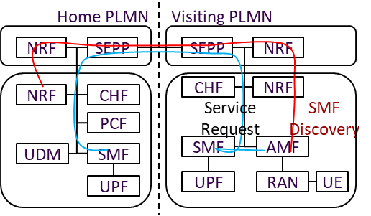
Figure 2.2-2: NF discovery and service request signalling in roaming cases
Observation 3: Current 5G NF discovery and selection mechanism is inefficient for cross-domain message forwarding and routing in case of localized service access.
When UE accesses localized services, local NFs, i.e., AMF and SMF in 5G, need to discover the centralized UDM for UE subscription data retrieval. As shown in Figure 2.2-3, local NFs tied to localized services can subscribe to changes of the UDM registered in the central NRF via the local NRF. In case of network upgrade, the centralized NRF needs to notify all subscribed NFs including local NFs, of NF profile changes of the upgraded NF, while such NF profiles can be the UDM that includes lots of SUPI ranges. This results in signalling storm of notification messages with large payload in the whole network.
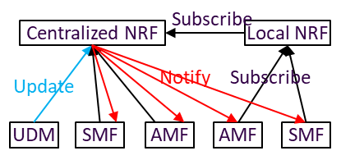
Figure 2.2-3: Subscribe-Notify with intermediate NRF
Observation 4: If localized service uses the current 5G NF management mechanism, it might cause signalling storm with large payload packet when the network upgrades, which happens frequently for localized service.

Study how to design 6G architecture to support the PLMN offered localized service access with certain level of local control is necessary. The motivation is not only to satisfy the SA1 requirements, but also, this promotes business opportunities for PLMN operators, and extremely enlarges the monetization space for operator’s PLMN network. In addition, this can help gain benefits on the operators’ CAPEX/OPEX reduction when providing localized services, e.g., by signaling overhead reduction in case of cross-domain interactions and avoiding signalling storm in case of network upgrade or network scaling.
Proposal: It is proposed to study 1) how to enable the 6G architecture to support certain level of local control for PLMN offered localized service access, and 2) how to enable efficient interactions between networks providing localized service and PLMN networks, and between different networks providing localized service.

2. Text Proposal
It is proposed to capture the following changes vs. TR 23.801-01.

* * * * First change * * * *

Annex A.X. WT#1.2 Scope for localized service access
The scope of localized service access is to study the overall architecture design and enablers for localized service access in 6G, including:
NOTE 1: Support for access to Localized Services as specified in 5G (refer to TS 23.501) is the starting point for the discussion on support of 6G use cases and requirements related to localized service access.
0. How to define the network providing localized service access.
1. Authorization and authentication of UE for localized service access including subscription aspects
NOTE 2a: Authorization, authentication aspects need to be coordinated with SA3
NOTE 2b: The subscription aspects include the study of subscription management, authorization and authentication that are performed by the related NFs present locally in the network providing localized service access.
2. Whether and how to support UE mobility, service continuity
2.1) between PLMN network and network providing localized service access, or between the networks providing localized service access, including interface and interaction procedure between PLMN network and networks providing localized service access, or between the networks providing localized service access.
2.2) within the network providing localized service access.
NOTE 3a: Service continuity refers to accessing the same service that can be reached through both the source network and the target network.
NOTE 3b: Localized service access can be provided by a part of a PLMN as well.
NOTE 3c: One single network can provide one or more localized services.
3. Whether and how to support session management, policy management for UE using localized service access.
4. Whether and how to perform the network access control in the PLMN network providing localized service access.
NOTE 4: It is assumed that there is no or minimal dependency on UE and RAN for network access control.

* * * * Second change * * * *

5.Y Key Issue #Y: Architecture impacts to support localized service offered by PLMN
To offer localized services, the network providing the localized service (e.g., local core network or access network) can be configured by MNOs as part of the PLMN network. The network providing the localized service should be easy to deploy and use, provide adequate performance, be cost effective, sufficiently flexible to meet demands etc. The key issue of localized service access is to study the overall architecture design and enablers for localized service access in 6G, including:
- study how to support certain level of local control for PLMN offered localized service access, including:
- The architecture and interface to support local control for the UE accessing the PLMN network providing localized service, i.e., enable NFs present locally to perform network access control, mobility management, session management, policy management, topology management etc.
- How to authenticate and authorize a UE, that is subscribed to localized services offered by PLMN network, to access the localized services when the UE is in specific area, with minimum impacts to PLMN network.
- How to update or provision the UE subscription in the network and UE configuration to enable the UE to access the subscribed localized services.
- How to support fast delivery of the new or updated services/capabilities for a specific localized service within the PLMN network providing localized service, and with no/minimal disruption to existing services.
- How to enable a UE to access the PLMN network providing localized services
- How to enable a UE to discover and select the localized services
- When the networks providing localized service are part of the same PLMN network, study the interface and interaction procedure between PLMN network and networks providing localized service, or between networks providing localized service, including:
- How to perform NF discovery and selection, message forwarding and routing between PLMN network and network providing localized services, or between networks providing localized service, this needs to take the minimization of impacts towards PLMN into account.
- Whether and how to support UE mobility, service continuity between PLMN network and network providing localized services, or between networks providing localized service.

* * * * End of changes * * * *

