**SA WG2 Meeting #170 S2-250xxxx**

**25 – 29 Aug, 2025, Goteborg, SE (Revision of S2-2506387 and multiple merged papers)**

**Source: OPPO, China Unicom, China Telecom, China Mobile, MediaTek**

**Title: [WT#6] 6G Computing Support**

**Document for: Agreement**

**Agenda Item: 20.6.6**

**Work Item / Release: FS_6G_ARC/Rel-20**

*Abstract of the contribution: This paper proposes the WT update and KI description on 6G computing in TR 23.801-01.*

# 1. Justifications

Editor's Note: This justification section is not included in the TR; it is intended solely to justify the scope of the proposed WT.

## 1.1 Motivation

Delay time is a key factor influencing User Experience. For the new emerging delay sensitive services (e.g., Intent-based AI task, online gaming, XR), delay time should comprise communication delay time and computing delay time. But the legacy QoS design in previous generations (i.e. 4G and 5G) only addresses the connectivity delay time, the computing delay was ignored in previous generations since very few services would require much computing time.

Not all UEs are able to support high computing performance, while offloading some complicated computing tasks to network can solve the issue of lack of sufficient computing resource at UE side; A side benefit would be to help the UE to save power and reduce cost by seeking computing assistance from 6G network.

In 5G design, the UE is agnostic whether Edge Computing is supported by network, which makes it impossible for the UE to request Edge Computing support for some services. But for some services (e.g., complicated computing task, Intent-based AI task, online gaming and immersive service), the UE should be able to request computing support from network in order to achieve differentiated user experience.

In 6G, it will be beneficial for network to coordinate the communication and computing resources, which achieves a high efficiency of resource usage to guarantee the overall end-to-end delay (i.e., communication delay and computing delay) which is a key factor for QoE.

## 1.2 Technical Impact

New functions (e.g., Computing Management Function) may need to be introduced into 6GS to manage computing resources in coordination with communication, which also requires corresponding interaction among the UE and the network functions.

The CMF is responsible for the computing resource management in 6G core network and can be collocated with 6G SMF.



Figure 1: Potential Computing Architecture in 6G

Regarding to the computing resource, basically, there are two scenarios to be studied for computing resource support in 6GS.

Scenario-1: computing resource from CN

The CN function provides computing resource managed by CMF/SMF. The computing resource can be provided by computing node(s) separate to UPF or collocated to UPF. Scenario-1 has benefits to operator provided new services (e.g., sensing, positioning), because the data needs to be processed within core network regarding the security/privacy and real-time requirement. In addition, computing nodes in CN helps to avoid the data transmission latency over N6 and better coordinate the communication and computing resources.

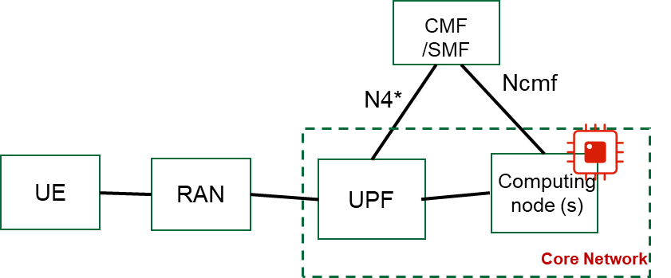

Figure-2: computing resource from CN

Scenario-2: computing resource from DN

the DN function provides computing resource managed by CMF/SMF via UPF. In this scenario-2, the edge computing resource in DN can be reused, the CN, with some enhancements, may get aware of computing resource status in DN in addition to N6 delay, so that CMF/SMF may configure a more suitable communication QoS and update it dynamically.

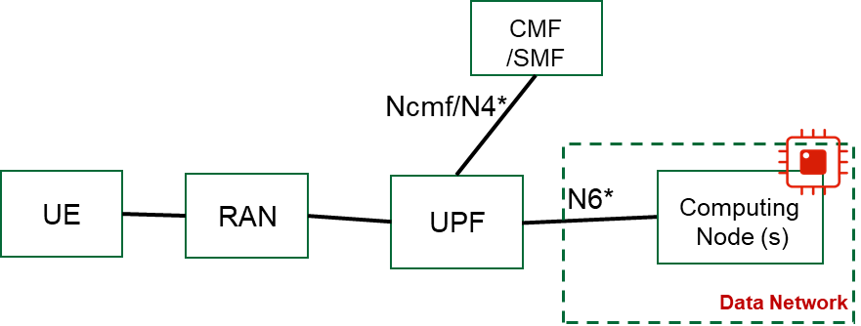

Figure-3: computing resource from DN

# 2. Addressing Missing Aspects from Merged Papers

Input from following papers were considered in the merged revision:

|  |  |  |  |  |  |
| --- | --- | --- | --- | --- | --- |
| 20.6.6 | **[S2-2506361](Docs\\S2-2506361.zip)** | P-CR | Approval | 23.801-01: [WT#6]Working tasks and key issues for 6G computing | China Mobile |
| 20.6.6 | **[S2-2506387](Docs\\S2-2506387.zip)** | P-CR | Approval | 23.801-01: [WT#6] 6G Computing Support | OPPO |
| 20.6.6 | **[S2-2506680](Docs\\S2-2506680.zip)** | P-CR | Approval | 23.801-01: [WT#6, Computing in 6G] Key Issue on Computing in 6G | NEC Corporation. |
| 20.6.6 | **[S2-2506891](Docs\\S2-2506891.zip)** | P-CR | Approval | 23.801-01: [WT#6] Compute as a service in 6G network | Intel |
| 20.6.6 | **[S2-2506924](Docs\\S2-2506924.zip)** | P-CR | Approval | 23.801-01: [WT#6, Computing] Key Issue for Computing in 6G | Lenovo |
| 20.6.6 | **[S2-2506985](Docs\\S2-2506985.zip)** | P-CR | Approval | 23.801-01: [WT#6, 6G computing] 6G computing for UE | Vivo |
| 20.6.6 | **[S2-2506995](Docs\\S2-2506995.zip)** | P-CR | Approval | 23.801-01: [WT#6] Computing Enabler service, coordination of communication and computing service | Huawei, HiSilicon |
| 20.6.6 | **[S2-2507020](Docs\\S2-2507020.zip)** | P-CR | Approval | 23.801-01: [WT#6] Working tasks and key issues for 6G computing (Resource as a Service (RaaS)) | Rakuten Mobile, SK Telecom, SoftBank, NVIDIA, NEC, NIST |
| 20.6.6 | **[S2-2507024](Docs\\S2-2507024.zip)** | P-CR | Approval | 23.801-01: [WT#6, Computing] Scope and New Key Issue for Computing | LG Electronics |
| 20.6.6 | **[S2-2507128](Docs\\S2-2507128.zip)** | P-CR | Approval | 23.801-01: [WT#6, Computing] Discussion and proposal for computing | ZTE |
| 20.6.6 | **[S2-2507165](Docs\\S2-2507165.zip)** | P-CR | Approval | 23.801-01: [WT#6, Computing in 6G] Work Task Scope and Key Issues for computing in 6G | Tencent, Tencent Cloud |
| 20.6.6 | **[S2-2507184](Docs\\S2-2507184.zip)** | P-CR | Approval | 23.801-01: [WT#6, Computing] Support computing in 6G | CATT |
| 20.6.6 | **[S2-2507430](Docs\\S2-2507430.zip)** | P-CR | Approval | 23.801-01: SA WG2#170_WT_6_supporting for computing service | Xiaomi |
| 20.6.6 | **[S2-2506810](Docs\\S2-2506810.zip)** | P-CR | Approval | 23.801-01: [WT#06] Scope and key issue on computing | NTT DOCOMO, T-Mobile USA, InterDigital Inc, Ofinno, KPN N.V. |
| 20.6.6 | **[S2-2507280](Docs\\S2-2507280.zip)** | P-CR | Approval | 23.801-01: [WT#6] Scope for work task on compute | Qualcomm |
| 20.6.6 | **[S2-2507395](Docs\\S2-2507395.zip)** | P-CR | Approval | 23.801-01: [WT#6] Justification: of work task scope for 6G Compute | Nokia, Ericsson |
| 20.6.6 | **[S2-2506441](Docs\\S2-2506441.zip)** | P-CR | Approval | 23.801-01: [WT#6] Work Task clarification | Samsung |
| 20.6.6 | **[S2-2506889](Docs\\S2-2506889.zip)** | P-CR | Approval | 23.801-01: [WT#6, Computing] Work task description for 6G Computing | Apple |
| 20.6.6 | **[S2-2506965](Docs\\S2-2506965.zip)** | P-CR | Approval | 23.801-01: [WT#6] WT Scope and KI proposal on computing | China Telecom |
| 20.6.6 | **[S2-2506982](Docs\\S2-2506982.zip)** | P-CR | Approval | 23.801-01: [WT#6, all topics] Computing service for 6G | MediaTek Germany GmbH |

## 2.1 Exposure to 3rd party AF

This aspect was mentioned by S2-2506361, S2-2506680, S2-2506891, S2-2506995, S2-2507020, S2-2507024, S2-2507128, S2-2507165, S2-2507430, S2-2506889, S2-2506965.

It’s now addressed in the revision.

## 2.2 Service Continuity upon Computing Resource Re-location

This aspect was mentioned by S2-2506361, S2-2507165, S2-2507184.

It’s now addressed in the revision.

## 2.3 Define new QoS characteristics or metrics

This aspect was mentioned by S2-2506361, S2-2507395.

It’s now addressed in the revision.

## 2.4 Charging

This aspect was mentioned by S2-2507430 and should be left to SA5. As charging aspect has been addressed in the 6G SID as general issue, there is no need to add a WT/KI bullet for computing.

## 2.5 Computing Server Discovery

This aspect was mentioned by S2-2507395.

It’s now addressed in the revision.

## 2.6 Leveraging 5G EC design

This aspect was mentioned by S2-2507395 and S2-2507280.

As we are going to discuss which of 5G features will be inherited by 6GS, this can be left to that general discussion, once determined, the features defined by 5G EC design can be considered during the solution development and normative phase.

In 5G EC design, only the communication delay aspect was considered, so just reusing 5G EC design with slight enhancement can’t satisfy the services requiring computing delay.

A NOTE is added to address this aspect in the revision.

**** First Change (all new text) ****

# Annex A.X. WT#6 Scope

Editor's Note: Describe the technical scope of the proposed Work Task. If applicable, suggest logical subdivision of this WT into smaller sub-WT. This clause is part of the TR Annex.

**WT#6:** Study aspects on support of computing for UE, core network and application server in 6G (e.g. coordination between UE, core network and application server, exposure of computing service in the core network, etc.).

NOTE 1: Application layer mechanism and exposure framework may require coordination with SA6.

The delay time comprises the connectivity delay and computing delay, but usually the computing delay was ignored in previous generations since very few services would require much computing time. In order to support the services (e.g., XR, rendering, online gaming, AI model inference, etc.) requiring low delay and high computing demand with better user experience from delay perspective, the UE or 3rd party may need computing resource support from the 6G network.

In order to support computing resource management among the UE, Core Network and Data Network in 6GS, the following aspects of need to be studied:

* How to authorize computing for UE and provisioning the corresponding policy and parameter to UE in case UE is a consumer for operator provided computing service.
* How does 6G network collect the computing resource information, whether and how to expose the computing resource information to an authorized 3rd party AF.
* How to discover and select Computing resource[s] under the control of 6G core network.
* How does the UE or 3rd party AF request the computing resource from 6G network and how does the 6G network authorize and allocate the network-side computing resource to UE or 3rd party AF.
* How does 6G network coordinate the communication and computing resources for E2E delay, and how to define and guarantee the QoS characteristics (e.g., delay budget) or new metrics for a service requiring computing support.

NOTE 2: Exposure of network metrics will follow the exposure framework defined in WT#1.2.

* How to guarantee the service continuity for computing service upon computing resource relocation (e.g., due to UE mobility, computing node load balancing, AF influence, etc.).
* Whether and how to re-use and/or enhance Edge Computing features specified in 5G (i.e., EAS discovery procedure specified in TS 23.548) to enable discovery of Application Server providing computing services to UEs.

NOTE 3: The selected features from 5G edge computing design can be considered to support 6G computing if necessary.

**** End of Changes ****