SA WG2 Meeting #170 S2-2507701
Goteborg, Sweden, 25 - 29 Aug, 2025,

Title: KI#4, New Sol: Direct Connection between gNB and Sensing Function for Sensing Data Collection and Transport
Source: BUPT, Toyota Motor Corporation
Document for: Approval
Agenda Item: 20.2.1
Abstract: A direct connection mechanism initiated by gNB for sensing data collection and transport is proposed for FS_Sensing_ARC

1. Discussion
This pCR proposes a solution for Key issue#4: Sensing Data Collection and Transport.

2. Proposal
It is proposed to capture the following changes in TR 23.700-14.

* * * * First change * * * *

6 Solutions

6.0 Mapping of Solutions to Key Issues
Table 6.0-1: Mapping of Solutions to Key Issues
 | Key Issues
Solutions | 1 | 2 | 3 | 4 | 5 | 6
X |  |  |  | X

* * * * Second change (All Text New) * * * *

6.X Solution #X: Direct Connection between gNB and Sensing Function for Sensing Data Collection and Transport

6.X.0 High-level solution Principles
The solution is based on the following general principles to support sensing service:
- The Sensing Control Function (SCF) is introduced to support the management of control plane signalling for sensing services.
- If the SCF decides to establish direct gNB-SPF connection. A sensing session is established, which enables the transmission of sensing data and the Associated Information between the gNB and the Sensing Processing Function (SPF).
- The sensing session provides an asssociation between the gNB and the SPF for carrying sensing data.

- The SCF provides the gNB with the information required for establishing the direct gNB-SPF connection.
- The gNB and SPF may maintain the established direct connection, which can be reused for subsequent transmissions of sensing data and related information triggered by either the gNB or the sensing function.

6.X.1 Description
This solution provides a method to support the transfer of sensing data and the associated information. It provides a sensing session establishment procedure between gNB and Sensing Function (SF).
When sensing signalling control and the sensing data processing separation is applied, the SCF is responsible for the management of the sensing session context. If the SCF determines that the direct gNB-SPF connection is to be used for the reporting of sensing information (e.g., sensing measurement data or sensing measurement results), the SCF may reuse an existing sensing session or trigger the establishment of a new sensing session.
The SCF may support further perform the sensing session policy association establishment procedure to obtain the policy information for the sensing session. The SCF supports the SPF selection function to determine a Sensing SPF that can be used for a sensing session to meet a specific sensing requirement. Through this session, the gNB can transfer sensing data directly to the SPF via the established connection.
The SPF is responsible for requesting and collecting sensing data the selected sensing entities processing the collected data to generate sensing results.

6.X.2 Procedures
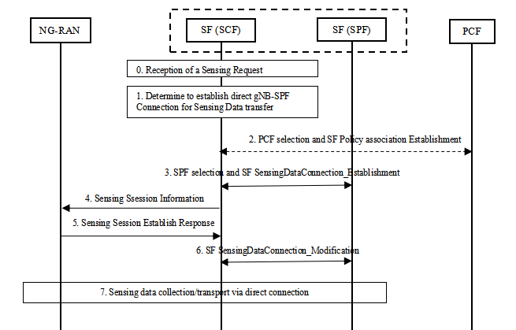
Figure 6.X.2: Direct gNB-SPF Connection
- The SCF receives a request to generate sensing results, for example, upon receiving a sensing request from an AF.
- The SCF decides to establish a direct gNB-SPF connection for the collection and transmission of sensing data and related information. Based on the received sensing request, the SCF discovers and selects sensing entities. If a sensing session context for the sensing entity already exists in the SCF and the SCF can use the existing direct gNB-SPF connection for sensing data transmission, steps 2-6 are skipped.
- Sensing session related policies can be pre configured in the SCF or obtained from the PCF by SCF. If needed, the SCF performs the PCF selection. The SCF may select a PCF instance from the available PCF instances obtained from the NRF or from locally configured information within the SCF. The SCF performs the sensing session policy association establishment procedure to establish the sensing policy association with the PCF. The SCF sends the request and the corresponding parameters, e.g., the gNB ID, the Sensing Service identification, session ID and Sensing Service Network Resource Selection Assistance Information (SNRSAI), to the PCF to obtain the policy information for the sensing session.
- The SCF selects one or more SPFs based on the sensing request to perform the transmission of sensing data, for example based on the following information: sensing area information, SPF capabilities, SPF load, SPF location information, SNRSAI, sensing entity information, sensing related policies and sensing service identification.
The SCF initiates the SF sensing data transport session establishment procedure with the selected SPF. The SCF sends an SPF sensing data transport session establishment/modification request to the chosen SPF to provide packet detection, enforcement and reporting rules for receiving, forwarding and/or processing sensing data. The SPF provides the SPF tunnel information to the SCF including the tunnel endpoint information.
- The SCF creates a sensing session context (e.g. Sensing Session ID, Sensing Service Identification, Tunnel information, Policy information, SPF selection information and NG-RAN node information) and sends direct sensing connection establishment information to the selected NG-RAN node, for sensing data transmission. The information may include SCF identifier and address, sensing session ID, sensing service identification, QoS information and SPF tunnel information.
Editor’s note: Details of sensing session context are FFS.
- After receiving the direct sensing connection establishment information, the NG-RAN node allocates (R)AN tunnel information for the sensing session and configures the resources according to the received resource configuration policy. And then returns a session establishment response including (R)AN tunnel information.
- The SCF initiates the sensing data transport session modification procedure.
- Sensing data and related information are transmitted between the sensing entity and the sensing function over the direct gNB-SPF connection.
Editor’s note: Impacts to RAN will be coordinated with RAN WGs..

6.X.3 Impacts on services, entities and interfaces
SCF:
- Support sensing session context management.
- Support to provide the direct gNB-SPF connection information to the NG-RAN node.
- Support to obtain the policy information for the sensing session.
- Support to configure the SPF for receiving, forwarding and/or processing sensing data.
SPF:
- Supports sensing data collection from NG-RAN nodes.
- Supports to receive, forward and/or process sensing data.
gNB:
- Support to establish a sensing session with the SPF.

* * * * End of changes * * * *

