3GPP SA WG2#170 S2-2507732

Goteborg, Sweden, 25-29 August, 2025 was S2-2506708

**Source: Tejas Networks Limited**

**Title:** **P-CR: New Solution for gNB based sensing**

**Spec: 3GPP TR 23.700-14**

**Agenda item: 20.2.1**

**Work Item / Release: FS_Sensing_ARC/ Rel-20**

**Document for:** **Approval**

*Abstract of the contribution: This contribution proposes a new solution to Key Issues 6 when gNB is chosen as a sensing entity.*

**1. Introduction**

The SA2 SID on architecture enhancement to support Integrated Sensing and Communication was approved in SP-250401 with the understanding that the scope of the sensing study in Rel-20 would be decided in alignment with RAN TSG. In RAN#108, RAN plenary decided to limit the scope of sensing related studies to gNB based monostatic sensing (reference:RP-251861).

Based on the decision of RAN#108, this paper proposes a new solution for the following KI defined in SP-250401viz.,

* Configuration parameters for the support of ISAC services (KI#6).

**2. Text Proposal**

It is proposed to adopt the following text within TR 23.700-14.

**\* * * First Change * * * \***

# 6 Solutions

## 6.0 Mapping of Solutions to Key Issues

Table 6.0-1: Mapping of Solutions to Key Issues

|  |  |  |  |  |  |  |
| --- | --- | --- | --- | --- | --- | --- |
|  | Key Issues | | | | | |
| Solutions | <Key Issue #1> | <Key Issue #2> | <Key Issue #3> | <Key Issue #4> | <Key Issue #5> | <**Key Issue #6**> |
| X |  |  |  |  |  | X |

**\* * * * Next Change (All New Text) * * * \***

## 6.X Solution #X: Monostatic sensing operation with gNB as serving entity

### 6.X.1 High-level solution principles

The solution proposed in this paper is based on the following principles:

* The discovery of the gNB which serves as the sensing entity is carried out via the AMF.
* The AMF collates information on the capabilities related to sensing from the associated gNBs and provides it to SF.
* SF is responsible for choosing and configuring the sensing entity for performing the monostatic sensing operation.

### 6.X.1 Description

Sensing service is initiated by an AF by sending a sensing service request. After the service request is successfully authorized, the SF chooses AMF(s) that serve a geographical area corresponding to the target sensing area. The sensing capability of these gNBs connected to these AMFs are then shared with the SF, which chooses candidate Sensing Entity (SEs) and configures the same.

### 6.X.2 Procedures

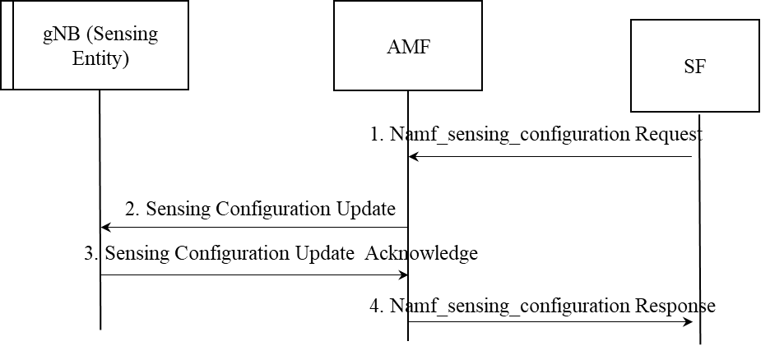

Figure 1: Configuring sensing entity via AMF.

### 6.X.2.1 Sensing configuration and associated transport mechanisms

Once SF chooses a sensing entity, it provides the following configurations for collecting the sensing data/information from the sensing entity. The set of example configurations are listed below:

1. Configurations related to the sensing request e.g., target sensing area, required sensing accuracy, vertical sensing resolution, horizontal sensing resolution, choice of sensing mode, object characteristics e.g, size, range of velocity of target etc.
2. Frequency of collection of sensing measurements/sensing reports/data/parameters: This configuration indicates the time unit of collection of sensing measurements e.g., Periodic, one-time.

Note: The actual set of configurations provided to the sensing entity depends on the service requirements and need not contain all of the above-mentioned parameters.

These configurations can be transported to the SE via the AMF. In order to carry out the same, extensions to AMF services to transport the configuration between AMF and SF is to be supported. For transporting the configurations between the AMF and the gNB(s), an enhanced version of NGAP or a new protocol for sensing defined between the endpoints as AMF and gNB can be used.

For example, if NGAP is to be used, it has to be enhanced to support the transport of sensing related configuration. For example, similar to “RAN configuration update” and “AMF configuration Update”, a “Sensing Configuration Update “message may be defined over NGAP to support this functionality.

Note: The decision of the transport protocol to be used between the AMF and gNB will be made by RAN3.

### 6.X.2.4 AMF Services for the support of ISAC services

For supporting gNB based monostatic sensing, the following services are required to be supported at the AMF.

|  |  |  |  |
| --- | --- | --- | --- |
| Service Name | Service Operations | Operation  Semantics | Example Consumer(s) |
| Namf_Sensing | Configuration | Request/Response | SF |

1. Namf_Sensing_Configuration

**Service operation name:** Namf_Sensing_Configuration

**Description:** This service operation enables the NF service consumer to provide AMF with the set of parameters used to configure Sensing Entities.

**Inputs, Required:**

1. SF ID
2. At least one of the following parameters are included:
   1. Identifier of Sensing Entity e.g., gNB ID
   2. Configurations related to sensing request
   3. Periodicity of sensing report requested
   4. Set of output parameters requested
3. Notification Endpoint.

**Inputs, Optional:** None

**Outputs, required:** Transaction ID, Acknowledgment Result (indicating if configuration was successful or failed), Failure cause in case of failure.

**Outputs, Optional:** None.

### 6.X.3 Impacts on Services, Entities and Interfaces

The following impacts are envisioned on the existing network functions:

AF:

* For supporting sensing service, the functionality of AF is enhanced to provide service parameters.

AMF:

* For supporting sensing, the AMF needs to support additional services to transport configurations related to sensing.

SF

* For supporting sensing, SF needs to be able to provide configurations related to sensing.

gNB

* The gNB should be able to serve as a sensing entity and be able to receive configurations related to sensing.

**\* * * * End of Changes * * * \***