**3GPP TSG-SA WG2 Meeting #170S2-2507480**

**Aug 25-29, 2025 Goteburgh, Sweden (a revision of S2-2506977)**

**Source: Skylo Technologies, Verizon, Qualcomm, Sateliot, Novamint**

**Title: Example message size and corresponding transmission delay for I1 messages**

**Agenda item: 20.1.1**

**Document for: Discussion/Approval**

**Work Item / Release: FS_5GSAT_Ph4_ARC /Rel-20**

*Abstract of the contribution:* *This paper proposes pCR to Annex A of TR 23.700-19*

# 1 Introduction

In IMS network, the I1 protocol is a lightweight application protocol specified in TS 24.294 to enable I1 session control entities to exchange the I1 protocol messages over any transport-layer protocol that connects the ICS UE and the SCC AS. The I1 protocol allows the ICS UE and SCC AS to exchange service control information related to session setup, modification, and release, regardless of the underlying access technology or transport layer.

The I1message includes I1 message common part and I1 information elements. The I1 message common part is included in every I1 message. The I1 information elements those are included in an I1 message depend on a type of I1 message being sent. The I1 message common part (message header, message type, protocol version, some basic fields) is 7 bytes. Each IE is encoded with a small TLV overhead (assumed ~2 bytes per IE to carry IE-type/length) plus the IE payload bytes.

TS 24.294 also defines various state for UE-originated establishment procedure.

* Trying: After sending I1 INVITE, waiting for provisional/positive response.
* Proceeding/Proceeding: After receiving I1 PROGRESS (“Call progressing” or “Ringing”), waiting for final success/failure.
* Alerted: After receiving I1 PROGRESS(“Ringing”), providing local alerting.
* Confirmed: After receiving I1 SUCCESS (session accepted).
* Released: After sending or receiving BYE/FAILURE, session torn down.

The UE moves between these states based on the message type (PROGRESS/SUCCESS/FAILURE) and the Reason value. Timers E, F, F1 also control retransmission and expiry in Trying and Proceeding.

And the following sates are defined for SCC AS.

* Initiated: After receiving INVITE, before sending provisional.
* Progressing/Proceeding: After sending PROGRESS (“Call progressing”), awaiting further signalling from UE or remote party.
* Alerting: After sending PROGRESS(“Ringing”), awaiting answer or release.
* Confirmed: After sending SUCCESS (session accepted).
* Released: After sending or receiving BYE/FAILURE, session torn down.

On unreliable transports, the SCC AS also maintains a retransmission state (Timer G) to resend SUCCESS if the UE retransmits INVITE.

Table 1 lists description for each message, typical included IE, and typical size.

**Table 1: Typical I1 Message and Size**

|  |  |  |  |
| --- | --- | --- | --- |
| **Message Name** | **Short Description** | **Typical Included IEs** | **Typical Size (octets)** |
| I1 INVITE | Sent by the UE or SCC AS to establish a session. | To-id, From-id, Privacy, Timestamp. | 36 |
| I1 PROGRESS (SCC AS - initiated) | A provisional response from the SCC AS, like a SIP 1xx response. | SCC AS PSI DN, Session-identifier. | 15 |
| I1 SUCCESS | Acknowledges that a requested action has been completed successfully. | No additional mandatory IEs. | 7 |
| I1 BYE | Used by either the UE or SCC AS to clear a session. | No additional mandatory IEs. | 7 |
| I1 FAILURE | Indicates that an error has occurred. | To-id, Reason Phrase. | 17 |
| I1 Mid Call Request | Used for invoking supplementary services during an active call, such as holding or resuming. | Mid-Call IE. | 9 |
| I1 REFER | Asks the recipient to contact a third party identified in the | Refer-to IE. | 7 |
| I1 NOTIFY | Notify either by the UE or the SCC AS to inform its peer about some event that has occurred |  | 15 |

# 2. Discussion

The principles of service centralization and continuity in the IMS, as specified in TS 23.237 and TS 23.292, ensure a consistent user experience regardless of the attached access network. This approach is particularly suitable for scenarios in which the transport used for IMS call control is bandwidth-constrained, yet IMS service control remains necessary. These principles can also be applied to IMS voice calls over NB-IoT NTN GEO satellite links, where low bandwidth and high latency transmission conditions exit.

As described in clause 6.4 in TR 23.700-19, by applying these principles, sessions that are originated or terminated via the NB-IoT NTN domain can be anchored in the SCC AS within the IMS core. This anchoring provides a centralized point for service control and continuity management.

The SCC AS is inserted into the session path using originating and terminating initial Filter Criteria (iFC), as specified in TS 23.228.

* For Mobile Originated (MO) calls, the SCC AS is the first invoked Application Server (AS). It acts as the initial point of contact for the call from the UE.
* For Mobile Terminated (MT) calls, after the session is routed to the Serving-CSCF (S-CSCF), the SCC AS is invoked before the session is routed to the NB-IoT NTN domain. In this case, the SCC AS acts as the last invoked AS in the session path.

As specified in TS 23.292, the SCC AS functions as a gateway, translating between the I1 protocol used by the IMS Centralized Services (ICS) UE and the SIP-based IMS core. This enables the lightweight I1 protocol to control sessions within a full-featured IMS network.

Additionally, solutions documented in TR 23.700-19 propose that P-CSCF could potentially be a termination point for I1 protocol.

## 2.1 MO Call Flow

Figure 1 shows an example MO call flow by using I1 messages.

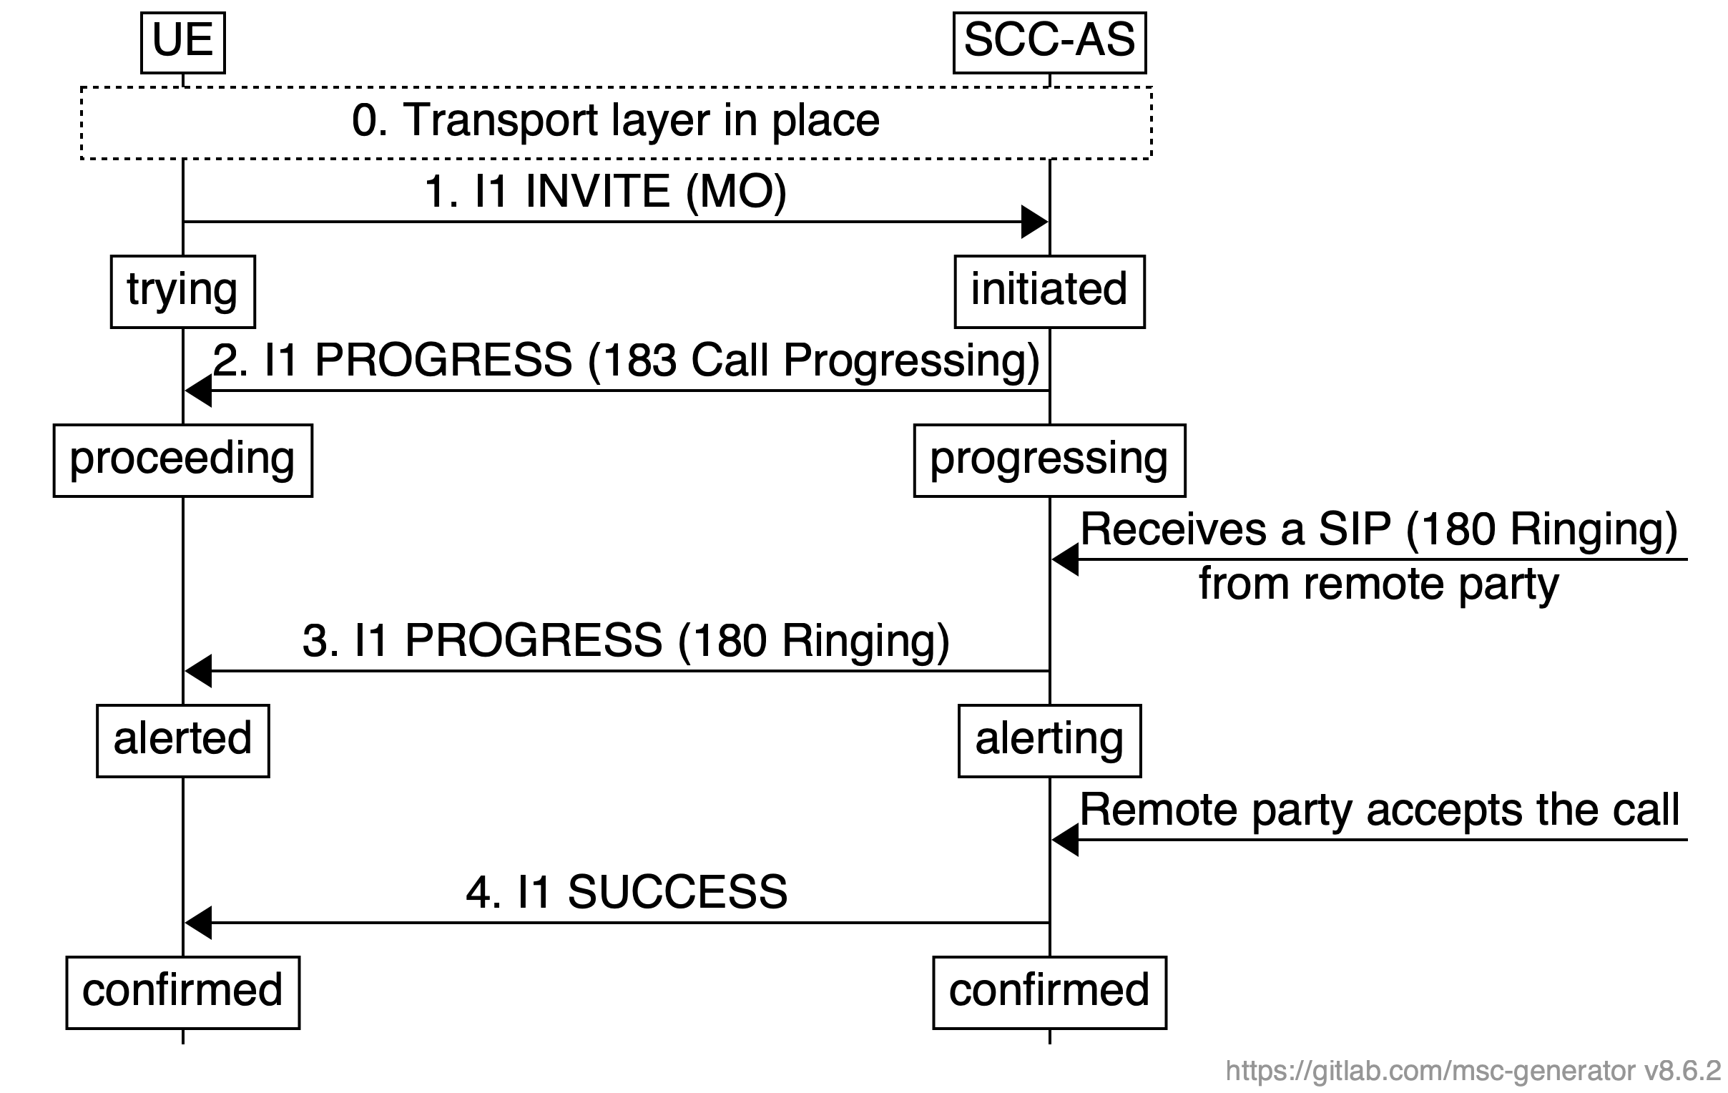

**Figure 1: MO Call Flow with I1 Messages**

1. UE attach over NB-IoT NTN with a default DRB for I1 signaling. A transport-layer connection between UE and SCC AS is in place.
2. When the UE wants to originate a session using the I1 protocol, it creates and sends an I1 INVITE message (in accordance with table 7.3.1 in TS 24.294) to the SCC AS over a default bearer for I1 signalling. This message typically includes Message Type indicating a MO I1 INVITE, a Call-Identifier to uniquely identify the session, a From-id IE containing the originating user’s public identity (e.g. SIP URI or E.164 number), To-id IE with the called party’s identity, and optionally Privacy IE indicating privacy preference, and optionally Timestamp IE is a non-real-time transport protocol is used
3. Upon receiving an Initial I1 Invite message from the ICS UE via the I1 reference point, based on the media codec information the SCC AS received in the I1 Invite, SCC AS analyzes the offered codecs and selects one that is compatible with the network and the remote party’s capabilities.

The SCC AS sends an I1 Progress message with Reason set to 183 (Call Progressing). After receiving the I1 Progress message, the UE start the process of setting up its media bearer with the specified codec.

1. Once the SCC AS receives a SIP 180 (ringing) response from the remote party, it sends an I1 Progress message with the Reason field set to 180 (Ringing) to the ICS UE. The cause the UE to provide a local alerting indication to the user.
2. When the remote party accepts the call (e.g. sends a SIP 200 (OK), the SCC AS sends an I1 Success message to the ICS UE. Upon receiving the I1 Success message, the ICS UE, after verifying, the media DRB has been connected, consider the I1 session is to be established.

## 2.2 MT Call Flow

Figure 2 shows an example MT call flow by using I1 messages.

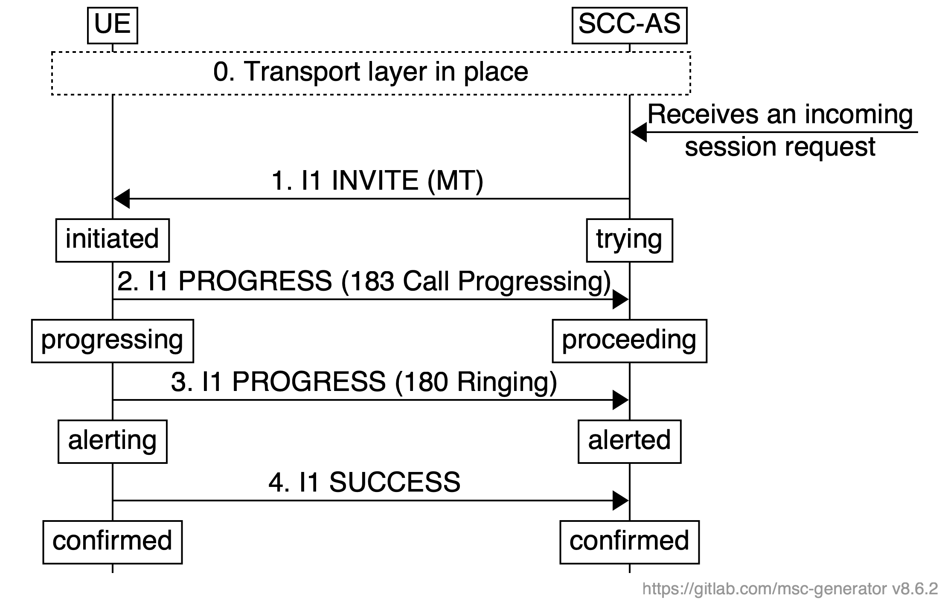

**Figure 2: MT Call Flow with I1 Messages**

1. A transport connection between SCC-AS and UE is in place
2. SCC AS receives an incoming session request from remote party. SCC AS allocates a Call-Identifier, initial Sequence ID, and associate them with the UE profile. SCC AS prepares the I1 INVITE with SCC-AS-id IE, To-id IE, From-id IE. Upon UE receives I1 INVITE, it stores the information contained in the I1 INVITE message, transitions to “initiated” state. The receipt of the I1 INVITE message at the UE will trigger the UE to set up the media connection toward the SCC AS for voice packets delivery.
3. UE Sends I1 PROGRESS with Reason 183 Call progressing to acknowledge and keep call setup alive.
4. When ready to alert the user, UE sends I1 PROGRESS with Reason 180 Ringing.
5. UE transitions to “confirmed “state locally, and sends I1 SUCCESS to SCC AS. Upon receiving UE’s I1 SUCCESS, SCC AS transitions to “confirmed” state, and starts media flow from remote party toward UE over the data radio bearer for media. And SCC AS signal the remote party that the call is connected (e.g. SIP 200 OK)

# 3 Proposal

It is proposed to add relevant description on the usage of I1 message in Annex A in TR 23.700-19 V0.2.0.

* * * First Change * * * *

# A.2 Example message size and corresponding transmission delay for SIP messages in IMS

Figure A.2-1 shows the typical IMS mobile call processing in TN scenario:



Figure A.2-1: IMS mobile call processing in TN scenario

Table A.2-1 shows the example SIP signalling size and corresponding transmission delay:

Table A.2-1: Example SIP message size and corresponding transmission delay in 1kbps

|  |  |  |  |
| --- | --- | --- | --- |
| Sequence | Message Name | Message Size (B) (proportional) | Transmission Delay (s) in 1kbps |
| 1 | INVITE | 2,564 (+52) | 20.93 |
| 2 | 100 Trying | 445 (+52) | 3.98 |
| 3 | 183 Progressing | 1,705 (+52) | 14.06 |
| 4 | PRACK | 1,054 (+52) | 8.85 |
| 5 | 200 OK (PRACK) | 726 (+52) | 6.22 |
| 6 | UPDATE | 1,929 (+52) | 15.85 |
| 7 | 200 OK (UPDATE) | 1,494 (+52) | 12.37 |
| 8 | 180 Ringing | 983 (+52) | 8.28 |
| 9 | 200 OK (INVITE) | 1,365 (+52) | 11.34 |
| 10 | ACK | 840 (+52) | 7.14 |

Table A.2-2 shows the example EPS signalling size and corresponding transmission delay during the call setup:

Table A.2-2: Example EPS message size and corresponding transmission delay in 1kbps

|  |  |  |  |  |
| --- | --- | --- | --- | --- |
| Sequence | Message Name | Direction | Message Size (B) (proportional) | Transmission Delay (s) in 1kbps |
| a.1 | RRCConnectionReconfiguration | DL | 92 (+5) | 0.78 |
| a.2 | RRCConnectionReconfigurationComplete | UL | 2 (+5) | 0.06 |

# A.x Example message size and corresponding transmission delay for I1 messages in IMS

Based on TS 24.294, Figure A.x-1 shows the typical MO call flow using I1 messages for IMS service control.

NOTE: Solutions documented in TR 23.700-19 propose that P-CSCF could potentially be a termination point for I1 protocol.

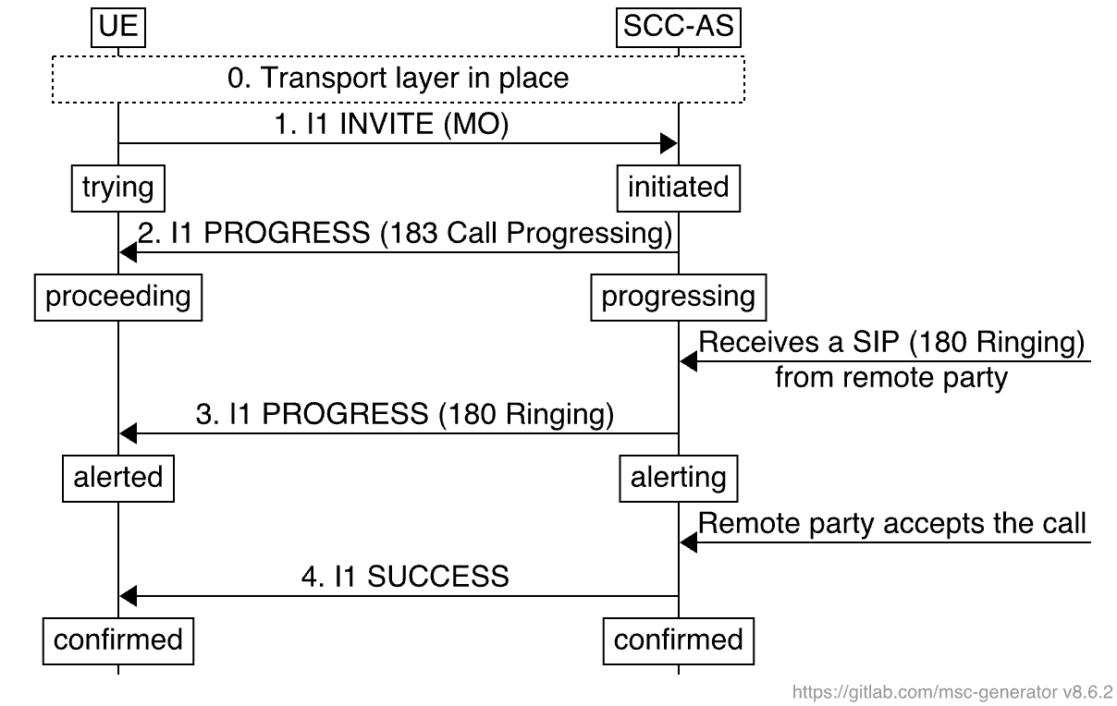

Figure A.x-1: IMS MO call flow using I1 messages

Based on TS 24.294, Figure A.x-2 shows the typical MT call flow using I1 messages for IMS service control.

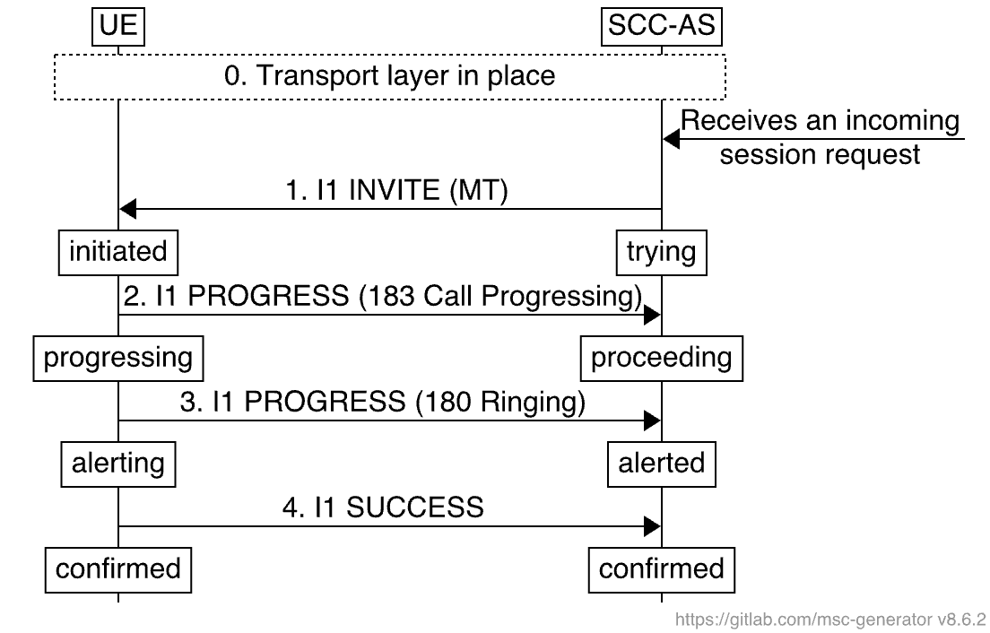

Figure A.x-2: IMS MT call flow using I1 messages

Table A.x-1 shows the example I1 message size and corresponding transmission delay, assuming a bandwidth of 1kbps transmission and pre-configured media codec:

Table A.x-1: Example I1 message size and corresponding transmission delay in 1kbps

|  |  |  |  |
| --- | --- | --- | --- |
| Sequence | Message Name | Message Size (B) | Transmission Delay (s) in 1kbps |
| 1 | I1 INVITE | 36 | 0.288 |
| 2 | I1 Progress (Call Progressing) | 15 | 0.120 |
| 3 | I1 Progress (Ringing) | 15 | 0.120 |
| 4 | I1 SUCCESS | 7 | 0.056 |
| 5 | I1 Notify | 7 | 0.056 |
| 6 | I1 BYE | 7 | 0.056 |

* * * End of Changes * * * *