3GPP TSG-RAN4 Meeting #119 R4-2606337

Dalian, China, 18th May 2026 - 22nd May 2026
CR-Form-v13.0
CHANGE REQUEST
 | 38.115-1 | CR | 0074 | rev | - | Current version: | 18.11.0
For HELP on using this form: comprehensive instructions can be found at
https://www.3gpp.org/Change-Requests.

Proposed change affects: | UICC apps |  | ME |  | Radio Access Network | X | Core Network

Title: | (NR_netcon_repeater-Perf) CR for TS 38.115-1, Correction on radiated reference point for NCR type 1-H
Source to WG: | CATT
Source to TSG: | R4
Work item code: | NR_netcon_repeater-Perf |  |  |  |  |  | Date: |  |  | 2026-05-08
Category: | F |  |  |  |  |  | Release: |  |  | Rel-18
 | Use one of the following categories:  F (correction)  A (mirror corresponding to a change in an earlier release)  B (addition of feature),  C (functional modification of feature)  D (editorial modification)  Detailed explanations of the above categories can  be found in 3GPP TR 21.900. |  |  |  |  |  |  |  | Use one of the following releases:  Rel-8 (Release 8)  Rel-9 (Release 9)  Rel-10 (Release 10)  Rel-11 (Release 11)  …  Rel-18 (Release 18)  Rel-19 (Release 19)  Rel-20 (Release 20)  Rel-21 (Release 21)
Reason for change: |  | The title of clause 4.2.1 "RF Repeater" is unclear. The interpretation of radiated reference point for NCR type 1-H is missing.
Summary of change: |  | 1) Change title of clause 4.2.1 from "RF Repeater" to "RF repeater type 1-C" .  2) Add the interpretation of radiated reference point for NCR type 1-H in clause 4.2.3.
Consequences if not approved: |  | The requirement for NCR would be unclear.
Clauses affected: |  | 4.2.1, 4.2.3
 |  | Y | N
Other specs |  |  | X | Other core specifications |  |  |  | TS/TR ... CR ...
affected: |  |  | X | Test specifications |  |  |  | TS/TR ... CR ...
(show related CRs) |  |  | X | O&M Specifications |  |  |  | TS/TR ... CR ...
Other comments:
Forge related attachments:
This CR's revision history:

==============First change==============

4.2 Conducted requirement reference points

4.2.1 RF repeater type 1-C
For repeater type 1-C, the requirements are applied at the repeater antenna connector (BS-side connector or UE-side connector) for downlink or uplink for the configuration in normal operating conditions.
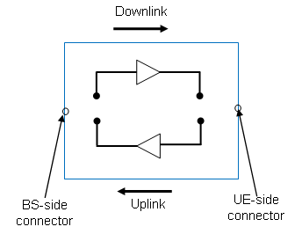
Figure 4.2.1-1: RF Repeater type 1-C downlink and uplink interface

4.2.2 NCR type 1-C
For NCR type 1-C, the NCR-Fwd RF requirements are applied at the NCR antenna connector (BS-side connector or UE-side connector) for downlink or uplink for the configuration in normal operating conditions.
For NCR type 1-C, the NCR-MT RF requirements are applied at the NCR antenna connector (BS-side connector) for the configuration in normal operating conditions.
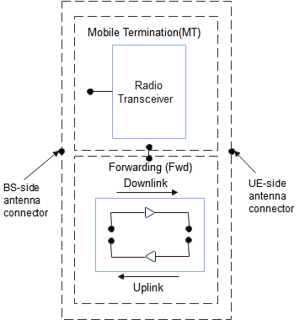
Figure 4.2.2-1: NCR type 1-C downlink and uplink interface
NOTE 1: the NCR-MT and NCR-Fwd may have the same or separate antenna connectors.

4.2.3 NCR type 1-H
For NCR type 1-H, the requirements are defined for two points of reference, signified by radiated requirements and conducted requirements.
For NCR type 1-H, the radiated characteristics are defined over the air (OTA), where the operating band specific radiated interface is referred to as the Radiated Interface Boundary (RIB). Radiated requirements are also referred to as OTA requirements. The (spatial) characteristics in which the OTA requirements apply are detailed for each requirement.
For NCR type 1-H, the NCR-MT radiated RF requirements are applied at the BS side RIB for the configuration in normal operating conditions.
NOTE: Radiated conformance requirements are captured in TS 38.115-2 [3] and are out of scope of this specification.
For NCR type 1-H, the NCR-Fwd conducted RF requirements are applied at the NCR individual or groups of TAB connectors at the transceiver array boundary (BS-side TAB connector or UE-side TAB connector) for downlink or uplink for the configuration in normal operating conditions.
For NCR type 1-H, the NCR-MT conducted RF requirements are applied at the NCR individual or groups of TAB connectors at the transceiver array boundary (BS-side TAB connector) for the configuration in normal operating conditions.
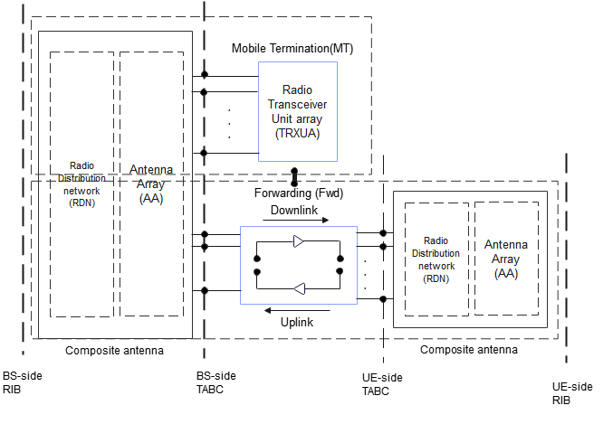
Figure 4.2.3-1: Radiated and conducted reference points for NCR type 1-H
NOTE 1: the NCR-MT and NCR-Fwd may have the same or separate TAB connectors.
==============End of change==============

