3GPP TSG-RAN4 Meeting #119 R4-2606335

Dalian, China, 18th May 2026 - 22nd May 2026
CR-Form-v13.0
CHANGE REQUEST
 | 38.106 | CR | 0130 | rev | - | Current version: | 18.10.0
For HELP on using this form: comprehensive instructions can be found at
https://www.3gpp.org/Change-Requests.

Proposed change affects: | UICC apps |  | ME |  | Radio Access Network | X | Core Network

Title: | (NR_netcon_repeater-Core) CR for TS 38.106, Correction on radiated reference point for NCR type 1-H
Source to WG: | CATT
Source to TSG: | R4
Work item code: | NR_netcon_repeater-Core |  |  |  |  |  | Date: |  |  | 2026-05-08
Category: | F |  |  |  |  |  | Release: |  |  | Rel-18
 | Use one of the following categories:  F (correction)  A (mirror corresponding to a change in an earlier release)  B (addition of feature),  C (functional modification of feature)  D (editorial modification)  Detailed explanations of the above categories can  be found in 3GPP TR 21.900. |  |  |  |  |  |  |  | Use one of the following releases:  Rel-8 (Release 8)  Rel-9 (Release 9)  Rel-10 (Release 10)  Rel-11 (Release 11)  …  Rel-18 (Release 18)  Rel-19 (Release 19)  Rel-20 (Release 20)  Rel-21 (Release 21)
Reason for change: |  | The title of clause 4.2.1B, 4.2.2 and 4.2.2A is not consistent with title of clause 4.2.1 "RF repeater type 1-C" and title of clause 4.2.1A "NCR type 1-C". The interpretation of radiated reference point for NCR type 1-H is missing. Since the OTA Repeater output power is not defined for NCR-Fwd type 1-H, so the applicability of OTA Repeater output power for NCR-Fwd type 1-H is incorrect. The conducted diversity characteristic for FR1 NCR type 1-C, 1-H is defined in sub-clause 6.15 instead of 6.13.
Summary of change: |  | 1) Change title of clause 4.2.1B from "Network controlled Repeater type 1-H" to "NCR type 1-H" to be consistent with title of clause 4.2.1A "NCR type 1-C" .  2) Change title of clause 4.2.2 from "Repeater type 2-O" to "RF repeater type 2-O" to be consistent with title of clause 4.2.1 "RF repeater type 1-C".  3) Change title of clause 4.2.2A from "Network controlled Repeater type 2-O" to "NCR type 2-O" to be consistent with title of clause 4.2.1A "NCR type 1-C" .  4) Add the interpretation of radiated reference point for NCR type 1-H in clause 4.2.1B.  5) Change "NCR-MT conducted RF requirements" to " NCR-MT radiated RF requirements" in clause 4.2.2A.  6) Change "sub-clause 6.13" to "sub-clause 6.15" in clause 7.12.2.
Consequences if not approved: |  | The requirment for NCR would be unclear.
Clauses affected: |  | 4.2.1B, 4.2.2, 4.2.2A, 4.5, 7.12.2
 |  | Y | N
Other specs |  |  | X | Other core specifications |  |  |  | TS/TR ... CR ...
affected: |  | X |  | Test specifications |  |  |  | TS38.115-1/2
(show related CRs) |  |  | X | O&M Specifications |  |  |  | TS/TR ... CR ...
Other comments:
Forge related attachments:
This CR's revision history:

==============First change==============

4.2 Conducted and radiated requirement reference points

4.2.1 RF repeater type 1-C
For RF Repeater type 1-C, the requirements are applied at the repeater antenna connector (BS-side connector or UE-side connector) for downlink or uplink for the configuration in normal operating conditions.
Downlink
Uplink
UE-side connector
BS-side connector
Figure 4.2.1-1: RF repeater type 1-C downlink and uplink interface

4.2.1A NCR type 1-C
For NCR type 1-C, the NCR-Fwd RF requirements are applied at the NCR antenna connector (BS-side connector or UE-side connector) for downlink or uplink for the configuration in normal operating conditions.
For NCR type 1-C, the NCR-MT RF requirements are applied at the NCR antenna connector (BS-side connector) for the configuration in normal operating conditions.
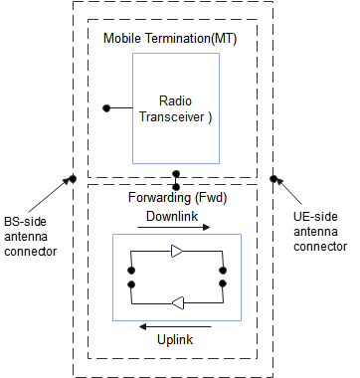
Figure 4.2.1-1A: Network controlled Repeater type 1-C downlink and uplink interface
NOTE 1: the NCR-MT and NCR-Fwd may have the same or separate antenna connectors.

4.2.1B NCR type 1-H
For NCR type 1-H, the requirements are defined for two points of reference, signified by radiated requirements and conducted requirements.
For NCR type 1-H, the radiated characteristics are defined over the air (OTA), where the operating band specific radiated interface is referred to as the Radiated Interface Boundary (RIB). Radiated requirements are also referred to as OTA requirements. The (spatial) characteristics in which the OTA requirements apply are detailed for each requirement.
For NCR type 1-H, the NCR-MT radiated RF requirements are applied at the BS side RIB for the configuration in normal operating conditions.
For NCR type 1-H, the NCR-Fwd conducted RF requirements are applied at the NCR individual or groups of TAB connectors at the transceiver array boundary (BS-side TAB connector or UE-side TAB connector) for downlink or uplink for the configuration in normal operating conditions.
For NCR type 1-H, the NCR-MT conducted RF requirements are applied at the NCR individual or groups of TAB connectors at the transceiver array boundary (BS-side TAB connector) for the configuration in normal operating conditions.
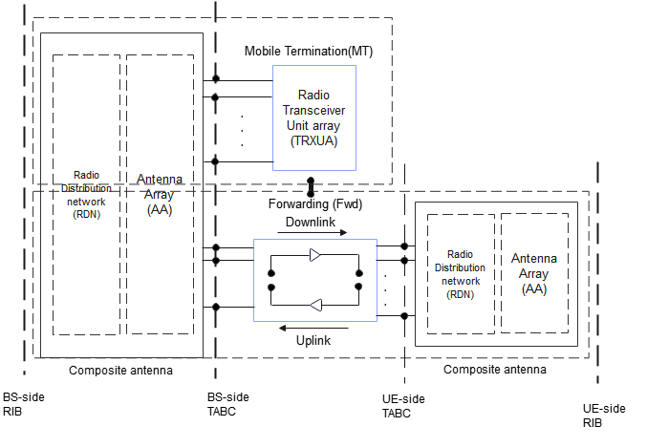
Figure 4.2.1-1B: Radiated and conducted reference points for NCR type 1-H
NOTE 1: the NCR-MT and NCR-Fwd may have the same or separate TAB connectors.

4.2.2 RF repeater type 2-O
For RF repeater type 2-O, the radiated characteristics are defined over the air (OTA), where the operating band specific radiated interface is referred to as the Radiated Interface Boundary (RIB). Radiated requirements are also referred to as OTA requirements. The (spatial) characteristics in which the OTA requirements apply are detailed for each requirement.
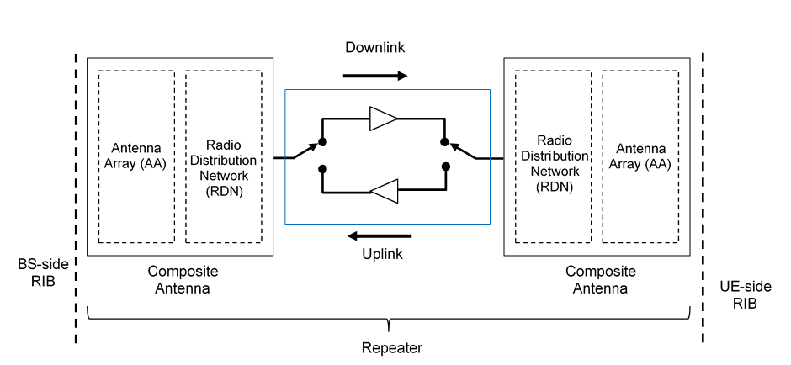
Figure 4.2.2-1: Radiated reference points for RF repeater type 2-O

4.2.2A NCR type 2-O
For NCR type 2-O, the radiated characteristics for NCR-Fwd and NCR-MT are defined over the air (OTA), where the operating band specific radiated interface is referred to as the Radiated Interface Boundary (RIB). Radiated requirements are also referred to as OTA requirements. The (spatial) characteristics in which the OTA requirements apply are detailed for each requirement.
For NCR type 2-O, the NCR-MT radiated RF requirements are applied at the BS side RIB for the configuration in normal operating conditions.
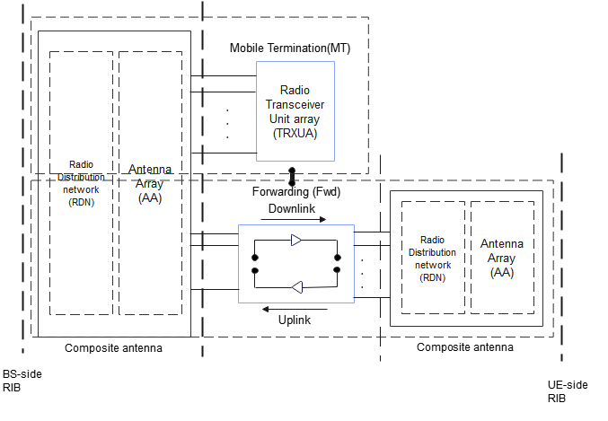
Figure 4.2.2-1A: Radiated reference points for NCR type 2-O
NOTE 1: the NCR-MT and NCR-Fwd may have the same or separate RIB
==============Next change==============

4.5 Applicability of requirements
In Table 4.5-1, the requirement applicability for each requirement set is defined. For each requirement, the applicable requirement clause in the specification is identified. Requirements not included in a requirement set is marked not applicable (NA).
Table 4.5-1: Requirement set applicability
Requirement | Requirement set
 | RFR  type 1-C,  NCR-Fwd  type 1-C | NCR-Fwd  type 1-H | NCR-MT type 1-C | NCR-MT type 1-H | -RFR type 2-O, NCR-Fwd type 2-O | NCR-MT type 2-O
Repeater output power | 6.2 | 6.2
Frequency stability | 6.3 | 6.3
Out of band gain | 6.4 | 6.4
Unwanted emissions | 6.5 | 6.5
Repeater Error Vector Magnitude | 6.6 | 6.6 | NA | NA | NA
Input intermodulation | 6.7 | 6.7
Output intermodulation | 6.8 | 6.8
Adjacent Channel Rejection Ratio (ACRR) | 6.9 | 6.9
Transmit ON/OFF power | 6.10 | 6.10
Repeater output power for NCR-MT |  |  | 6.2.3.2 | 6.2.3.2
Output power dynamics for NCR-MT |  |  | 6.11 | 6.11
Transmit signal quality for NCR-MT |  |  | 6.12 | 6.12
Unwanted emissions for NCR-MT |  |  | 6.5 | 6.5 |  | NA
Transmit intermodulation for NCR-MT |  | NA | 6.13 | 6.13
Diversity characteristics for NCR-MT |  |  | 6.15 | 6.15
Reference sensitivity for NCR-MT |  |  | 6.16 | 6.16
Maximum input level for NCR-MT |  |  | 6.17 | 6.17
Adjacent channel selectivity for NCR-MT |  |  | 6.18 | 6.18
Blocking characteristics for NCR-MT |  |  | 6.19 | 6.19
Spurious response for NCR-MT |  |  | 6.20 | 6.20
Receiver intermodulation characteristics for NCR-MT |  |  | 6.21 | 6.21
Receiver spurious emissions for NCR-MT |  |  | 6.22 | 6.22
Performance requirements for NCR-MT |  |  | 8 | 8
OTA Repeater output power |  | NA |  |  | 7.2
OTA frequency stability |  |  |  |  | 7.3
OTA out of band gain |  |  |  |  | 7.4
OTA unwanted emissions |  |  |  |  | 7.5
OTA Repeater Error Vector Magnitude | NA |  |  | NA | 7.6
OTA input intermodulation |  |  |  |  | 7.7
OTA Adjacent Channel Rejection Ratio (ACRR) |  |  |  |  | 7.8
OTA transmit ON/OFF power |  |  |  |  | 7.9
OTA repeater output power for NCR-MT |  | NA | NA | 7.2 |  | 7.2
OTA output power dynamics for NCR-MT |  |  |  |  |  | 7.10
OTA transmit signal quality for NCR-MT |  |  |  |  |  | 7.11
OTA unwanted emissions for NCR-MT |  |  |  |  |  | 7.5
OTA diversity characteristics for NCR-MT |  |  |  |  |  | 7.12
OTA reference sensitivity for NCR-MT |  |  |  | NA | NA | 7.13
OTA maximum input level for NCR-MT |  |  |  |  |  | 7.14
OTA adjacent channel selectivity for NCR-MT |  |  |  |  |  | 7.15
OTA blocking characteristics for NCR-MT |  |  |  |  |  | 7.16
OTA receiver spurious emissions for NCR-MT |  |  |  |  |  | 7.17
Radiated performance requirements for NCR-MT |  |  |  |  |  | 9

Table 4.5-1a: Void
Table 4.5-1b: Void
==============Next change==============

7.12 Diversity characteristics for NCR-MT

7.12.1 General

7.12.2 Minimum requirement for NCR-MT type 2-O
The OTA diversity characteristic is specified the same as conducted diversity characteristic for FR1 NCR type 1-C, 1-H in sub-clause 6.15.
==============End of change==============

