3GPP TSG-RAN WG4 Meeting #116 R4-2510714

Bangaluru, India, August 25th – 29th 2025

Agenda item: 7.12.2
Source: Ericsson
Title: TP for TR38.753: Content of chapter 7
Document for: Endorsement

Introduction
In RAN4#115 meeting, alignment simulation parameters were discussed, and preliminary results were delivered based on candidate SCM models. In this contribution, further changes are provided to remove extra SCM model and add potential metrics for 8 layers.

References
[1] R4-2508776, Way Forward for [115][321] FS_NR_demod_SCM, Nokia
[2] R4-2508621, Summary of alignment simulation for FS_NR_demod_SCM, Apple, Ericsson
[3] R4-2508622, Simulation assumptions for SCM, Huawei, MTK
[4] R4-2510711, Discussion on NR SCM general aspects, Ericsson

Text Proposal

7 Alignment of Spatial Channel Models
Simulation results and analysis of different test cases with different channel models are captured in chapter 6 for model comparison. Chapter 7 for alignment is to capture companies’ simulation results on agreed performance metric per channel model and also the span and average value of companies results.
The following alignment test cases are included in this chapter:
- FR1 SU-MIMO PDSCH 4Tx4Rx with 4 layers. The SNR of 30% and 70% maximum throughput are captured. The detailed parameter assumptions can be found in Table 6.2-1 and 6.2-2.
- FR1 SU-MIMO PDSCH 8Tx8Rx with 8 layers. The SNR of 30% and 70% maximum throughput per codeword are captured. The detailed parameter assumptions can be found in Table 6.2-1 and 6.2-2.
- FR1 SU-MIMO PMI 8Tx4Rx with 4 layers and Type-I codebook. The SNR of 70% and 90% maximum throughput are captured. The detailed parameter assumptions can be found in Table 6.1-1 and 6.1-2.
- FR1 SU-MIMO PMI 8Tx4Rx with 4 layers and eType-II codebook. The SNR of 70% and 90% maximum throughput are captured. The detailed parameter assumptions can be found in Table 6.1-1 and 6.1-2.

There are two CDL based models and two TDL based models are captured for alignment simulation.

- CDLC option 2 final model: The model has 12 clusters which is derived based on CDLC model in Table 7.7.1-3 in TR 38.901 with further cluster truncation. The model profile is in Table [X-Y2].
- Enhanced TDLC option 3 final model: The model description is in Table [X-Y3].

The BS antenna configuration for CDL alignment is one antenna element per subarray.
- 4Tx case: (M, N, P, Ms, Ns) = (1, 2, 2, 1, 1).
- 8Tx case: (M, N, P, Ms, Ns) = (1, 4, 2, 1, 1).

The Doppler shift configurations are 3km/h for CDL based models and 10Hz for TDL based models.

7.1 CDLC option 2 final model results alignment

Table 7.1-1 Simulation result summary for FR1 SU-MIMO PDSCH 4Tx4Rx with 4 layers
SNR at Norm. Throughput [dB] | Source #1 | Source #2 | Source #3 | Source #4 | Source #5 | Source #6 | Source #7 | Source #8 | Average | Span
30% | 8.5 | 6 | 6.4 | 6.6 | 6.4 | 7 | 5.9 | 6.7 | 6.7 | 2.6
70% | 15.5 | 14.3 | 16.5 | 15.6 | 15.9 | 16.6 | 14.7 | 15.6 | 15.6 | 2.3

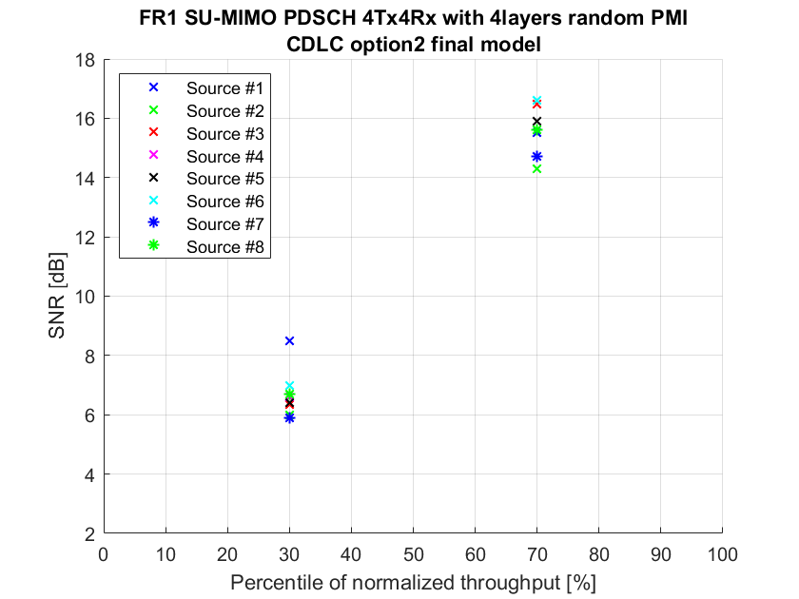
Observation 1: 7 from 8 sources could achieve SNR span < 2.5dB at both 30% and 70% normalized throughput percentiles.

Table 7.1-2 Simulation result summary for FR1 SU-MIMO PDSCH 8Tx8Rx with 8 layers
SNR at Norm. Throughput [dB] |  | Source #1 | Source #2 | Source #3 | Source #4 | Source #5 | Source #6 | Source #7 | Average | Span
CW1 | 30% | 6.4 | 4.9 | 4.8 | 6.1 | 6.8 | 6.9 | 6.3 | 6.0 | 2.1
 | 70% | 16.9 | 14.2 | 16.5 | 16.7 | 17.5 | 17.2 | 18.5 | 16.8 | 4.3
CW2 | 30% | 10.1 | 15.7 | 10 | 9.9 | 11.6 | 12.3 | 12.4 | 11.7 | 5.8
 | 70% | 23.7 | 26 | 24.4 | 24 | 24.7 | 23.4 | 24.4 | 24.4 | 2.6

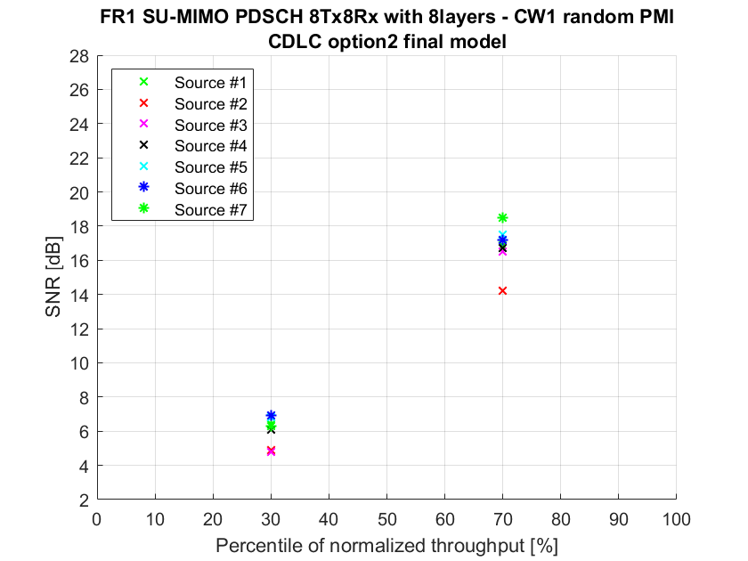
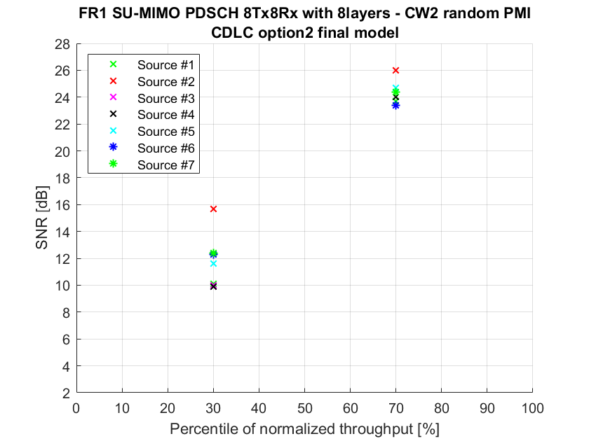
Observation 2: 6 from 7 sources could achieve SNR span <2.5dB for both CW1 and CW2 at both 30% and 70% normalized throughput percentiles.

Table 7.1-3 Simulation result summary for FR1 SU-MIMO PMI 8Tx4Rx with 4 layers, follow PMI
SNR at Norm. Throughput [dB] |  | Source #1 | Source #2 | Source #3 | Source #4 | Source #5 | Source #6 | Source #7 | Source #8 | Source #9 | Average | Span
Type-I | 70% | 12.4 | 11.0 | 10.4 | 10.3 | 10.2 | 9.7 | 9.5 | 10.2 | 9.8 | 10.4 | 2.9
 | 90% | 14.4 | 13.1 | 12.2 | 12.8 | 12.6 | 12.6 | 12.0 | 12.5 | 12.3 | 12.7 | 2.4
eType-II | 70% | 14.0 | 14.3 | 10.3 | 11.6 | 10.1 | 10.8 | 8.2 | 13.8 | 10.8 | 11.5 | 6.1
 | 90% | 15.9 | 17.1 | 12.3 | 14.0 | 12.6 | 13.9 | 10.6 | 16.8 | 12.9 | 14.0 | 6.5

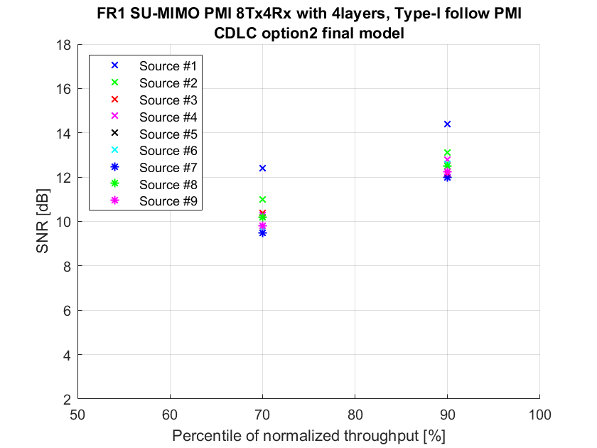
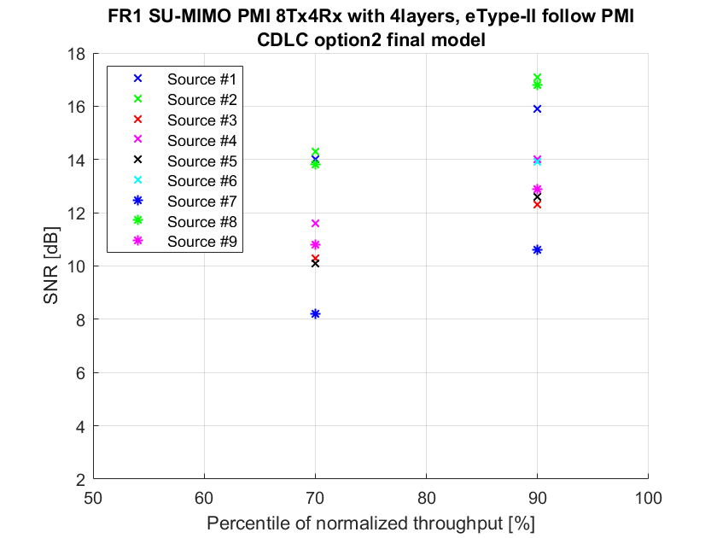
Observation 3: In type-I codebook case, 8 from 9 companies could achieve SNR span < 2.5dB at 70% and 90% normalized throughput percentiles.
Observation 4: In eType-II codebook case, three clusters of results can be observed:
- Cluster 1: include source #7.
- Cluster 2: include source #3, #4, #5, #6, #9. The span of this cluster < 2.5dB for both 70% and 90% normalized throughput percentiles.
- Cluster 3: include source #1, #2, #8. The span of this cluster < 2.5dB for both 70% and 90% normalized throughput percentiles.

7.2 Void

7.3 Enhanced TDLC option 3 final model results alignment

Table 7.3-1 Simulation result summary for FR1 SU-MIMO PDSCH 4Tx4Rx with 4 layers
SNR at Norm. Throughput [dB] | Source #1 | Source #2 | Source #3 | Source #4 | Source #5 | Source #6 | Average | Span
30% | 5.3 | 5.8 | 6 | 6 |  |  | 5.8 | 0.7
70% | 13.5 | 15.9 | 15.4 | 15.8 |  |  | 15.2 | 2.4

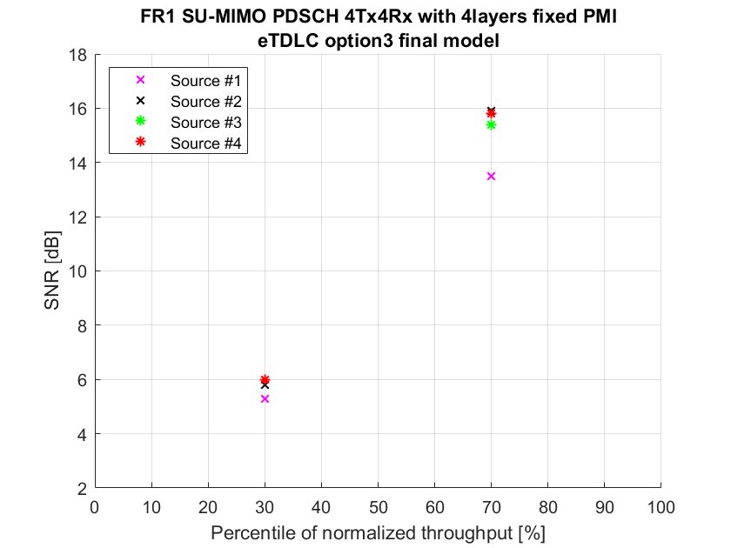
Observation 5: 4 from 4 sources could achieve SNR span < 2.5dB for both 30% and 70% normalized throughput percentiles.

Table 7.3-2 Simulation result summary for FR1 SU-MIMO PDSCH 8Tx8Rx with 8 layers
SNR at Norm. Throughput [dB] |  | Source #1 | Source #2 | Source #3 | Source #4 | Source #5 | Source #6 | Average | Span
CW1 | 30% | 4 | 2.3 | 5.7 |  |  |  | 4.0 | 3.4
 | 70% | 14.5 | 11.1 | 14.8 |  |  |  | 13.5 | 3.7
CW2 | 30% | 10.8 | 11 | 11 |  |  |  | 10.9 | 0.2
 | 70% | 21.2 | 19.7 | 20.4 |  |  |  | 20.4 | 1.5

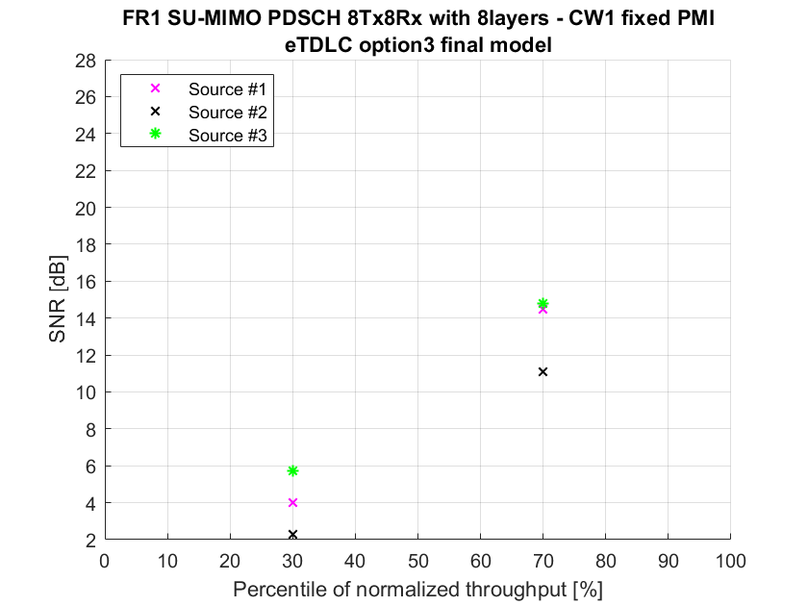

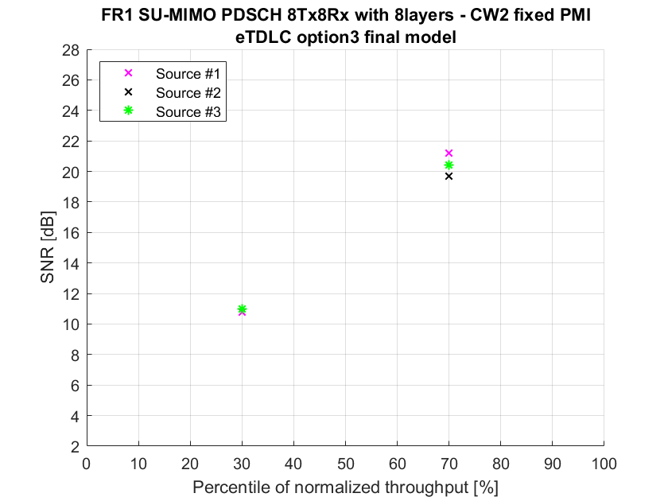
Observation 6: 2 from 3 sources could achieve SNR span < 2.5dB for CW1 at both 30% and 70% normalized throughput percentiles; 3 from 3 sources could achieve SNR span < 2.5dB for CW2 at both 30% and 70% normalized throughput percentiles.

Table 7.3-3 Simulation result summary for FR1 SU-MIMO PMI 8Tx4Rx with 4 layers, follow PMI
SNR at Norm. Throughput [dB] |  | Source #1 | Source #2 | Source #3 | Source #4 | Source #5 | Source #6 | Average | Span
Type-I | 70% | 12.3 | 13.0 | 10.8 |  |  |  | 12.0 | 2.2
 | 90% | 14.0 | 15.0 | 13.6 |  |  |  | 14.2 | 1.4
eType-II | 70% | 13.5 | 14.7 | 11.6 |  |  |  | 13.3 | 3.1
 | 90% | 17.0 | 16.8 | 17.3 |  |  |  | 17.0 | 0.5

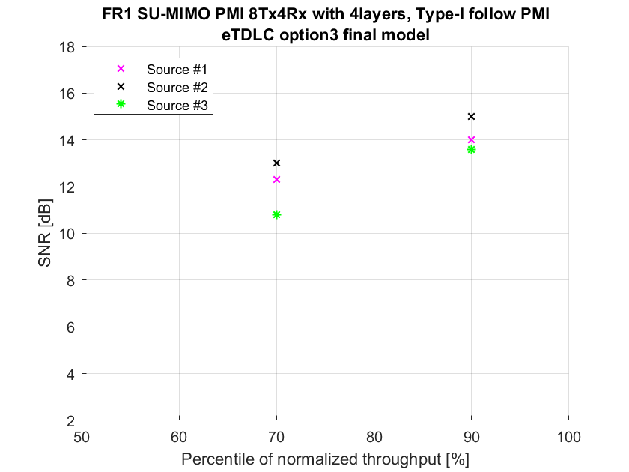

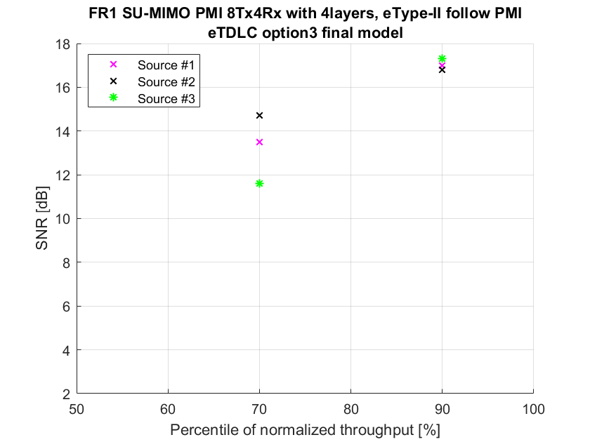
Observation 7: In type-I codebook case, 3 from 3 sources could achieve SNR span< 2.5dB at both 70% and 90% normalized throughput percentiles.
Observation 8: In eType-II codebook case, 2 from 3 sources could achieve SNR span< 2.5dB at 70% normalized throughput percentile; 3 from 3 sources could achieve SNR span< 2.5dB at 90% normalized throughput percentile.

7.4 Void

