3GPP TSG-RAN WG4 # 116 R4-2509654
Bengaluru, India, 25th August 2025 – 29th August 2025
Agenda item: 7.12.3
Source: MediaTek Inc.
Title: TP to TR38.753: TDL approaches and related Annex
Document for: Approval

Introduction
This TP handles sections of “TDL approaches” and “Annex B TDL approaches”.

Reference
[1] RP-241610 SID: Study on spatial channel model for demodulation performance requirements

Text proposal to TR 38.753
The following TP to TR 38.753 is proposed for approval.

-------------------------------------------------- Start of text proposal --------------------------------------------------

5.2 TDL Approaches
The novel multi-cluster TDL approach builds on top of the widely used and well tested legacy RAN4 TDL channel models. In the legacy models, spatial selectivity is introduced by applying MIMO correlation matrices on top of uncorrelated fading MIMO channel. However, the legacy correlation models (TS 38.101-4: Annex B.2.3) amplify the signal only in the broadside direction (AOD/AOA) of the TX and RX antenna arrays. As a result, the spatial degrees of freedom remain limited, and only a relatively low number of spatial layers can be supported. In order to support a higher number of layers, multiple separate spatial signal directions should exist. This can be achieved by introducing spatial clusters, where each cluster has its own separable mean AOD/AOA.
The multi-cluster TDL models aim to be an easier-to-use and easier-to-configure alternative to CDL models. There is just a handful of high-level parameters that can be chosen to achieve desired channel properties, and to match the scope of different performance tests. To further improve the test coverage, the spatial properties of the clusters (in terms of AOA/AOD) could be defined to be time-varying.

5.2.1 MIMO correlation and angular spread
For both LTE and NR, RAN4 demodulation and CSI reporting tests until 3GPP Release 18 employ TDL fading channel models. In many of those tests, spatial selectivity is introduced by applying MIMO correlation matrices on top of an uncorrelated fading MIMO channel. Correlation models are defined for two different antenna array assumptions: Uniform Linear Array (ULA) and Cross-polarized Antennas (X-pol).
MIMO correlation (TDL) and angular spread (CDL) approaches are alternative ways to generate spatial selectivity. High angular spread corresponds to low MIMO correlation and vice versa. As can be seen in Figure 5.2.1-1, a typical 3GPP correlation model generates spatial selectivity that resembles that of a single-cluster CDL channel model. As a result of the real-valued spatial correlation matrix, the strongest beam direction is always at 0⁰ AOD/AOA angle (broadside) of each linear array dimension.
The spatial selectivity of a MIMO channel can be depicted as power angular distribution (PAD) that represents the average channel power response as function of TX or RX direction. Figure 5.2.1-1(a) illustrates the (PAD) measured from an 8TX-8RX X-pol medium correlated TDL channel model (α₁=0.3, β=0.6). As can be seen, this channel favors the AODs and AOAs close to zero degrees. The PAD at the TX side is slightly wider than at the RX side because the TX-correlation is lower than the RX-correlation (α < β). Similarly, Figure 5.2.1-1(b) shows the PAD measured from a single-cluster 8TX-8RX CDL channel model with mean AOA = 0 degrees. Here, the angular spread is at the TX side CASD = 1.3710 and at the RX side CASA = 15.632 degrees, and the assumed antenna element radiation patterns is flat.
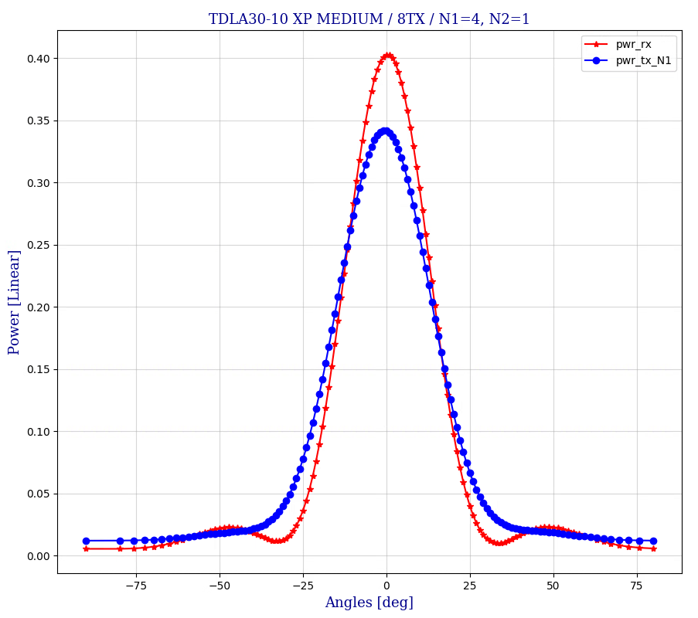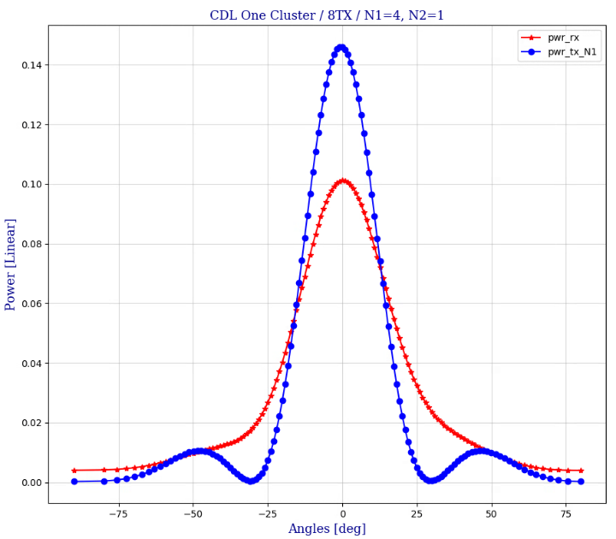
(a) (b)
Figure 5.2.1-1: Spatial selectivity of X-pol correlated TDL channel (a) and single-cluster CDL channel (b).

5.2.2 Multi-cluster TDL channel via TX-RX beam steering
The multi-cluster TDL channel model re-uses and extends the concept of beam steering that has earlier been specified for RAN4 PMI reporting tests ([X] TS 38.101-4: B.2.3.2.3 and B.2.3.2.3A). In TX-RX beam steering, the average AOA and AOD present in a correlated TDL MIMO channel are shifted to desired directions by post-processing. Note that beam steering is a part of the channel model, it is not an action taken by the transmitter or the receiver.
An example of multi-cluster channel is illustrated in Figure 5-2.
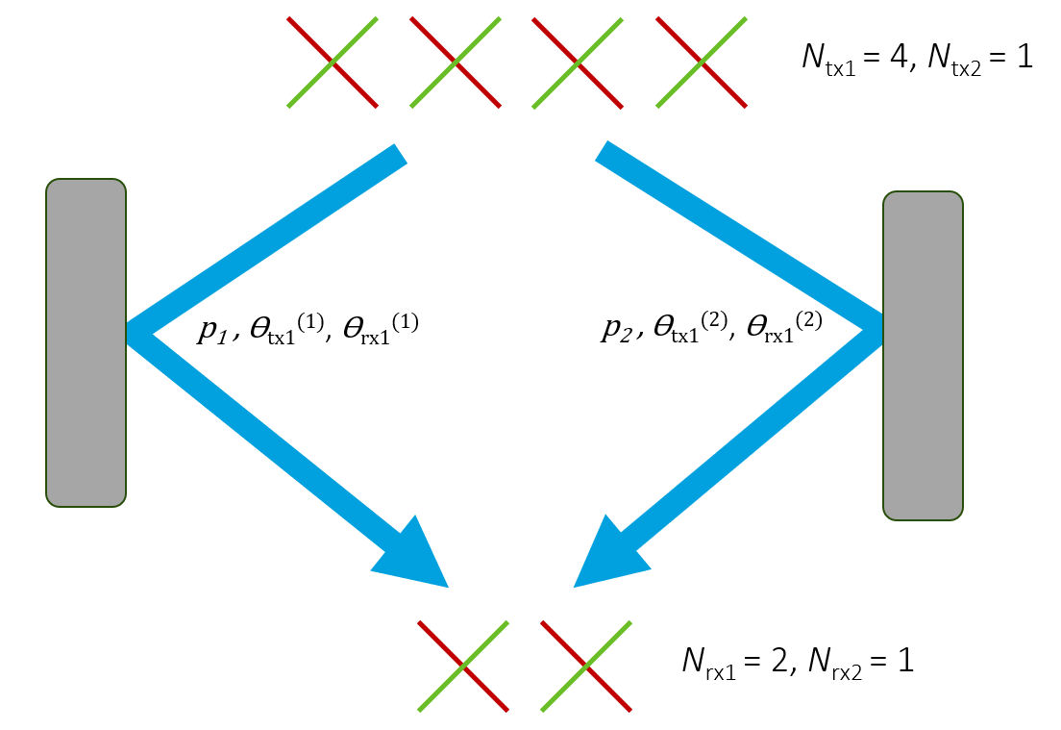
Figure 5.2.2-1: TX-RX beam steering channel with two spatial clusters.

The general channel model employs one or more statistically independent time-varying legacy TDL channel instances using some existing spatial correlation model. For the purpose of TX and RX beam steering, the delay taps of each TDL channel instance are split into spatial clusters. The delay taps in a spatial cluster are steered corresponding to common cluster-specific AOD/AOA angles. For mathematical notation, let n(k,m) denote the cluster index corresponding to delay tap m of TDL channel instance k.
The MIMO channel impulse response matrix with dimensions $N_{rx}×$ $N_{tx}$ at some time instant is
$H\left(τ\right)=\sum_{k=1}^{K}{\sum_{m=1}^{M}{\sqrt{P_{k}∙p_{m}}∙D_{n(k,m)}^{(rx)}H_{k,m}D_{n(k,m)}^{(tx)}∙δ\left({τ-τ}_{m}\right)}}$ (5.2.2-1)
where
k is the TDL channel instance index, m is the delay tap index, and $τ$ is the delay variable
K is the number of legacy TDL channel instances, and $M$ is the number of delay taps in the TDL model
$p_{m}$ is the power of delay tap m from the TDL power-delay profile, and $P_{k}$ the power weight of TDL model instance k so that $\sum_{k}{\sum_{m}{P_{k}∙p_{m}}=1}$
$τ_{m}$ is the propagation delay of tap m
$H_{k,m}$ is the spatially correlated fading MIMO channel matrix of delay tap m of TDL channel instance k with unit average power response and dimensions $N_{rx}×$ $N_{tx}$
$D_{n(k,m)}^{(rx)}$ is the diagonal RX steering matrix of cluster n(k,m) with dimensions $N_{rx}×$ $N_{rx}$
$D_{n(k,m)}^{(tx)}$ is the diagonal TX steering matrix of cluster n(k,m) with dimensions $N_{tx}×$ $N_{tx}$
$δ\left(τ\right)$ is the Dirac delta function.
The implementation complexity of the channel model grows with the number of underlying TDL channel instances K. It is anticipated that one or two TDL channels is adequate for most testing purposes. Due to the diagonal structure of the steering matrices, the matrix multiplications in equation 5.2.2-1 can be implemented with low complexity as element-wise complex phase rotations of matrix Hk,m.

5.2.2.1 Steering matrices for cross-polarized antenna arrays
Steering parameters with cross-polarized (X-pol) antenna array assumption:
- gNB TX-array dimensions:
- $N_{tx1}$ and $N_{tx2}$ are the number of antenna elements with the same polarization in the first and the second array dimension. The total number of TX antennas is
- $N_{tx}=2∙N_{tx1}∙N_{tx2}$.
- UE RX-array dimensions:
- $N_{rx1}$ and $N_{rx2}$ are the number of antenna elements with the same polarization in the first and the second array dimension. Nrx2=1The total number of TX antennas is Nrx=2∙Nrx1∙Nrx2. Note that 3GPP X-pol model (TS 38.101-4 Annex B.2.3.2) supports only 1D RX-arrays so that Nrx2=1.
- TX phases: $θ_{tx1}^{(n)}$ and $θ_{tx2}^{(n)}$ per cluster n
- RX phases: $θ_{rx1}^{(n)}$ and $θ_{rx2}^{(n)}$ per cluster n

Nrx=2∙Nrx1∙Nrx2

The steering matrices are defined as:
$$D_{n}^{(tx)}=\left[\begin{matrix}1 & 0 \\ 0 & 1\end{matrix}\right]⊗\left(D\left(θ_{tx1}^{(n)},N_{tx1}\right)⊗D\left(θ_{tx2}^{(n)},N_{tx2}\right)\right)$$
$$D_{n}^{(rx)}=\left[\begin{matrix}1 & 0 \\ 0 & 1\end{matrix}\right]⊗\left(D\left(θ_{rx1}^{(n)},N_{rx1}\right)⊗D\left(θ_{rx2}^{(n)},N_{rx2}\right)\right)$$
where the steering matrix of size $N×$ $N$ as function of phase $θ$ is defined as
$$D\left(θ,N\right)=diag\left(\left[\begin{matrix}\begin{matrix}1 & e^{jθ}\end{matrix} & \begin{matrix}⋯ & e^{jθ(N-1)}\end{matrix}\end{matrix}\right]\right)$$
Assuming the antenna arrays employ uniform distance between elements in each linear dimension, the phase shift $θ$ corresponds to AOA or AOD angle $φ$ so that $θ\left(φ,\frac{d}{λ}\right)=2π∙\frac{d}{λ}∙sin\left(φ\right)$, where d is the distance between adjacent antenna elements and λ is the carrier wavelength.
The steering phases $θ_{tx1}^{(n)}$, $θ_{tx2}^{(n)}$, $θ_{rx1}^{(n)}$, $θ_{rx2}^{(n)}$ may be specified either directly or by specifying the corresponding directional angles $φ_{tx1}^{(n)}$, $φ_{tx2}^{(n)}$, $φ_{rx1}^{(n)}$, $φ_{rx2}^{(n)}$.
The beam steering phases can be either constant or (slowly) time-varying. In general, the model parameters can be chosen to match the scope of each test case. For example, the number of clusters can be selected so that the desired number of layers (rank) is supported. Optionally, cluster-specific Doppler shifts can also be specified.

5.2.3 Example cluster model
In this section, parameterization of a four-cluster channel employing two TDLC channel instances is given. In model xTDL-C1 in Table 5.2.3-1, the two TDLC instances are each further split into two clusters so that delay taps 1-4 are grouped into one and taps 5-12 into another cluster.
Assuming 8TX-8RX array setup with $(N_{tx1}$, $N_{tx2}$, $N_{rx1}$, $N_{rx2})=$ (4, 1, 4, 1), the steering phases both at TX and RX side are chosen so that the TX and RX beams become mutually orthogonal between clusters. Orthogonality between the beams maximizes the spatial multi-layer capacity of the channel for a given set of power weights.
The cluster power distribution also affects the spatial properties of the channel. For a set of orthogonal beams, assigning equal power for all clusters results in the highest channel capacity. The total power of a cluster depends on the power weight of the corresponding TDL channel instance, and on the sum power of the delay taps included in the cluster. Thus, the cluster power distribution can be adjusted by two different methods: by setting the power weights and by splitting the delay taps into clusters so that a desired distribution is achieved.

Table 5.2.3-1: Cluster model xTDL-C1: 2 TDLC channel instances, 4 clusters
TDLC-300 / XP-high |  |  | TX-RX beam steering
Tap | Delay (ns) | Tap power  (dB) | TDL channel 1  Power: 0 dB |  |  | TDL channel 2  Power: -9 dB
 |  |  | Cluster index | $$θ_{tx1}$$ | $$θ_{rx1}$$ | Cluster index | $$θ_{tx1}$$ | $$θ_{rx1}$$
1 | 0 | -6.9 | 1 | 0 | 0 | 3 | $$π$$ | $$π$$
2 | 65 | 0
3 | 70 | -7.7
4 | 190 | -2.5
5 | 195 | -2.4 | 2 | $$-π/2$$ | $$-π/2$$ | 4 | $$π/2$$ | $$π/2$$
6 | 200 | -9.9
7 | 240 | -8.0
8 | 325 | -6.6
9 | 520 | -7.1
10 | 1045 | -13.0
11 | 1510 | -14.2
12 | 2595 | -16.0

C.1 TDL Approaches

C.1.1 Multi-cluster TDL channel for 2-CW fixed-MCS testing
As one example, testing of two-codeword (up to 8 layers) MIMO demodulation – so that consistently different channel quality per CW is maintained – has turned out to be challenging with current RAN4 correlation models. This section presents examples how to construct PDSCH demodulation tests with fixed rank, fixed Type I PMI, and different fixed MCS per CW.

C.1.1.1 Example 1
For fixed PMI testing, the per-cluster phase shifts: $θ_{tx1}^{(n)}$ and $θ_{tx2}^{(n)}$ can be chosen to be fixed and to match the beams of the transmit PMI. In Type I codebook, each CW often maps to a subset of the orthogonal PMI-beams. This is illustrated below for the 5-layer precoder (TS 38.214: 5.2.2.2.1). Consequently, per-CW channel quality levels can be adjusted by adjusting the cluster-specific channel powers.
To minimize cross-layer/CW interference at the UE, the RX-phases $θ_{rx1}^{(n)}$ can be chosen so that the corresponding steering vectors are orthogonal. Alternatively, by choosing non-orthogonal RX steering vectors, cross-layer/CW interference can be increased if so desired. Finally, the selection of the X-pol spatial correlation model parameters (α₁, α₂, β) determines how strictly the mean spatial directions are maintained. Higher correlation is analogous to narrower angular spread per cluster.
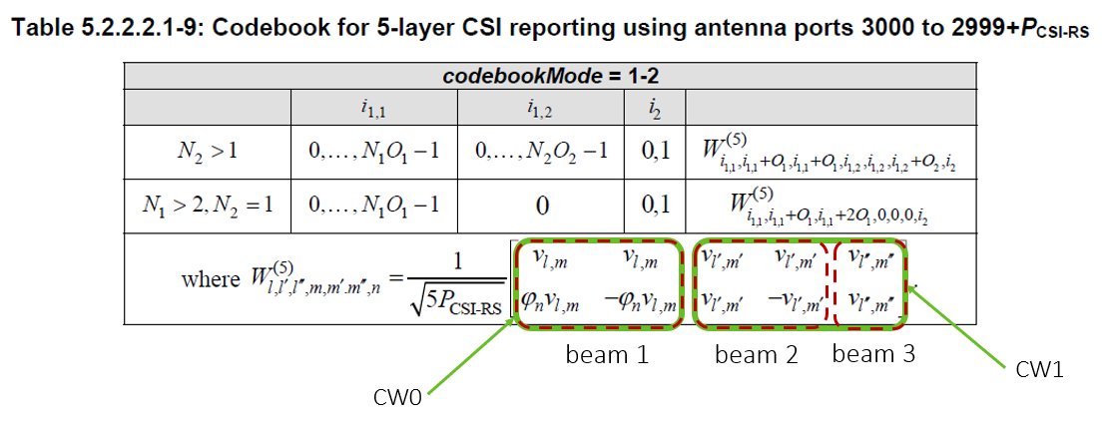
Figure C.1.1.1-1: Illustration of a codebook for 5-layer CSI reporting
To demonstrate the concept, a rank 5 PDSCH setup as detailed in Table C.1.1.1-1 was simulated in the channel model defined in Table C.1.1.1-2. The results are depicted in Figure C.1.1.1-1. Here, CW0 employs 16QAM while CW1 has QPSK, but as clusters corresponding to CW0 are 6dB stronger, the BLER performances of the two CWs are almost on par. Thus, it can be concluded that CW-specific TX-RX beam steering clusters can effectively be used to scale CW-specific demodulation and decoding performance.
Table C.1.1.1-1: Simulation setup
Antenna setup: N_{tx1}, N_{tx2}, N_{rx1}, N_{rx2} | 2, 2, 4, 1
Rank 5 Type1 TX-PMI: i_{1,1}, i_{1,2}, i₂  1st dim PMI beam indexes: l, l’, l”  2nd dim PMI beam indexes: m, m’, m” | 0, 0, 0  0, O₁, O₁ => phase 2πl/O₁N₁ = 0, π, π  0, 0, O₂ => phase 2πm/O₂N₂ = 0, 0, π
MCS / CW0  MCS / CW1 | MCS13, 16-QAM, code rate 0.48  MCS7, QPSK, code rate 0.51

Table C.1.1.1-2: Cluster model with 3 TDL-A channel instances and 3 clusters
TDLA-30  delay profile  10Hz Doppler  XP-high correlation | TX-RX beam steering
 | TDL channel 1 / cluster 1  Power: 0 dB |  |  | TDL channel 2 / cluster 2  Power: -6 dB |  |  | TDL channel 3 / cluster 3  Power: -6 dB
 | $$θ_{tx1}$$ | $$θ_{tx2}$$ | $$θ_{rx1}$$ | $$θ_{tx1}$$ | $$θ_{tx2}$$ | $$θ_{rx1}$$ | $$θ_{tx1}$$ | $$θ_{tx2}$$ | $$θ_{rx1}$$
 | 0 | 0 | $$0$$ | -π | $$0$$ | $$π/2$$ | -π | -π | $$π$$

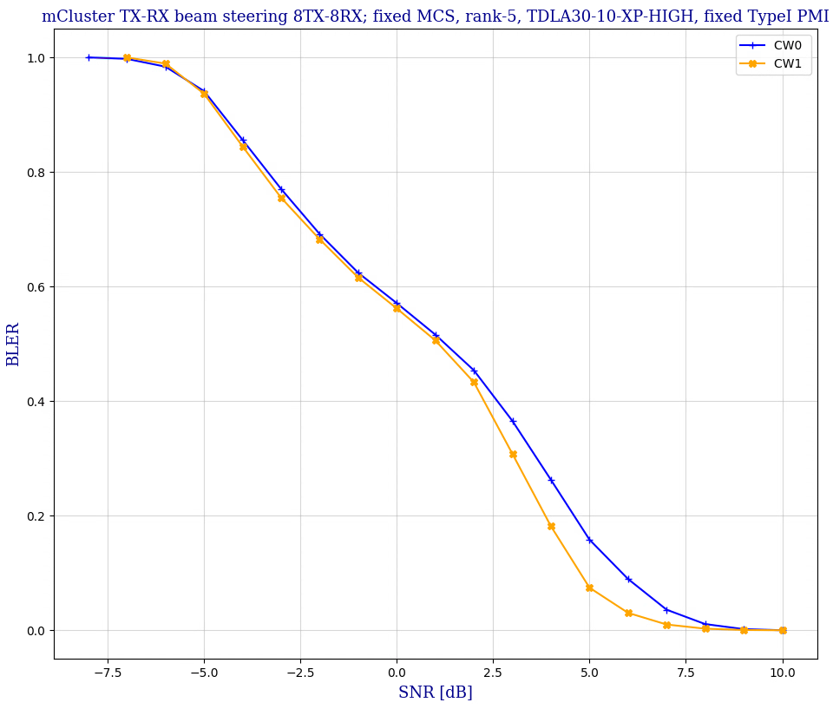
Figure C.1.1.1-2: 2: CW fixed MCS case in three-cluster TDL-A channel.

C.1.1.2 Example 2
A model with just one TDL channel instance can also satisfy the 2-CW fixed MCS testing requirements by setting mapping relation between clusters and taps to control the 2CWs power and delay difference in the reasonable level. Take channel model in Table C.1.1.2-1 as an example, where cluster 3 and cluster 4 correspond to last four taps, leading to large power and delay difference with cluster 1 and 2. Specific precoder mapping the 1st CW to first two clusters and 2nd CW to second two clusters leads to large SINR difference between two CWs. In the case, different MCSs could be configured to match performance difference.
Table C.1.1.2-1: Cluster model with one TDL-C channel instance and 4 clusters
TDLC-300 / XP-high / 100Hz Doppler |  |  | TX-RX beam steering
Tap | Delay (ns) | Tap power  (dB) | Cluster index | $$θ_{tx1}$$ | $$θ_{rx1}$$
1 | 0 | -6.9 | 1 | 0 | 0
2 | 65 | 0
3 | 70 | -7.7 | 2 | $$-π/2$$ | $$-π/2$$
4 | 190 | -2.5
5 | 195 | -2.4
6 | 200 | -9.9
7 | 240 | -8.0
8 | 325 | -6.6
9 | 520 | -7.1 | 3 | $$-π$$ | $$-π$$
10 | 1045 | -13.0
11 | 1510 | -14.2 | 4 | $$π/2$$ | $$π/2$$
12 | 2595 | -16.0

A simulation is performed to verify the characteristic with simulation assumptions captured in Table C.1.1.2-2. For rank 8 with fixed Type I Single panel precoder i_{1,1}=i_{1,2}=i₂=0, the 2nd and the 3rd cluster are mapped to the last four channel taps with low power and large delay. This leads to a big performance difference between two codewords as shown in Figure C.1.1.2-1.
Table C1.1.2-2: Simulation setup
Parameters | Values
Antenna setup: N_{tx1}, N_{tx2}, N_{rx1}, N_{rx2} | (4,1,4,1) for 8TX-8RX (1-dimensional antenna arrays)
Precoder | Type I Single panel, Fixed precoder i_{1,1}=i_{1,2}=i₂=0
Rank | 8
MCS | 13

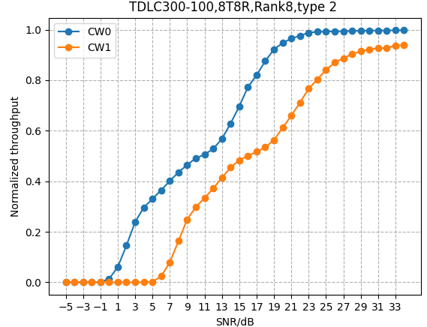
Figure C.1.1.2-1: 2-CW fixed MCS case in four-cluster TDL-C channel

-------------------------------------------------- End of text proposal --------------------------------------------------

